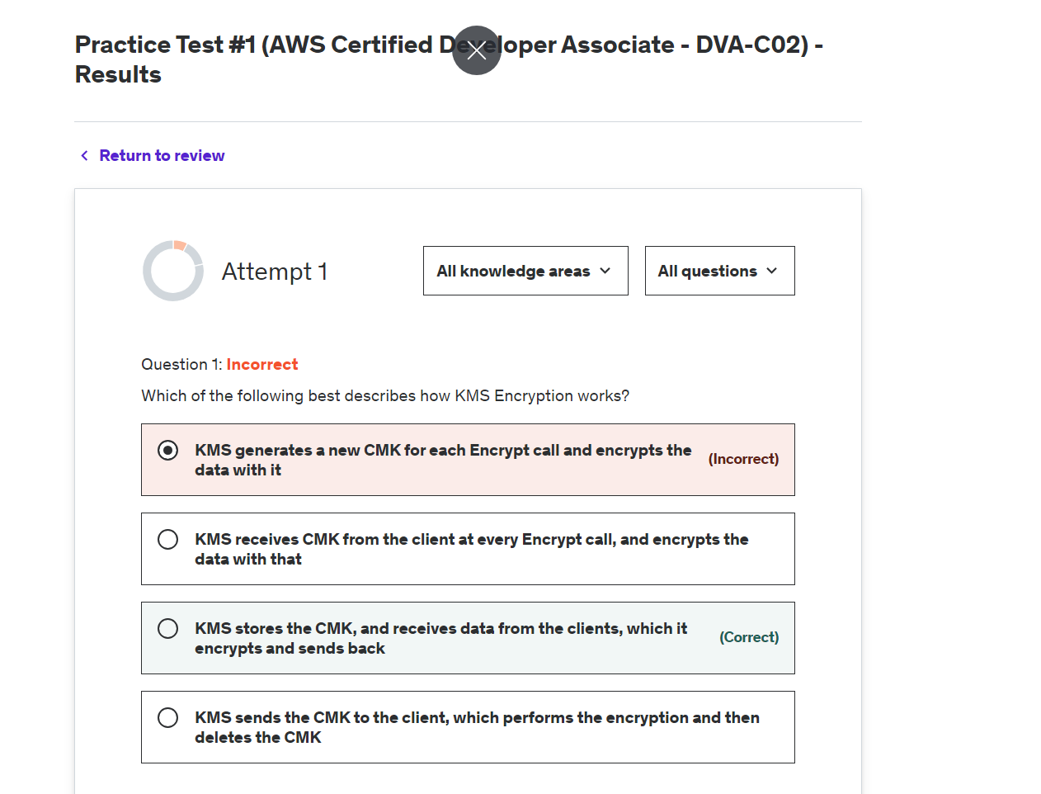

**Explanation**

Correct option:

**KMS stores the CMK, and receives data from the clients, which it encrypts and sends back**

A customer master key (CMK) is a logical representation of a master key. The CMK includes metadata, such as the key ID, creation date, description, and key state. The CMK also contains the key material used to encrypt and decrypt data. You can generate CMKs in KMS, in an AWS CloudHSM cluster, or import them from your key management infrastructure.

AWS KMS supports symmetric and asymmetric CMKs. A symmetric CMK represents a 256-bit key that is used for encryption and decryption. An asymmetric CMK represents an RSA key pair that is used for encryption and decryption or signing and verification (but not both), or an elliptic curve (ECC) key pair that is used for signing and verification.

AWS KMS supports three types of CMKs: customer-managed CMKs, AWS managed CMKs, and AWS owned CMKs.

Overview of Customer master keys (CMKs): 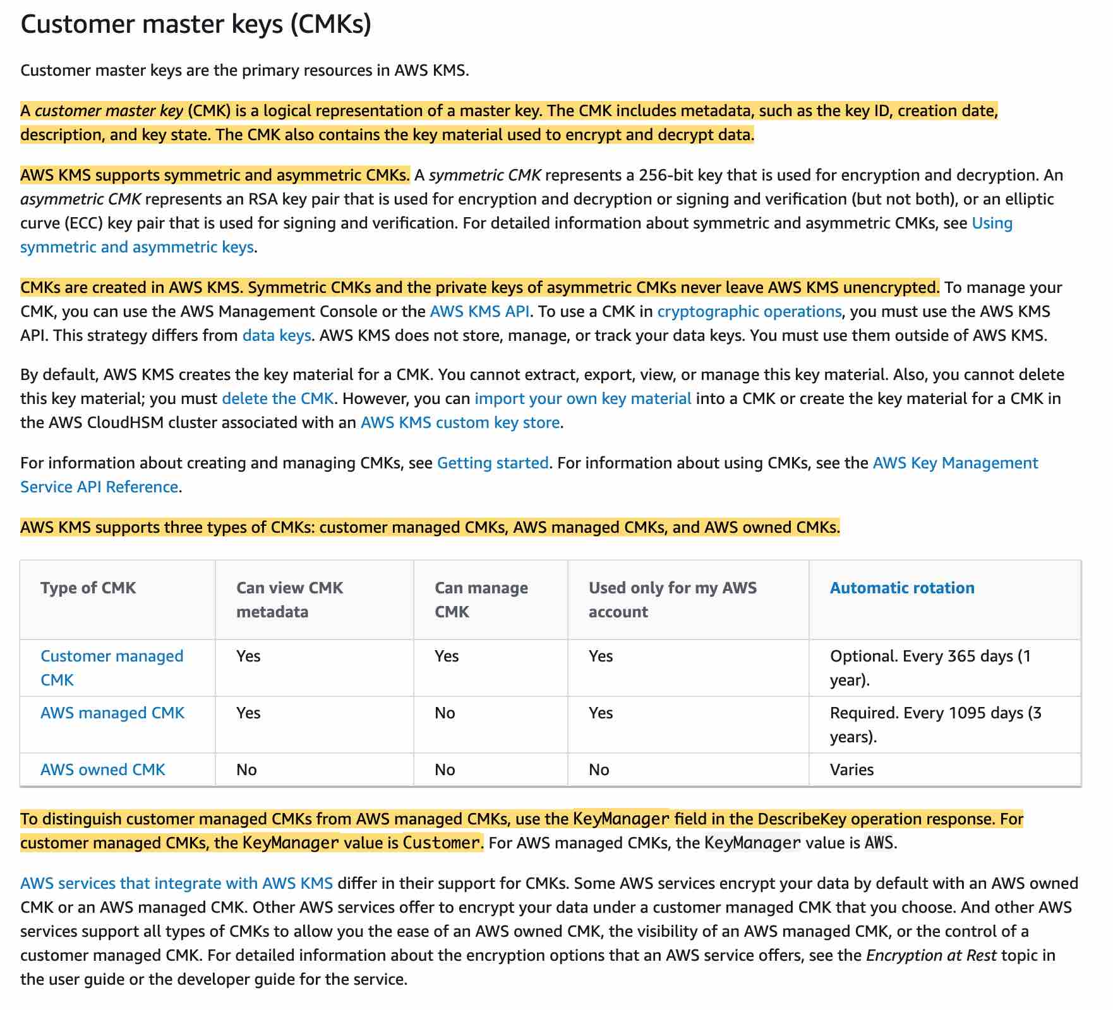

via - <https://docs.aws.amazon.com/kms/latest/developerguide/concepts.html#master_keys>

Incorrect options:

**KMS receives CMK from the client at every encrypt call, and encrypts the data with that** - You can import your own CMK (Customer Master Key) but it is done once and then you can encrypt/decrypt as needed.

**KMS sends the CMK to the client, which performs the encryption and then deletes the CMK** - KMS does not send CMK to the client, KMS itself encrypts, and then decrypts the data.

**KMS generates a new CMK for each Encrypt call and encrypts the data with it** - KMS does not generate a new key each time but you can have KMS rotate the keys for you. Best practices discourage extensive reuse of encryption keys so it is good practice to generate new keys.

References:

<https://docs.aws.amazon.com/kms/latest/developerguide/concepts.html#master_keys>

<https://docs.aws.amazon.com/kms/latest/developerguide/rotate-keys.html>

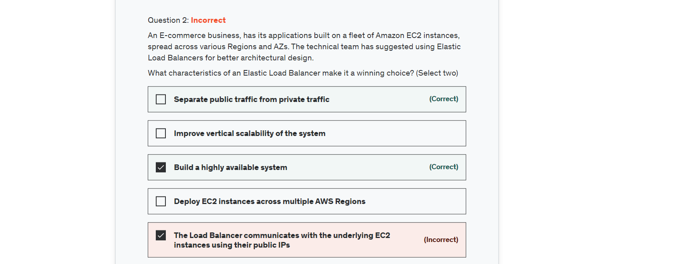

Explanation

Correct options:

A load balancer accepts incoming traffic from clients and routes requests to its registered targets (such as EC2 instances) in one or more Availability Zones. The load balancer also monitors the health of its registered targets and ensures that it routes traffic only to healthy targets. When the load balancer detects an unhealthy target, it stops routing traffic to that target. It then resumes routing traffic to that target when it detects that the target is healthy again.

Elastic Load Balancing supports three types of load balancers:

Application Load Balancers

Network Load Balancers

Classic Load Balancers

**Separate public traffic from private traffic** - The nodes of an internet-facing load balancer have public IP addresses. Load balancers route requests to your targets using private IP addresses. Therefore, your targets do not need public IP addresses to receive requests from users over the internet.

**Build a highly available system** - Elastic Load Balancing provides fault tolerance for your applications by automatically balancing traffic across targets – Amazon EC2 instances, containers, IP addresses, and Lambda functions – in multiple Availability Zones while ensuring only healthy targets receive traffic.

Incorrect options:

**The Load Balancer communicates with the underlying EC2 instances using their public IPs** - This is an incorrect statement. The Load Balancer communicates with the underlying EC2 instances using their private IPs.

**Improve vertical scalability of the system** - This is an incorrect statement. Elastic Load Balancers can connect with Auto Scaling groups to provide horizontal scaling.

**Deploy EC2 instances across multiple AWS Regions** - A Load Balancer can target EC2 instances only within an AWS Region.

References:

<https://aws.amazon.com/elasticloadbalancing/>

<https://docs.aws.amazon.com/elasticloadbalancing/latest/userguide/how-elastic-load-balancing-works.html>

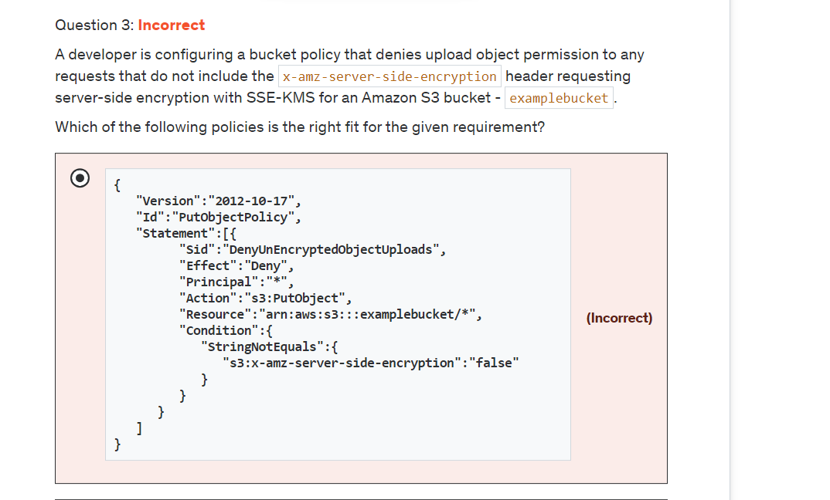

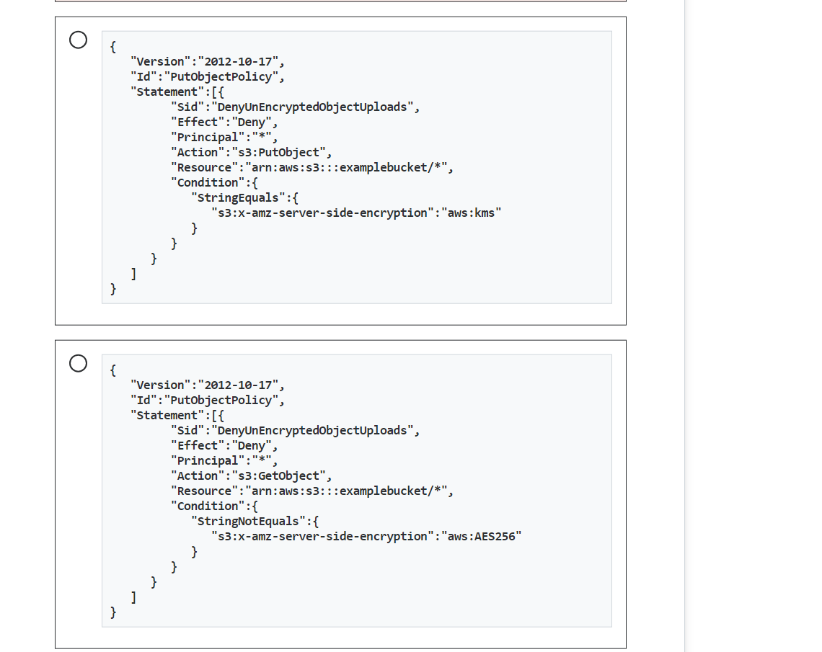

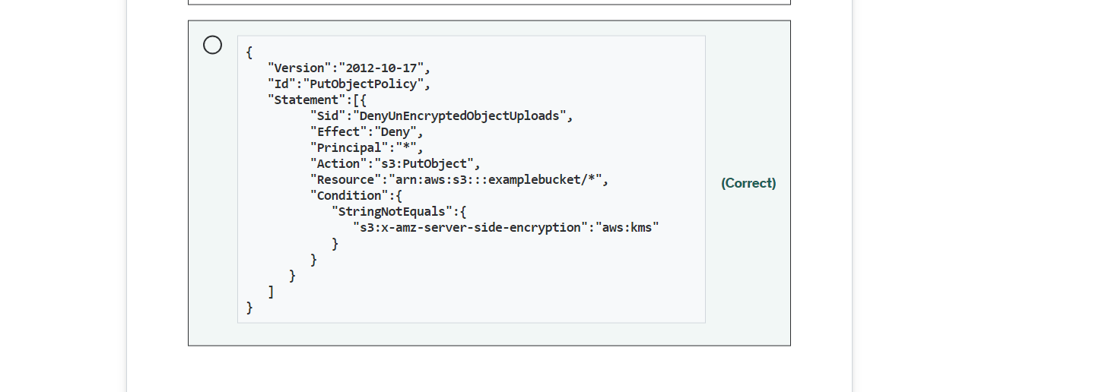

Explanation

Correct option:

**{ "Version":"2012-10-17", "Id":"PutObjectPolicy", "Statement":[{ "Sid":"DenyUnEncryptedObjectUploads", "Effect":"Deny", "Principal":"", "Action":"s3:PutObject", "Resource":"arn:aws:s3:::examplebucket/", "Condition":{ "StringNotEquals":{ "s3:x-amz-server-side-encryption":"aws:kms" } } } ] }** - This bucket policy denies upload object (s3:PutObject) permission if the request does not include the x-amz-server-side-encryption header requesting server-side encryption with SSE-KMS. To ensure that a particular AWS KMS CMK be used to encrypt the objects in a bucket, you can use the s3:x-amz-server-side-encryption-aws-kms-key-id condition key. To specify the AWS KMS CMK, you must use a key Amazon Resource Name (ARN) that is in the "arn:aws:kms:region:acct-id:key/key-id" format.

When you upload an object, you can specify the AWS KMS CMK using the x-amz-server-side-encryption-aws-kms-key-id header. If the header is not present in the request, Amazon S3 assumes the AWS-managed CMK.

Incorrect options:

**{ "Version":"2012-10-17", "Id":"PutObjectPolicy", "Statement":[{ "Sid":"DenyUnEncryptedObjectUploads", "Effect":"Deny", "Principal":"", "Action":"s3:PutObject", "Resource":"arn:aws:s3:::examplebucket/", "Condition":{ "StringEquals":{ "s3:x-amz-server-side-encryption":"aws:kms" } } } ] }** - The condition is incorrect in this policy. The condition should use StringNotEquals.

**{ "Version":"2012-10-17", "Id":"PutObjectPolicy", "Statement":[{ "Sid":"DenyUnEncryptedObjectUploads", "Effect":"Deny", "Principal":"", "Action":"s3:GetObject", "Resource":"arn:aws:s3:::examplebucket/", "Condition":{ "StringNotEquals":{ "s3:x-amz-server-side-encryption":"aws:AES256" } } } ] }** - AES256 is used for Amazon S3-managed encryption keys (SSE-S3). Amazon S3 server-side encryption uses one of the strongest block ciphers available to encrypt your data, 256-bit Advanced Encryption Standard (AES-256).

**{ "Version":"2012-10-17", "Id":"PutObjectPolicy", "Statement":[{ "Sid":"DenyUnEncryptedObjectUploads", "Effect":"Deny", "Principal":"", "Action":"s3:PutObject", "Resource":"arn:aws:s3:::examplebucket/", "Condition":{ "StringNotEquals":{ "s3:x-amz-server-side-encryption":"false" } } } ] }** - The condition is incorrect in this policy. The condition should use "s3:x-amz-server-side-encryption":"aws:kms".

Reference:

<https://docs.aws.amazon.com/AmazonS3/latest/userguide/UsingKMSEncryption.html>

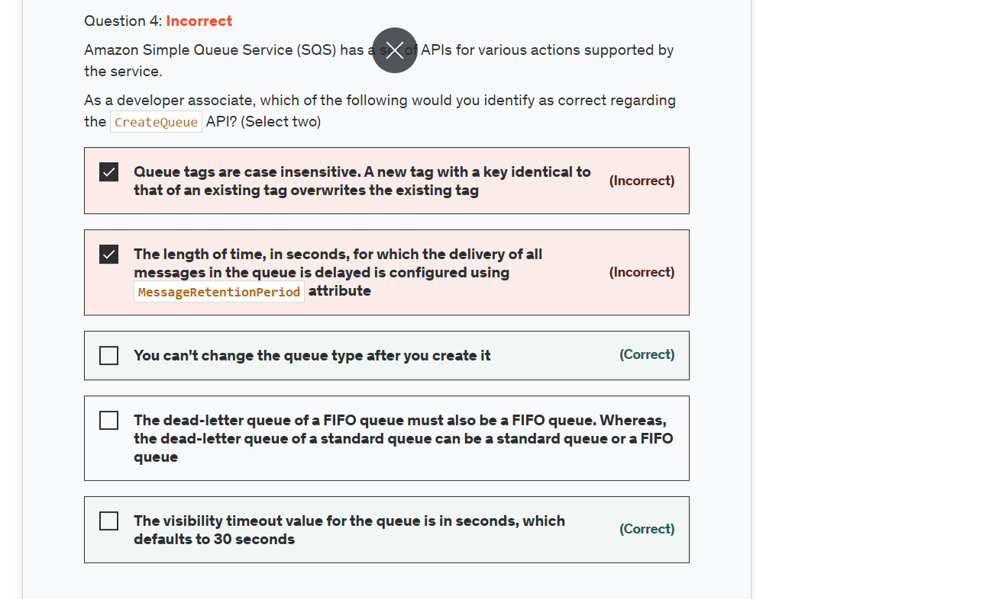Explanation

Correct options:

**You can't change the queue type after you create it** - You can't change the queue type after you create it and you can't convert an existing standard queue into a FIFO queue. You must either create a new FIFO queue for your application or delete your existing standard queue and recreate it as a FIFO queue.

**The visibility timeout value for the queue is in seconds, which defaults to 30 seconds** - The visibility timeout for the queue is in seconds. Valid values are: An integer from 0 to 43,200 (12 hours), the Default value is 30.

Incorrect options:

**The dead-letter queue of a FIFO queue must also be a FIFO queue. Whereas, the dead-letter queue of a standard queue can be a standard queue or a FIFO queue** - The dead-letter queue of a FIFO queue must also be a FIFO queue. Similarly, the dead-letter queue of a standard queue must also be a standard queue.

**The length of time, in seconds, for which the delivery of all messages in the queue is delayed is configured using MessageRetentionPeriod attribute** - The length of time, in seconds, for which the delivery of all messages in the queue is delayed is configured using DelaySeconds attribute. MessageRetentionPeriod attribute controls the length of time, in seconds, for which Amazon SQS retains a message.

**Queue tags are case insensitive. A new tag with a key identical to that of an existing tag overwrites the existing tag** - Queue tags are case-sensitive. A new tag with a key identical to that of an existing tag overwrites the existing tag. To be able to tag a queue on creation, you must have the sqs:CreateQueue and sqs:TagQueue permissions.

Reference:

<https://docs.aws.amazon.com/AWSSimpleQueueService/latest/APIReference/API_CreateQueue.html>

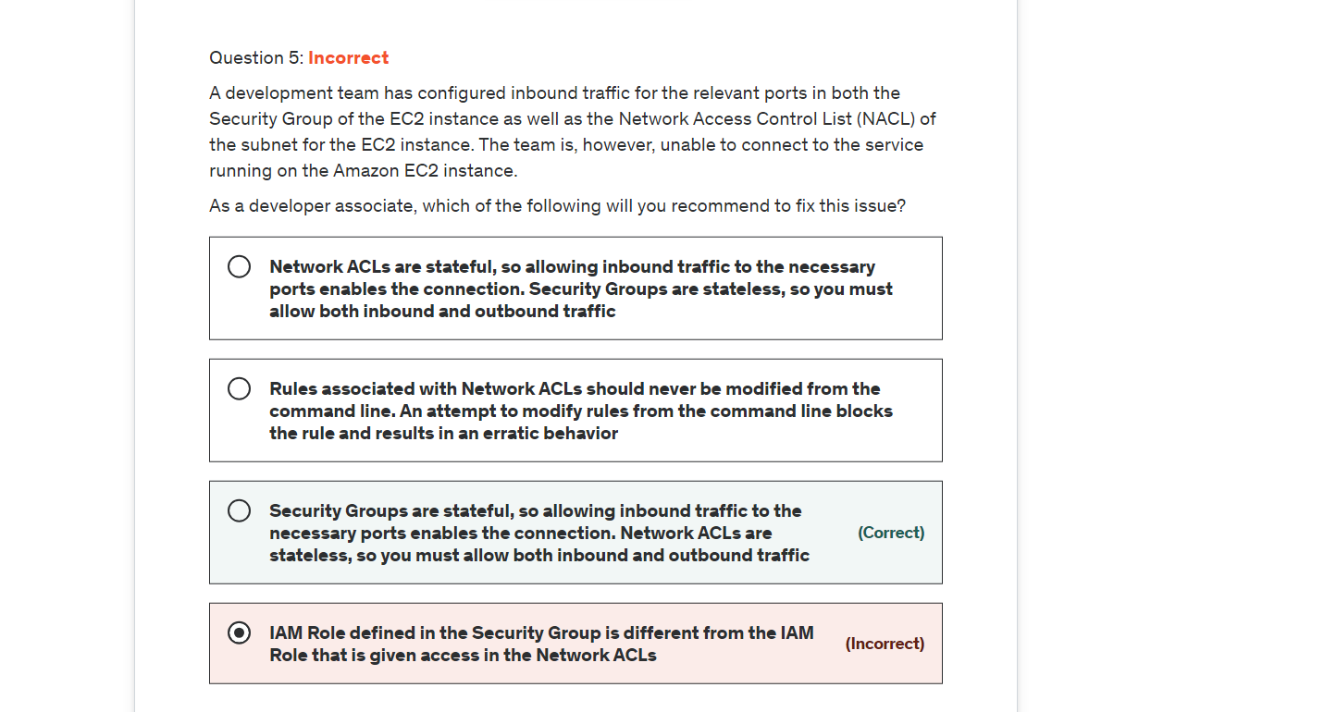

Explanation

Correct option:

**Security Groups are stateful, so allowing inbound traffic to the necessary ports enables the connection. Network ACLs are stateless, so you must allow both inbound and outbound traffic** - Security groups are stateful, so allowing inbound traffic to the necessary ports enables the connection. Network ACLs are stateless, so you must allow both inbound and outbound traffic.

To enable the connection to a service running on an instance, the associated network ACL must allow both inbound traffic on the port that the service is listening on as well as allow outbound traffic from ephemeral ports. When a client connects to a server, a random port from the ephemeral port range (1024-65535) becomes the client's source port.

The designated ephemeral port then becomes the destination port for return traffic from the service, so outbound traffic from the ephemeral port must be allowed in the network ACL.

By default, network ACLs allow all inbound and outbound traffic. If your network ACL is more restrictive, then you need to explicitly allow traffic from the ephemeral port range.

If you accept traffic from the internet, then you also must establish a route through an internet gateway. If you accept traffic over VPN or AWS Direct Connect, then you must establish a route through a virtual private gateway.

Incorrect options:

**Network ACLs are stateful, so allowing inbound traffic to the necessary ports enables the connection. Security Groups are stateless, so you must allow both inbound and outbound traffic** - This is incorrect as already discussed.

**IAM Role defined in the Security Group is different from the IAM Role that is given access in the Network ACLs** - This is a made-up option and just added as a distractor.

**Rules associated with Network ACLs should never be modified from the command line. An attempt to modify rules from the command line blocks the rule and results in an erratic behavior** - This option is a distractor. AWS does not support modifying rules of Network ACLs from the command line tool.

Reference:

<https://aws.amazon.com/premiumsupport/knowledge-center/resolve-connection-sg-acl-inbound/>

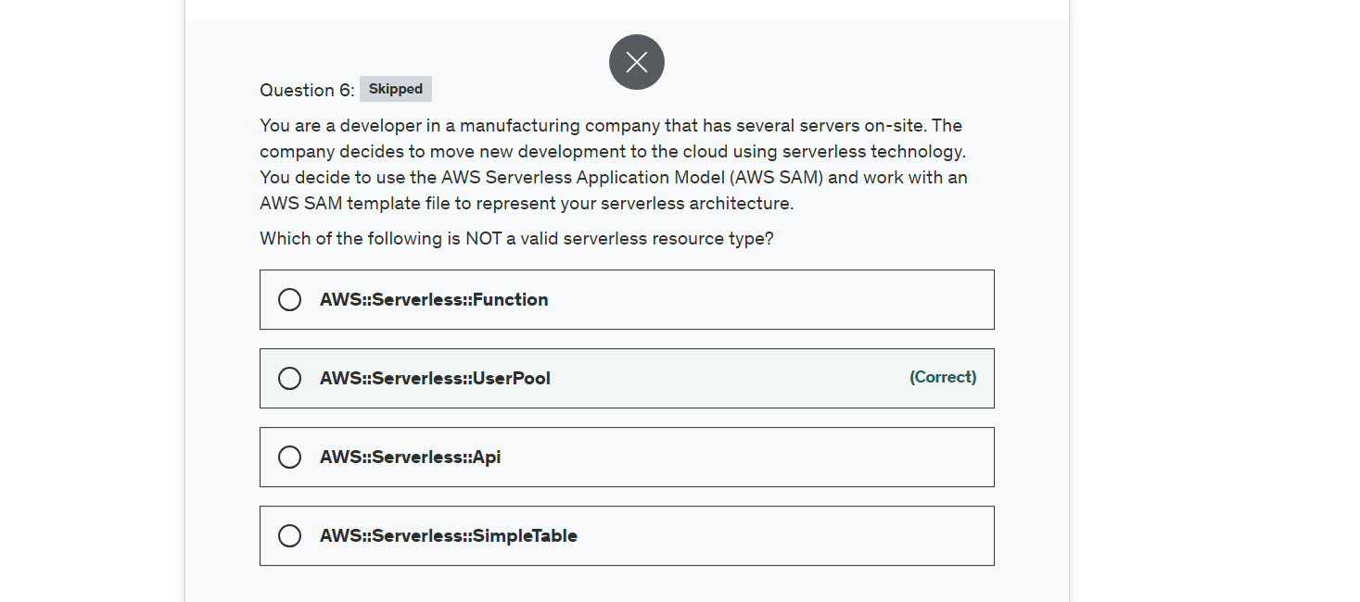

Explanation

Correct option:

**AWS::Serverless::UserPool**

The AWS Serverless Application Model (SAM) is an open-source framework for building serverless applications. It provides shorthand syntax to express functions, APIs, databases, and event source mappings. With just a few lines per resource, you can define the application you want and model it using YAML.

SAM supports the following resource types:

AWS::Serverless::Api

AWS::Serverless::Application

AWS::Serverless::Function

AWS::Serverless::HttpApi

AWS::Serverless::LayerVersion

AWS::Serverless::SimpleTable

AWS::Serverless::StateMachine

UserPool applies to the Cognito service which is used for authentication for mobile app and web. There is no resource named UserPool in the Serverless Application Model.

Incorrect options:

**AWS::Serverless::Function** - This resource creates a Lambda function, IAM execution role, and event source mappings that trigger the function.

**AWS::Serverless::Api** - This creates a collection of Amazon API Gateway resources and methods that can be invoked through HTTPS endpoints. It is useful for advanced use cases where you want full control and flexibility when you configure your APIs.

**AWS::Serverless::SimpleTable** - This creates a DynamoDB table with a single attribute primary key. It is useful when data only needs to be accessed via a primary key.

Reference:

<https://docs.aws.amazon.com/serverless-application-model/latest/developerguide/sam-specification-resources-and-properties.html>

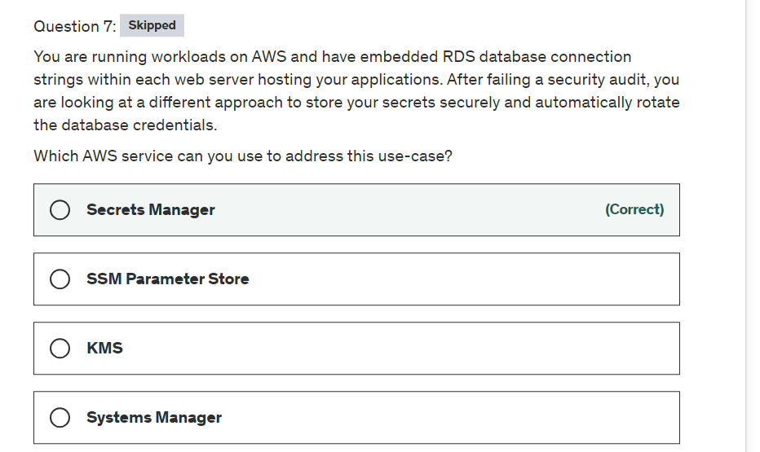

Explanation

Correct option:

**Secrets Manager**

AWS Secrets Manager enables you to easily rotate, manage, and retrieve database credentials, API keys, and other secrets throughout their lifecycle. Users and applications retrieve secrets with a call to Secrets Manager APIs, eliminating the need to hardcode sensitive information in plain text. Secrets Manager offers secret rotation with built-in integration for Amazon RDS, Amazon Redshift, and Amazon DocumentDB.

Benefits of Secrets Manager: 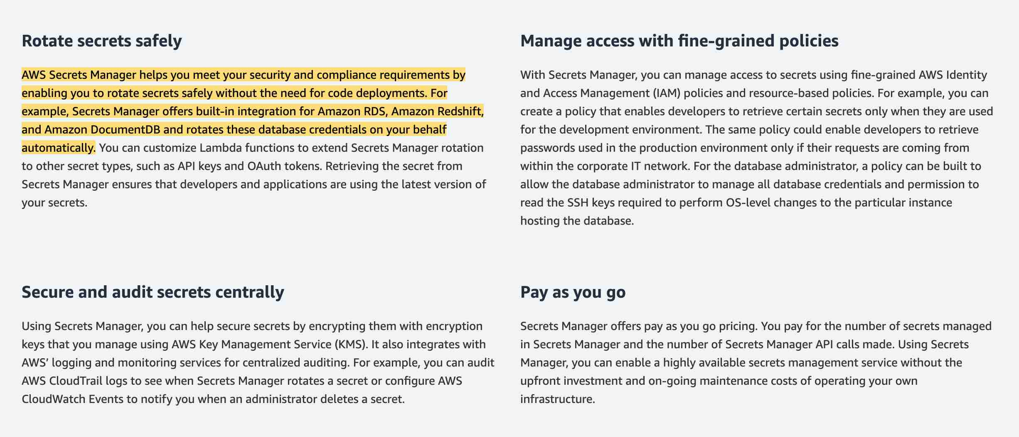 via - <https://aws.amazon.com/secrets-manager/>

Incorrect options:

**SSM Parameter Store** - AWS Systems Manager Parameter Store provides secure, hierarchical storage for configuration data management and secrets management. You can store data such as passwords, database strings, and license codes as parameter values. SSM Parameter Store cannot be used to automatically rotate the database credentials.

**Systems Manager** - AWS Systems Manager gives you visibility and control of your infrastructure on AWS. Systems Manager provides a unified user interface so you can view operational data from multiple AWS services and allows you to automate operational tasks across your AWS resources. Systems Manager cannot be used to store your secrets securely and automatically rotate the database credentials.

**KMS** - AWS Key Management Service (KMS) makes it easy for you to create and manage cryptographic keys and control their use across a wide range of AWS services and in your applications. KMS cannot be used to store your secrets securely and automatically rotate the database credentials.

References:

<https://aws.amazon.com/secrets-manager/>

<https://docs.aws.amazon.com/systems-manager/latest/userguide/systems-manager-paramstore.html>

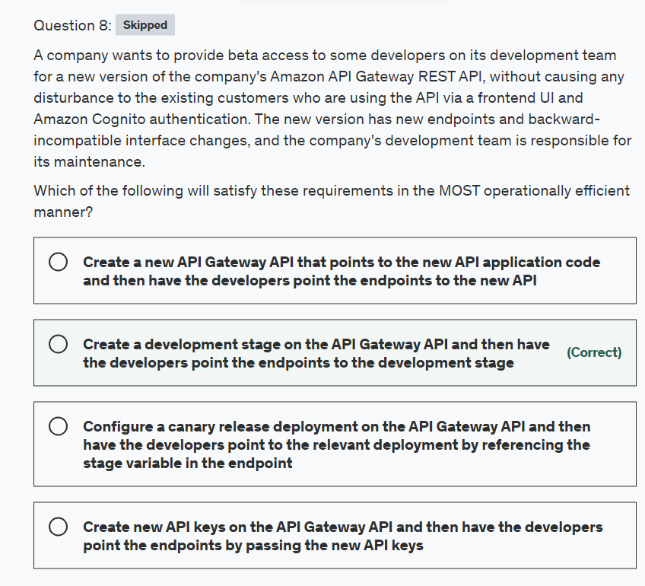

Explanation

Correct option:

**Create a development stage on the API Gateway API and then have the developers point the endpoints to the development stage**

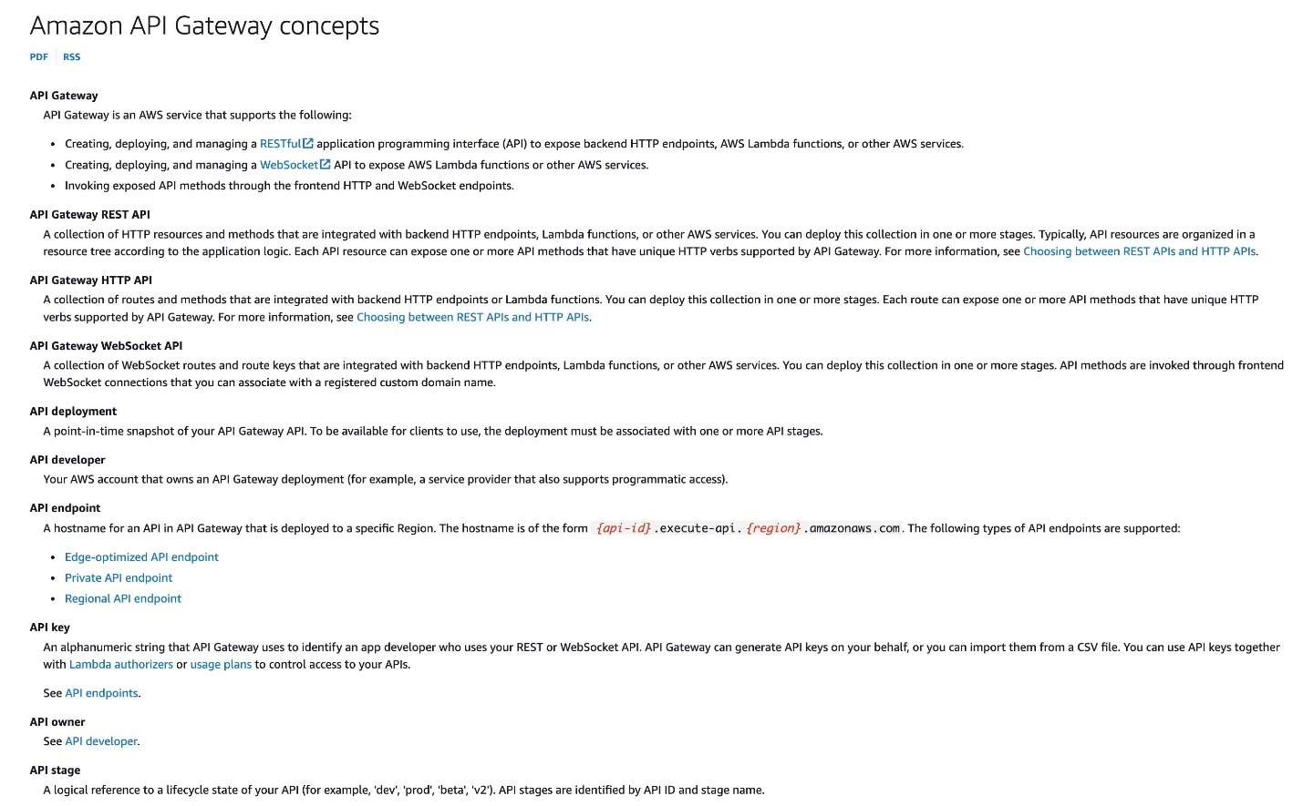 via - <https://docs.aws.amazon.com/apigateway/latest/developerguide/api-gateway-basic-concept.html>

A stage is a logical reference to a lifecycle state of your API (for example, 'dev', 'prod', 'beta', 'v2'). API stages are identified by API ID and stage name. You use a stage to manage and optimize a particular deployment. For example, you can configure stage settings to enable caching, customize request throttling, configure logging, define stage variables, or attach a canary release for testing. After the initial deployment, you can add more stages and associate them with existing deployments. You can use the API Gateway console to create a new stage, or you can choose an existing stage while deploying an API. In general, you can add a new stage to an API deployment before redeploying the API.

For the given use case, you can configure a development stage for your API Gateway API and then integrate it with the new version of the backend functionality that has new endpoints and backward-incompatible interface changes. The customers can continue to use the existing API.

Incorrect options:

**Configure a canary release deployment on the API Gateway API and then have the developers point to the relevant deployment by referencing the stage variable in the endpoint** - An API deployment is a point-in-time snapshot of your API Gateway API. To be available for clients to use, the deployment must be associated with one or more API stages. Canary release is a software development strategy in which a new version of an API (as well as other software) is deployed for testing purposes, and the base version remains deployed as a production release for normal operations on the same stage. In a canary release deployment, total API traffic is separated at random into a production release and a canary release with a pre-configured ratio. Typically, the canary release receives a small percentage of API traffic and the production release takes up the rest. The updated API features are only visible to API traffic through the canary. You can adjust the canary traffic percentage to optimize test coverage or performance. By keeping canary traffic small and the selection random, most users are not adversely affected at any time by potential bugs in the new version, and no single user is adversely affected all the time.

This option is incorrect for the given use case as some of the customers would also access the new version of the API.

**Create new API keys on the API Gateway API and then have the developers point the endpoints by passing the new API keys** - AN API key is an alphanumeric string that API Gateway uses to identify an app developer who uses your REST or WebSocket API. This option is a distractor as you cannot selectively provide access to the new version just based on API keys.

**Create a new API Gateway API that points to the new API application code and then have the developers point the endpoints to the new API** - This is an overkill for the given requirement as there is no need to create a completely new API just to provide some developers early access to the beta version.

References:

<https://docs.aws.amazon.com/apigateway/latest/developerguide/how-to-deploy-api.html>

<https://docs.aws.amazon.com/apigateway/latest/developerguide/api-gateway-basic-concept.html>

<https://docs.aws.amazon.com/apigateway/latest/developerguide/canary-release.html>

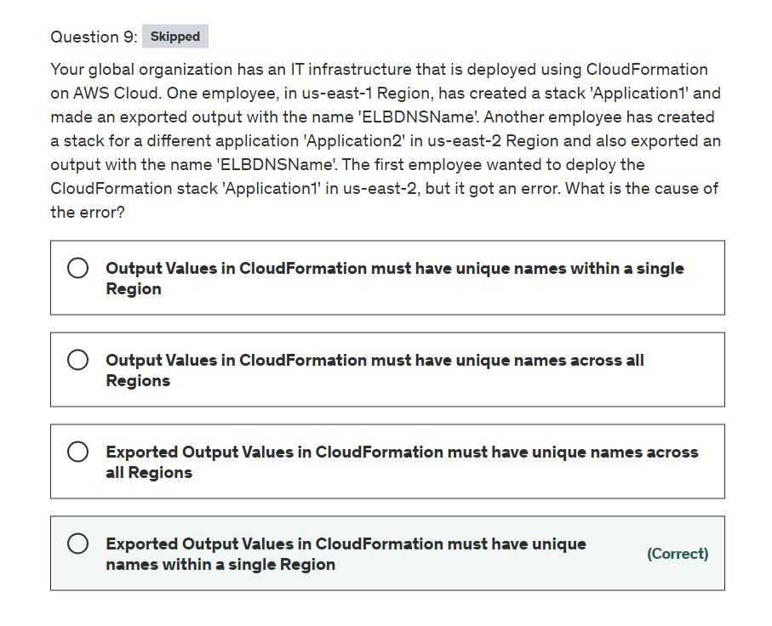

Explanation

Correct option:

"Exported Output Values in CloudFormation must have unique names within a single Region"

Using CloudFormation, you can create a template that describes all the AWS resources that you want (like Amazon EC2 instances or Amazon RDS DB instances), and AWS CloudFormation takes care of provisioning and configuring those resources for you.

A CloudFormation template has an optional Outputs section which declares output values that you can import into other stacks (to create cross-stack references), return in response (to describe stack calls), or view on the AWS CloudFormation console. For example, you can output the S3 bucket name for a stack to make the bucket easier to find.

You can use the Export Output Values to export the name of the resource output for a cross-stack reference. For each AWS account, export names must be unique within a region. In this case, we would have a conflict within us-east-2.

‘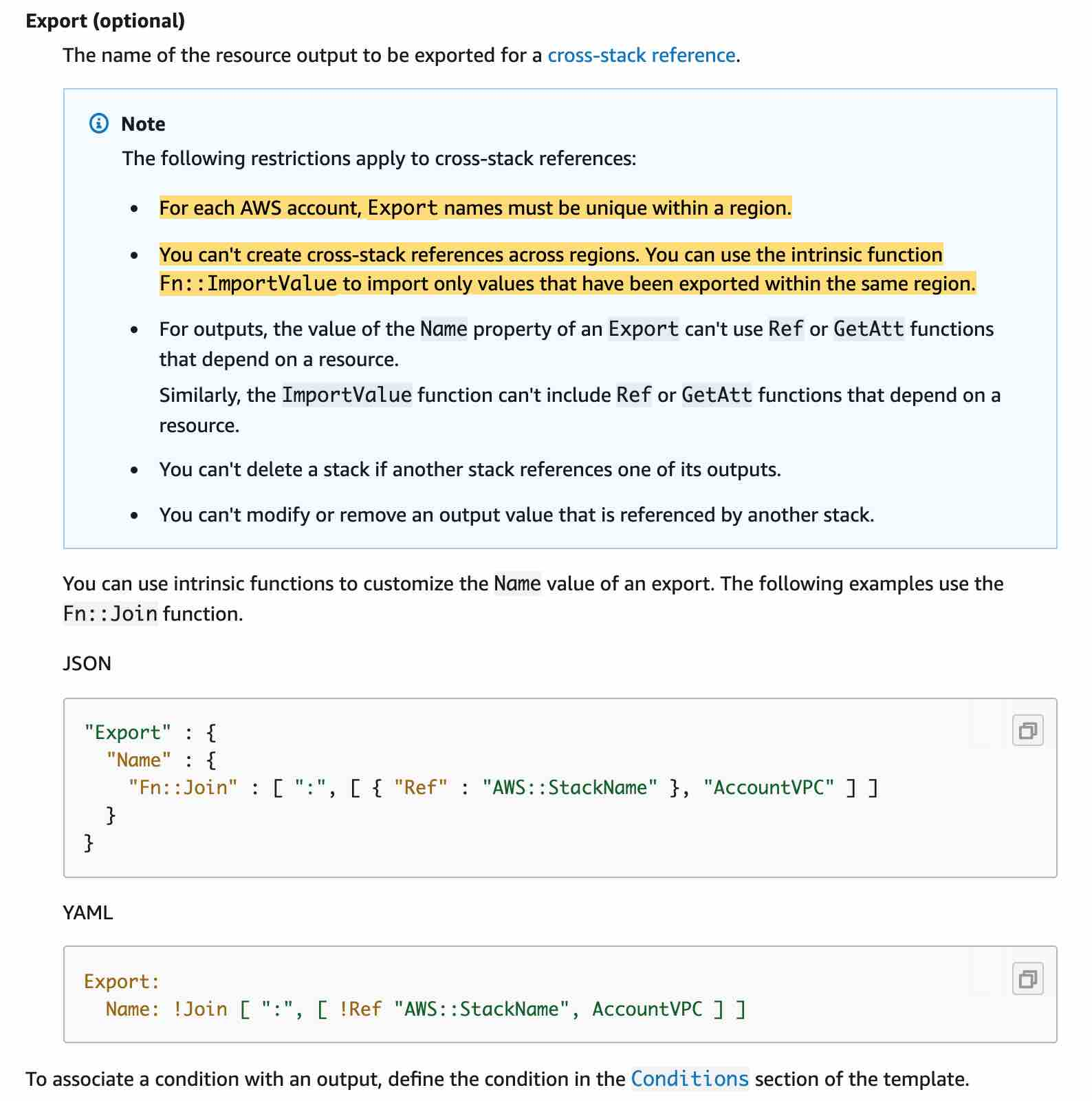 via - <https://docs.aws.amazon.com/AWSCloudFormation/latest/UserGuide/outputs-section-structure.html>

Incorrect options:

"Output Values in CloudFormation must have unique names across all Regions"

"Exported Output Values in CloudFormation must have unique names across all Regions"

"Output Values in CloudFormation must have unique names within a single Region"

These three options contradict the explanation provided earlier, hence these options are incorrect.

Reference:

<https://docs.aws.amazon.com/AWSCloudFormation/latest/UserGuide/outputs-section-structure.html>

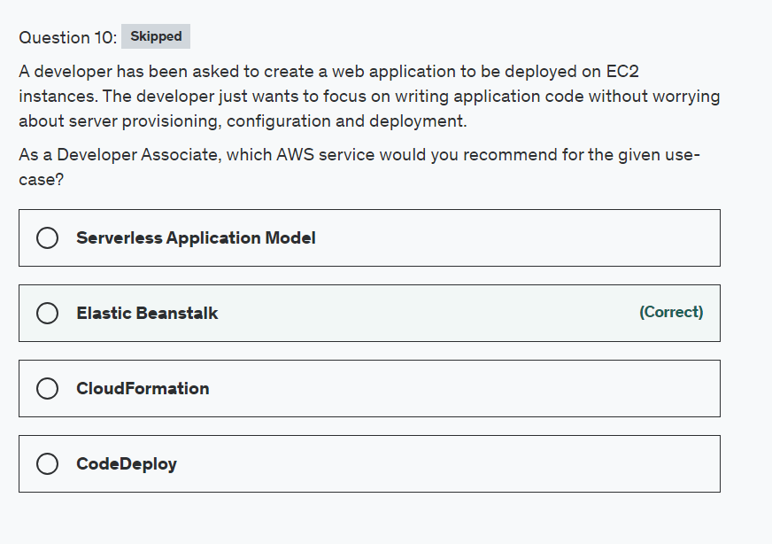

Explanation

Correct option:

**Elastic Beanstalk**

AWS Elastic Beanstalk provides an environment to easily deploy and run applications in the cloud. It is integrated with developer tools and provides a one-stop experience for you to manage the lifecycle of your applications.

AWS Elastic Beanstalk lets you manage all of the resources that run your application as environments where each environment runs only a single application version at a time. When an environment is being created, Elastic Beanstalk provisions all the required resources needed to run the application version. You don't need to worry about server provisioning, configuration, and deployment as that's taken care of by Beanstalk.

Benefits of Elastic Beanstalk: 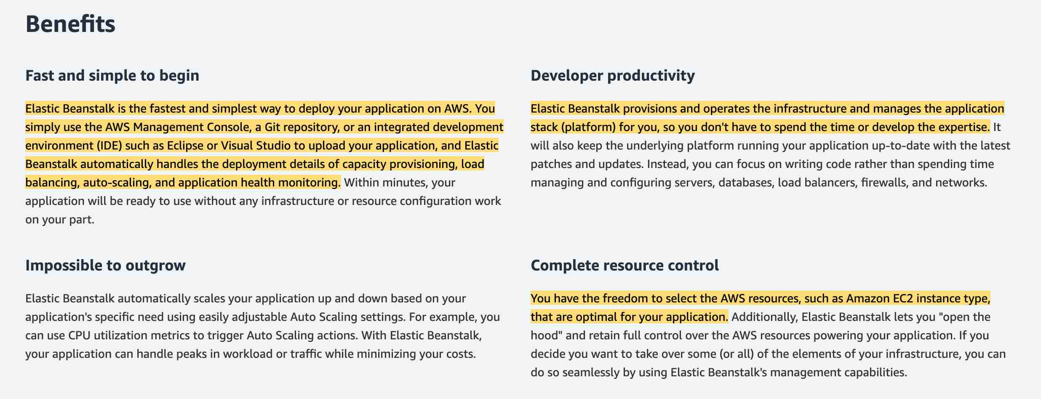 via - <https://aws.amazon.com/elasticbeanstalk/>

Incorrect options:

**CloudFormation** - AWS CloudFormation is a service that gives developers and businesses an easy way to create a collection of related AWS and third-party resources and provision them in an orderly and predictable fashion. With CloudFormation, you still need to create a template to specify the type of resources you need, hence this option is not correct.

How CloudFormation Works: 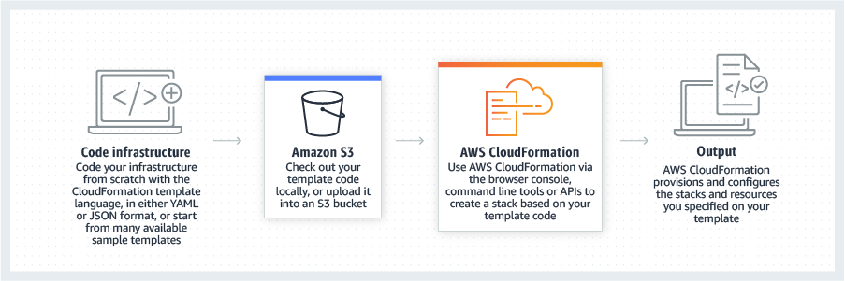 via - <https://aws.amazon.com/cloudformation/>

**CodeDeploy** - AWS CodeDeploy is a fully managed deployment service that automates software deployments to a variety of compute services such as Amazon EC2, AWS Fargate, AWS Lambda, and your on-premises servers. AWS CodeDeploy makes it easier for you to rapidly release new features, helps you avoid downtime during application deployment, and handles the complexity of updating your applications. It can deploy an application to an instance but it cannot provision the instance.

**Serverless Application Model** - The AWS Serverless Application Model (AWS SAM) is an open-source framework for building serverless applications. It provides shorthand syntax to express functions, APIs, databases, and event source mappings. You define the application you want with just a few lines per resource and model it using YAML. As the web application needs to be deployed on EC2 instances, so this option is ruled out.

References:

<https://docs.aws.amazon.com/elasticbeanstalk/latest/dg/concepts.html>

<https://aws.amazon.com/cloudformation/>

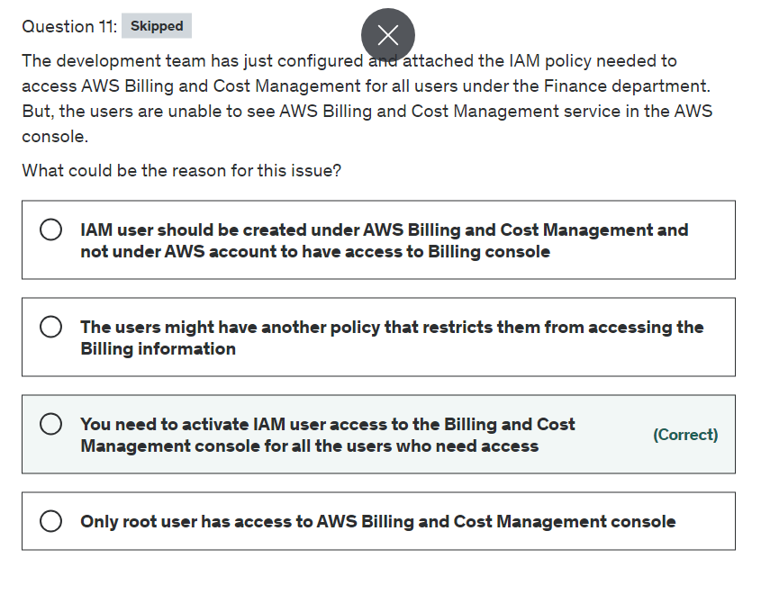

Explanation

Correct option:

**You need to activate IAM user access to the Billing and Cost Management console for all the users who need access** - By default, IAM users do not have access to the AWS Billing and Cost Management console. You or your account administrator must grant users access. You can do this by activating IAM user access to the Billing and Cost Management console and attaching an IAM policy to your users. Then, you need to activate IAM user access for IAM policies to take effect. You only need to activate IAM user access once.

Incorrect options:

**The users might have another policy that restricts them from accessing the Billing information** - This is an incorrect option, as deduced from the given use-case.

**Only root user has access to AWS Billing and Cost Management console** - This is an incorrect statement. AWS Billing and Cost Management access can be provided to any user through user activation and policies, as discussed above.

**IAM user should be created under AWS Billing and Cost Management and not under the AWS account to have access to Billing console** - IAM is a feature of your AWS account. All IAM users are created and managed from a single place, irrespective of the services they wish to you.

Reference:

<https://docs.aws.amazon.com/awsaccountbilling/latest/aboutv2/control-access-billing.html>

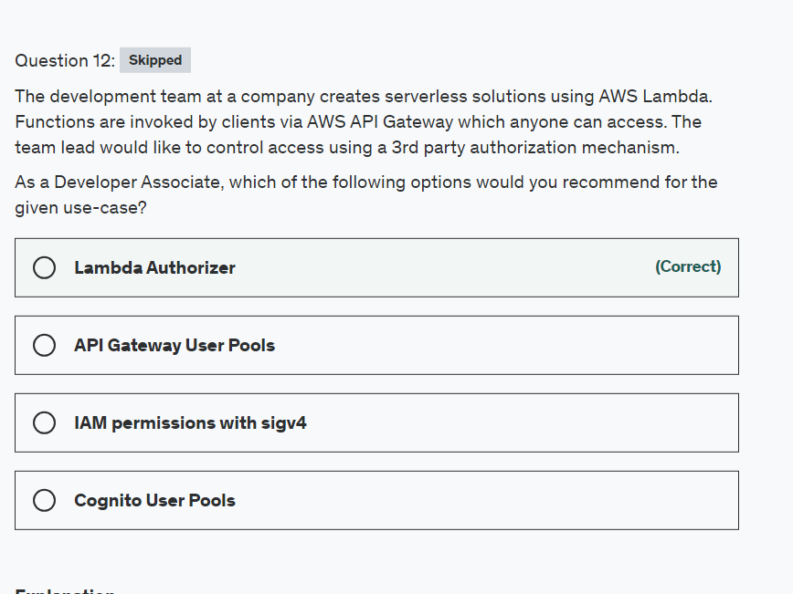

Explanation

Correct option:

"Lambda Authorizer"

An Amazon API Gateway Lambda authorizer (formerly known as a custom authorizer) is a Lambda function that you provide to control access to your API. A Lambda authorizer uses bearer token authentication strategies, such as OAuth or SAML. Before creating an API Gateway Lambda authorizer, you must first create the AWS Lambda function that implements the logic to authorize and, if necessary, to authenticate the caller.

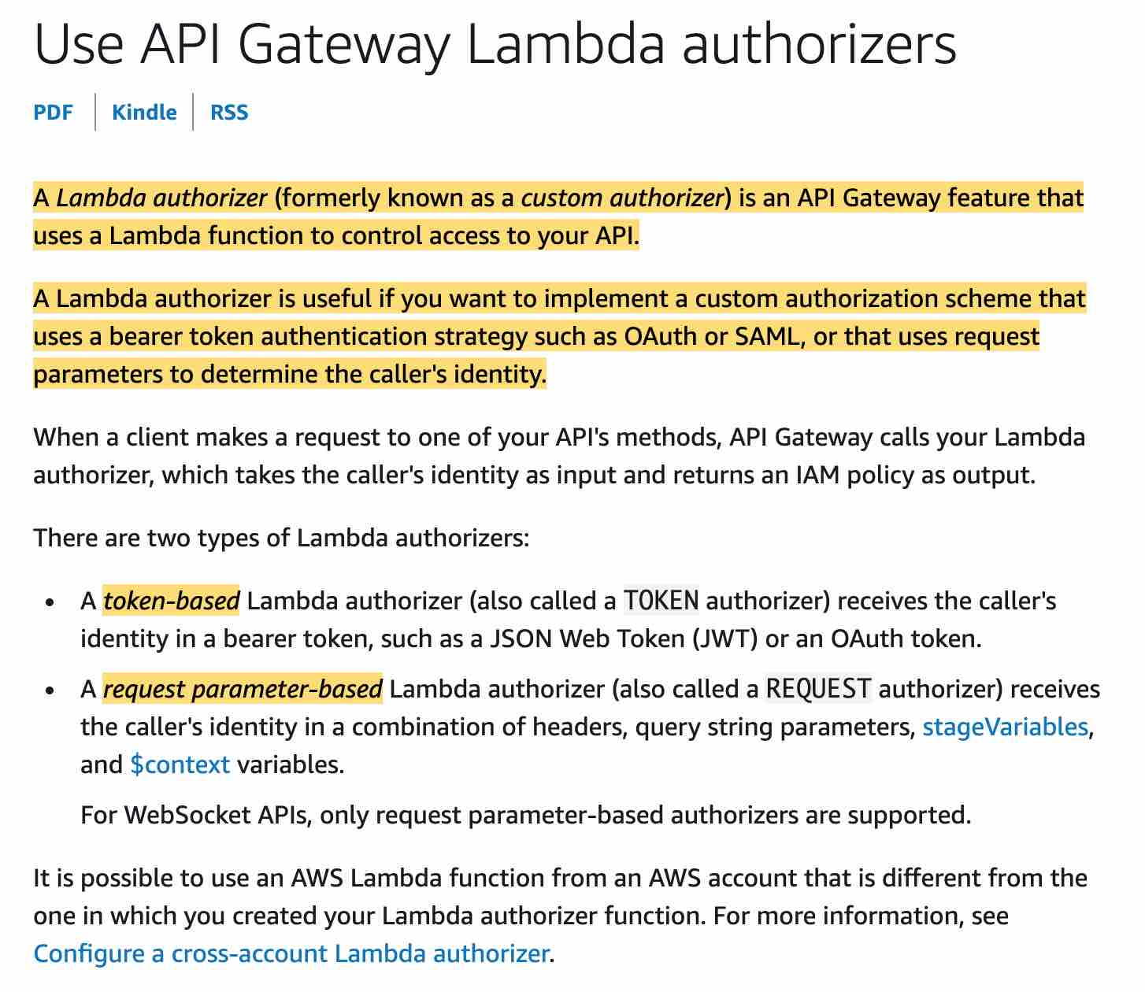 via - <https://docs.aws.amazon.com/apigateway/latest/developerguide/apigateway-use-lambda-authorizer.html>

Incorrect options:

"IAM permissions with sigv4" - Signature Version 4 is the process to add authentication information to AWS requests sent by HTTP. You will still need to provide permissions but our requirements have a need for 3rd party authentication which is where Lambda Authorizer comes in to play.

"Cognito User Pools" - A Cognito user pool is a user directory in Amazon Cognito. With a user pool, your users can sign in to your web or mobile app through Amazon Cognito, or federate through a third-party identity provider (IdP). Whether your users sign-in directly or through a third party, all members of the user pool have a directory profile that you can access through an SDK. This is managed by AWS, therefore, does not meet our requirements.

"API Gateway User Pools" - This is a made-up option, added as a distractor.

Reference:

<https://docs.aws.amazon.com/apigateway/latest/developerguide/apigateway-use-lambda-authorizer.html>

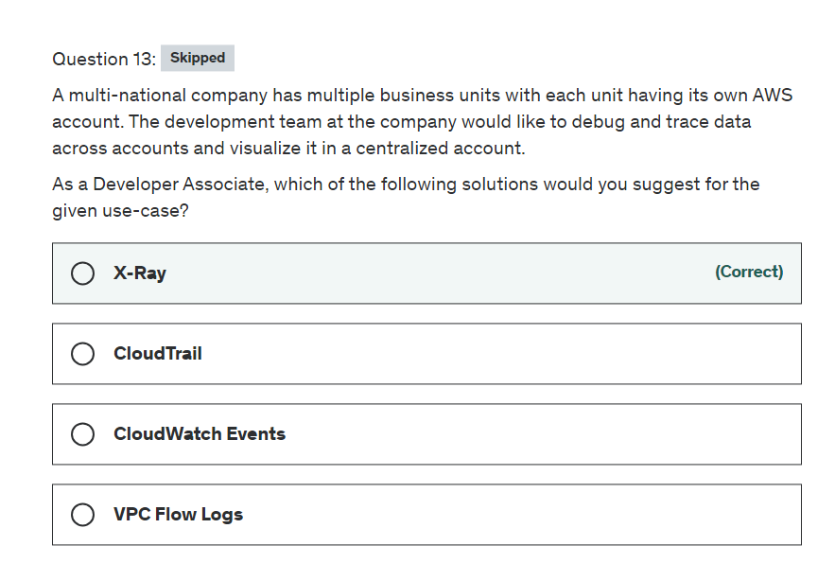

Explanation

Correct option:

**X-Ray**

AWS X-Ray helps developers analyze and debug production, distributed applications, such as those built using a microservices architecture. With X-Ray, you can understand how your application and its underlying services are performing to identify and troubleshoot the root cause of performance issues and errors. X-Ray provides an end-to-end view of requests as they travel through your application, and shows a map of your application’s underlying components.

You can use X-Ray to collect data across AWS Accounts. The X-Ray agent can assume a role to publish data into an account different from the one in which it is running. This enables you to publish data from various components of your application into a central account.

How X-Ray Works: 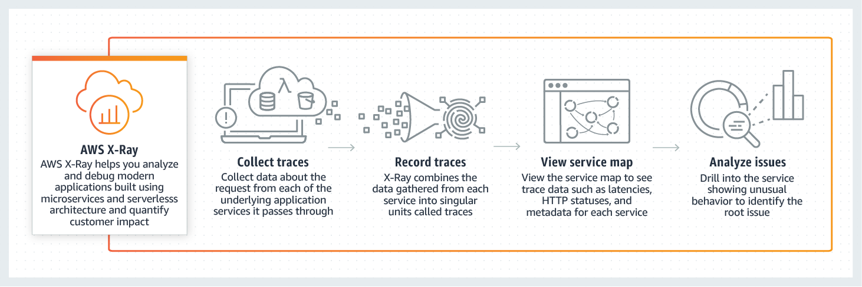 via - <https://aws.amazon.com/xray/>

Incorrect options:

**VPC Flow Logs**: VPC Flow Logs is a feature that enables you to capture information about the IP traffic going to and from network interfaces in your VPC. Flow log data is used to analyze network traces and helps with network security. Flow log data can be published to Amazon CloudWatch Logs or Amazon S3. You cannot use VPC Flow Logs to debug and trace data across accounts.

**CloudWatch Events**: Amazon CloudWatch Events delivers a near real-time stream of system events that describe changes in Amazon Web Services (AWS) resources. These help to trigger notifications based on changes happening in AWS services. You cannot use CloudWatch Events to debug and trace data across accounts.

**CloudTrail**: With CloudTrail, you can log, continuously monitor, and retain account activity related to actions across your AWS infrastructure. You can use AWS CloudTrail to answer questions such as - “Who made an API call to modify this resource?”. CloudTrail provides event history of your AWS account activity thereby enabling governance, compliance, operational auditing, and risk auditing of your AWS account. You cannot use CloudTrail to debug and trace data across accounts.

Reference:

<https://aws.amazon.com/xray/>

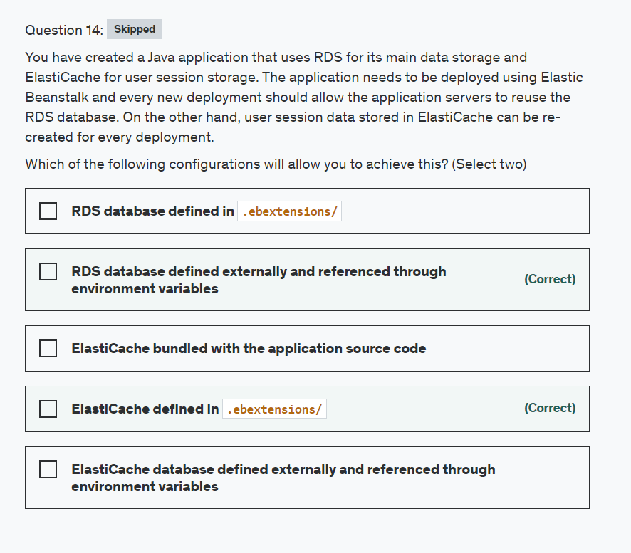

Explanation

Correct option:

**ElastiCache defined in .ebextensions/** - Any resources created as part of your .ebextensions is part of your Elastic Beanstalk template and will get deleted if the environment is terminated.

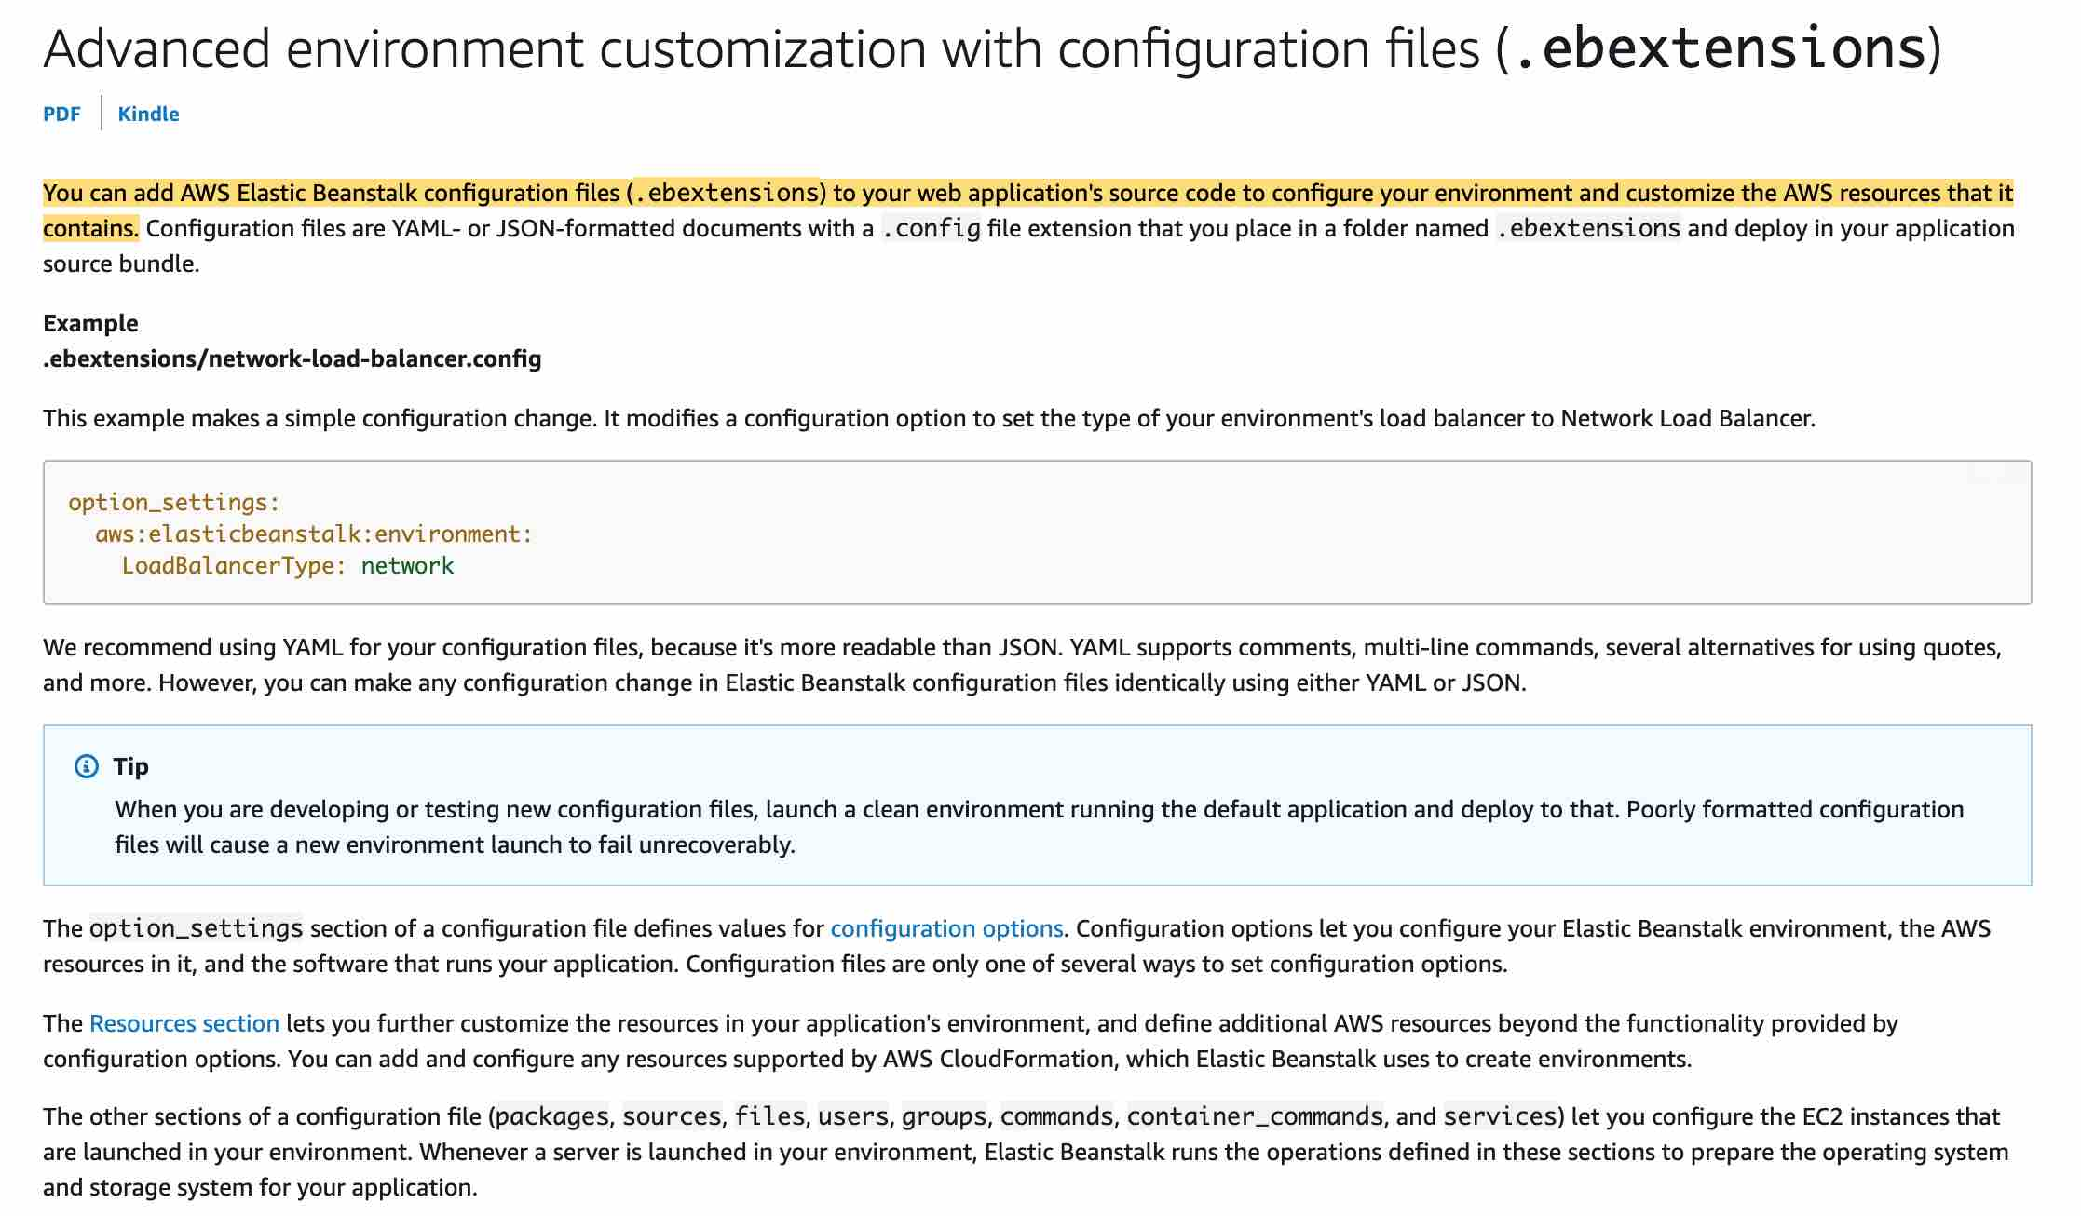 via - <https://docs.aws.amazon.com/elasticbeanstalk/latest/dg/ebextensions.html>

**RDS database defined externally and referenced through environment variables** - To decouple your database instance from your environment, you can run a database instance in Amazon RDS and configure your application to connect to it on launch. This enables you to connect multiple environments to a database, terminate an environment without affecting the database, and perform seamless updates with blue-green deployments. To allow the Amazon EC2 instances in your environment to connect to an outside database, you can configure the environment's Auto Scaling group with an additional security group.

Using Elastic Beanstalk with Amazon RDS: 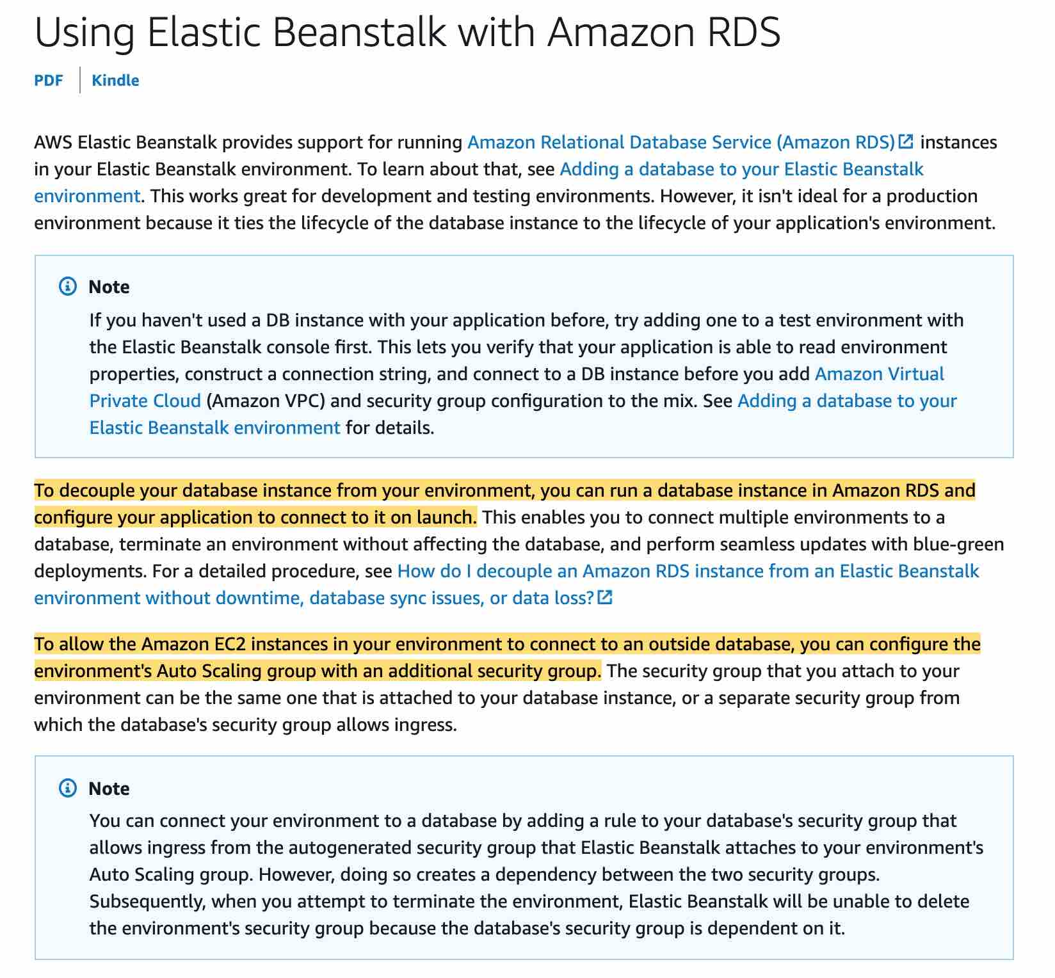 via - <https://docs.aws.amazon.com/elasticbeanstalk/latest/dg/AWSHowTo.RDS.html>

Incorrect options:

**ElastiCache bundled with the application source code** - ElastiCache is an AWS service and cannot be bundled with the source code.

**RDS database defined in .ebextensions/** - The lifetime of the RDS instance gets tied to the lifetime of the Elastic Beanstalk environment, so this option is incorrect.

**ElastiCache database defined externally and referenced through environment variables** - For the given use-case, the client is fine with losing user session data and hence defining it in .ebextensions/ is more appropriate.

References:

<https://docs.aws.amazon.com/elasticbeanstalk/latest/dg/AWSHowTo.RDS.html>

<https://docs.aws.amazon.com/elasticbeanstalk/latest/dg/ebextensions.html>

<https://docs.aws.amazon.com/elasticbeanstalk/latest/dg/customize-environment-resources-elasticache.html>

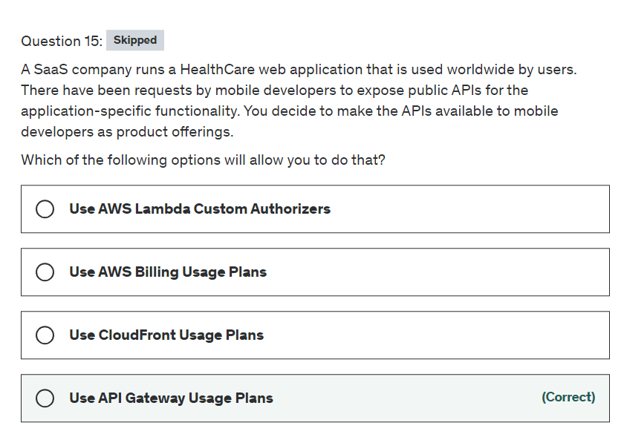

Explanation

Correct option:

**Use API Gateway Usage Plans**

Amazon API Gateway is an AWS service for creating, publishing, maintaining, monitoring, and securing REST, HTTP, and WebSocket APIs at any scale. API developers can create APIs that access AWS or other web services, as well as data stored in the AWS Cloud.

How API Gateway Works: 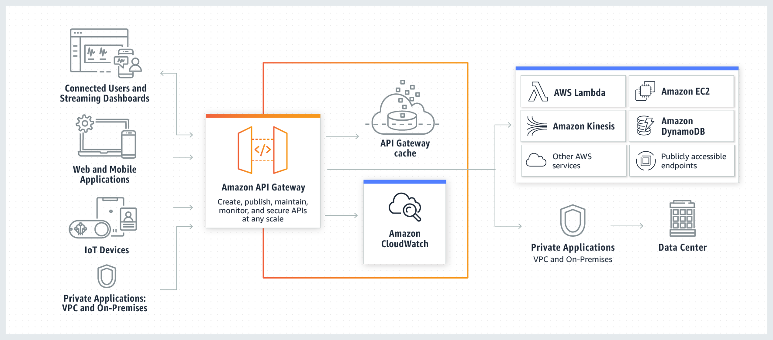 via - <https://aws.amazon.com/api-gateway/>

A usage plan specifies who can access one or more deployed API stages and methods—and also how much and how fast they can access them. The plan uses API keys to identify API clients and meters access to the associated API stages for each key.

You can configure usage plans and API keys to allow customers to access selected APIs at agreed-upon request rates and quotas that meet their business requirements and budget constraints.

Overview of API Gateway Usage Plans and API keys: 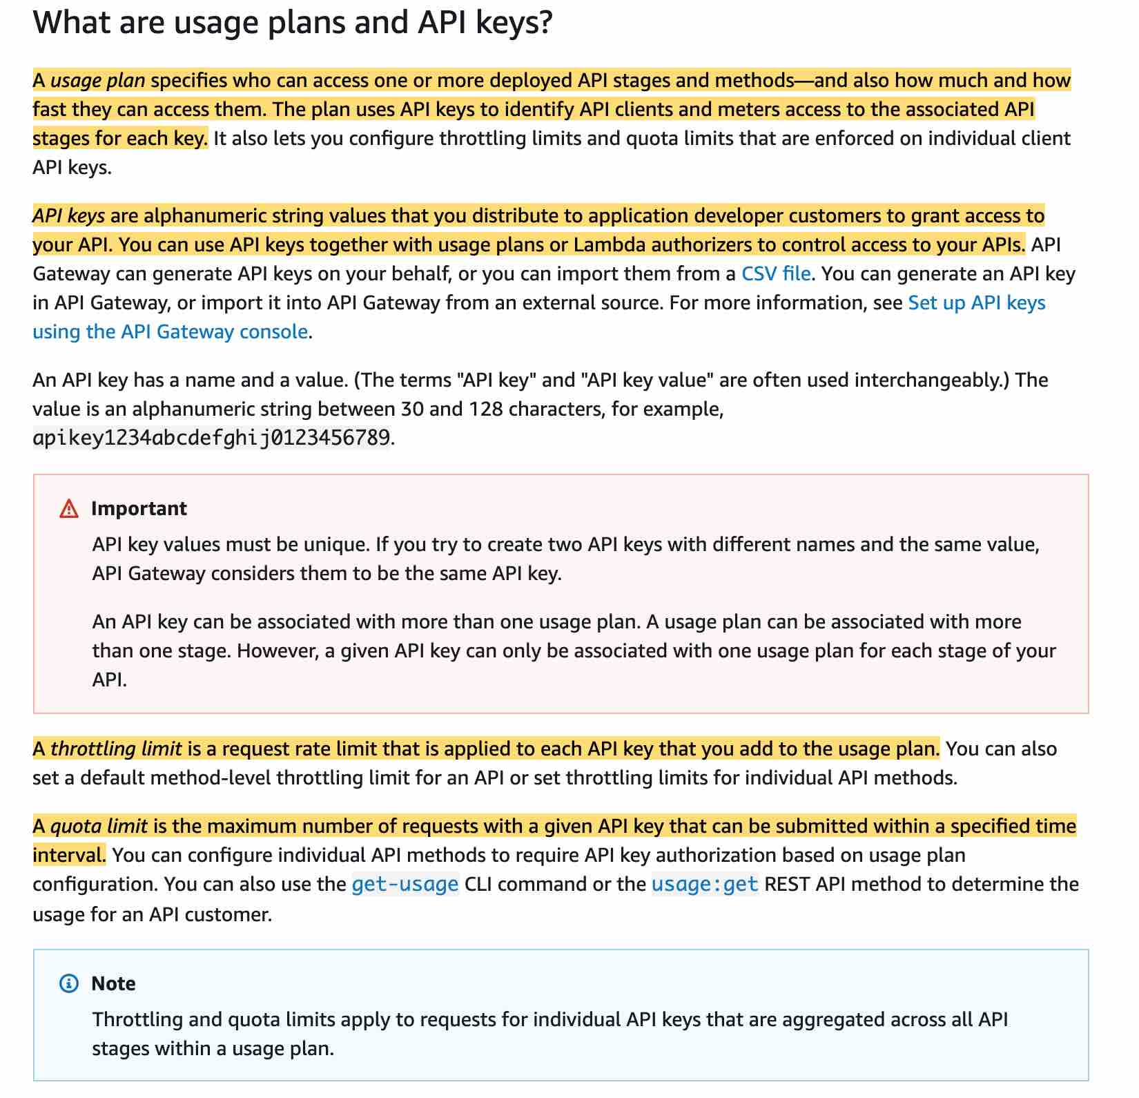 via - <https://docs.aws.amazon.com/apigateway/latest/developerguide/api-gateway-api-usage-plans.html>

Incorrect options:

**Use AWS Billing Usage Plans** - AWS Billing and Cost Management is the service that you use to pay your AWS bill, monitor your usage, and analyze and control your costs. There is no such thing as AWS Billing Usage Plans. You cannot use AWS Billing to set up public APIs for the application.

**Use CloudFront Usage Plans** - Amazon CloudFront is a fast content delivery network (CDN) service that securely delivers data, videos, applications, and APIs to customers globally with low latency, high transfer speeds, all within a developer-friendly environment. There is no such thing as CloudFront Usage Plans. You cannot use CloudFront to set up public APIs for the application.

**Use AWS Lambda Custom Authorizers** - Lambda is a separate service than Gateway API, therefore, it cannot be used to determine the API usage limits.

Reference:

<https://docs.aws.amazon.com/apigateway/latest/developerguide/api-gateway-api-usage-plans.html>

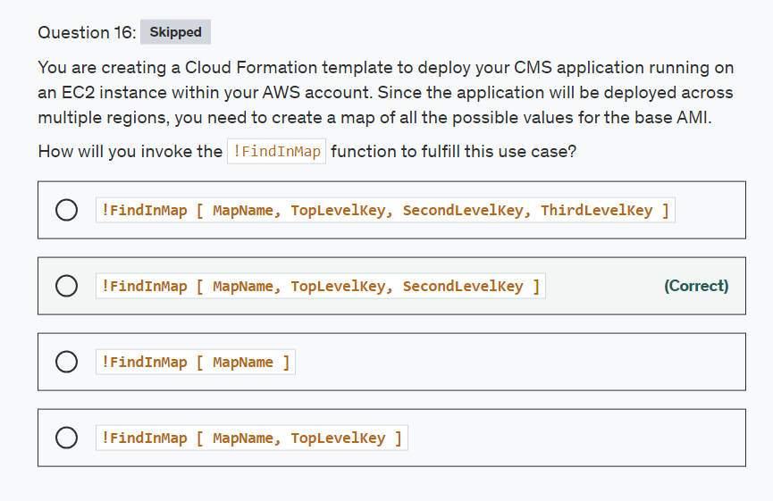

**Explanation**

Correct option:

**!FindInMap [ MapName, TopLevelKey, SecondLevelKey ]** - The intrinsic function Fn::FindInMap returns the value corresponding to keys in a two-level map that is declared in the Mappings section. YAML Syntax for the full function name: Fn::FindInMap: [ MapName, TopLevelKey, SecondLevelKey ]

Short form of the above syntax is : !FindInMap [ MapName, TopLevelKey, SecondLevelKey ]

Where,

MapName - Is the logical name of a mapping declared in the Mappings section that contains the keys and values. TopLevelKey - The top-level key name. Its value is a list of key-value pairs. SecondLevelKey - The second-level key name, which is set to one of the keys from the list assigned to TopLevelKey.

Consider the following YAML template:

Mappings:

RegionMap:

us-east-1:

HVM64: "ami-0ff8a91507f77f867"

HVMG2: "ami-0a584ac55a7631c0c"

us-west-1:

HVM64: "ami-0bdb828fd58c52235"

HVMG2: "ami-066ee5fd4a9ef77f1"

eu-west-1:

HVM64: "ami-047bb4163c506cd98"

HVMG2: "ami-31c2f645"

ap-southeast-1:

HVM64: "ami-08569b978cc4dfa10"

HVMG2: "ami-0be9df32ae9f92309"

ap-northeast-1:

HVM64: "ami-06cd52961ce9f0d85"

HVMG2: "ami-053cdd503598e4a9d"

Resources:

myEC2Instance:

Type: "AWS::EC2::Instance"

Properties:

ImageId: !FindInMap

- RegionMap

- !Ref 'AWS::Region'

- HVM64

InstanceType: m1.small

The example template contains an AWS::EC2::Instance resource whose ImageId property is set by the FindInMap function.

MapName is set to the map of interest, "RegionMap" in this example. TopLevelKey is set to the region where the stack is created, which is determined by using the "AWS::Region" pseudo parameter. SecondLevelKey is set to the desired architecture, "HVM64" for this example.

FindInMap returns the AMI assigned to FindInMap. For a HVM64 instance in us-east-1, FindInMap would return "ami-0ff8a91507f77f867".

Incorrect options:

**!FindInMap [ MapName, TopLevelKey ]**

**!FindInMap [ MapName ]**

**!FindInMap [ MapName, TopLevelKey, SecondLevelKey, ThirdLevelKey ]**

These three options contradict the explanation provided above, hence these options are incorrect.

Reference:

<https://docs.aws.amazon.com/AWSCloudFormation/latest/UserGuide/intrinsic-function-reference-findinmap.html>

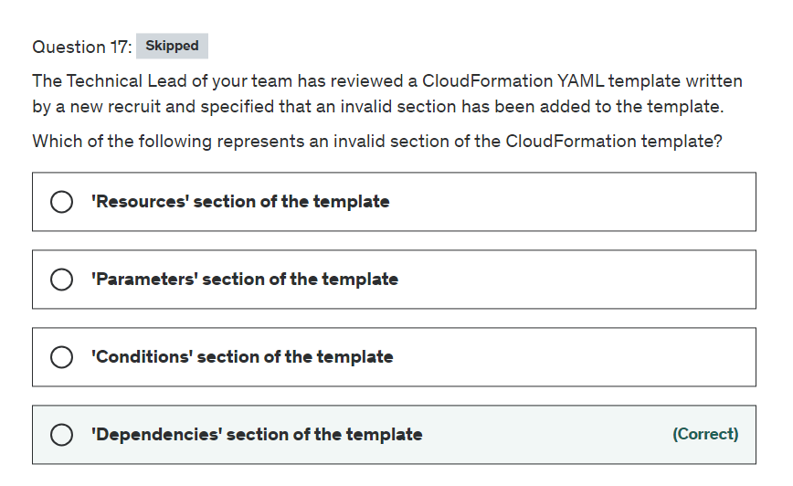

Explanation

Correct option:

Templates include several major sections. The Resources section is the only required section.

Sample CloudFormation YAML template: 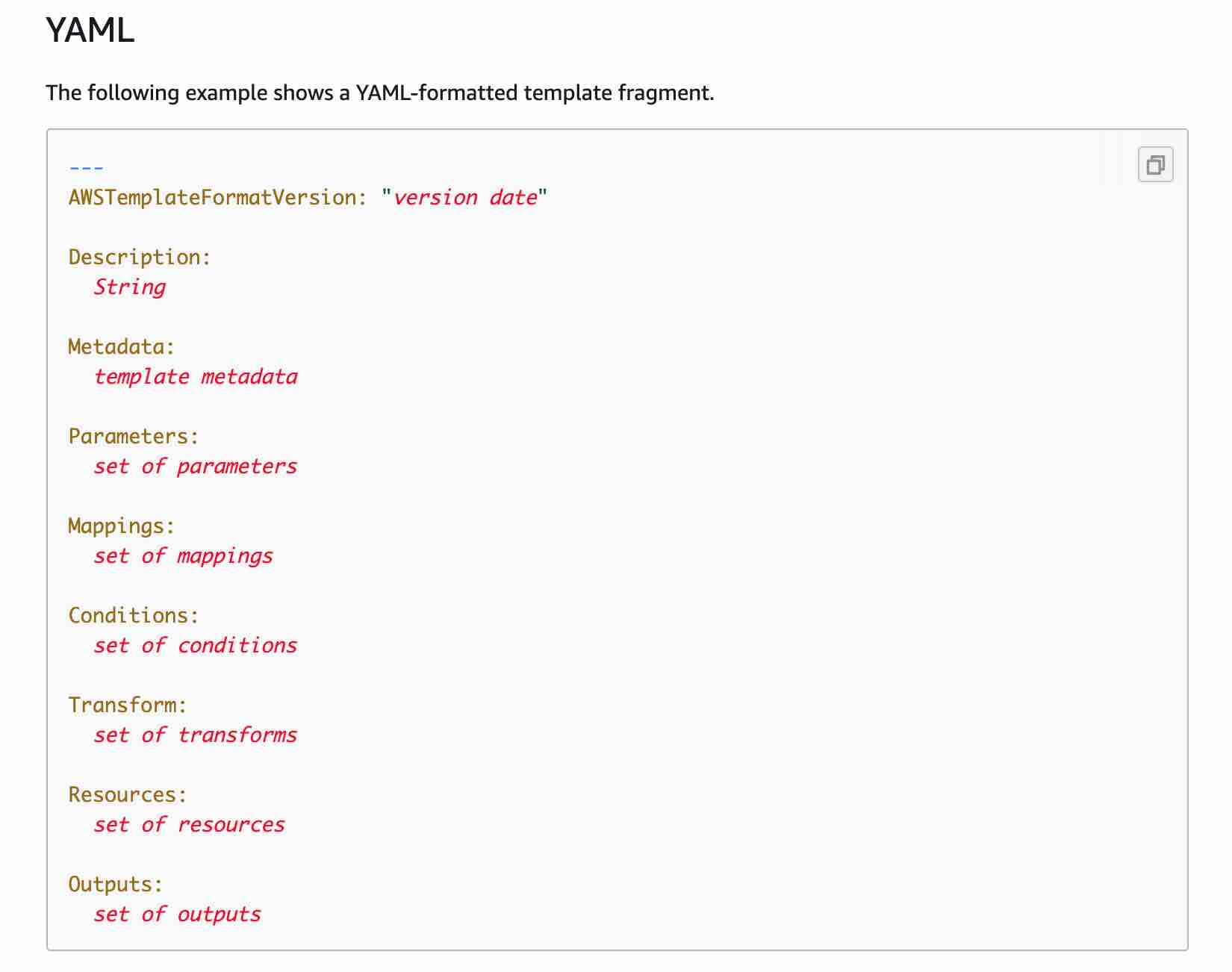 via - <https://docs.aws.amazon.com/AWSCloudFormation/latest/UserGuide/template-anatomy.html>

**'Dependencies' section of the template** - As you can see, there is no section called 'Dependencies' in the template. Although dependencies can be mentioned, there is no section itself for dependencies.

Incorrect options:

**'Conditions' section of the template** - This optional section includes conditions that control whether certain resources are created or whether certain resource properties are assigned a value during stack creation or update. For example, you could conditionally create a resource that depends on whether the stack is for a production or test environment.

**'Resources' section of the template** - This is the only required section and specifies the stack resources and their properties, such as an Amazon Elastic Compute Cloud instance or an Amazon Simple Storage Service bucket. You can refer to resources in the Resources and Outputs sections of the template.

**'Parameters' section of the template** - This optional section is helpful in passing Values to your template at runtime (when you create or update a stack). You can refer to parameters from the Resources and Outputs sections of the template.

Reference:

<https://docs.aws.amazon.com/AWSCloudFormation/latest/UserGuide/template-anatomy.html>

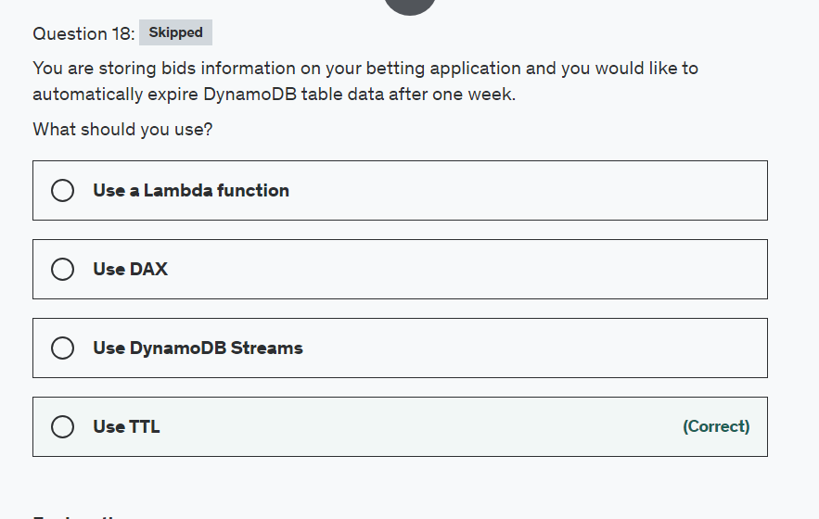

Explanation

Correct option:

**Use TTL**

Time To Live (TTL) for DynamoDB allows you to define when items in a table expire so that they can be automatically deleted from the database. TTL is provided at no extra cost as a way to reduce storage usage and reduce the cost of storing irrelevant data without using provisioned throughput. With TTL enabled on a table, you can set a timestamp for deletion on a per-item basis, allowing you to limit storage usage to only those records that are relevant.

Incorrect options:

**Use DynamoDB Streams** - These help you get a changelog of your DynamoDB table but won't help you delete expired data. Note that data expired using a TTL will appear as an event in your DynamoDB streams.

**Use DAX** - Amazon DynamoDB Accelerator (DAX) is a fully managed, highly available, in-memory cache for DynamoDB that delivers up to a 10x performance improvement: from milliseconds to microseconds: even at millions of requests per second. This is a caching technology for your DynamoDB tables.

**Use a Lambda function** - This could work but would require setting up indexes, queries, or scans to work, as well as trigger them often enough using a CloudWatch Events. This band-aid solution would never be as good as using the TTL feature in DynamoDB.

Reference:

<https://docs.aws.amazon.com/amazondynamodb/latest/developerguide/TTL.html>

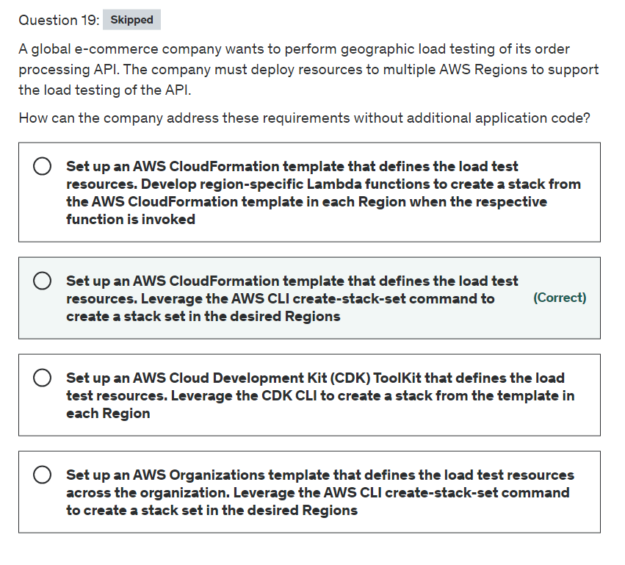

Explanation

Correct option:

**Set up an AWS CloudFormation template that defines the load test resources. Leverage the AWS CLI create-stack-set command to create a stack set in the desired Regions**

AWS CloudFormation StackSets extends the capability of stacks by enabling you to create, update, or delete stacks across multiple accounts and AWS Regions with a single operation. Using an administrator account, you define and manage an AWS CloudFormation template, and use the template as the basis for provisioning stacks into selected target accounts across specified AWS Regions.

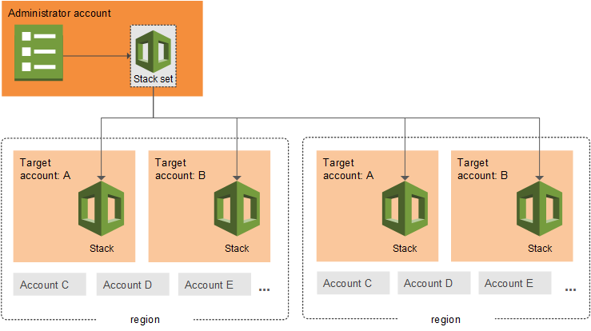 via - <https://docs.aws.amazon.com/AWSCloudFormation/latest/UserGuide/what-is-cfnstacksets.html>

A stack set lets you create stacks in AWS accounts across regions by using a single CloudFormation template. A stack set's CloudFormation template defines all the resources in each stack. As you create the stack set, specify the template to use, in addition to any parameters and capabilities that the template requires.

After you've defined a stack set, you can create, update, or delete stacks in the target accounts and AWS Regions you specify.

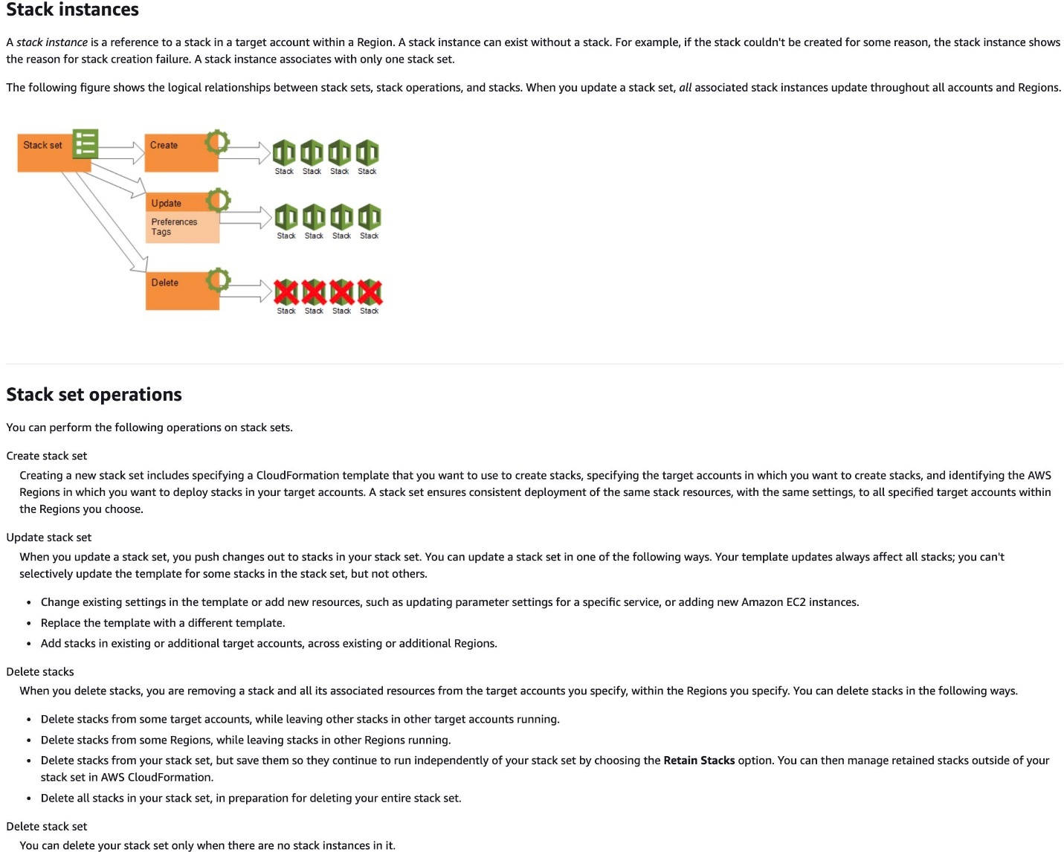 via - <https://docs.aws.amazon.com/AWSCloudFormation/latest/UserGuide/stacksets-concepts.html>

Incorrect options:

**Set up an AWS CloudFormation template that defines the load test resources. Develop region-specific Lambda functions to create a stack from the AWS CloudFormation template in each Region when the respective function is invoked** - If you do not use a stack set, then you need to define the CloudFormation templates in each region as well as develop lambda functions in each region to create a stack from the corresponding CloudFormation template. This is unnecessary bloat that can be avoided by simply using the CloudFormation StackSets.

**Set up an AWS Cloud Development Kit (CDK) ToolKit that defines the load test resources. Leverage the CDK CLI to create a stack from the template in each Region** - AWS CDK is a framework for defining cloud infrastructure in code and provisioning it through AWS CloudFormation. The CDK Toolkit again poses regional limitations and is not the right fit for the given use case.

**Set up an AWS Organizations template that defines the load test resources across the organization. Leverage the AWS CLI create-stack-set command to create a stack set in the desired Regions** - This option acts as a distractor. AWS Organizations cannot be used to create templates for provisioning AWS infrastructure. AWS Organizations is an account management service that enables you to consolidate multiple AWS accounts into an organization that you create and centrally manage.

References:

<https://docs.aws.amazon.com/organizations/latest/userguide/orgs_introduction.html>

<https://docs.aws.amazon.com/AWSCloudFormation/latest/UserGuide/stacksets-concepts.html>

<https://docs.aws.amazon.com/AWSCloudFormation/latest/UserGuide/what-is-cfnstacksets.html>

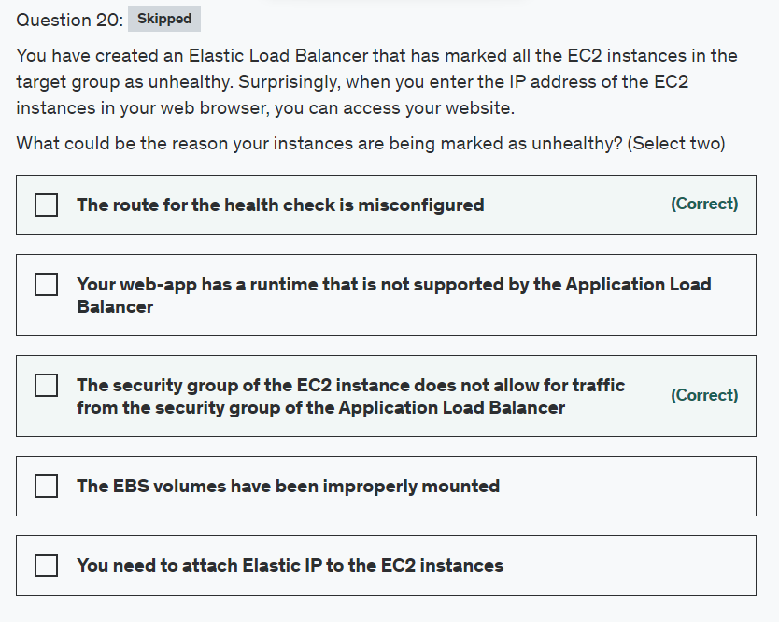

Explanation

Correct options

**The security group of the EC2 instance does not allow for traffic from the security group of the Application Load Balancer**

**The route for the health check is misconfigured**

You must ensure that your load balancer can communicate with registered targets on both the listener port and the health check port. Whenever you add a listener to your load balancer or update the health check port for a target group used by the load balancer to route requests, you must verify that the security groups associated with the load balancer allow traffic on the new port in both directions.

Application Load Balancer Configuration for Security Groups and Health Check Routes: 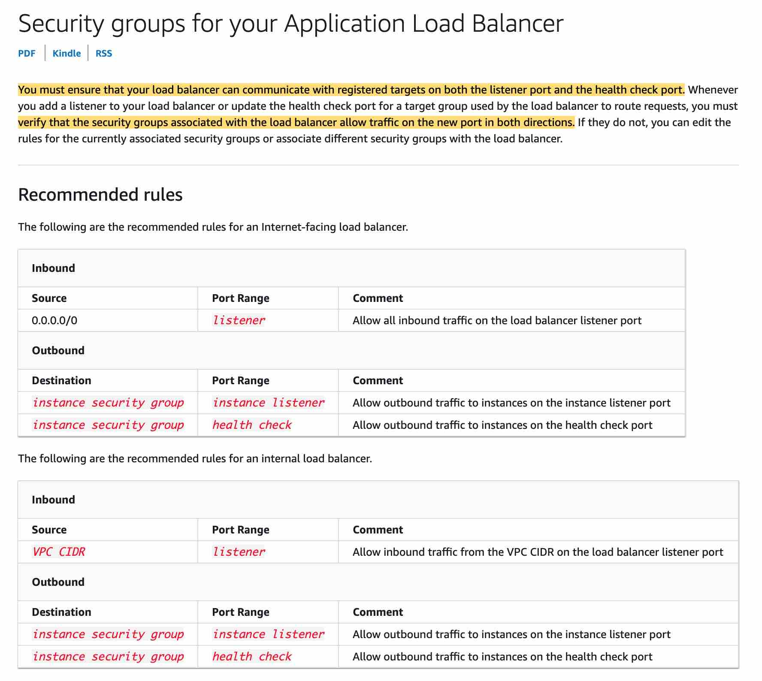 via - <https://docs.aws.amazon.com/elasticloadbalancing/latest/application/load-balancer-update-security-groups.html>

Incorrect options:

**The EBS volumes have been improperly mounted** - You can access the website using the IP address which means there is no issue with the EBS volumes. So this option is not correct.

**Your web-app has a runtime that is not supported by the Application Load Balancer** - There is no connection between a web app and the application load balancer. This option has been added as a distractor.

**You need to attach Elastic IP to the EC2 instances** - This option is a distractor as Elastic IPs do not need to be assigned to EC2 instances while using an Application Load Balancer.

References:

<https://docs.aws.amazon.com/elasticloadbalancing/latest/application/load-balancer-update-security-groups.html>

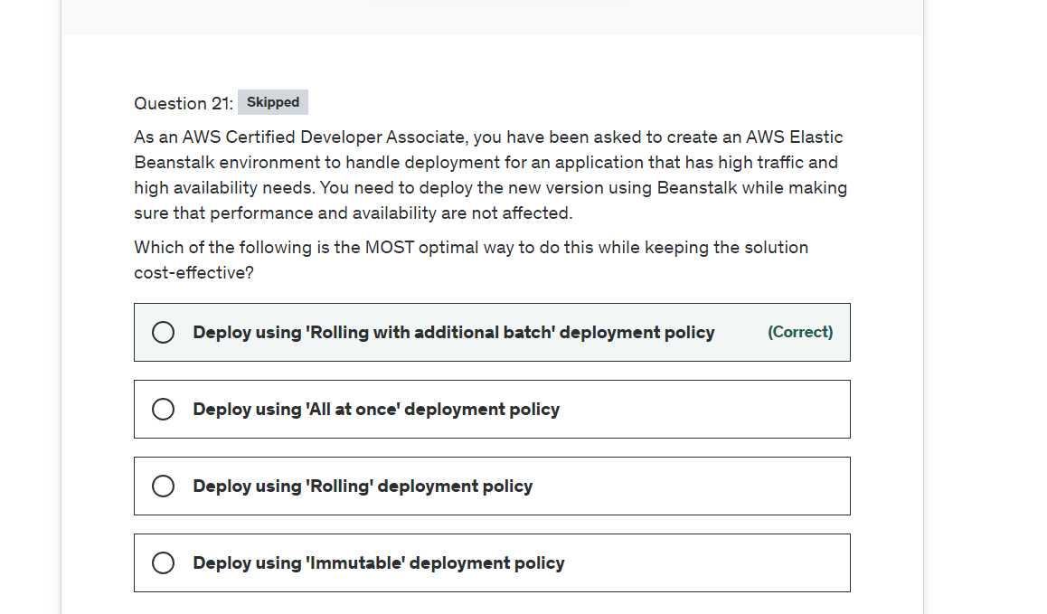

Explanation

Correct option:

AWS Elastic Beanstalk offers several deployment policies and settings. Choosing the right deployment policy for your application is a tradeoff based on a few considerations and depends on your business needs.

**Deploy using 'Rolling with additional batch' deployment policy** - With this method, Elastic Beanstalk launches an extra batch of instances, then performs a rolling deployment. Launching the extra batch takes time, and ensures that the same bandwidth is retained throughout the deployment. This policy also avoids any reduced availability, although at a cost of an even longer deployment time compared to the Rolling method. Finally, this option is suitable if you must maintain the same bandwidth throughout the deployment.

Overview of Elastic Beanstalk Deployment Policies: 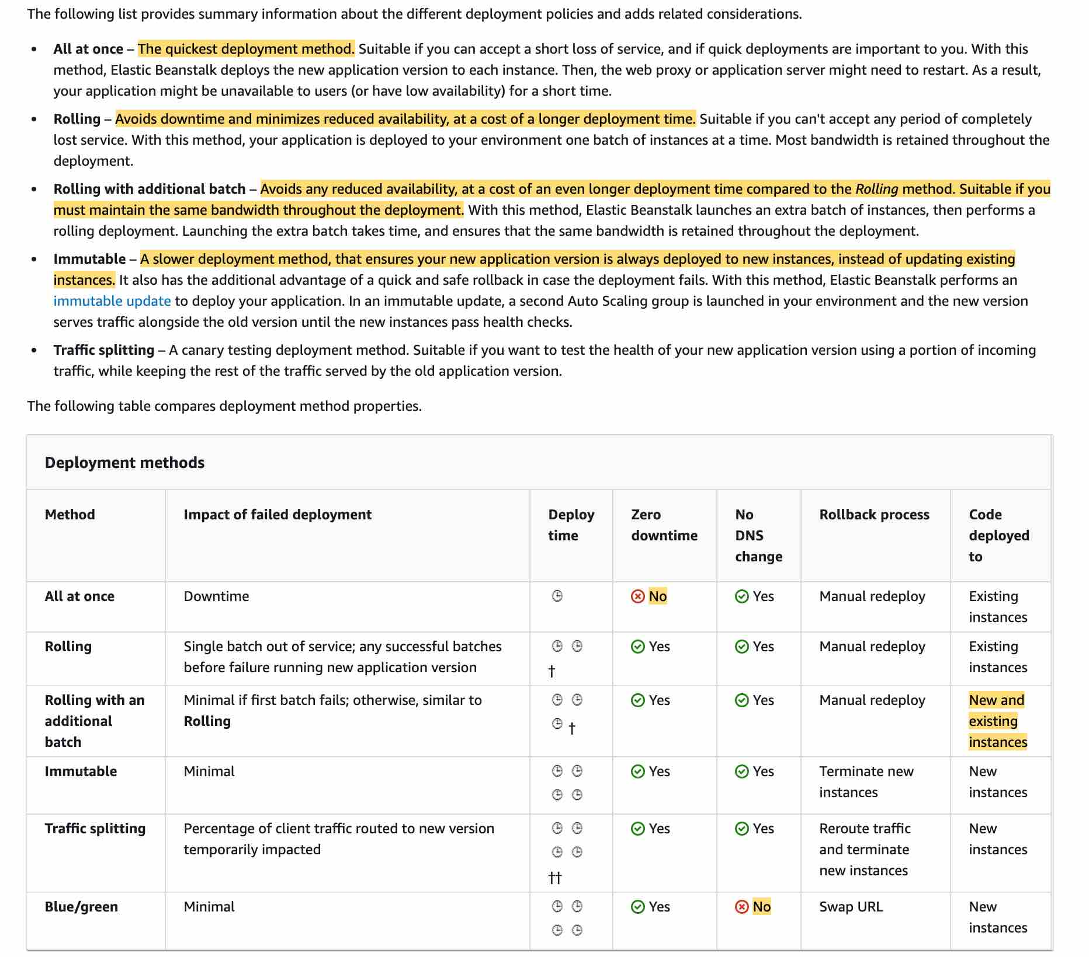 via - <https://docs.aws.amazon.com/elasticbeanstalk/latest/dg/using-features.deploy-existing-version.html>

Incorrect options:

**Deploy using 'Immutable' deployment policy** - A slower deployment method, that ensures your new application version is always deployed to new instances, instead of updating existing instances. It also has the additional advantage of a quick and safe rollback in case the deployment fails. With this method, Elastic Beanstalk performs an immutable update to deploy your application. In an immutable update, a second Auto Scaling group is launched in your environment and the new version serves traffic alongside the old version until the new instances pass health checks.

**Deploy using 'All at once' deployment policy** - This is the quickest deployment method. Suitable if you can accept a short loss of service, and if quick deployments are important to you. With this method, Elastic Beanstalk deploys the new application version to each instance. Then, the web proxy or application server might need to restart. As a result, your application might be unavailable to users (or have low availability) for a short time.

**Deploy using 'Rolling' deployment policy** - With this method, your application is deployed to your environment one batch of instances at a time. Most bandwidth is retained throughout the deployment. Avoids downtime and minimizes reduced availability, at a cost of a longer deployment time. Suitable if you can't accept any period of completely lost service. The use case states that the application has high traffic and high availability requirements, so full capacity must be maintained during deployments, hence rolling with additional batch deployment is a better fit than the rolling deployment.

Reference:

<https://docs.aws.amazon.com/elasticbeanstalk/latest/dg/using-features.deploy-existing-version.html>

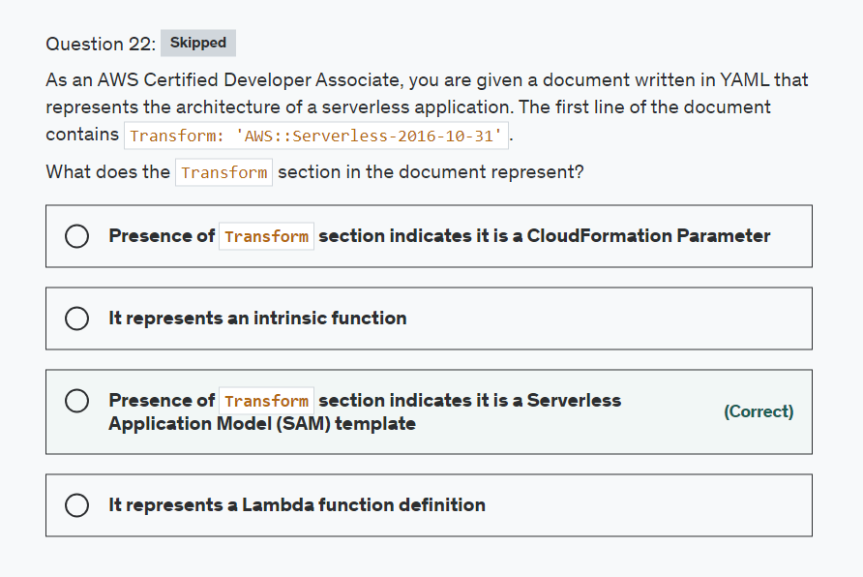

Explanation

Correct option:

AWS CloudFormation template is a JSON- or YAML-formatted text file that describes your AWS infrastructure. Templates include several major sections. The "Resources" section is the only required section. The optional "Transform" section specifies one or more macros that AWS CloudFormation uses to process your template.

The AWS Serverless Application Model (SAM) is an open-source framework for building serverless applications. It provides shorthand syntax to express functions, APIs, databases, and event source mappings. With just a few lines per resource, you can define the application you want and model it using YAML.

**Presence of 'Transform' section indicates it is a Serverless Application Model (SAM) template** - The AWS::Serverless transform, which is a macro hosted by AWS CloudFormation, takes an entire template written in the AWS Serverless Application Model (AWS SAM) syntax and transforms and expands it into a compliant AWS CloudFormation template. So, presence of "Transform" section indicates, the document is a SAM template.

Sample CloudFormation YAML template:  via - <https://docs.aws.amazon.com/AWSCloudFormation/latest/UserGuide/template-anatomy.html>

Incorrect options:

**It represents a Lambda function definition** - Lambda function is created using "AWS::Lambda::Function" resource and has no connection to 'Transform' section.

**It represents an intrinsic function** - Intrinsic Functions in templates are used to assign values to properties that are not available until runtime. They usually start with Fn:: or !. Example: !Sub or Fn::Sub.

**Presence of 'Transform' section indicates it is a CloudFormation Parameter** - CloudFormation parameters are part of Parameters block of the template, like so:

Parameters in YAML: 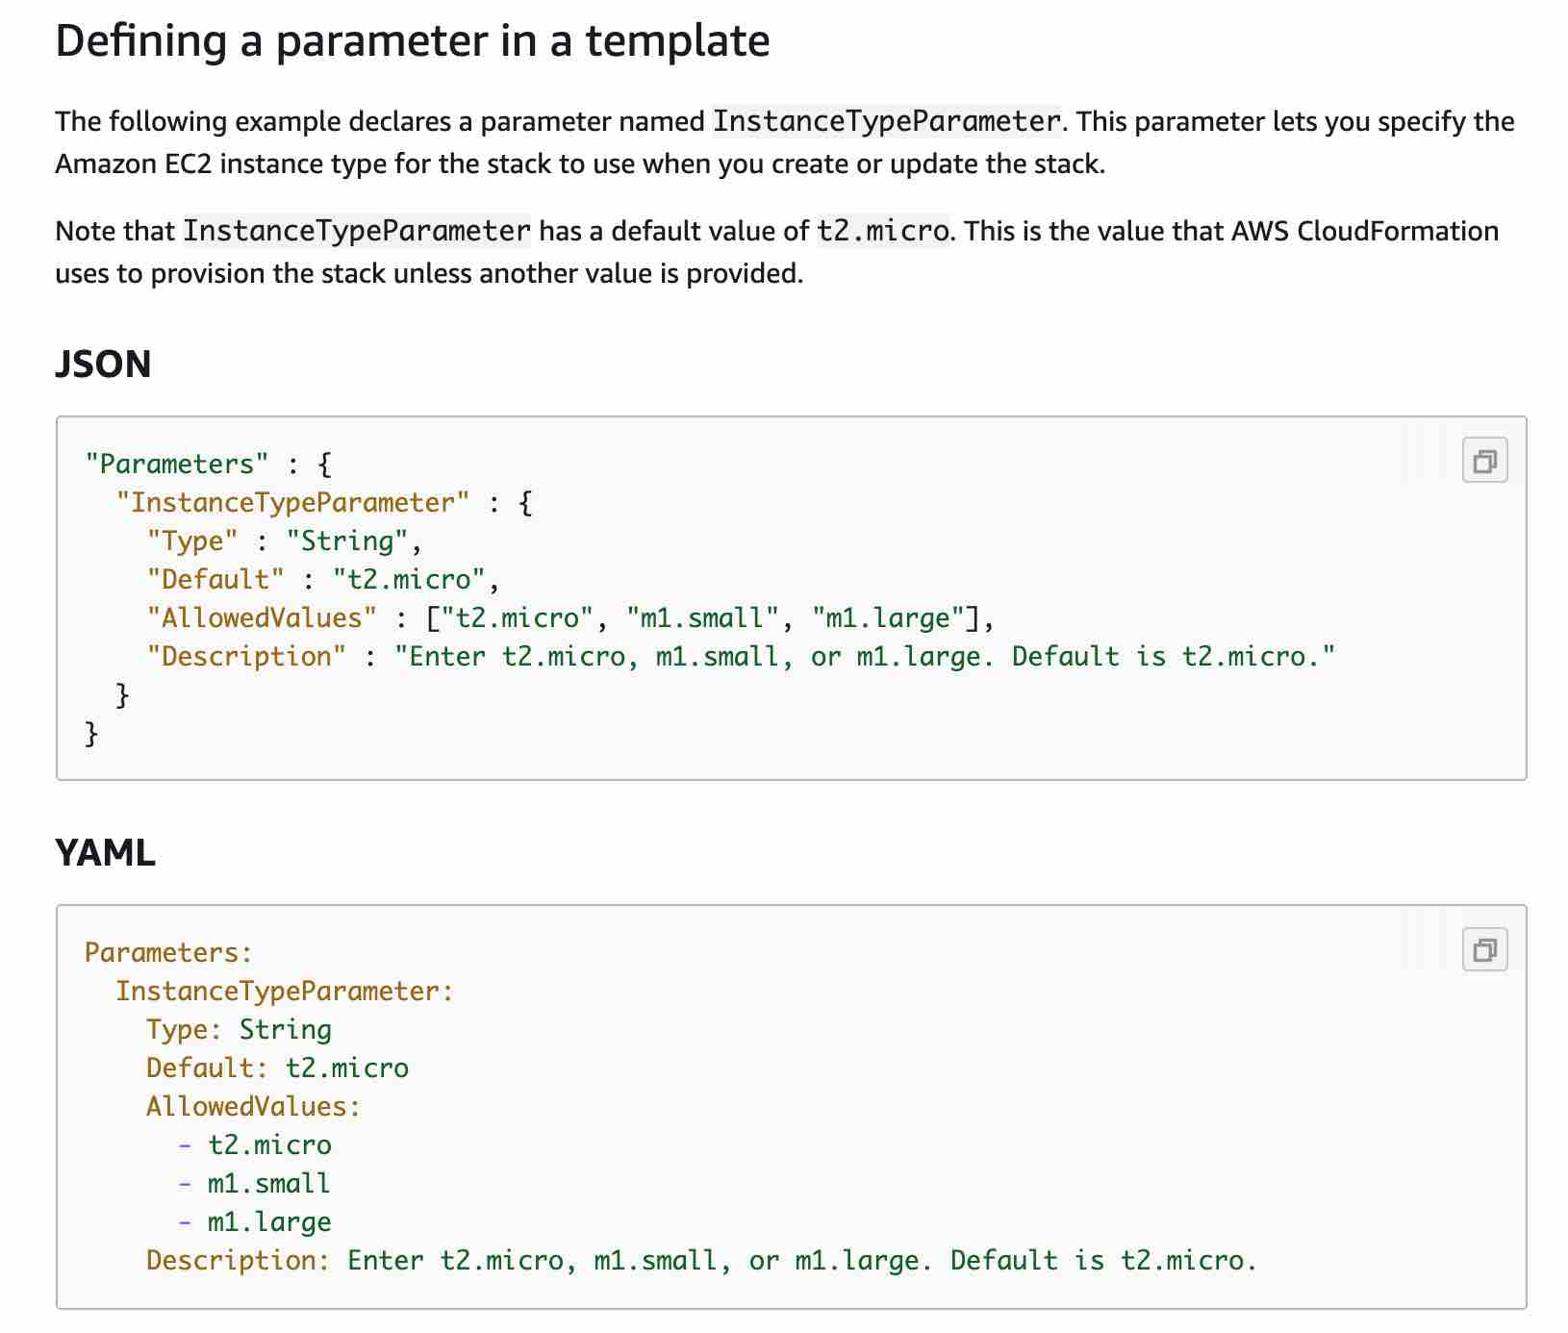 via - <https://docs.aws.amazon.com/AWSCloudFormation/latest/UserGuide/parameters-section-structure.html>

References:

<https://docs.aws.amazon.com/AWSCloudFormation/latest/UserGuide/transform-aws-serverless.html>

<https://docs.aws.amazon.com/AWSCloudFormation/latest/UserGuide/template-anatomy.html>

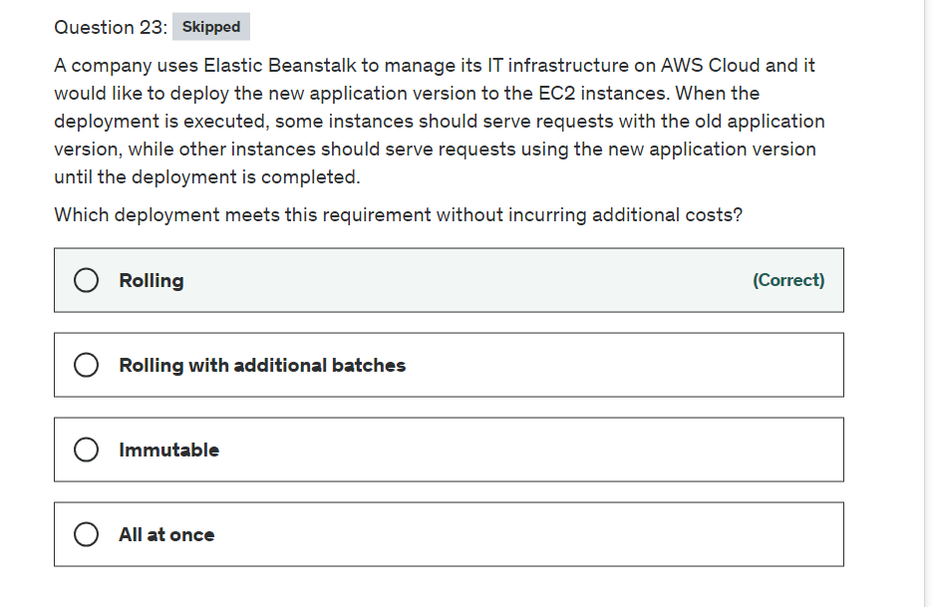

Explanation

Correct option:

**Rolling**

With Elastic Beanstalk, you can quickly deploy and manage applications in the AWS Cloud without having to learn about the infrastructure that runs those applications. Elastic Beanstalk reduces management complexity without restricting choice or control. You simply upload your application, and Elastic Beanstalk automatically handles the details of capacity provisioning, load balancing, scaling, and application health monitoring.

How Elastic BeanStalk Works: 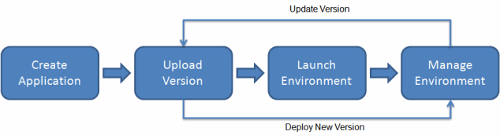 via - <https://docs.aws.amazon.com/elasticbeanstalk/latest/dg/Welcome.html>

The rolling deployment policy deploys the new version in batches. Each batch is taken out of service during the deployment phase, reducing your environment's capacity by the number of instances in a batch. The cost remains the same as the number of EC2 instances does not increase. This policy avoids downtime and minimizes reduced availability, at a cost of a longer deployment time.

Overview of Elastic Beanstalk Deployment Policies:  via - <https://docs.aws.amazon.com/elasticbeanstalk/latest/dg/using-features.deploy-existing-version.html>

Incorrect options:

**Immutable** - The 'Immutable' deployment policy ensures that your new application version is always deployed to new instances, instead of updating existing instances. It also has the additional advantage of a quick and safe rollback in case the deployment fails.

**All at once** - This policy deploys the new version to all instances simultaneously. Although 'All at once' is the quickest deployment method, but the application may become unavailable to users (or have low availability) for a short time.

**Rolling with additional batches** - This policy deploys the new version in batches, but first launches a new batch of instances to ensure full capacity during the deployment process. This policy avoids any reduced availability, at a cost of an even longer deployment time compared to the Rolling method. Suitable if you must maintain the same bandwidth throughout the deployment. These increase the costs as you're adding extra instances during the deployment.

Reference:

<https://docs.aws.amazon.com/elasticbeanstalk/latest/dg/using-features.deploy-existing-version.html>

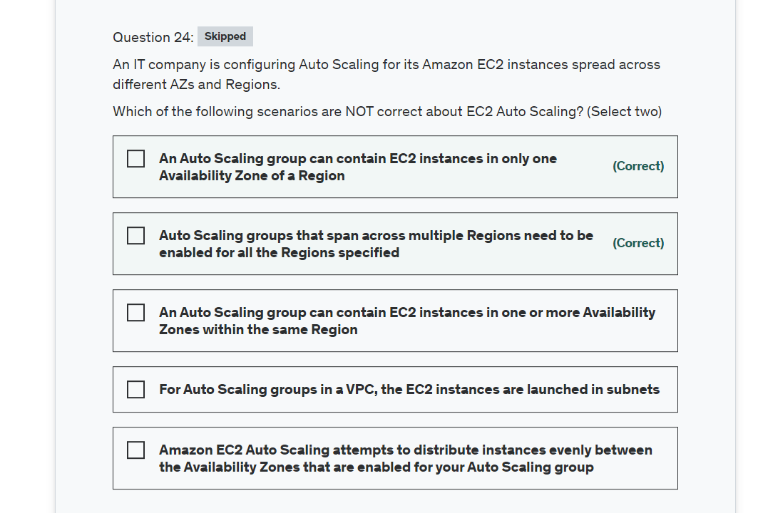

Explanation

Correct options:

**Auto Scaling groups that span across multiple Regions need to be enabled for all the Regions specified** - This is not valid for Auto Scaling groups. Auto Scaling groups cannot span across multiple Regions.

**An Auto Scaling group can contain EC2 instances in only one Availability Zone of a Region** - This is not valid for Auto Scaling groups. An Auto Scaling group can contain EC2 instances in one or more Availability Zones within the same Region.

Amazon EC2 Auto Scaling Overview: 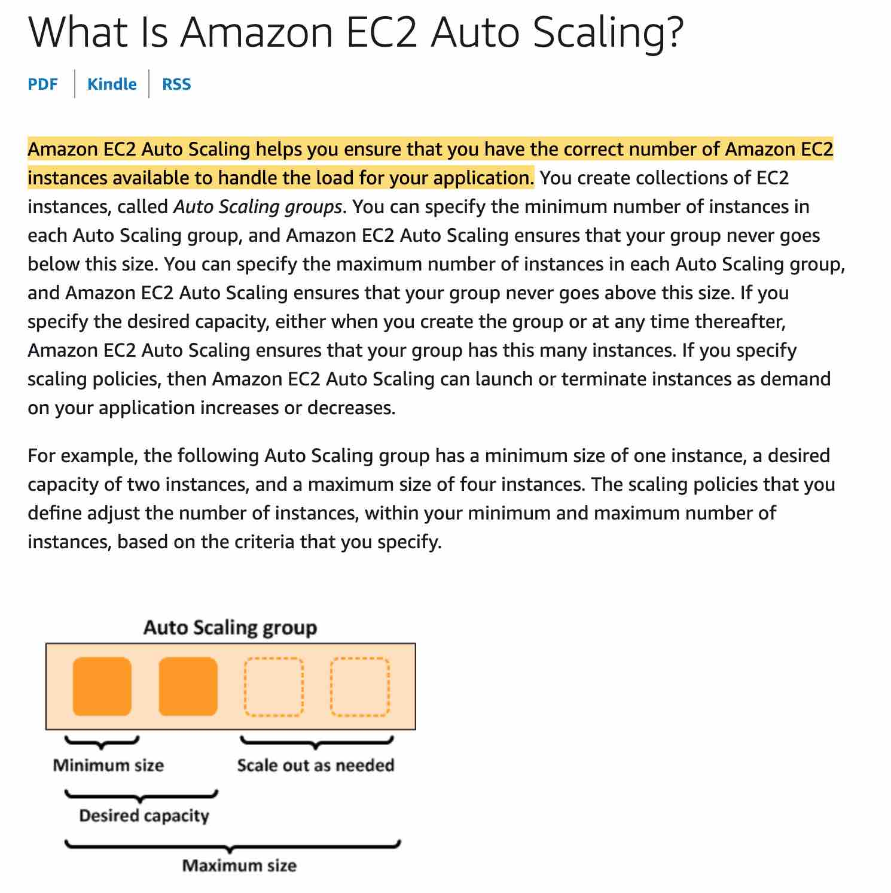 via - <https://docs.aws.amazon.com/autoscaling/ec2/userguide/what-is-amazon-ec2-auto-scaling.html>

Incorrect options:

**An Auto Scaling group can contain EC2 instances in one or more Availability Zones within the same Region** - This is a valid statement. Auto Scaling groups can span across the availability Zones of a Region.

**Amazon EC2 Auto Scaling attempts to distribute instances evenly between the Availability Zones that are enabled for your Auto Scaling group** - When one Availability Zone becomes unhealthy or unavailable, Auto Scaling launches new instances in an unaffected Availability Zone. When the unhealthy Availability Zone returns to a healthy state, Auto Scaling automatically redistributes the application instances evenly across all of the designated Availability Zones.

**For Auto Scaling groups in a VPC, the EC2 instances are launched in subnets** - For Auto Scaling groups in a VPC, the EC2 instances are launched in subnets. Customers can select the subnets for your EC2 instances when you create or update the Auto Scaling group.

References:

<https://docs.aws.amazon.com/autoscaling/ec2/userguide/what-is-amazon-ec2-auto-scaling.html>

<https://docs.aws.amazon.com/autoscaling/ec2/userguide/auto-scaling-benefits.html>

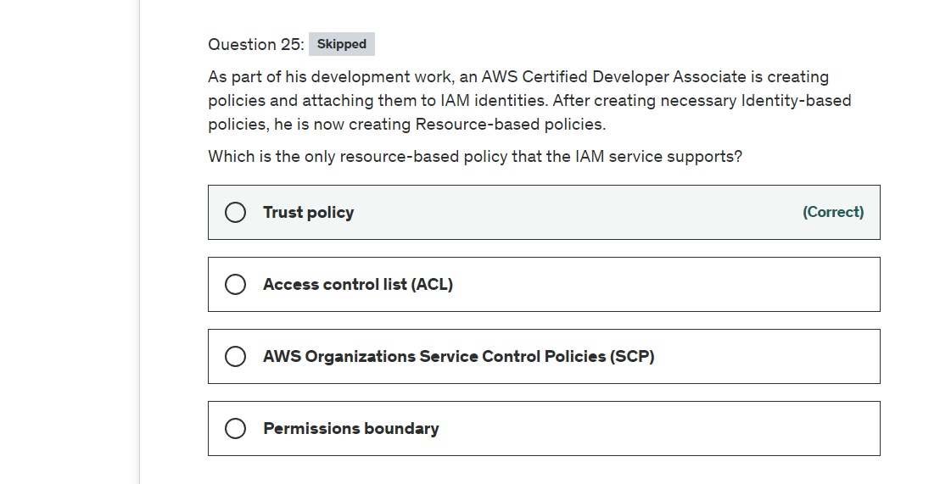

Explanation

Correct option:

You manage access in AWS by creating policies and attaching them to IAM identities (users, groups of users, or roles) or AWS resources. A policy is an object in AWS that, when associated with an identity or resource, defines their permissions. Resource-based policies are JSON policy documents that you attach to a resource such as an Amazon S3 bucket. These policies grant the specified principal permission to perform specific actions on that resource and define under what conditions this applies.

**Trust policy** - Trust policies define which principal entities (accounts, users, roles, and federated users) can assume the role. An IAM role is both an identity and a resource that supports resource-based policies. For this reason, you must attach both a trust policy and an identity-based policy to an IAM role. The IAM service supports only one type of resource-based policy called a role trust policy, which is attached to an IAM role.

Incorrect options:

**AWS Organizations Service Control Policies (SCP)** - If you enable all features of AWS organization, then you can apply service control policies (SCPs) to any or all of your accounts. SCPs are JSON policies that specify the maximum permissions for an organization or organizational unit (OU). The SCP limits permissions for entities in member accounts, including each AWS account root user. An explicit deny in any of these policies overrides the allow.

**Access control list (ACL)** - Access control lists (ACLs) are service policies that allow you to control which principals in another account can access a resource. ACLs cannot be used to control access for a principal within the same account. Amazon S3, AWS WAF, and Amazon VPC are examples of services that support ACLs.

**Permissions boundary** - AWS supports permissions boundaries for IAM entities (users or roles). A permissions boundary is an advanced feature for using a managed policy to set the maximum permissions that an identity-based policy can grant to an IAM entity. An entity's permissions boundary allows it to perform only the actions that are allowed by both its identity-based policies and its permissions boundaries.

References:

<https://docs.aws.amazon.com/IAM/latest/UserGuide/access_policies.html#policies_resource-based>

<https://docs.aws.amazon.com/IAM/latest/UserGuide/access_policies_boundaries.html>

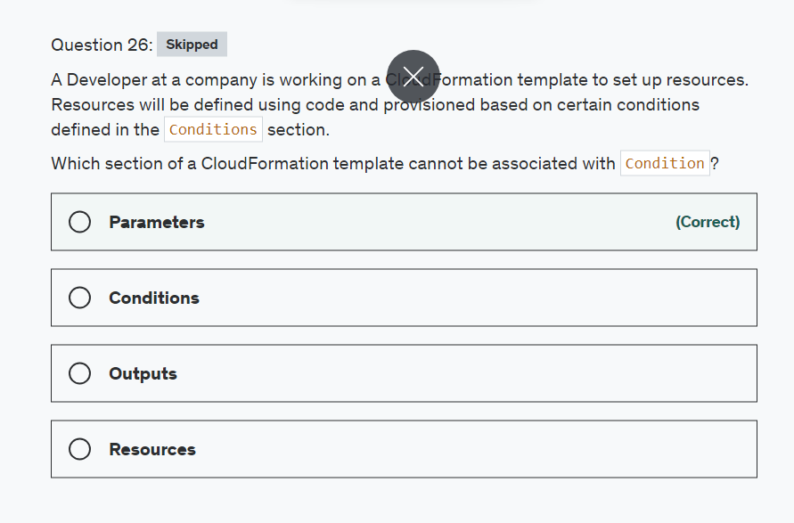

Explanation

Correct option:

**Parameters**

Parameters enable you to input custom values to your CloudFormation template each time you create or update a stack. Please see this note to understand how to define a parameter in a template: 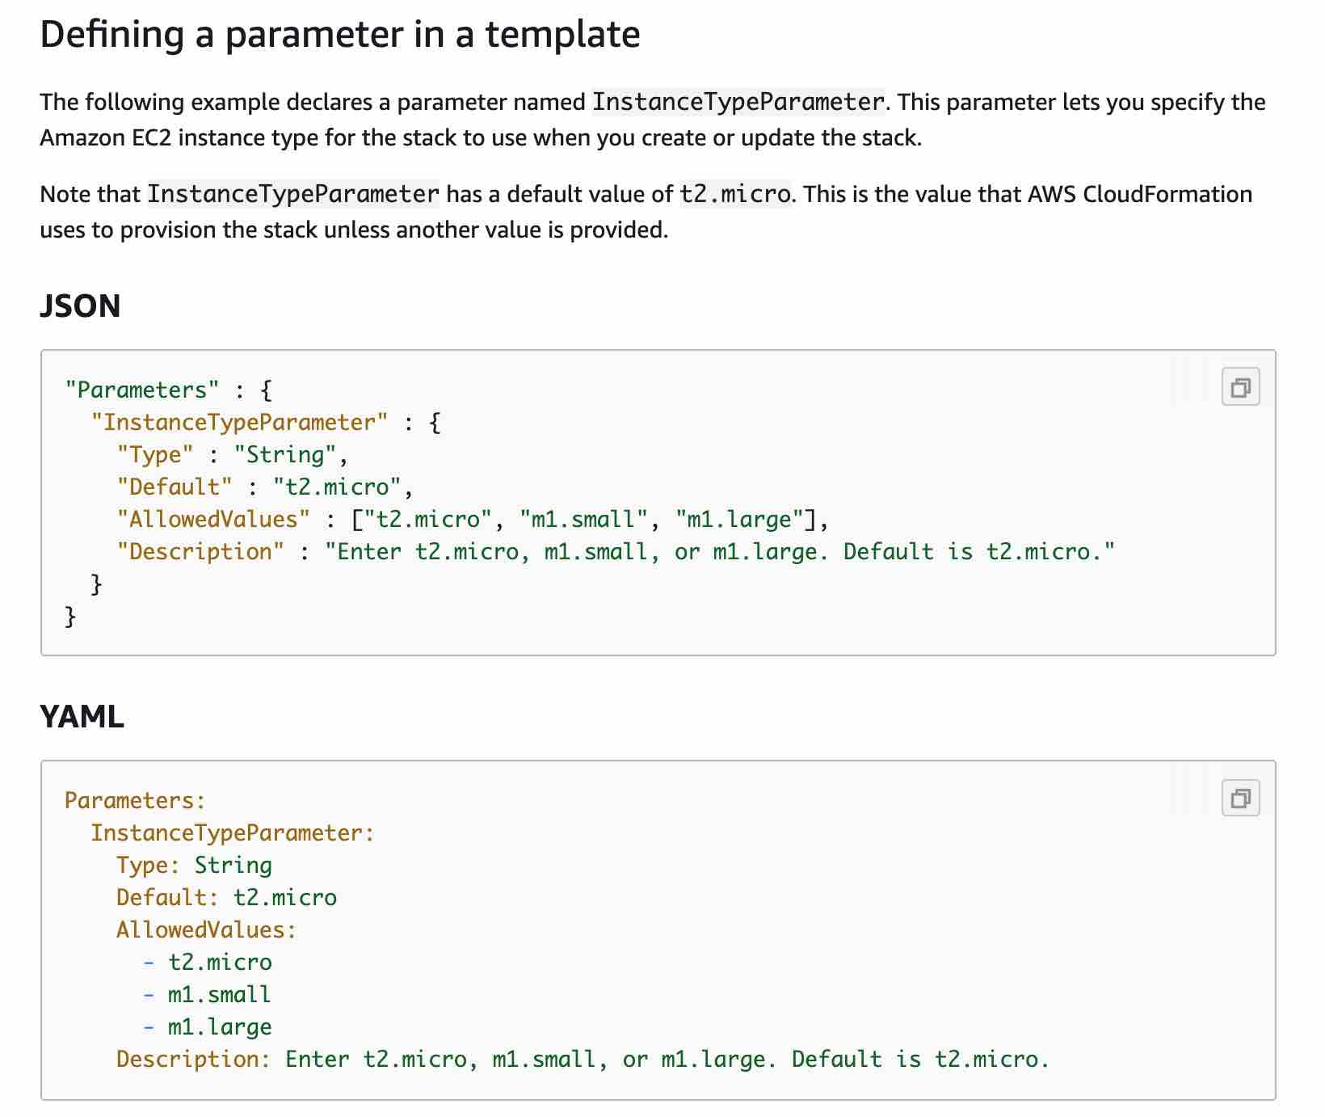 via - <https://docs.aws.amazon.com/AWSCloudFormation/latest/UserGuide/parameters-section-structure.html>

The optional Conditions section contains statements that define the circumstances under which entities are created or configured. For example, you can create a condition and then associate it with a resource or output so that AWS CloudFormation only creates the resource or output if the condition is true.

You might use conditions when you want to reuse a template that can create resources in different contexts, such as a test environment versus a production environment. In your template, you can add an EnvironmentType input parameter, which accepts either prod or test as inputs. For the production environment, you might include Amazon EC2 instances with certain capabilities; however, for the test environment, you want to use reduced capabilities to save money.

Conditions cannot be used within the Parameters section. After you define all your conditions, you can associate them with resources and resource properties only in the Resources and Outputs sections of a template.

Please review this note for more details: 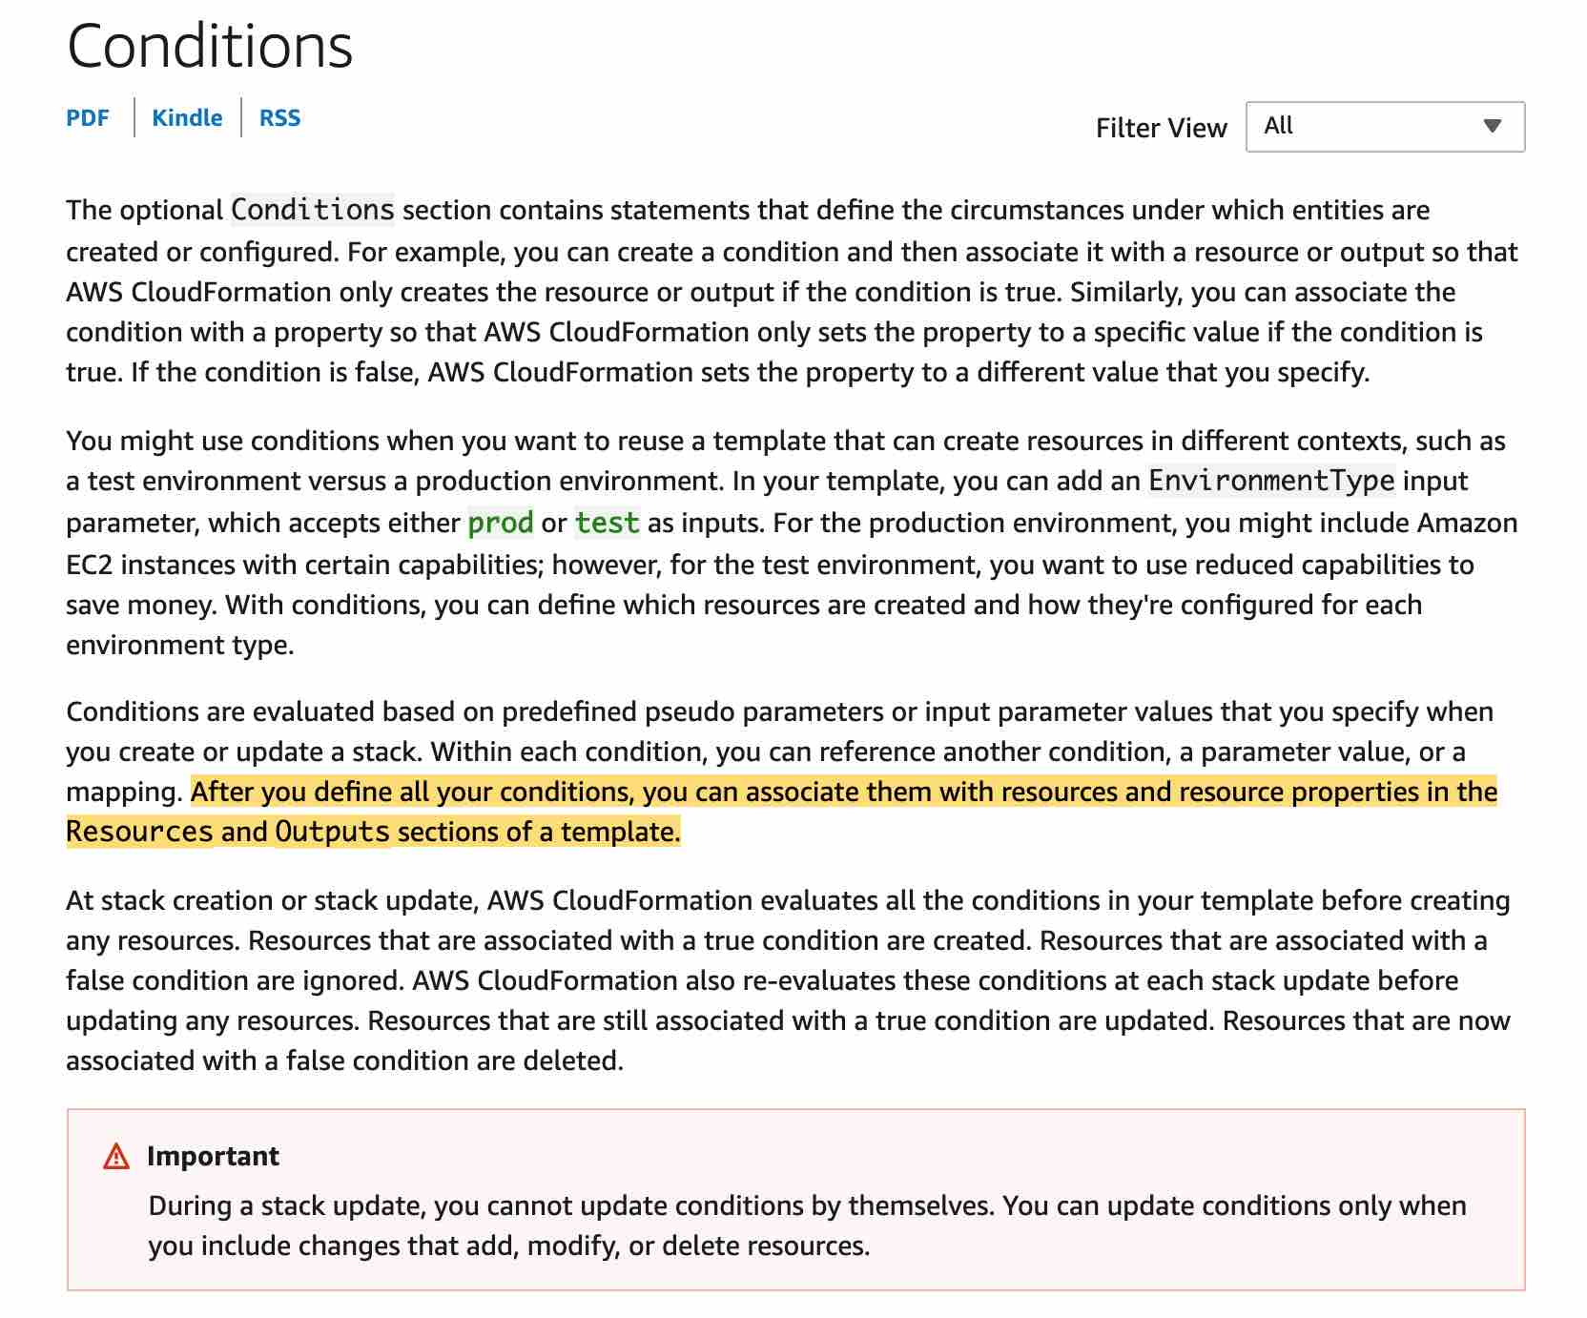 via - <https://docs.aws.amazon.com/AWSCloudFormation/latest/UserGuide/conditions-section-structure.html>

Please visit https://docs.aws.amazon.com/AWSCloudFormation/latest/UserGuide/parameters-section-structure.html for more information on the parameter structure.

Incorrect options:

**Resources** - Resources section describes the resources that you want to provision in your AWS CloudFormation stacks. You can associate conditions with the resources that you want to conditionally create.

**Conditions** - You actually define conditions in this section of the CloudFormation template

**Outputs** - The optional Outputs section declares output values that you can import into other stacks (to create cross-stack references), return in response (to describe stack calls), or view on the AWS CloudFormation console. For example, you can output the S3 bucket name for a stack to make the bucket easier to find. You can associate conditions with the outputs that you want to conditionally create.

References:

<https://docs.aws.amazon.com/AWSCloudFormation/latest/UserGuide/parameters-section-structure.html>

<https://docs.aws.amazon.com/AWSCloudFormation/latest/UserGuide/conditions-section-structure.html>

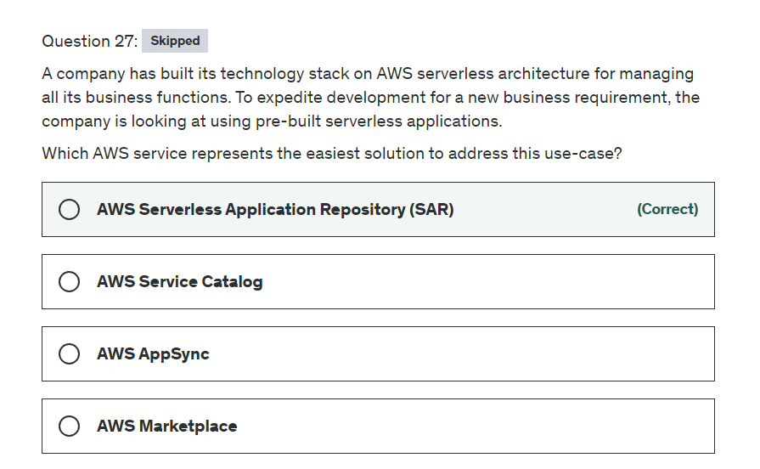

Explanation

Correct option:

**AWS Serverless Application Repository (SAR)** - The AWS Serverless Application Repository is a managed repository for serverless applications. It enables teams, organizations, and individual developers to store and share reusable applications, and easily assemble and deploy serverless architectures in powerful new ways. Using the Serverless Application Repository, you don't need to clone, build, package, or publish source code to AWS before deploying it. Instead, you can use pre-built applications from the Serverless Application Repository in your serverless architectures, helping you and your teams reduce duplicated work, ensure organizational best practices, and get to market faster. Integration with AWS Identity and Access Management (IAM) provides resource-level control of each application, enabling you to publicly share applications with everyone or privately share them with specific AWS accounts.

Deploying applications using SAR: 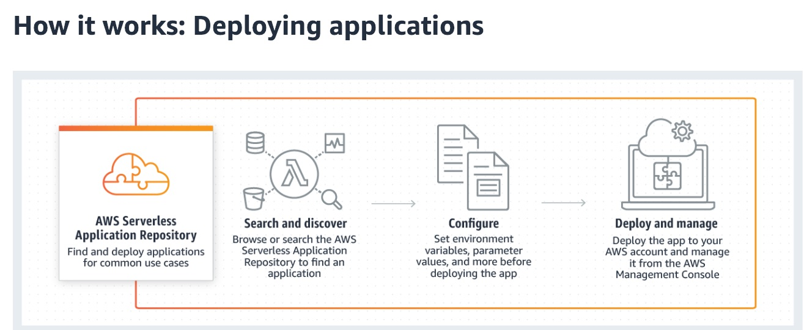 via - <https://aws.amazon.com/serverless/serverlessrepo/>

Incorrect options:

**AWS Marketplace** - The AWS Marketplace enables qualified partners to market and sell their software to AWS Customers. AWS Marketplace is an online software store that helps customers find, buy, and immediately start using the software and services that run on AWS. AWS Marketplace is designed for Independent Software Vendors (ISVs), Value-Added Resellers (VARs), and Systems Integrators (SIs) who have software products they want to offer to customers in the cloud.

**AWS AppSync** - AWS AppSync is a fully managed service that makes it easy to develop GraphQL APIs by handling the heavy lifting of securely connecting to data sources like AWS DynamoDB, Lambda, and more. Organizations choose to build APIs with GraphQL because it helps them develop applications faster, by giving front-end developers the ability to query multiple databases, microservices, and APIs with a single GraphQL endpoint.

**AWS Service Catalog** - AWS Service Catalog allows organizations to create and manage catalogs of IT services that are approved for use on AWS. These IT services can include everything from virtual machine images, servers, software, and databases to complete multi-tier application architectures. AWS Service Catalog allows you to centrally manage deployed IT services and your applications, resources, and metadata. This helps you achieve consistent governance and meet your compliance requirements while enabling users to quickly deploy only the approved IT services they need.

Reference:

<https://aws.amazon.com/serverless/serverlessrepo/>

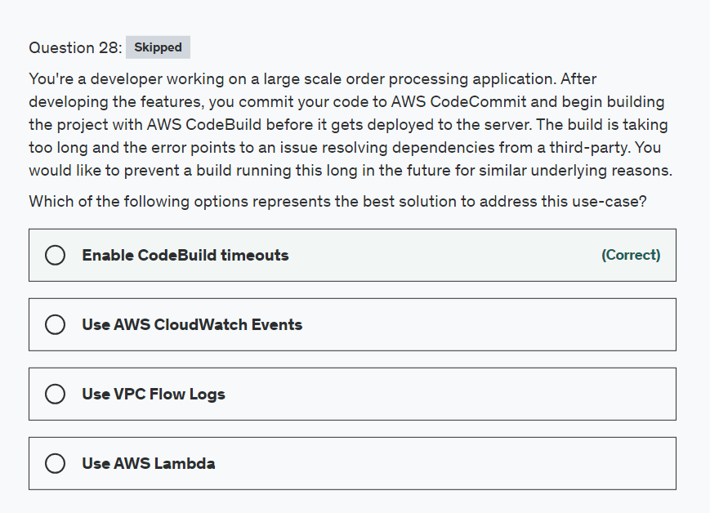

Explanation

Correct option:

**Enable CodeBuild timeouts**

A build represents a set of actions performed by AWS CodeBuild to create output artifacts (for example, a JAR file) based on a set of input artifacts (for example, a collection of Java class files).

The following rules apply when you run multiple builds:

When possible, builds run concurrently. The maximum number of concurrently running builds can vary.

Builds are queued if the number of concurrently running builds reaches its limit. The maximum number of builds in a queue is five times the concurrent build limit.

A build in a queue that does not start after the number of minutes specified in its time out value is removed from the queue. The default timeout value is eight hours. You can override the build queue timeout with a value between five minutes and eight hours when you run your build.

By setting the timeout configuration, the build process will automatically terminate post the expiry of the configured timeout.

Incorrect options:

**Use AWS Lambda** - AWS Lambda lets you run code without provisioning or managing servers. You pay only for the compute time you consume. Lambda cannot be used to impact the code build process.

**Use AWS CloudWatch Events** - Amazon CloudWatch allows you to monitor AWS cloud resources and the applications you run on AWS. Metrics are provided automatically for a number of AWS products and services. CloudWatch is good for monitoring and viewing logs. CloudWatch cannot be used to impact the code build process.

**Use VPC Flow Logs** - VPC Flow Logs is a feature that enables you to capture information about the IP traffic going to and from network interfaces in your VPC but not for code compiling configuration. VPC Flow Logs cannot be used to impact the code build process.

Reference:

<https://docs.aws.amazon.com/codebuild/latest/userguide/builds-working.html>

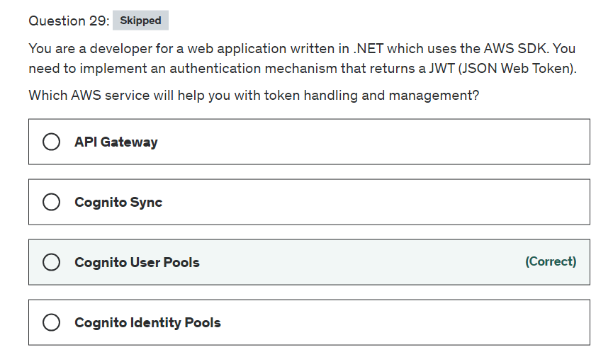

Explanation

Correct option:

"Cognito User Pools"

After successful authentication, Amazon Cognito returns user pool tokens to your app. You can use the tokens to grant your users access to your own server-side resources, or to the Amazon API Gateway.

Amazon Cognito user pools implement ID, access, and refresh tokens as defined by the OpenID Connect (OIDC) open standard.

The ID token is a JSON Web Token (JWT) that contains claims about the identity of the authenticated user such as name, email, and phone_number. You can use this identity information inside your application. The ID token can also be used to authenticate users against your resource servers or server applications.

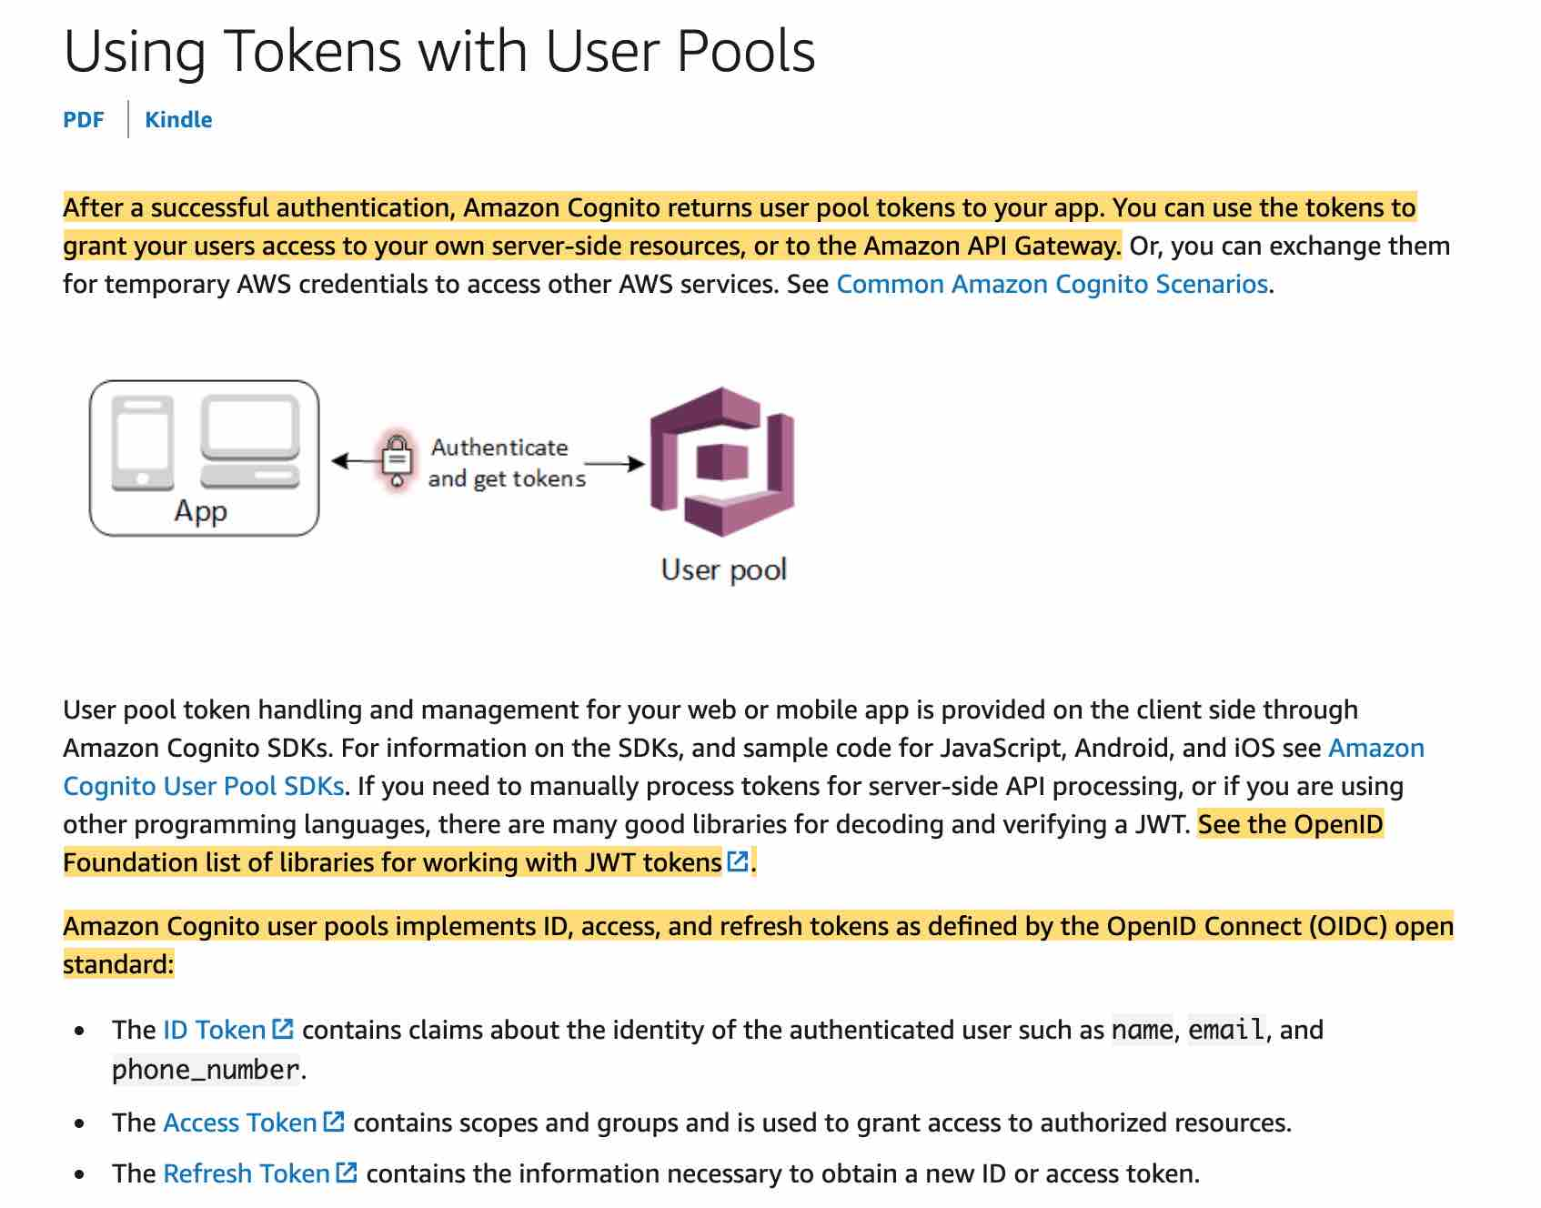 via - <https://docs.aws.amazon.com/cognito/latest/developerguide/amazon-cognito-user-pools-using-tokens-with-identity-providers.html>

Incorrect options:

"API Gateway" - If you are processing tokens server-side and using other programming languages not supported in AWS it may be a good choice. Other than that, go with a service already providing the functionality.

"Cognito Identity Pools" - You can use Identity pools to grant your users access to other AWS services. With an identity pool, your users can obtain temporary AWS credentials to access AWS services, such as Amazon S3 and DynamoDB. Identity pools support anonymous guest users, as well as the specific identity providers that you can use to authenticate users for identity pools.

"Cognito Sync" - Amazon Cognito Sync is an AWS service and client library that enables cross-device syncing of application-related user data. You can use it to synchronize user profile data across mobile devices and the web without requiring your own backend.

Exam Alert:

Please review the following note to understand the differences between Cognito User Pools and Cognito Identity Pools: 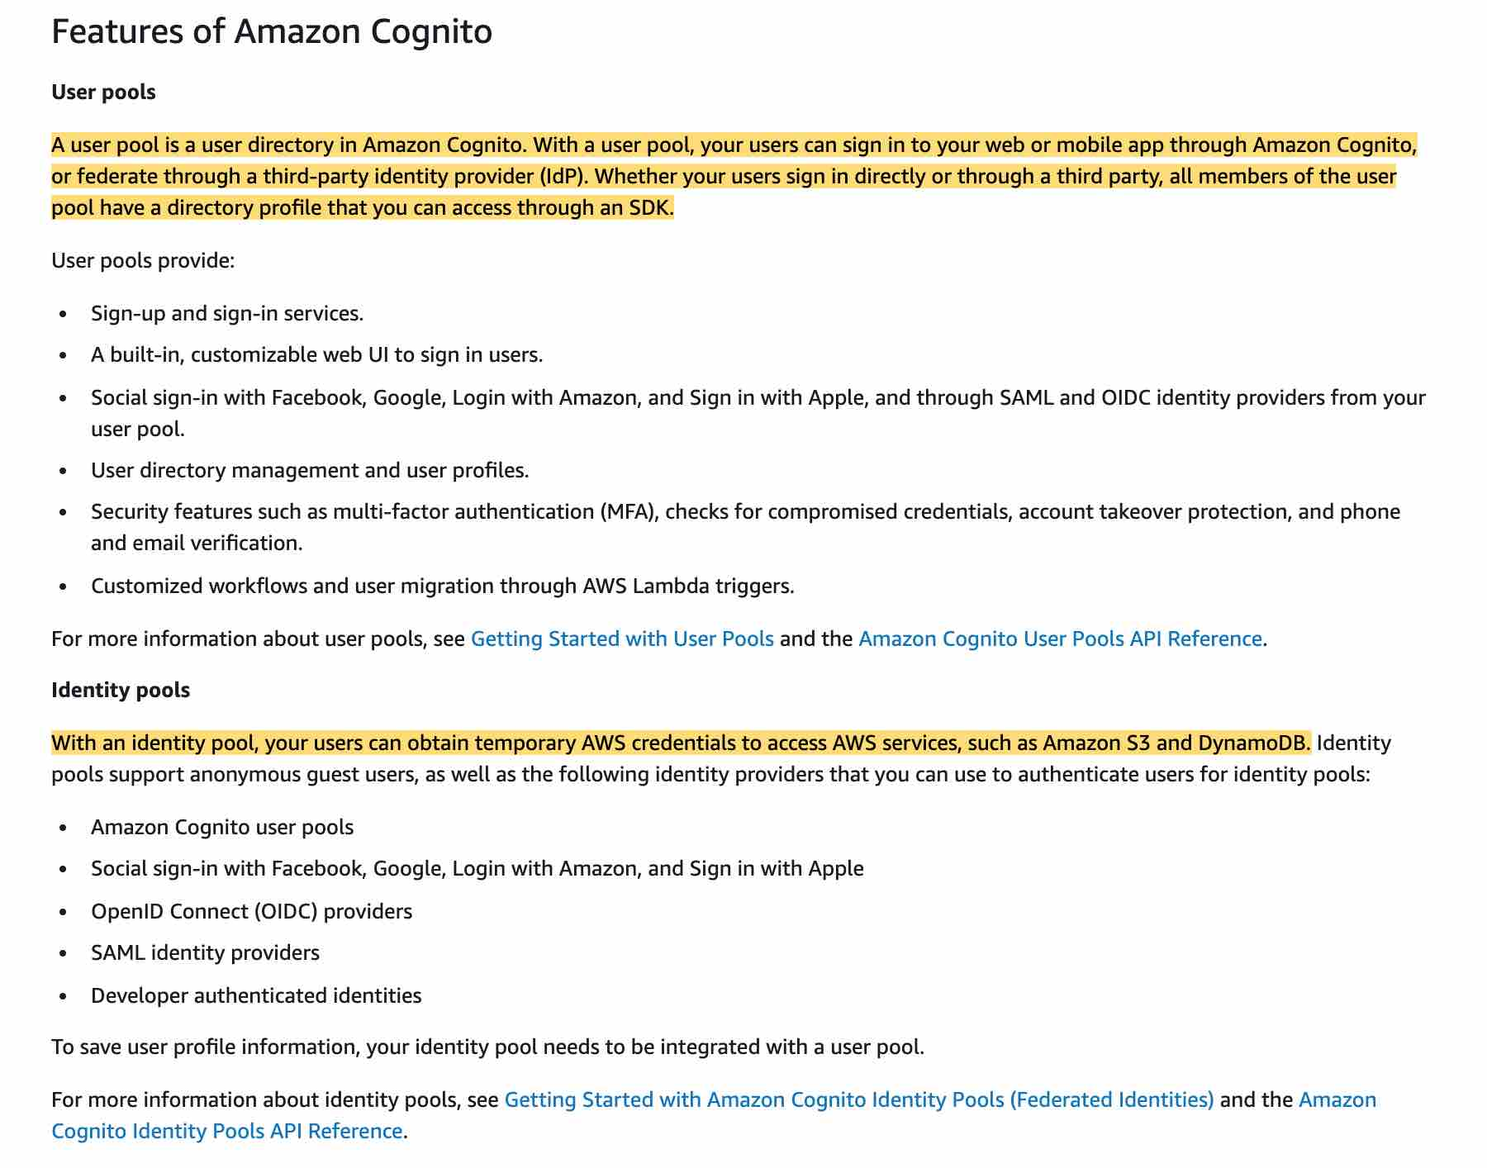 via - <https://docs.aws.amazon.com/cognito/latest/developerguide/what-is-amazon-cognito.html>

Reference:

<https://docs.aws.amazon.com/cognito/latest/developerguide/amazon-cognito-user-pools-using-tokens-with-identity-providers.html>

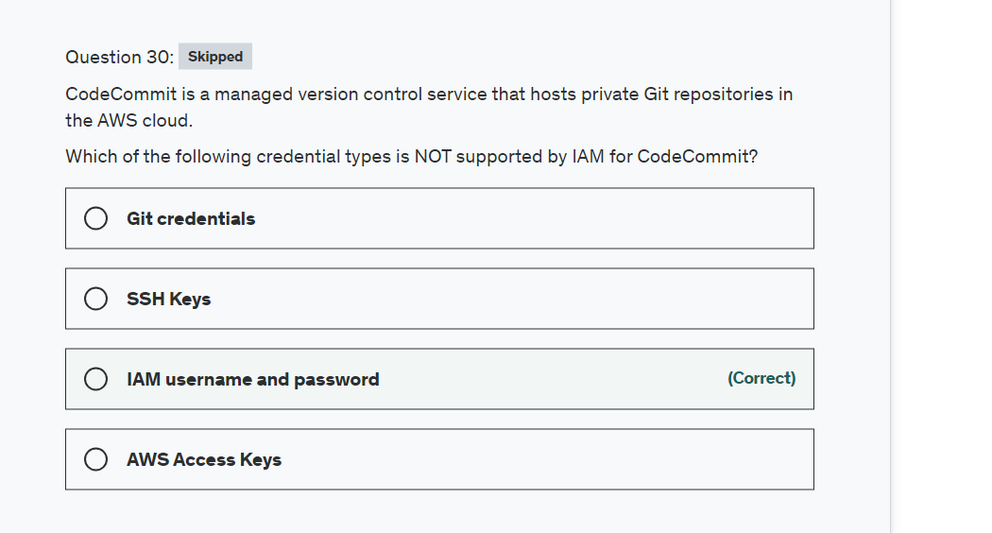

Explanation

Correct option:

**IAM username and password** - IAM username and password credentials cannot be used to access CodeCommit.

Incorrect options:

**Git credentials** - These are IAM -generated user name and password pair you can use to communicate with CodeCommit repositories over HTTPS.

**SSH Keys** - Are locally generated public-private key pair that you can associate with your IAM user to communicate with CodeCommit repositories over SSH.

**AWS access keys** - You can use these keys with the credential helper included with the AWS CLI to communicate with CodeCommit repositories over HTTPS.

Reference:

<https://docs.aws.amazon.com/IAM/latest/UserGuide/id_credentials_ssh-keys.html>

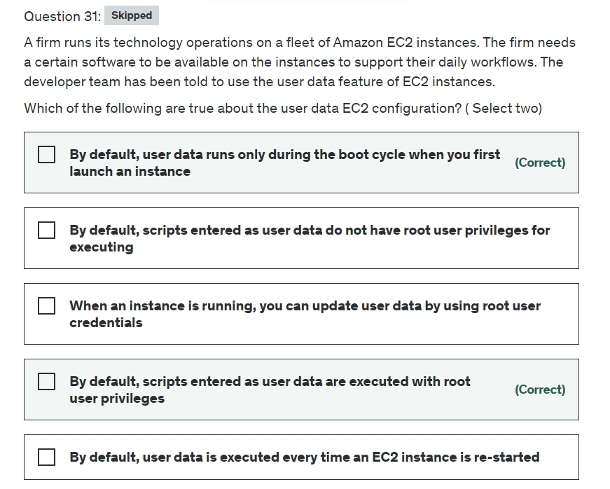

Explanation

Correct options:

User Data is generally used to perform common automated configuration tasks and even run scripts after the instance starts. When you launch an instance in Amazon EC2, you can pass two types of user data - shell scripts and cloud-init directives. You can also pass this data into the launch wizard as plain text or as a file.

**By default, scripts entered as user data are executed with root user privileges** - Scripts entered as user data are executed as the root user, hence do not need the sudo command in the script. Any files you create will be owned by root; if you need non-root users to have file access, you should modify the permissions accordingly in the script.

**By default, user data runs only during the boot cycle when you first launch an instance** - By default, user data scripts and cloud-init directives run only during the boot cycle when you first launch an instance. You can update your configuration to ensure that your user data scripts and cloud-init directives run every time you restart your instance.

Incorrect options:

**By default, user data is executed every time an EC2 instance is re-started** - As discussed above, this is not a default configuration of the system. But, can be achieved by explicitly configuring the instance.

**When an instance is running, you can update user data by using root user credentials** - You can't change the user data if the instance is running (even by using root user credentials), but you can view it.

**By default, scripts entered as user data do not have root user privileges for executing** - Scripts entered as user data are executed as the root user, hence do not need the sudo command in the script.

Reference:

<https://docs.aws.amazon.com/AWSEC2/latest/UserGuide/user-data.html>

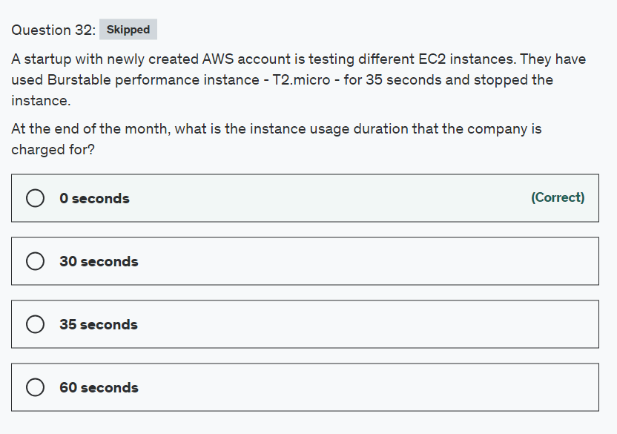

Explanation

Correct option:

Burstable performance instances, which are T3, T3a, and T2 instances, are designed to provide a baseline level of CPU performance with the ability to burst to a higher level when required by your workload. Burstable performance instances are the only instance types that use credits for CPU usage.

**0 seconds** - AWS states that, if your AWS account is less than 12 months old, you can use a t2.micro instance for free within certain usage limits.

Incorrect options:

**35 seconds**

**60 seconds**

**30 seconds**

These three options contradict the explanation provided earlier, so these are incorrect.

Reference:

<https://docs.aws.amazon.com/AWSEC2/latest/UserGuide/burstable-performance-instances.html>

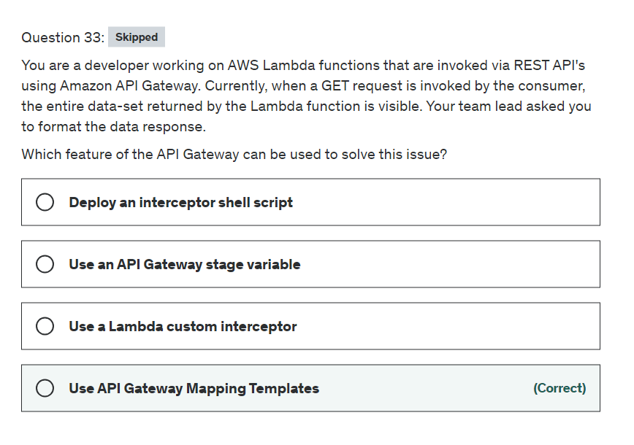

Explanation

Correct option:

**Use API Gateway Mapping Templates** - In API Gateway, an API's method request can take a payload in a different format from the corresponding integration request payload, as required in the backend. Similarly, vice versa is also possible. API Gateway lets you use mapping templates to map the payload from a method request to the corresponding integration request and from an integration response to the corresponding method response.

Suppose we have an API for managing fruit and vegetable inventory in the produce department of a supermarket. When a manager queries the backend for the current inventory, the server sends back the following response payload:

{

"department": "produce",

"categories": [

"fruit",

"vegetables"

],

"bins": [

{

"category": "fruit",

"type": "apples",

"price": 1.99,

"unit": "pound",

"quantity": 232

},

{

"category": "fruit",

"type": "bananas",

"price": 0.19,

"unit": "each",

"quantity": 112

},

{

"category": "vegetables",

"type": "carrots",

"price": 1.29,

"unit": "bag",

"quantity": 57

}

]

}

When the backend returns the query results shown above, the manager of the produce department might be interested in reading them, as follows:

{

"choices": [

{

"kind": "apples",

"suggestedPrice": "1.99 per pound",

"available": 232

},

{

"kind": "bananas",

"suggestedPrice": "0.19 per each",

"available": 112

},

{

"kind": "carrots",

"suggestedPrice": "1.29 per bag",

"available": 57

}

]

}

To enable this, we need to provide API Gateway with a mapping template to translate the data from the backend format like so:

#set($inputRoot = $input.path('$'))

{

"choices": [

#foreach($elem in $inputRoot.bins)

{

"kind": "$elem.type",

"suggestedPrice": "$elem.price per $elem.unit",

"available": $elem.quantity

}#if($foreach.hasNext),#end

#end

]

}

Incorrect options:

**Deploy an interceptor shell script** - This option has been added as a distractor.

**Use an API Gateway stage variable** - Stage variables are name-value pairs that you can define as configuration attributes associated with a deployment stage of a REST API. They act like environment variables and can be used in your API setup and mapping templates. This feature is not useful for the current use case.

**Use a Lambda custom interceptor** - This is a made-up option. Lambda cannot intercept the response for the given use-case.

References:

<https://docs.aws.amazon.com/apigateway/latest/developerguide/rest-api-data-transformations.html>

<https://docs.aws.amazon.com/apigateway/latest/developerguide/stage-variables.html>

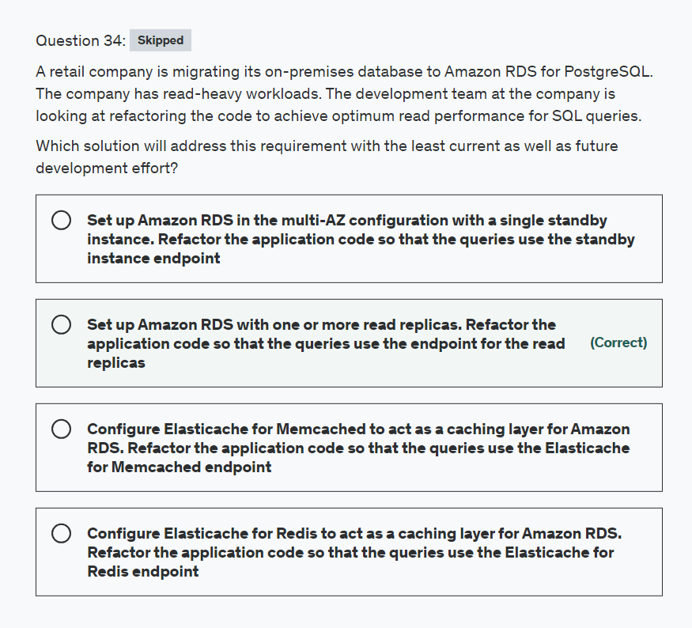

Explanation

Correct option:

**Set up Amazon RDS with one or more read replicas. Refactor the application code so that the queries use the endpoint for the read replicas**

Amazon RDS uses the PostgreSQL DB engine's built-in replication functionality to create a special type of DB instance called a read replica from a source DB instance. The source DB instance becomes the primary DB instance. Updates made to the primary DB instance are asynchronously copied to the read replica. You can reduce the load on your primary DB instance by routing read queries from your applications to the read replica. Using read replicas, you can elastically scale out beyond the capacity constraints of a single DB instance for read-heavy database workloads. For the given use case, you can achieve optimum read performance for SQL queries by using the read-replica endpoint for the read-heavy workload.

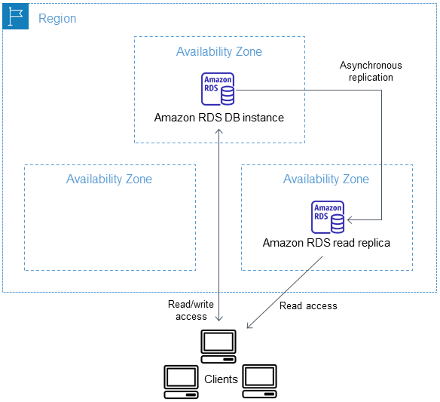 via - <https://docs.aws.amazon.com/AmazonRDS/latest/UserGuide/USER_ReadRepl.html>

Incorrect options:

**Configure Elasticache for Redis to act as a caching layer for Amazon RDS. Refactor the application code so that the queries use the Elasticache for Redis endpoint**

**Configure Elasticache for Memcached to act as a caching layer for Amazon RDS. Refactor the application code so that the queries use the Elasticache for Memcached endpoint**

Both Redis and Memcached are popular, open-source, in-memory data stores (also known as in-memory caches). These are not relational databases and cannot be used to run SQL queries. So, both these options are incorrect.

**Set up Amazon RDS in the multi-AZ configuration with a single standby instance. Refactor the application code so that the queries use the standby instance endpoint** - In an Amazon RDS Multi-AZ deployment with a single standby instance, Amazon RDS automatically creates a primary database (DB) instance and synchronously replicates the data to an instance in a different AZ. When it detects a failure, Amazon RDS automatically fails over to a standby instance without manual intervention. You cannot route the read queries from an application to the standby instance of a multi-AZ RDS database as it's not accessible for the read traffic in the single standby instance configuration.

References:

<https://docs.aws.amazon.com/AmazonRDS/latest/UserGuide/USER_ReadRepl.html>

<https://aws.amazon.com/premiumsupport/knowledge-center/requests-rds-read-replicas/>

<https://aws.amazon.com/rds/features/multi-az/>

<https://aws.amazon.com/blogs/database/readable-standby-instances-in-amazon-rds-multi-az-deployments-a-new-high-availability-option/>

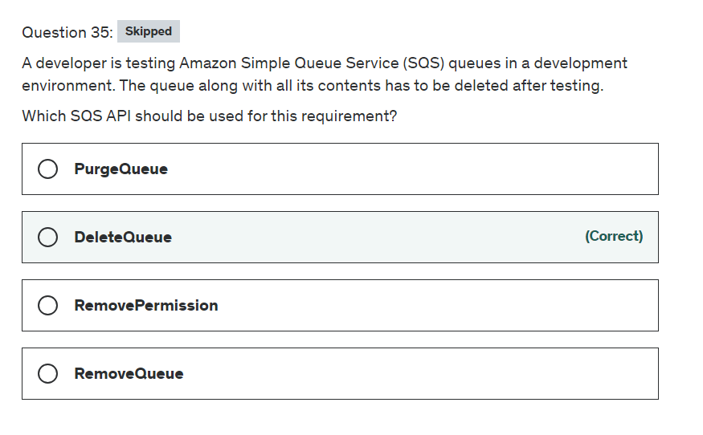

Explanation

Correct option:

**DeleteQueue** - Deletes the queue specified by the QueueUrl, regardless of the queue's contents. When you delete a queue, any messages in the queue are no longer available.

When you delete a queue, the deletion process takes up to 60 seconds. Requests you send involving that queue during the 60 seconds might succeed. For example, a SendMessage request might succeed, but after 60 seconds the queue and the message you sent no longer exist.

When you delete a queue, you must wait at least 60 seconds before creating a queue with the same name.

Incorrect options:

**PurgeQueue** - Deletes the messages in a queue specified by the QueueURL parameter. When you use the PurgeQueue action, you can't retrieve any messages deleted from a queue. The queue however remains.

**RemoveQueue** - This is an invalid option, given only as a distractor.

**RemovePermission** - Revokes any permissions in the queue policy that matches the specified Label parameter.

Reference:

<https://docs.aws.amazon.com/AWSSimpleQueueService/latest/APIReference/API_RemovePermission.html>

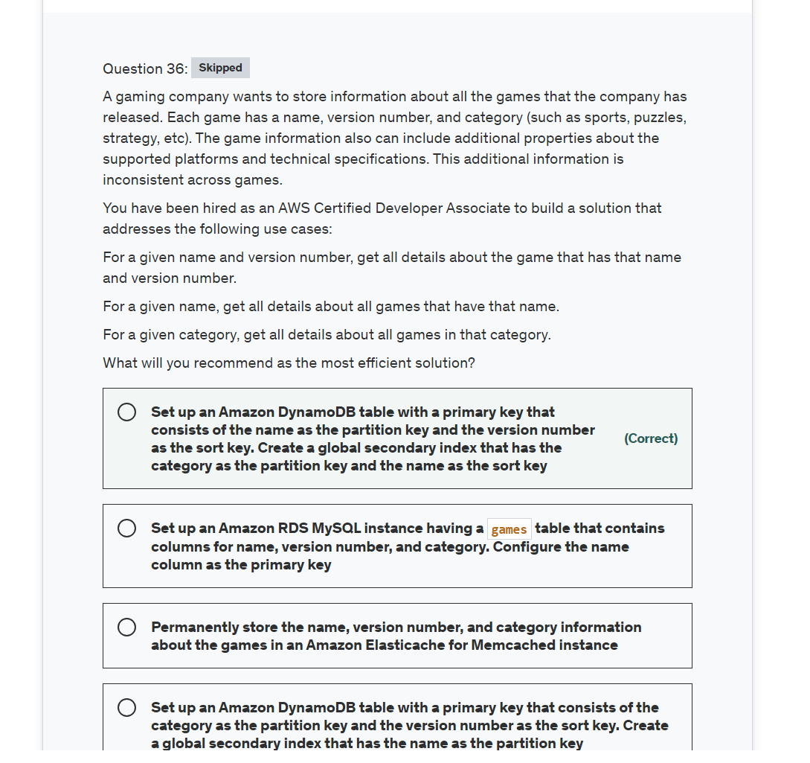

Explanation

Correct option:

**Set up an Amazon DynamoDB table with a primary key that consists of the name as the partition key and the version number as the sort key. Create a global secondary index that has the category as the partition key and the name as the sort key**

When you create a DynamoDB table, in addition to the table name, you must specify the primary key of the table. The primary key uniquely identifies each item in the table, so that no two items can have the same key. You can create one or more secondary indexes on a table. A secondary index lets you query the data in the table using an alternate key, in addition to queries against the primary key. DynamoDB doesn't require that you use indexes, but they give your applications more flexibility when querying your data.

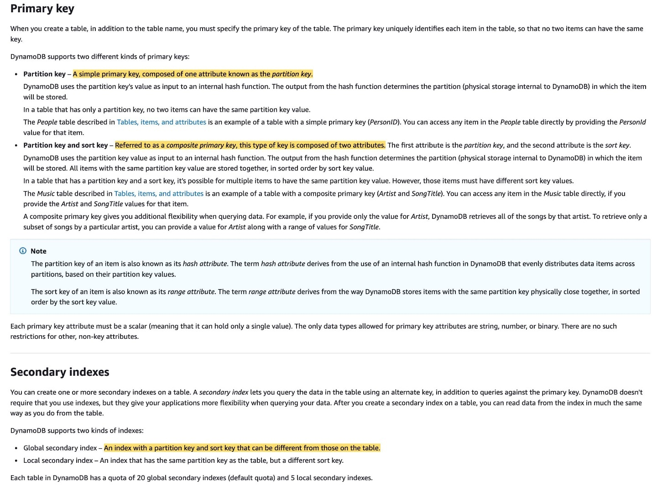 via - <https://docs.aws.amazon.com/amazondynamodb/latest/developerguide/HowItWorks.CoreComponents.html>

You should note that a global secondary index (GSI) contains a selection of attributes from the base table, but they are organized by a primary key that is different from that of the table. The Global secondary indexes allow you to perform queries on attributes that are not part of the table's primary key.

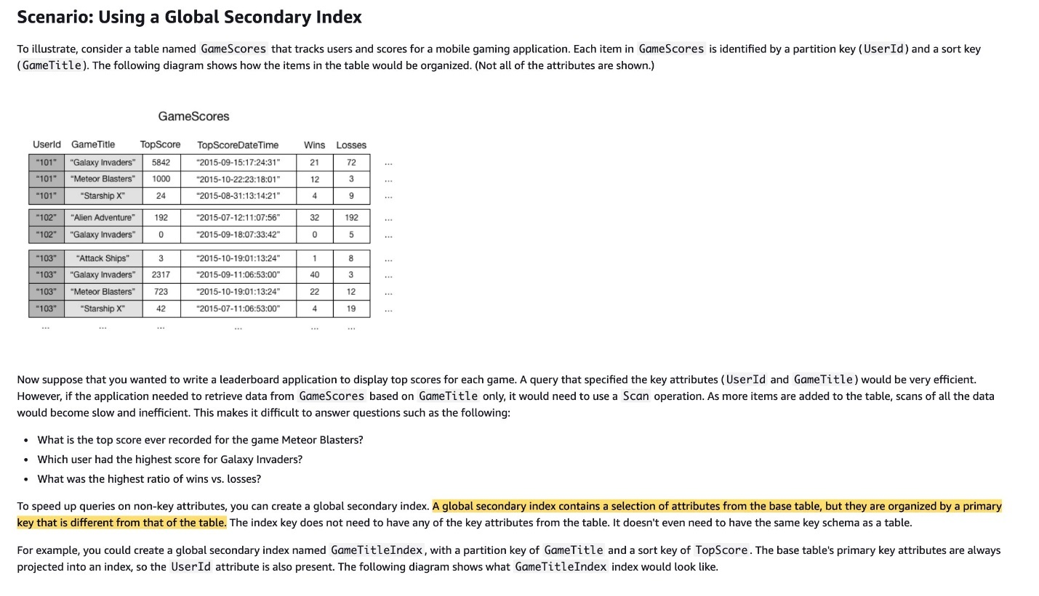 via - <https://docs.aws.amazon.com/amazondynamodb/latest/developerguide/GSI.html>

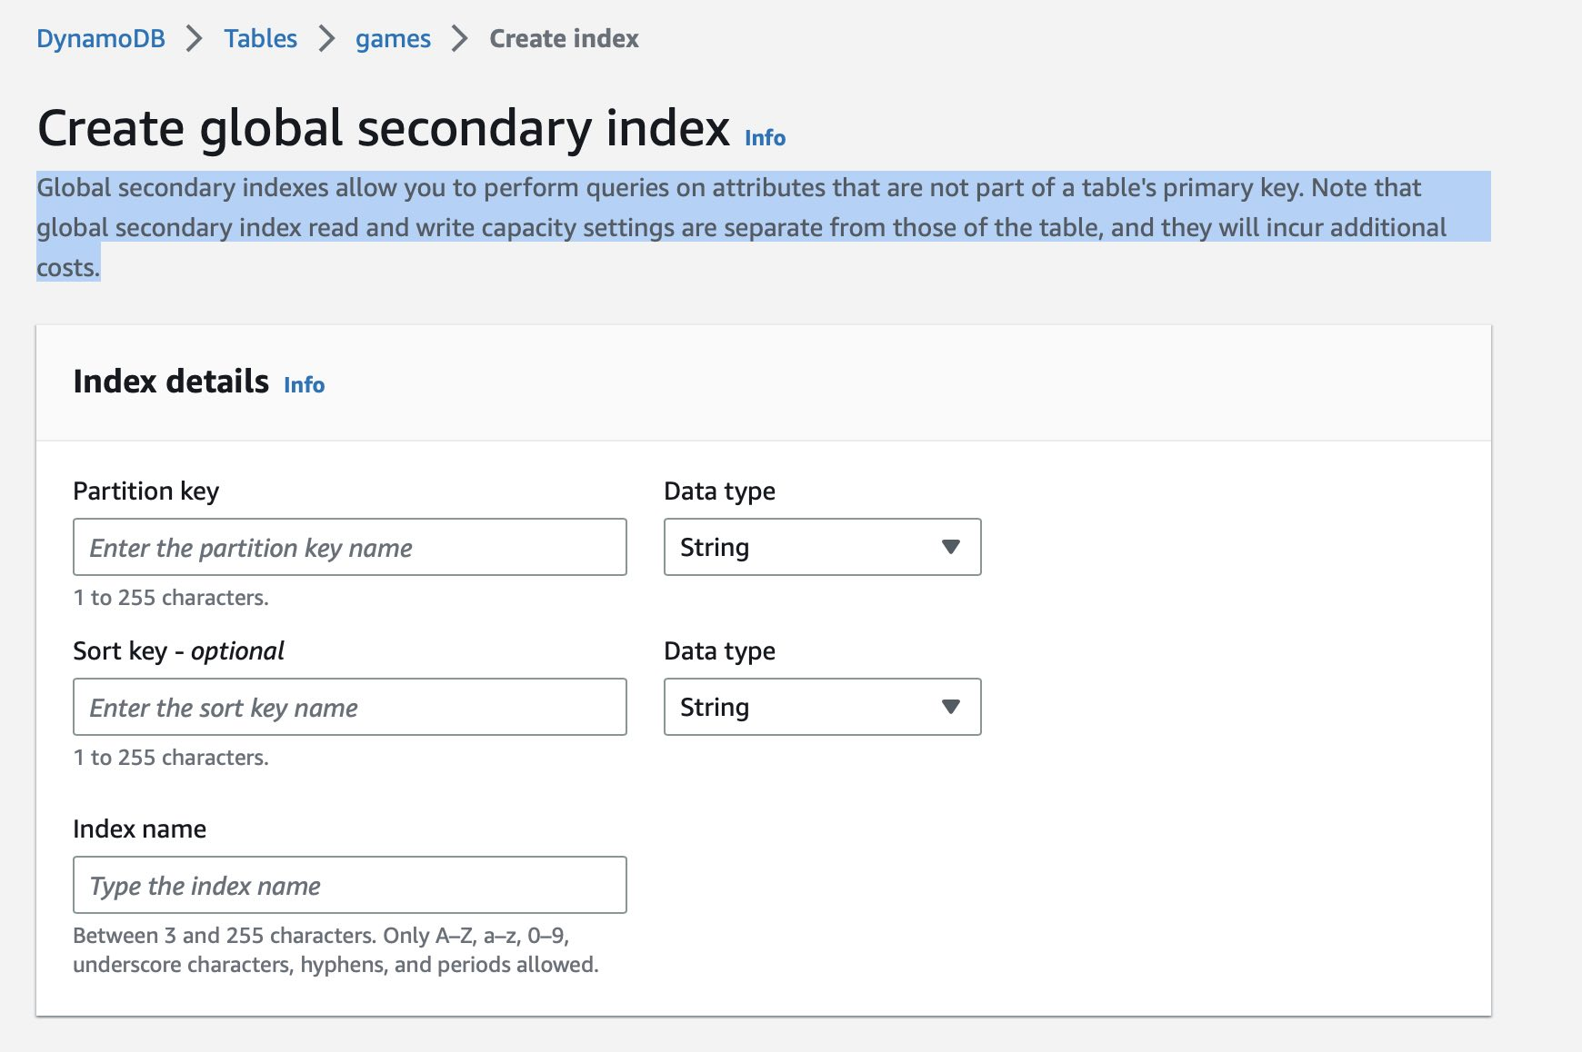

Incorrect options:

**Set up an Amazon DynamoDB table with a primary key that consists of the category as the partition key and the version number as the sort key. Create a global secondary index that has the name as the partition key** - The DynamoDB table for this option has the primary key and GSI that do not solve for the condition - "For a given name and version number, get all details about the game that has that name and version number". This option does not allow for efficient querying of a specific game by its name and version number as you need multiple queries which would be less efficient than the single query allowed by the correct option.

**Set up an Amazon RDS MySQL instance having a games table that contains columns for name, version number, and category. Configure the name column as the primary key** - This option is not the right fit as it does not allow you to efficiently query on the version number and category columns.

**Permanently store the name, version number, and category information about the games in an Amazon Elasticache for Memcached instance** - You cannot use Elasticache for Memcached to permanently store values meant to be persisted in a database (relational or NoSQL). Elasticache is a caching layer. So this option is incorrect.

References:

<https://docs.aws.amazon.com/amazondynamodb/latest/developerguide/HowItWorks.CoreComponents.html>

<https://docs.aws.amazon.com/amazondynamodb/latest/developerguide/GSI.html>

<https://aws.amazon.com/premiumsupport/knowledge-center/primary-key-dynamodb-table/>

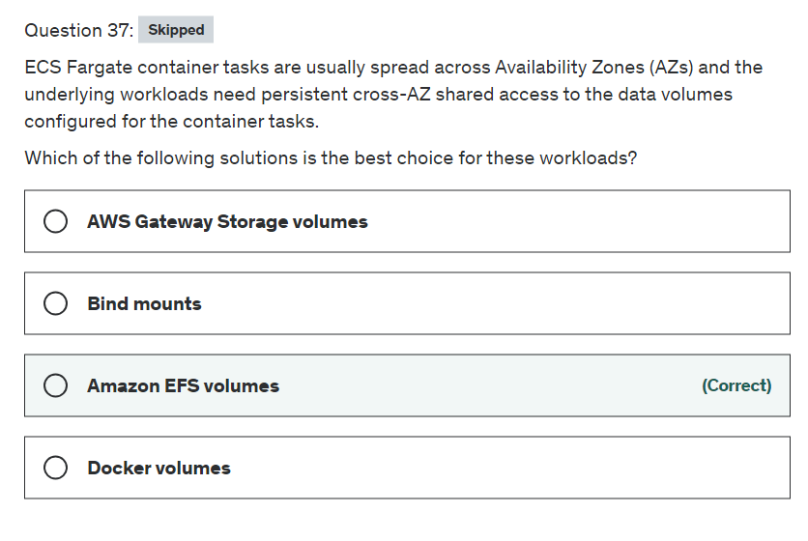

Explanation

Correct option:

**Amazon EFS volumes** - EFS volumes provide a simple, scalable, and persistent file storage for use with your Amazon ECS tasks. With Amazon EFS, storage capacity is elastic, growing and shrinking automatically as you add and remove files. Your applications can have the storage they need, when they need it. Amazon EFS volumes are supported for tasks hosted on Fargate or Amazon EC2 instances.

You can use Amazon EFS file systems with Amazon ECS to export file system data across your fleet of container instances. That way, your tasks have access to the same persistent storage, no matter the instance on which they land. However, you must configure your container instance AMI to mount the Amazon EFS file system before the Docker daemon starts. Also, your task definitions must reference volume mounts on the container instance to use the file system.

Incorrect options:

**Docker volumes** - A Docker-managed volume that is created under /var/lib/docker/volumes on the host Amazon EC2 instance. Docker volume drivers (also referred to as plugins) are used to integrate the volumes with external storage systems, such as Amazon EBS. The built-in local volume driver or a third-party volume driver can be used. Docker volumes are only supported when running tasks on Amazon EC2 instances.

**Bind mounts** - A file or directory on the host, such as an Amazon EC2 instance or AWS Fargate, is mounted into a container. Bind mount host volumes are supported for tasks hosted on Fargate or Amazon EC2 instances. Bind mounts provide temporary storage, and hence these are a wrong choice for this use case.

**AWS Storage Gateway volumes** - This is an incorrect choice, given only as a distractor.

Reference:

<https://docs.aws.amazon.com/AmazonECS/latest/developerguide/using_data_volumes.html>

<https://aws.amazon.com/blogs/containers/amazon-ecs-availability-best-practices/>

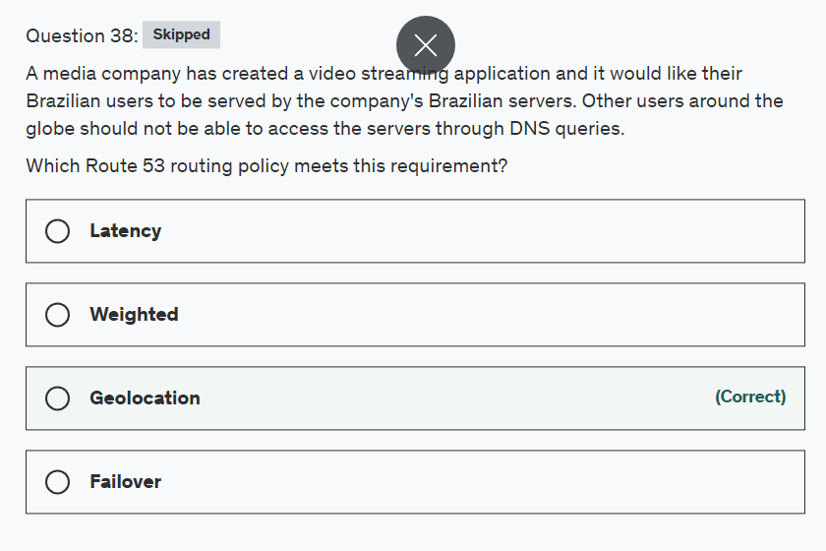

Explanation

Correct option:

**Geolocation**

Geolocation routing lets you choose the resources that serve your traffic based on the geographic location of your users, meaning the location that DNS queries originate from. For example, you might want all queries from Europe to be routed to an ELB load balancer in the Frankfurt region. You can also use geolocation routing to restrict distribution of content to only the locations in which you have distribution rights

You can create a default record that handles both queries from IP addresses that aren't mapped to any location and queries that come from locations that you haven't created geolocation records for. If you don't create a default record, Route 53 returns a "no answer" response for queries from those locations.

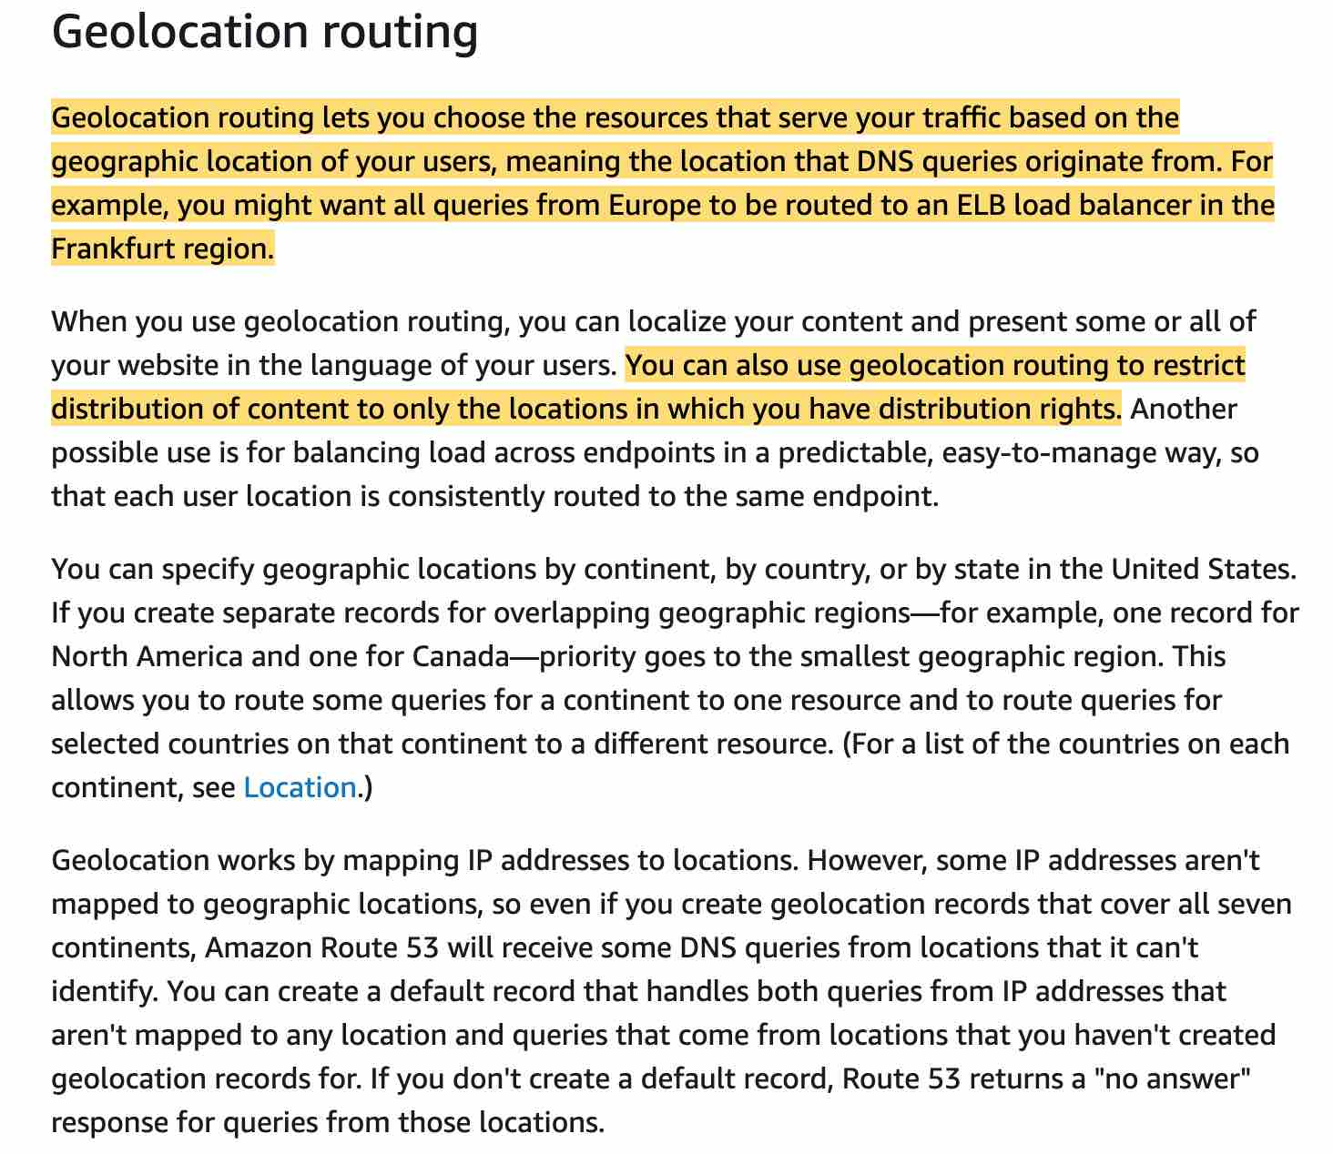

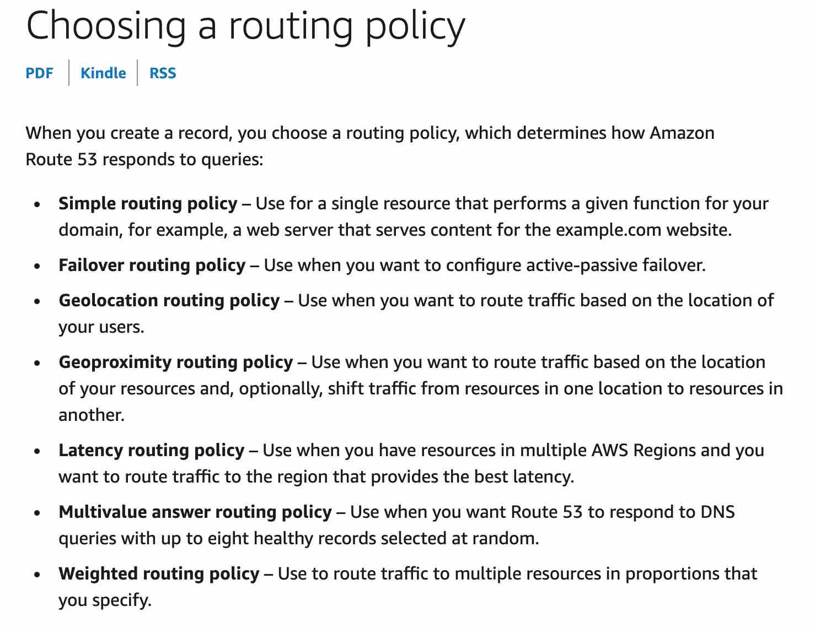

via - <https://docs.aws.amazon.com/Route53/latest/DeveloperGuide/routing-policy.html>

Incorrect options:

**Failover** - Failover routing lets you route traffic to a resource when the resource is healthy or to a different resource when the first resource is unhealthy.

**Latency** - If your application is hosted in multiple AWS Regions, you can improve performance for your users by serving their requests from the AWS Region that provides the lowest latency.

**Weighted** - Use this policy to route traffic to multiple resources in proportions that you specify.

Reference:

<https://docs.aws.amazon.com/Route53/latest/DeveloperGuide/routing-policy.html>

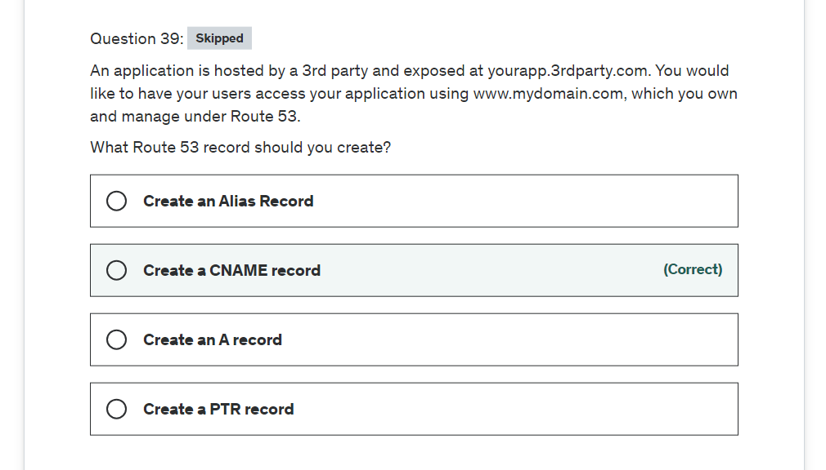

Explanation

Correct option:

**Create a CNAME record**

A CNAME record maps DNS queries for the name of the current record, such as acme.example.com, to another domain (example.com or example.net) or subdomain (acme.example.com or zenith.example.org).

CNAME records can be used to map one domain name to another. Although you should keep in mind that the DNS protocol does not allow you to create a CNAME record for the top node of a DNS namespace, also known as the zone apex. For example, if you register the DNS name example.com, the zone apex is example.com. You cannot create a CNAME record for example.com, but you can create CNAME records for www.example.com, newproduct.example.com, and so on.

Please review the major differences between CNAME and Alias Records: 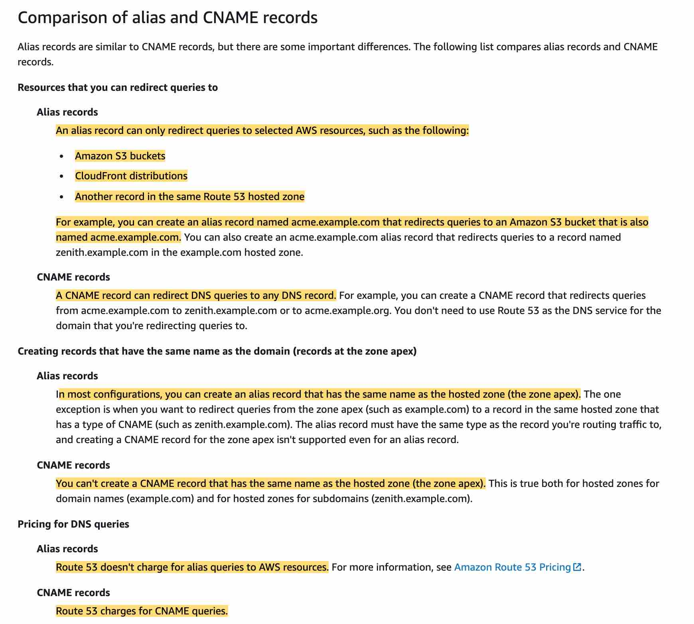 via - <https://docs.aws.amazon.com/Route53/latest/DeveloperGuide/resource-record-sets-choosing-alias-non-alias.html>

Incorrect options:

**Create an A record** - Used to point a domain or subdomain to an IP address. 'A record' cannot be used to map one domain name to another.

**Create a PTR record** - A Pointer (PTR) record resolves an IP address to a fully-qualified domain name (FQDN) as an opposite to what A record does. PTR records are also called Reverse DNS records. 'PTR record' cannot be used to map one domain name to another.

**Create an Alias Record** - Alias records let you route traffic to selected AWS resources, such as CloudFront distributions and Amazon S3 buckets. They also let you route traffic from one record in a hosted zone to another record. 3rd party websites do not qualify for these as we have no control over those. 'Alias record' cannot be used to map one domain name to another.

Reference:

<https://docs.aws.amazon.com/Route53/latest/DeveloperGuide/resource-record-sets-choosing-alias-non-alias.html>

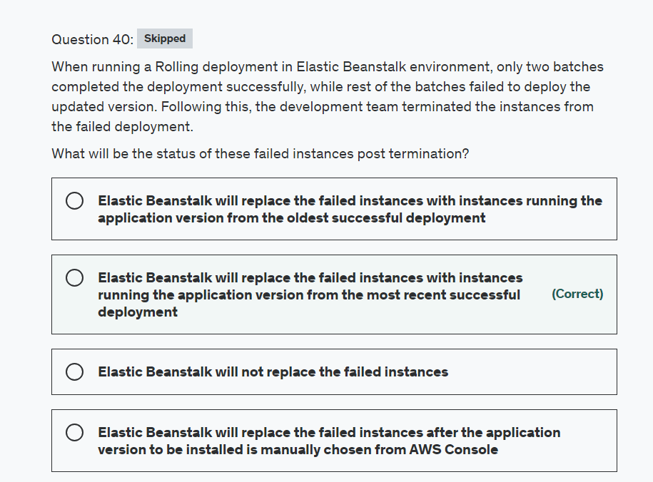

Explanation

Correct option:

**Elastic Beanstalk will replace them with instances running the application version from the most recent successful deployment**

When processing a batch, Elastic Beanstalk detaches all instances in the batch from the load balancer, deploys the new application version, and then reattaches the instances. If you enable connection draining, Elastic Beanstalk drains existing connections from the Amazon EC2 instances in each batch before beginning the deployment.

If a deployment fails after one or more batches completed successfully, the completed batches run the new version of your application while any pending batches continue to run the old version. You can identify the version running on the instances in your environment on the health page in the console. This page displays the deployment ID of the most recent deployment that was executed on each instance in your environment. If you terminate instances from the failed deployment, Elastic Beanstalk replaces them with instances running the application version from the most recent successful deployment.

Incorrect options:

**Elastic Beanstalk will not replace the failed instances**

**Elastic Beanstalk will replace the failed instances with instances running the application version from the oldest successful deployment**

**Elastic Beanstalk will replace the failed instances after the application version to be installed is manually chosen from AWS Console**

These three options contradict the explanation provided above, so these options are incorrect.

Reference:

<https://docs.aws.amazon.com/elasticbeanstalk/latest/dg/using-features.rolling-version-deploy.html>

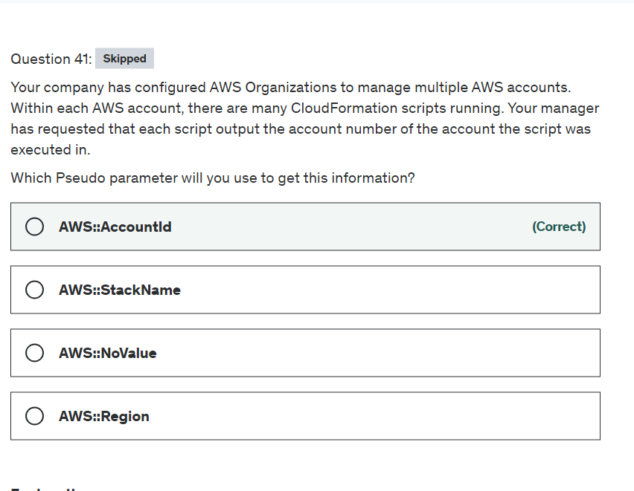

Explanation

Correct option:

**AWS::AccountId**

Using CloudFormation, you can create a template that describes all the AWS resources that you want (like Amazon EC2 instances or Amazon RDS DB instances), and AWS CloudFormation takes care of provisioning and configuring those resources for you.

Pseudo parameters are parameters that are predefined by AWS CloudFormation. You do not declare them in your template. Use them the same way as you would a parameter, as the argument for the Ref function.

AWS::AccountId returns the AWS account ID of the account in which the stack is being created.

Incorrect options:

**AWS::NoValue** - This removes the corresponding resource property when specified as a return value in the Fn::If intrinsic function.

**AWS::Region** - Returns a string representing the AWS Region in which the encompassing resource is being created, such as us-west-2.

**AWS::StackName** - Returns the name of the stack as specified with the aws cloudformation create-stack command, such as "teststack".

Reference:

<https://docs.aws.amazon.com/AWSCloudFormation/latest/UserGuide/pseudo-parameter-reference.html>

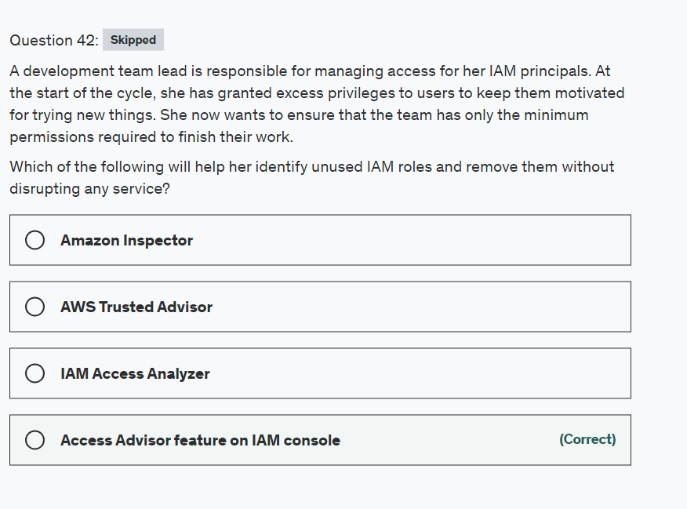

Explanation

Correct option:

**Access Advisor feature on IAM console**- To help identify the unused roles, IAM reports the last-used timestamp that represents when a role was last used to make an AWS request. Your security team can use this information to identify, analyze, and then confidently remove unused roles. This helps improve the security posture of your AWS environments. Additionally, by removing unused roles, you can simplify your monitoring and auditing efforts by focusing only on roles that are in use.

Incorrect options:

**AWS Trusted Advisor** - AWS Trusted Advisor is an online tool that provides you real-time guidance to help you provision your resources following AWS best practices on cost optimization, security, fault tolerance, service limits, and performance improvement.

**IAM Access Analyzer** - AWS IAM Access Analyzer helps you identify the resources in your organization and accounts, such as Amazon S3 buckets or IAM roles, that are shared with an external entity. This lets you identify unintended access to your resources and data, which is a security risk.

**Amazon Inspector** - Amazon Inspector is an automated security assessment service that helps improve the security and compliance of applications deployed on AWS. Amazon Inspector automatically assesses applications for exposure, vulnerabilities, and deviations from best practices.

Reference:

<https://docs.aws.amazon.com/IAM/latest/UserGuide/access_policies_access-advisor-view-data.html>

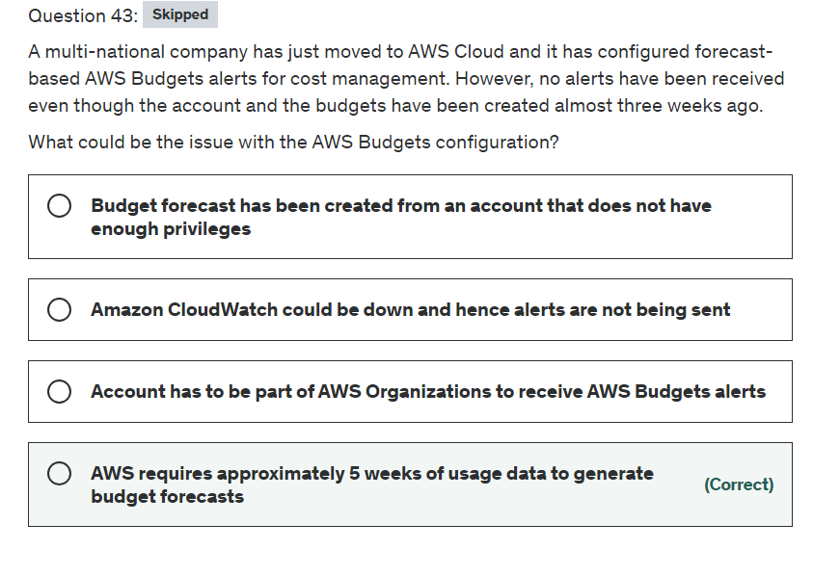

Explanation

Correct option:

AWS Budgets lets customers set custom budgets and receive alerts if their costs or usage exceed (or are forecasted to exceed) their budgeted amount.

**AWS requires approximately 5 weeks of usage data to generate budget forecasts** - AWS requires approximately 5 weeks of usage data to generate budget forecasts. If you set a budget to alert based on a forecasted amount, this budget alert isn't triggered until you have enough historical usage information.

Incorrect options:

**Budget forecast has been created from an account that does not have enough privileges** - This is an incorrect statement. If the user account does not have enough privileges, the user will not be able to create the budget at all.

**Amazon CloudWatch could be down and hence alerts are not being sent** - Amazon CloudWatch is fully managed by AWS, this option has been added as a distractor.

**Account has to be part of AWS Organizations to receive AWS Budget alerts** - This is an incorrect statement. Stand-alone accounts too can create budgets and being part of an Organization is not mandatory to use AWS Budgets.

Reference:

<https://docs.aws.amazon.com/awsaccountbilling/latest/aboutv2/budgets-best-practices.html>

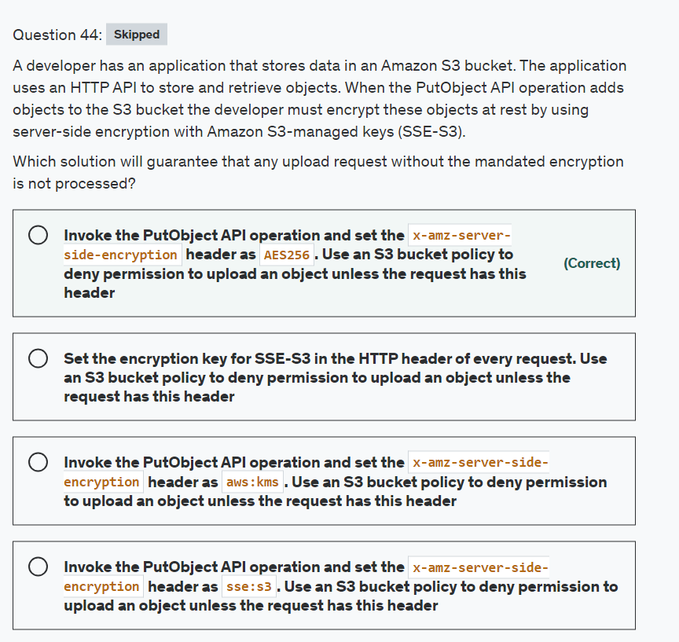

Explanation

Correct option:

**Invoke the PutObject API operation and set the x-amz-server-side-encryption header as AES256. Use an S3 bucket policy to deny permission to upload an object unless the request has this header**

SSE-S3 server-side encryption protects data at rest. Amazon S3 encrypts each object with a unique key. As an additional safeguard, it encrypts the key itself with a key that it rotates regularly. Amazon S3 server-side encryption uses one of the strongest block ciphers available to encrypt your data, 256-bit Advanced Encryption Standard (AES-256).

You can use the following bucket policy to deny permissions to upload an object unless the request includes the x-amz-server-side-encryption header to request server-side encryption using SSE-S3:

{

"Version": "2012-10-17",

"Id": "PutObjectPolicy",

"Statement": [

{

"Sid": "DenyIncorrectEncryptionHeader",

"Effect": "Deny",

"Principal": "*",

"Action": "s3:PutObject",

"Resource": "arn:aws:s3:::DOC-EXAMPLE-BUCKET/*",

"Condition": {

"StringNotEquals": {

"s3:x-amz-server-side-encryption": "AES256"

}

}

},

{

"Sid": "DenyUnencryptedObjectUploads",

"Effect": "Deny",

"Principal": "*",

"Action": "s3:PutObject",

"Resource": "arn:aws:s3:::DOC-EXAMPLE-BUCKET/*",

"Condition": {

"Null": {

"s3:x-amz-server-side-encryption": "true"

}

}

}

]

}

Incorrect options:

**Invoke the PutObject API operation and set the x-amz-server-side-encryption header as aws:kms. Use an S3 bucket policy to deny permission to upload an object unless the request has this header** - As mentioned above, you need to use AES256 rather than aws:kms for the given use case. aws:kms is used when you want to use server-side encryption with AWS KMS (SSE-KMS).

**Invoke the PutObject API operation and set the x-amz-server-side-encryption header as sse:s3. Use an S3 bucket policy to deny permission to upload an object unless the request has this header** - This is a made-up option as the x-amz-server-side-encryption header has no such value as sse:s3.

**Set the encryption key for SSE-S3 in the HTTP header of every request. Use an S3 bucket policy to deny permission to upload an object unless the request has this header** - This option has been added as a distractor. For SSE-S3, Amazon S3 encrypts each object with a unique key. As an additional safeguard, it encrypts the key itself with a key that it rotates regularly. The encryption key for SSE-S3 encryption key cannot be accessed.

References:

<https://docs.aws.amazon.com/AmazonS3/latest/API/API_PutObject.html>

<https://docs.aws.amazon.com/AmazonS3/latest/userguide/UsingServerSideEncryption.html>

<https://docs.aws.amazon.com/AmazonS3/latest/userguide/UsingKMSEncryption.html>

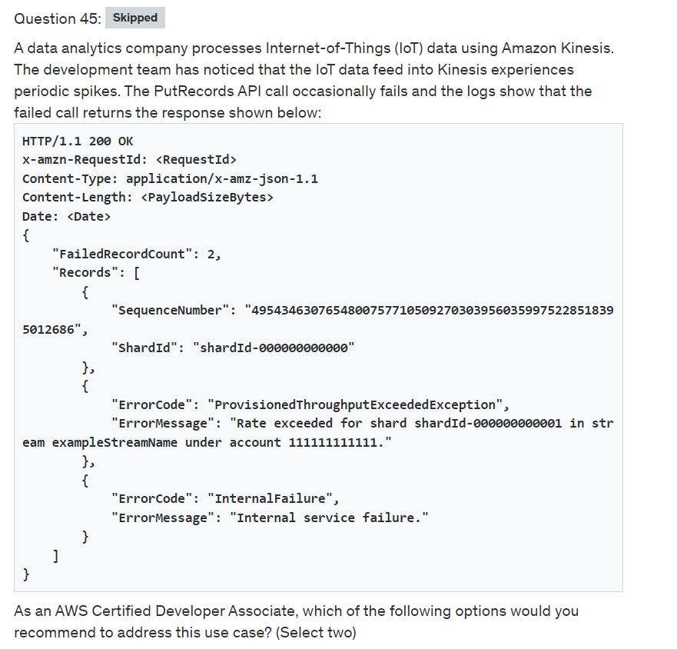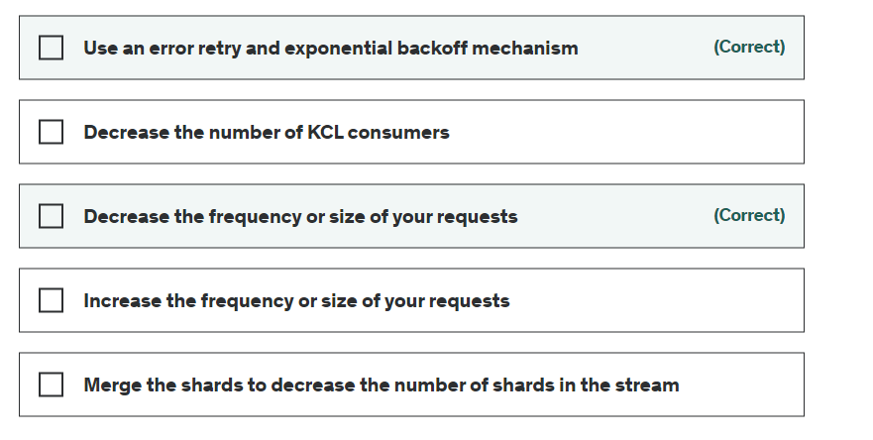

Explanation

Correct options:

**Use an error retry and exponential backoff mechanism**

**Decrease the frequency or size of your requests**

You can use PutRecords API call to write multiple data records into a Kinesis data stream in a single call. Each PutRecords request can support up to 500 records. Each record in the request can be as large as 1 MiB, up to a limit of 5 MiB for the entire request, including partition keys. Each shard can support writes up to 1,000 records per second, up to a maximum data write of 1 MiB per second.

The response Records array includes both successfully and unsuccessfully processed records. Kinesis Data Streams attempts to process all records in each PutRecords request. A single record failure does not stop the processing of subsequent records. As a result, PutRecords doesn't guarantee the ordering of records. An unsuccessfully processed record includes ErrorCode and ErrorMessage values. ErrorCode reflects the type of error and can be one of the following values: ProvisionedThroughputExceededException or InternalFailure. ProvisionedThroughputExceededException indicates that the request rate for the stream is too high, or the requested data is too large for the available throughput. Reduce the frequency or size of your requests.

To address the given use case, you can apply these best practices:

Reshard your stream to increase the number of shards in the stream.

Reduce the frequency or size of your requests.

Distribute read and write operations as evenly as possible across all of the shards in Data Streams.

Use an error retry and exponential backoff mechanism.

Incorrect options:

**Merge the shards to decrease the number of shards in the stream**

**Increase the frequency or size of your requests**

These two options contradict the explanation provided above, so these options are incorrect.

**Decrease the number of KCL consumers** - This option has been added as a distractor. The number of KCL consumers is irrelevant for the given use case since the ProvisionedThroughputExceededException is due to the PutRecords API call being used by the producers.

References:

<https://aws.amazon.com/premiumsupport/knowledge-center/kinesis-readprovisionedthroughputexceeded/>

<https://docs.aws.amazon.com/kinesis/latest/APIReference/API_PutRecords.html>

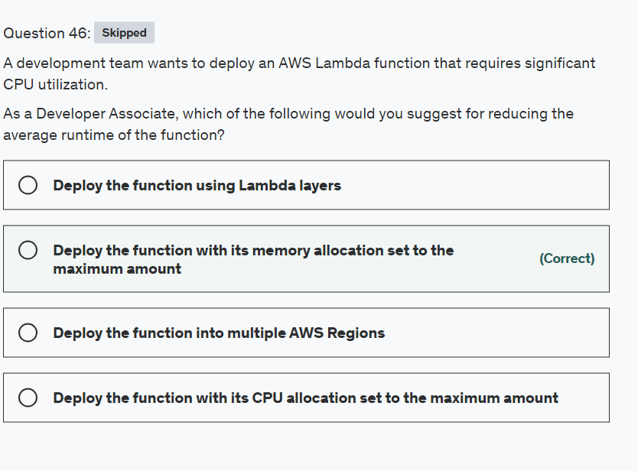

Explanation

Correct option:

**Deploy the function with its memory allocation set to the maximum amount** - Lambda allocates CPU power in proportion to the amount of memory configured. Memory is the amount of memory available to your Lambda function at runtime. You can increase or decrease the memory and CPU power allocated to your function using the Memory (MB) setting. To configure the memory for your function, set a value between 128 MB and 10,240 MB in 1-MB increments. At 1,769 MB, a function has the equivalent of one vCPU (one vCPU-second of credits per second).

Configuring function memory from AWS console: 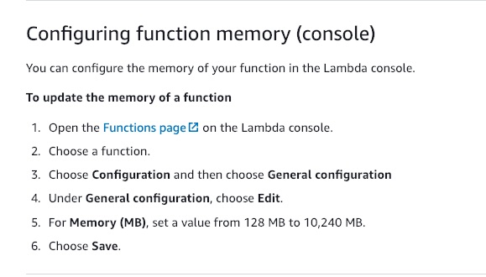 via - <https://docs.aws.amazon.com/lambda/latest/dg/configuration-memory.html>

Incorrect options:

**Deploy the function into multiple AWS Regions** - Deploying the Lambda function to multiple AWS Regions does not increase the compute capacity or CPU utilization capacity of Lambda. So, this option is irrelevant.

**Deploy the function using Lambda layers** - A Lambda layer is a .zip file archive that can contain additional code or data. A layer can contain libraries, a custom runtime, data, or configuration files. Layers promote code sharing and separation of responsibilities so that you can iterate faster on writing business logic. Layers do not increase the computational capacity of Lambda.

**Deploy the function with its CPU allocation set to the maximum amount** - This statement is given as a distractor. CPU allocation is an invalid parameter. As discussed above, the CPU is allocated in proportion to the memory allocated to the function.

References:

<https://docs.aws.amazon.com/lambda/latest/dg/configuration-memory.html>

<https://docs.aws.amazon.com/lambda/latest/dg/configuration-layers.html>

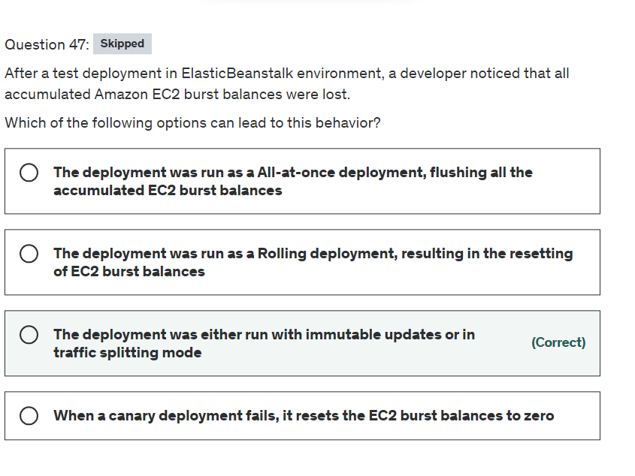

**Explanation**

Correct option:

**The deployment was either run with immutable updates or in traffic splitting mode** - Immutable deployments perform an immutable update to launch a full set of new instances running the new version of the application in a separate Auto Scaling group, alongside the instances running the old version. Immutable deployments can prevent issues caused by partially completed rolling deployments.

Traffic-splitting deployments let you perform canary testing as part of your application deployment. In a traffic-splitting deployment, Elastic Beanstalk launches a full set of new instances just like during an immutable deployment. It then forwards a specified percentage of incoming client traffic to the new application version for a specified evaluation period.

Some policies replace all instances during the deployment or update. This causes all accumulated Amazon EC2 burst balances to be lost. It happens in the following cases:

Managed platform updates with instance replacement enabled

Immutable updates

Deployments with immutable updates or traffic splitting enabled

Incorrect options:

**The deployment was run as a Rolling deployment, resulting in the resetting of EC2 burst balances** - With rolling deployments, Elastic Beanstalk splits the environment's Amazon EC2 instances into batches and deploys the new version of the application to one batch at a time. Rolling deployments do not result in loss of EC2 burst balances.

**The deployment was run as a All-at-once deployment, flushing all the accumulated EC2 burst balances** - The traditional All-at-once deployment, wherein all the instances are updated simultaneously, does not result in loss of EC2 burst balances.

**When a canary deployment fails, it resets the EC2 burst balances to zero** - This is incorrect and given only as a distractor.

Reference:

<https://docs.aws.amazon.com/elasticbeanstalk/latest/dg/using-features.rolling-version-deploy.html>

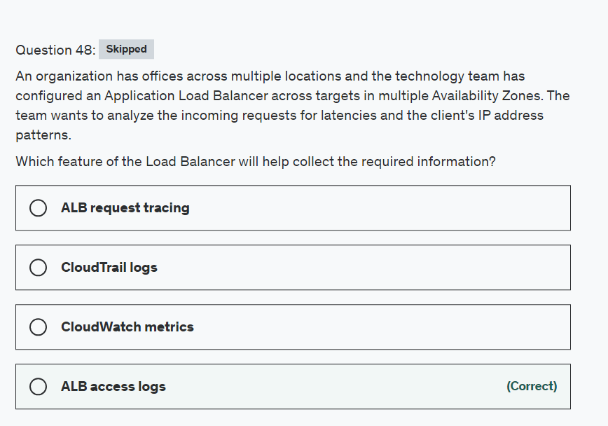

Explanation

Correct option:

**ALB access logs** - Elastic Load Balancing provides access logs that capture detailed information about requests sent to your load balancer. Each log contains information such as the time the request was received, the client's IP address, latencies, request paths, and server responses. You can use these access logs to analyze traffic patterns and troubleshoot issues. Access logging is an optional feature of Elastic Load Balancing that is disabled by default.

Access logs for your Application Load Balancer: 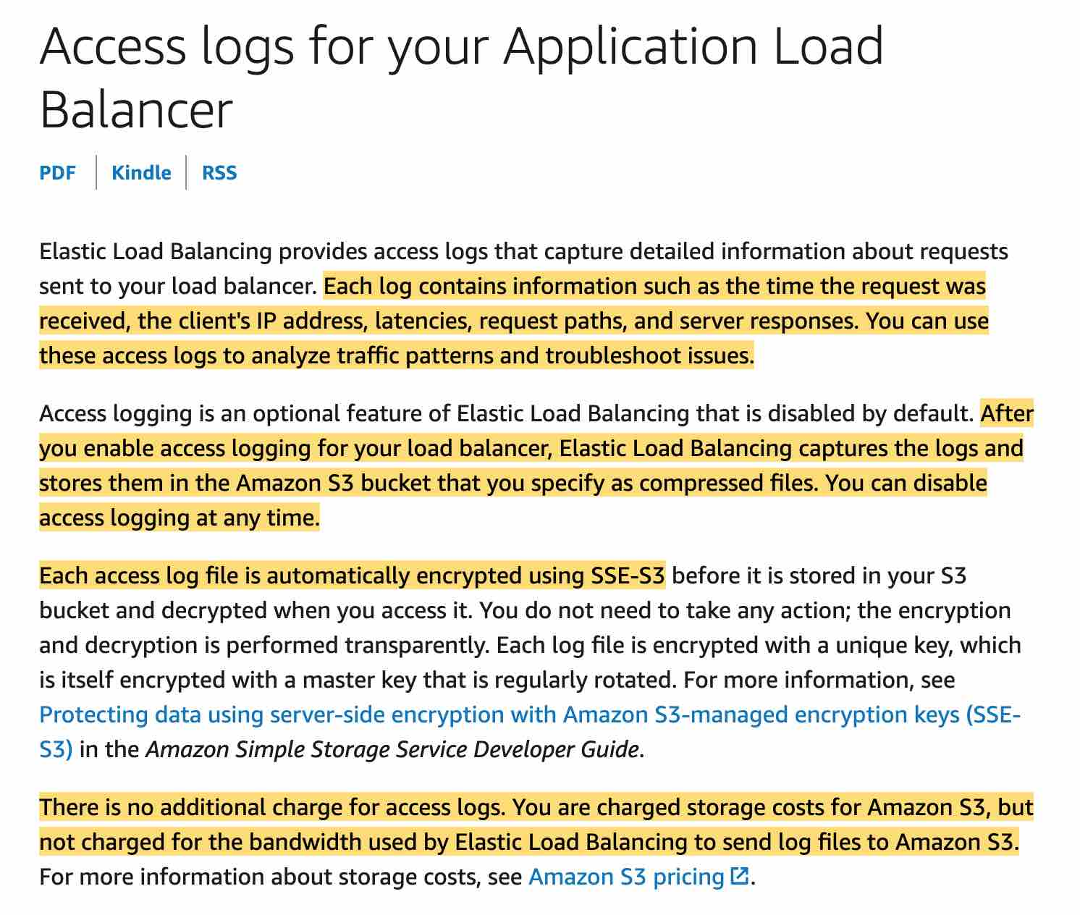 via - <https://docs.aws.amazon.com/elasticloadbalancing/latest/application/load-balancer-access-logs.html>

Incorrect options:

**CloudTrail logs** - Elastic Load Balancing is integrated with AWS CloudTrail, a service that provides a record of actions taken by a user, role, or an AWS service in Elastic Load Balancing. CloudTrail captures all API calls for Elastic Load Balancing as events. You can use AWS CloudTrail to capture detailed information about the calls made to the Elastic Load Balancing API and store them as log files in Amazon S3. You can use these CloudTrail logs to determine which API calls were made, the source IP address where the API call came from, who made the call, when the call was made, and so on.

**CloudWatch metrics** - Elastic Load Balancing publishes data points to Amazon CloudWatch for your load balancers and your targets. CloudWatch enables you to retrieve statistics about those data points as an ordered set of time-series data, known as metrics. You can use metrics to verify that your system is performing as expected. This is the right feature if you wish to track a certain metric.

**ALB request tracing** - You can use request tracing to track HTTP requests. The load balancer adds a header with a trace identifier to each request it receives. Request tracing will not help you to analyze latency specific data.

Reference:

<https://docs.aws.amazon.com/elasticloadbalancing/latest/application/load-balancer-monitoring.html>

<https://docs.aws.amazon.com/elasticloadbalancing/latest/application/load-balancer-access-logs.html>

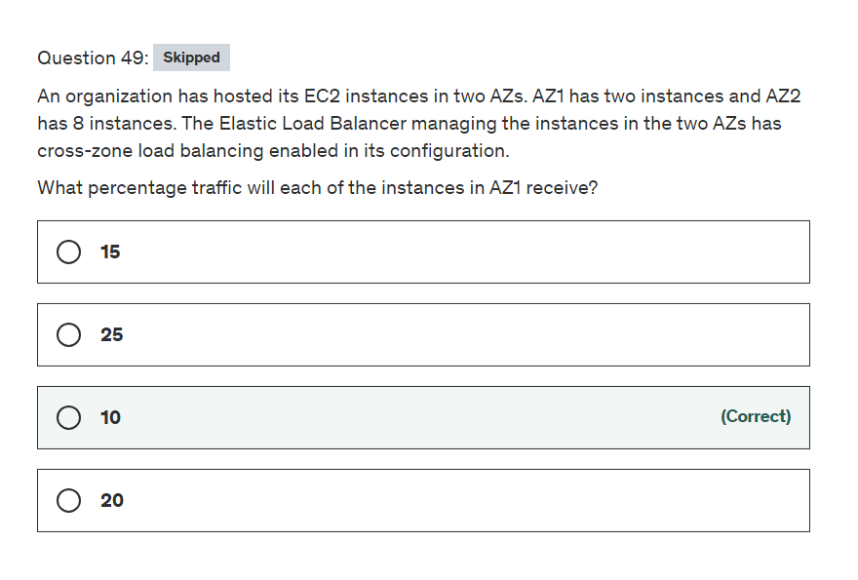

Explanation

Correct option:

A load balancer accepts incoming traffic from clients and routes requests to its registered targets (such as EC2 instances) in one or more Availability Zones.

The nodes for a load balancer distribute requests from clients to registered targets. When cross-zone load balancing is enabled, each load balancer node distributes traffic across the registered targets in all enabled Availability Zones. When cross-zone load balancing is disabled, each load balancer node distributes traffic only across the registered targets in its Availability Zone. With Application Load Balancers, cross-zone load balancing is always enabled.

**10** - When cross-zone load balancing is enabled, each of the 10 targets receives 10% of the traffic. This is because each load balancer node can route its 50% of the client traffic to all 10 targets (present in both AZs).

Cross-Zone Load Balancing Overview: 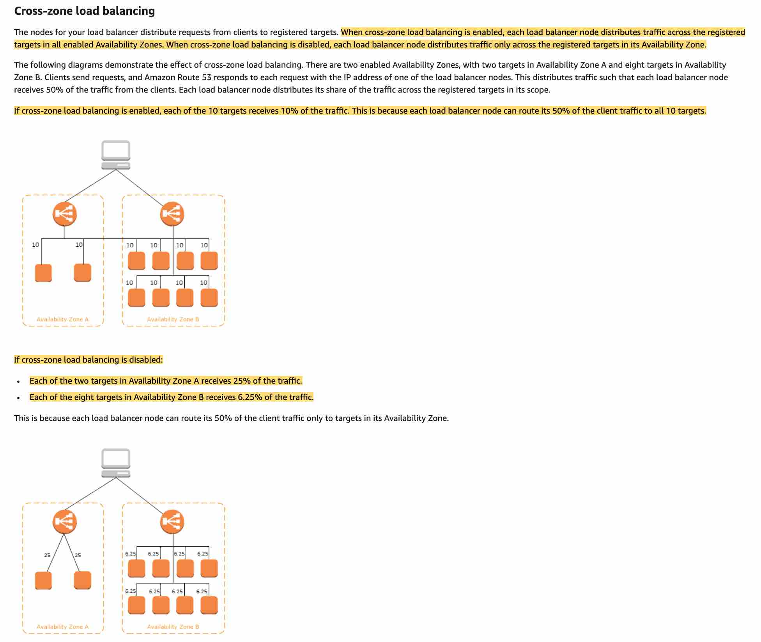 via - <https://docs.aws.amazon.com/elasticloadbalancing/latest/userguide/how-elastic-load-balancing-works.html>

Incorrect options:

**25** - If cross-zone load balancing is disabled, each of the two targets in AZ1 will receive 25% of the traffic. Because the load balancer is only able to send to the targets registered in AZ1 (AZ2 instances are not accessible for load balancer on AZ1)

**20** - Invalid option, given only as a distractor.

**15** - Invalid option, given only as a distractor.

Reference:

<https://docs.aws.amazon.com/elasticloadbalancing/latest/userguide/how-elastic-load-balancing-works.html>

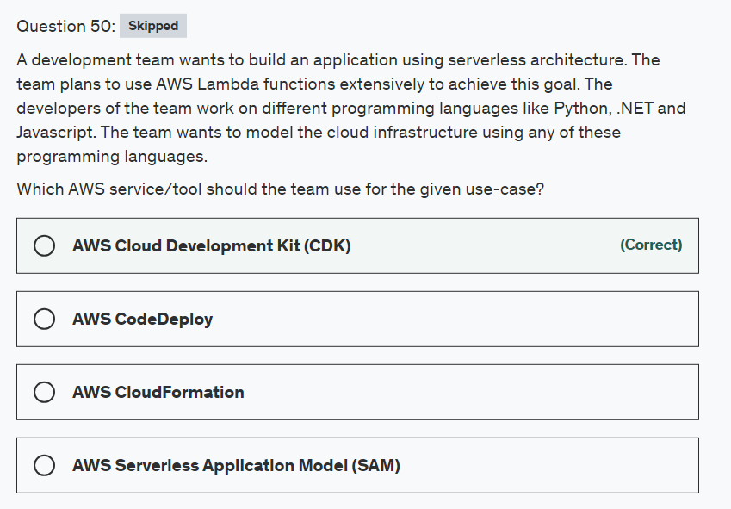

Explanation

Correct option:

**AWS Cloud Development Kit (CDK)** - The AWS Cloud Development Kit (AWS CDK) is an open-source software development framework to define your cloud application resources using familiar programming languages.

Provisioning cloud applications can be a challenging process that requires you to perform manual actions, write custom scripts, maintain templates, or learn domain-specific languages. AWS CDK uses the familiarity and expressive power of programming languages such as JavaScript/TypeScript, Python, Java, and .NET for modeling your applications. It provides you with high-level components called constructs that preconfigure cloud resources with proven defaults, so you can build cloud applications without needing to be an expert. AWS CDK provisions your resources in a safe, repeatable manner through AWS CloudFormation. It also enables you to compose and share your own custom constructs that incorporate your organization's requirements, helping you start new projects faster.

Incorrect options:

**AWS CloudFormation** - When AWS CDK applications are run, they compile down to fully formed CloudFormation JSON/YAML templates that are then submitted to the CloudFormation service for provisioning. Because the AWS CDK leverages CloudFormation, you still enjoy all the benefits CloudFormation provides such as safe deployment, automatic rollback, and drift detection. But, CloudFormation by itself is not sufficient for the current use case.

**AWS Serverless Application Model (SAM)** - The AWS Serverless Application Repository is a managed repository for serverless applications. It enables teams, organizations, and individual developers to store and share reusable applications, and easily assemble and deploy serverless architectures in powerful new ways. Using the Serverless Application Repository, you don't need to clone, build, package, or publish source code to AWS before deploying it.

AWS Serverless Application Model and AWS CDK both abstract AWS infrastructure as code making it easier for you to define your cloud infrastructure. If you prefer defining your serverless infrastructure in concise declarative templates, SAM is the better fit. If you want to define your AWS infrastructure in a familiar programming language, as is the requirement in the current use case, AWS CDK is the right fit.

**AWS CodeDeploy** - AWS CodeDeploy is a fully managed deployment service that automates software deployments to a variety of compute services such as Amazon EC2, AWS Fargate, AWS Lambda, and your on-premises servers. AWS CodeDeploy makes it easier for you to rapidly release new features, helps you avoid downtime during application deployment, and handles the complexity of updating your applications. CodeDeploy can be used with AWS CDK for deployments.

Reference:

<https://aws.amazon.com/cdk/faqs/>

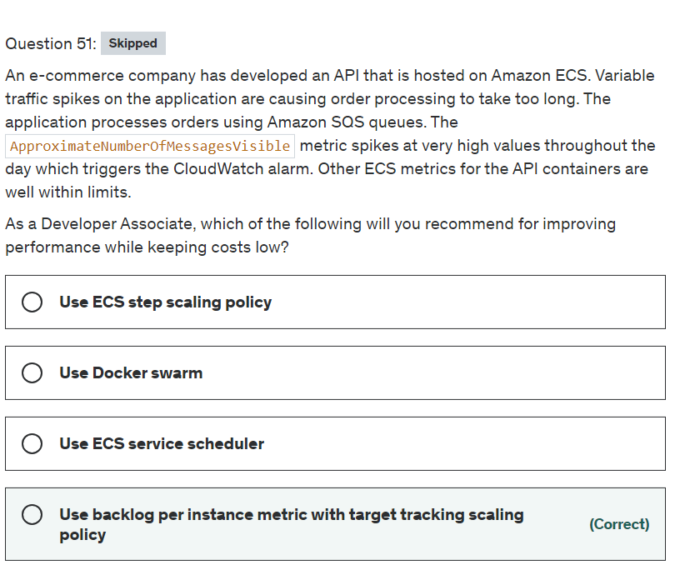

Explanation

Correct option:

**Use backlog per instance metric with target tracking scaling policy** - If you use a target tracking scaling policy based on a custom Amazon SQS queue metric, dynamic scaling can adjust to the demand curve of your application more effectively.

The issue with using a CloudWatch Amazon SQS metric like ApproximateNumberOfMessagesVisible for target tracking is that the number of messages in the queue might not change proportionally to the size of the Auto Scaling group that processes messages from the queue. That's because the number of messages in your SQS queue does not solely define the number of instances needed. The number of instances in your Auto Scaling group can be driven by multiple factors, including how long it takes to process a message and the acceptable amount of latency (queue delay).

The solution is to use a backlog per instance metric with the target value being the acceptable backlog per instance to maintain. You can calculate these numbers as follows:

Backlog per instance: To calculate your backlog per instance, start with the ApproximateNumberOfMessages queue attribute to determine the length of the SQS queue (number of messages available for retrieval from the queue). Divide that number by the fleet's running capacity, which for an Auto Scaling group is the number of instances in the InService state, to get the backlog per instance.

Acceptable backlog per instance: To calculate your target value, first determine what your application can accept in terms of latency. Then, take the acceptable latency value and divide it by the average time that an EC2 instance takes to process a message.

To illustrate with an example, let's say that the current ApproximateNumberOfMessages is 1500 and the fleet's running capacity is 10. If the average processing time is 0.1 seconds for each message and the longest acceptable latency is 10 seconds, then the acceptable backlog per instance is 10 / 0.1, which equals 100. This means that 100 is the target value for your target tracking policy. If the backlog per instance is currently at 150 (1500 / 10), your fleet scales out, and it scales out by five instances to maintain proportion to the target value.

Incorrect options:

**Use Docker swarm** - A Docker swarm is a container orchestration tool, meaning that it allows the user to manage multiple containers deployed across multiple host machines. A swarm consists of multiple Docker hosts which run in swarm mode and act as managers (to manage membership and delegation) and workers (which run swarm services).

**Use ECS service scheduler** - Amazon ECS provides a service scheduler (for long-running tasks and applications), the ability to run tasks manually (for batch jobs or single run tasks), with Amazon ECS placing tasks on your cluster for you. You can specify task placement strategies and constraints that allow you to run tasks in the configuration you choose, such as spread out across Availability Zones. It is also possible to integrate with custom or third-party schedulers.

**Use ECS step scaling policy** - Although Amazon ECS Service Auto Scaling supports using Application Auto Scaling step scaling policies, AWS recommends using target tracking scaling policies instead. For example, if you want to scale your service when CPU utilization falls below or rises above a certain level, create a target tracking scaling policy based on the CPU utilization metric provided by Amazon ECS.

With step scaling policies, you create and manage the CloudWatch alarms that trigger the scaling process. If the target tracking alarms don't work for your use case, you can use step scaling. You can also use target tracking scaling with step scaling for an advanced scaling policy configuration. For example, you can configure a more aggressive response when utilization reaches a certain level.

Step Scaling scales your cluster on various lengths of steps based on different ranges of thresholds. Target tracking on the other hand intelligently picks the smart lengths needed for the given configuration.

References:

<https://docs.aws.amazon.com/autoscaling/ec2/userguide/as-using-sqs-queue.html>

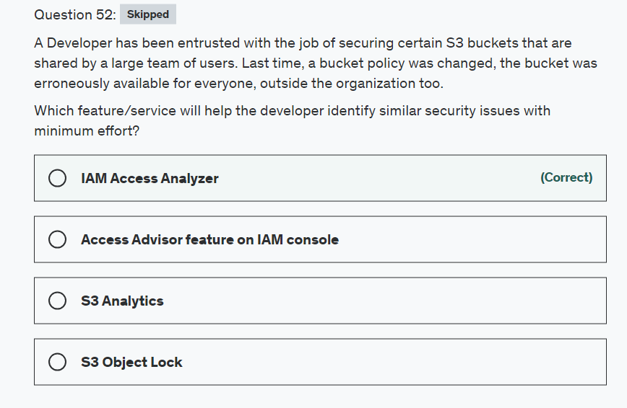

Explanation

Correct option:

**IAM Access Analyzer** - AWS IAM Access Analyzer helps you identify the resources in your organization and accounts, such as Amazon S3 buckets or IAM roles, that are shared with an external entity. This lets you identify unintended access to your resources and data, which is a security risk.

You can set the scope for the analyzer to an organization or an AWS account. This is your zone of trust. The analyzer scans all of the supported resources within your zone of trust. When Access Analyzer finds a policy that allows access to a resource from outside of your zone of trust, it generates an active finding.

Incorrect options:

**Access Advisor feature on IAM console** - To help identify the unused roles, IAM reports the last-used timestamp that represents when a role was last used to make an AWS request. Your security team can use this information to identify, analyze, and then confidently remove unused roles. This helps improve the security posture of your AWS environments. This does not provide information about non-IAM entities such as S3, hence it's not a correct choice here.

**S3 Object Lock** - S3 Object Lock enables you to store objects using a "Write Once Read Many" (WORM) model. S3 Object Lock can help prevent accidental or inappropriate deletion of data, it is not the right choice for the current scenario.

**S3 Analytics** - By using Amazon S3 analytics Storage Class Analysis you can analyze storage access patterns to help you decide when to transition the right data to the right storage class. You cannot use S3 Analytics to identify unintended access to your S3 resources.

References:

<https://docs.aws.amazon.com/IAM/latest/UserGuide/what-is-access-analyzer.html>

<https://docs.aws.amazon.com/AmazonS3/latest/dev/security-best-practices.html>

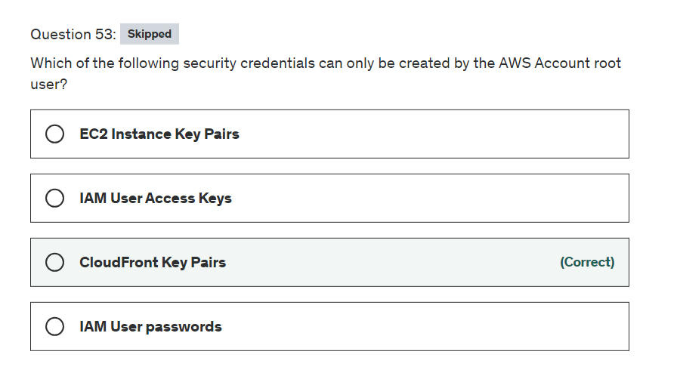

Explanation

Correct option:

For Amazon CloudFront, you use key pairs to create signed URLs for private content, such as when you want to distribute restricted content that someone paid for.

**CloudFront Key Pairs** - IAM users can't create CloudFront key pairs. You must log in using root credentials to create key pairs.

To create signed URLs or signed cookies, you need a signer. A signer is either a trusted key group that you create in CloudFront, or an AWS account that contains a CloudFront key pair. AWS recommends that you use trusted key groups with signed URLs and signed cookies instead of using CloudFront key pairs.

Incorrect options:

**EC2 Instance Key Pairs** - You use key pairs to access Amazon EC2 instances, such as when you use SSH to log in to a Linux instance. These key pairs can be created from the IAM user login and do not need root user access.

**IAM User Access Keys** - Access keys consist of two parts: an access key ID and a secret access key. You use access keys to sign programmatic requests that you make to AWS if you use AWS CLI commands (using the SDKs) or using AWS API operations. IAM users can create their own Access Keys, does not need root access.

**IAM User passwords** - Every IAM user has access to his own credentials and can reset the password whenever they need to.

References:

<https://docs.aws.amazon.com/general/latest/gr/aws-sec-cred-types.html#access-keys-and-secret-access-keys>

<https://docs.aws.amazon.com/AmazonCloudFront/latest/DeveloperGuide/private-content-trusted-signers.html>

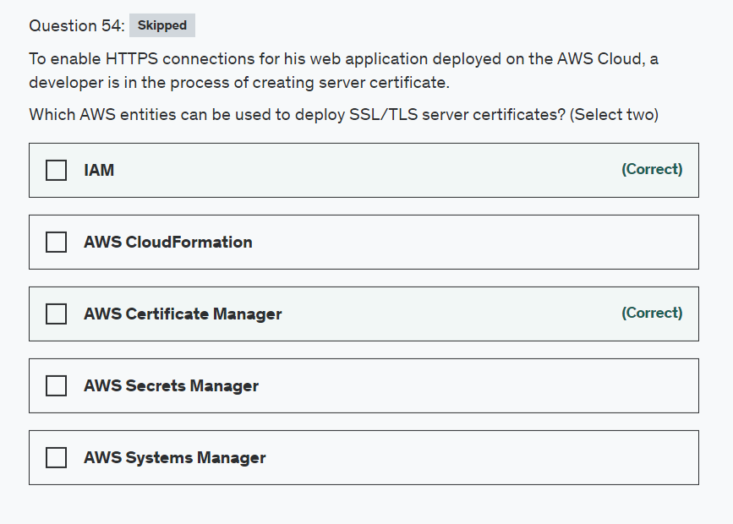

Explanation

Correct options:

**AWS Certificate Manager** - AWS Certificate Manager (ACM) is the preferred tool to provision, manage, and deploy server certificates. With ACM you can request a certificate or deploy an existing ACM or external certificate to AWS resources. Certificates provided by ACM are free and automatically renew. In a supported Region, you can use ACM to manage server certificates from the console or programmatically.

**IAM** - IAM is used as a certificate manager only when you must support HTTPS connections in a Region that is not supported by ACM. IAM securely encrypts your private keys and stores the encrypted version in IAM SSL certificate storage. IAM supports deploying server certificates in all Regions, but you must obtain your certificate from an external provider for use with AWS. You cannot upload an ACM certificate to IAM. Additionally, you cannot manage your certificates from the IAM Console.

Incorrect options:

**AWS Secrets Manager** - AWS Secrets Manager helps you protect secrets needed to access your applications, services, and IT resources. The service enables you to easily rotate, manage, and retrieve database credentials, API keys, and other secrets throughout their lifecycle. Users and applications retrieve secrets with a call to Secrets Manager APIs, eliminating the need to hardcode sensitive information in plain text. It cannot be used to discover and protect your sensitive data in AWS.

**AWS Systems Manager** - AWS Systems Manager gives you visibility and control of your infrastructure on AWS. Systems Manager provides a unified user interface so you can view operational data from multiple AWS services and allows you to automate operational tasks such as running commands, managing patches, and configuring servers across AWS Cloud as well as on-premises infrastructure.

**AWS CloudFormation** - AWS CloudFormation allows you to use programming languages or a simple text file to model and provision, in an automated and secure manner, all the resources needed for your applications across all Regions and accounts. Think infrastructure as code; think CloudFormation. You cannot use CloudFormation for running commands or managing patches on servers.

Reference:

<https://docs.aws.amazon.com/IAM/latest/UserGuide/id_credentials_server-certs.html>

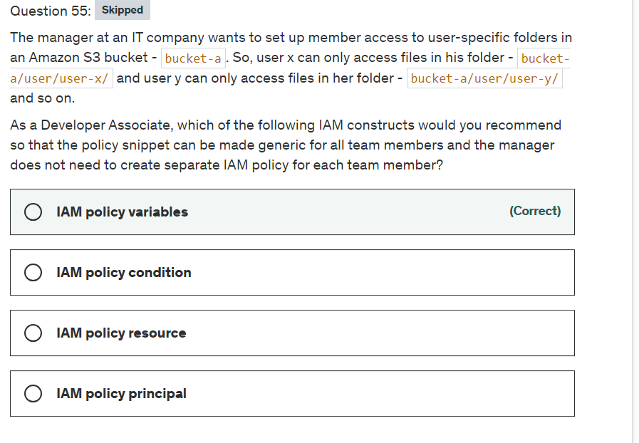

Explanation

Correct option:

**IAM policy variables**

Instead of creating individual policies for each user, you can use policy variables and create a single policy that applies to multiple users (a group policy). Policy variables act as placeholders. When you make a request to AWS, the placeholder is replaced by a value from the request when the policy is evaluated.

As an example, the following policy gives each of the users in the group full programmatic access to a user-specific object (their own "home directory") in Amazon S3.

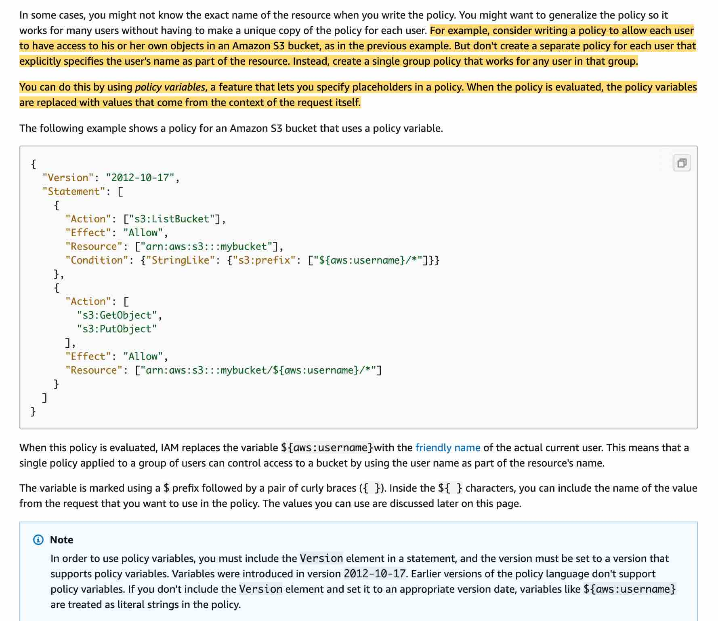 via - <https://docs.aws.amazon.com/IAM/latest/UserGuide/reference_policies_variables.html>

Incorrect options:

**IAM policy principal** - You can use the Principal element in a policy to specify the principal that is allowed or denied access to a resource (In IAM, a principal is a person or application that can make a request for an action or operation on an AWS resource. The principal is authenticated as the AWS account root user or an IAM entity to make requests to AWS). You cannot use the Principal element in an IAM identity-based policy. You can use it in the trust policies for IAM roles and in resource-based policies.

**IAM policy condition** - The Condition element (or Condition block) lets you specify conditions for when a policy is in effect, like so - "Condition" : { "StringEquals" : { "aws:username" : "johndoe" }}. This can not be used to address the requirements of the given use-case.

**IAM policy resource** - The Resource element specifies the object or objects that the statement covers. You specify a resource using an ARN. This can not be used to address the requirements of the given use-case.

Reference:

<https://aws.amazon.com/blogs/security/writing-iam-policies-grant-access-to-user-specific-folders-in-an-amazon-s3-bucket/>

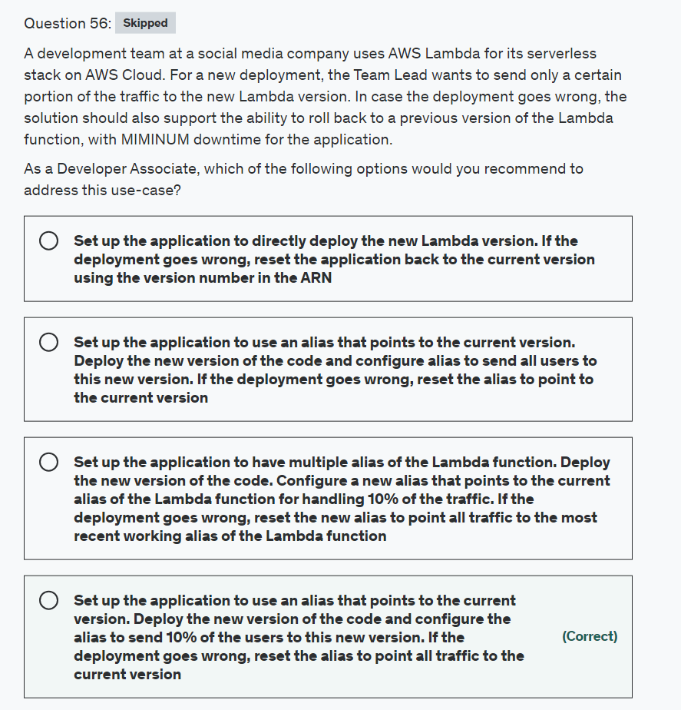

Explanation

Correct option:

**Set up the application to use an alias that points to the current version. Deploy the new version of the code and configure the alias to send 10% of the users to this new version. If the deployment goes wrong, reset the alias to point all traffic to the current version**

You can use versions to manage the deployment of your AWS Lambda functions. For example, you can publish a new version of a function for beta testing without affecting users of the stable production version. You can change the function code and settings only on the unpublished version of a function. When you publish a version, the code and most of the settings are locked to ensure a consistent experience for users of that version.

You can create one or more aliases for your AWS Lambda function. A Lambda alias is like a pointer to a specific Lambda function version. You can use routing configuration on an alias to send a portion of traffic to a Lambda function version. For example, you can reduce the risk of deploying a new version by configuring the alias to send most of the traffic to the existing version, and only a small percentage of traffic to the new version.

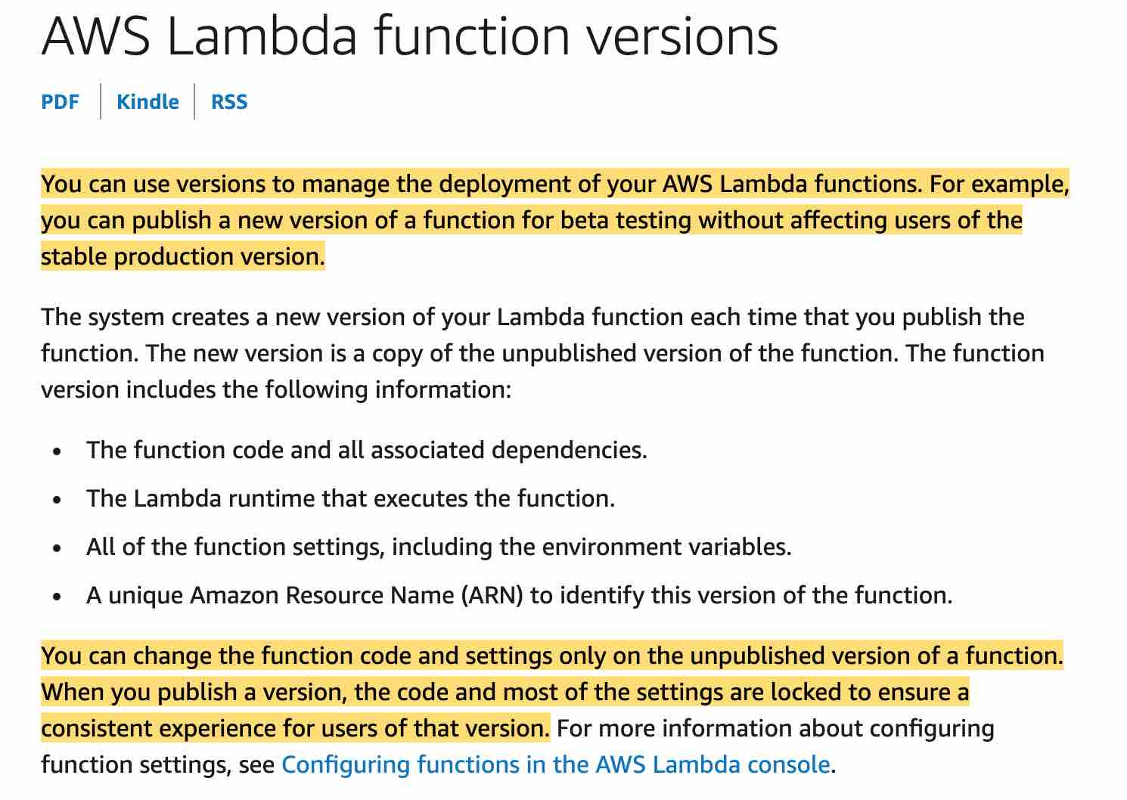 via - <https://docs.aws.amazon.com/lambda/latest/dg/configuration-versions.html>

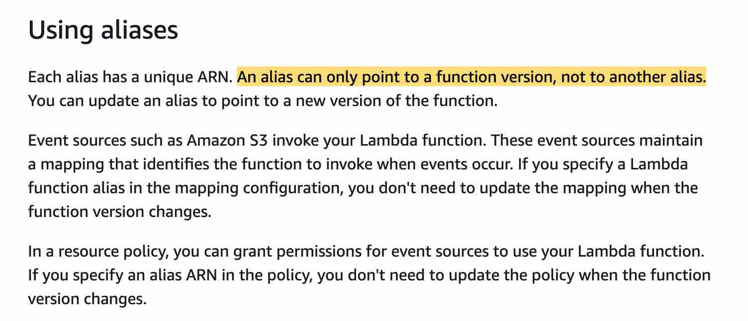 via - <https://docs.aws.amazon.com/lambda/latest/dg/configuration-aliases.html>

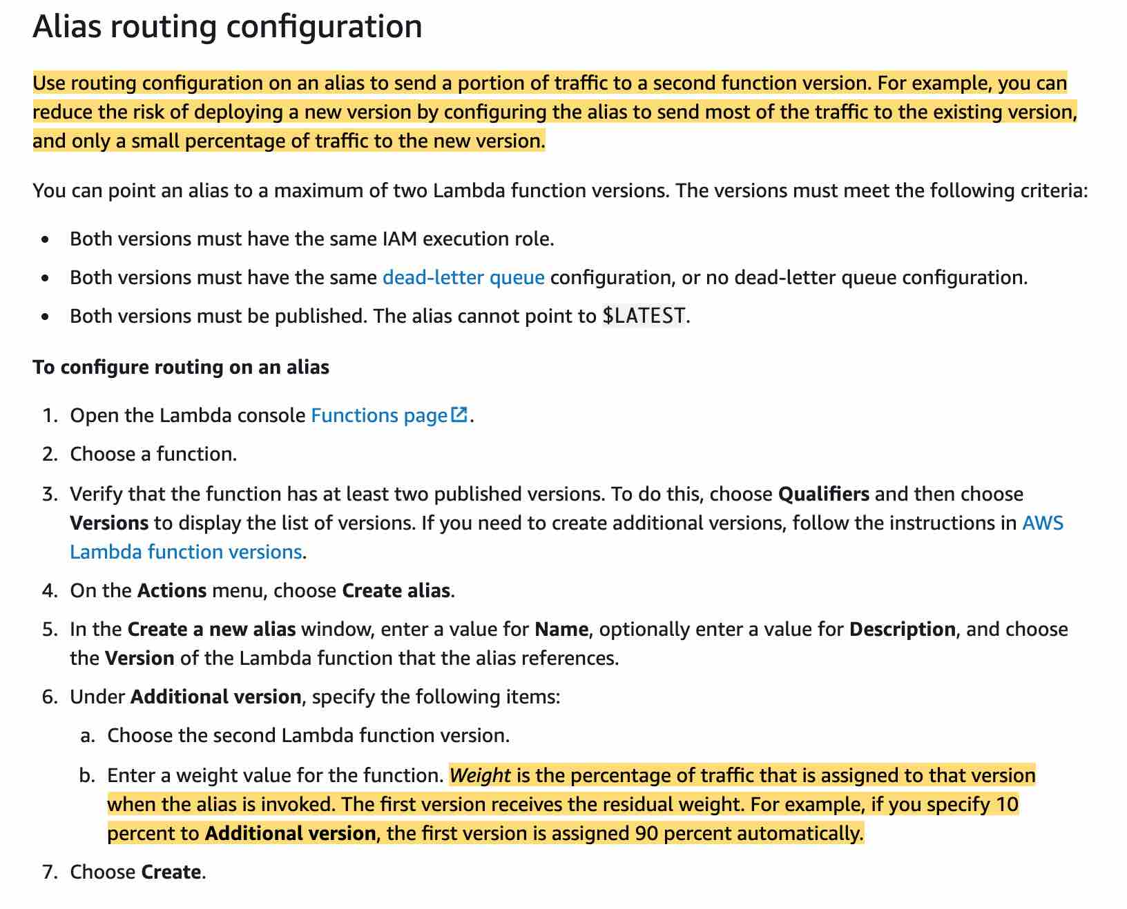 via - <https://docs.aws.amazon.com/lambda/latest/dg/configuration-aliases.html>

Incorrect options:

**Set up the application to use an alias that points to the current version. Deploy the new version of the code and configure alias to send all users to this new version. If the deployment goes wrong, reset the alias to point to the current version** - In this case, the application uses an alias to send all traffic to the new version which does not meet the requirement of sending only a certain portion of the traffic to the new Lambda version. In addition, if the deployment goes wrong, the application would see a downtime. Hence this option is incorrect.

**Set up the application to directly deploy the new Lambda version. If the deployment goes wrong, reset the application back to the current version using the version number in the ARN** - In this case, the application sends all traffic to the new version which does not meet the requirement of sending only a certain portion of the traffic to the new Lambda version. In addition, if the deployment goes wrong, the application would see a downtime. Hence this option is incorrect.

**Set up the application to have multiple alias of the Lambda function. Deploy the new version of the code. Configure a new alias that points to the current alias of the Lambda function for handling 10% of the traffic. If the deployment goes wrong, reset the new alias to point all traffic to the most recent working alias of the Lambda function** - This option has been added as a distractor. The alias for a Lambda function can only point to a Lambda function version. It cannot point to another alias.

References:

<https://docs.aws.amazon.com/lambda/latest/dg/configuration-aliases.html>

<https://docs.aws.amazon.com/lambda/latest/dg/configuration-versions.html>

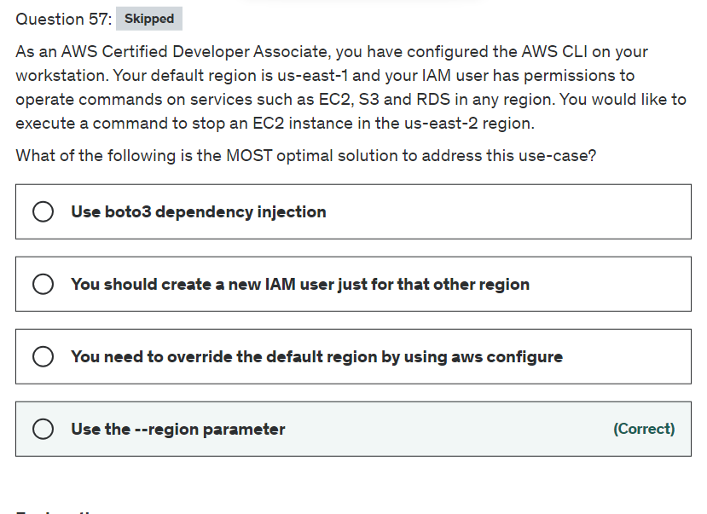

Explanation

Correct option:

**Use the --region parameter**: If the region parameter is not set, then the CLI command is executed against the default AWS region.

You can also review all general options for AWS CLI: 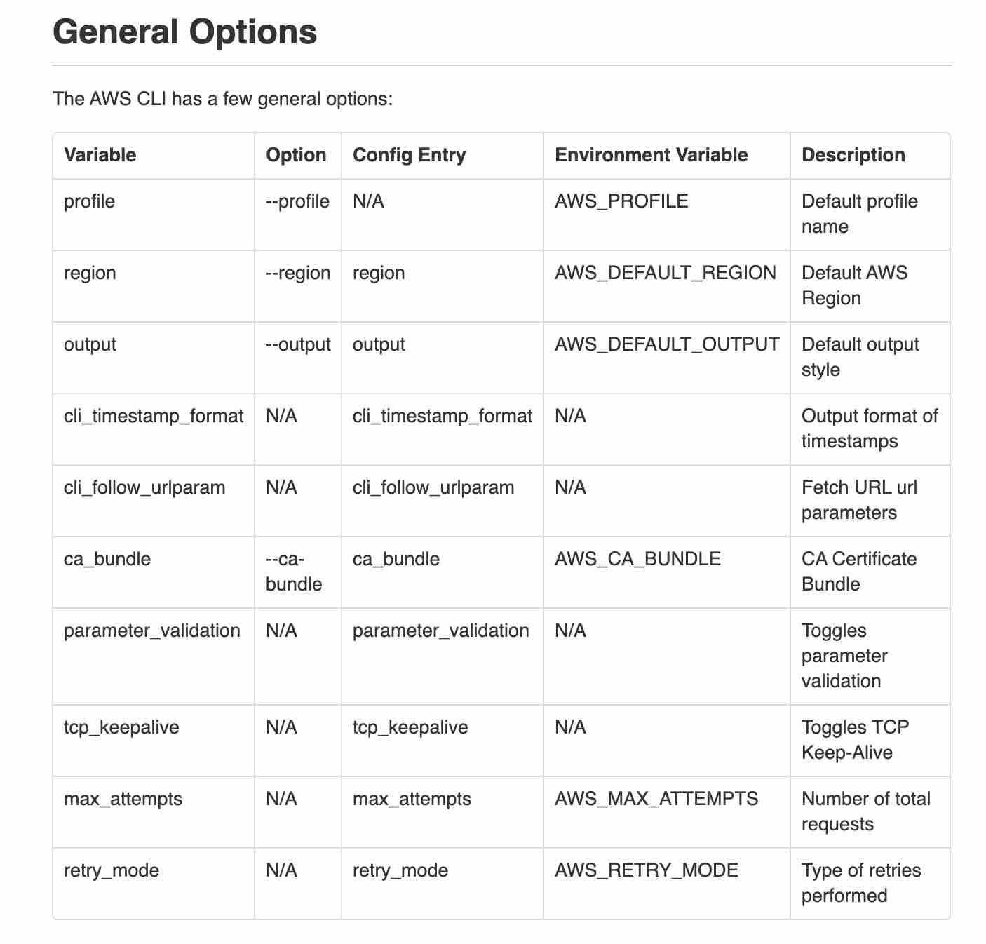 via - <https://docs.aws.amazon.com/cli/latest/topic/config-vars.html#general-options>

Incorrect options:

**You need to override the default region by using aws configure** - This is not the most optimal way as you will have to change it again to reset the default region.

**You should create a new IAM user just for that other region** - This is not the most optimal way as you would need to manage two IAM user profiles.

**Use boto3 dependency injection** - With the CLI you do not use boto3. This option is a distractor.

Reference:

<https://docs.aws.amazon.com/cli/latest/topic/config-vars.html#general-options>

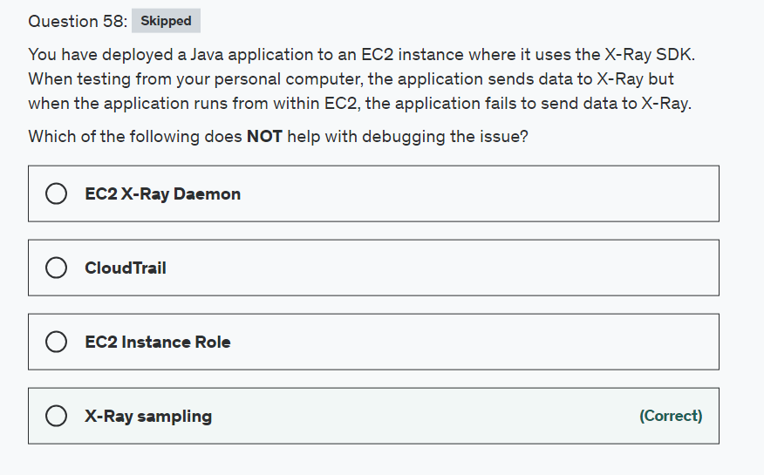

Explanation

Correct option:

**X-Ray sampling**

By customizing sampling rules, you can control the amount of data that you record, and modify sampling behavior on the fly without modifying or redeploying your code. Sampling rules tell the X-Ray SDK how many requests to record for a set of criteria. X-Ray SDK applies a sampling algorithm to determine which requests get traced however because our application is failing to send data to X-Ray it does not help in determining the cause of failure.

X-Ray Overview: 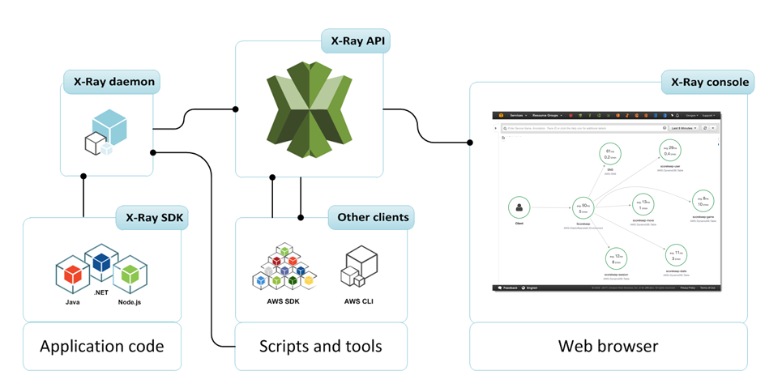 via - <https://docs.aws.amazon.com/xray/latest/devguide/aws-xray.html>

Incorrect options:

**EC2 X-Ray Daemon** - The AWS X-Ray daemon is a software application that listens for traffic on UDP port 2000, gathers raw segment data, and relays it to the AWS X-Ray API. The daemon logs could help with figuring out the problem.

**EC2 Instance Role** - The X-Ray daemon uses the AWS SDK to upload trace data to X-Ray, and it needs AWS credentials with permission to do that. On Amazon EC2, the daemon uses the instance's instance profile role automatically. Eliminates API permission issues (in case the role doesn't have IAM permissions to write data to the X-Ray service)

**CloudTrail** - With CloudTrail, you can log, continuously monitor, and retain account activity related to actions across your AWS infrastructure. You can use AWS CloudTrail to answer questions such as - “Who made an API call to modify this resource?”. CloudTrail provides event history of your AWS account activity thereby enabling governance, compliance, operational auditing, and risk auditing of your AWS account. You can check CloudTrail to see if any API call is being denied on X-Ray.

Reference:

<https://docs.aws.amazon.com/xray/latest/devguide/aws-xray.html>

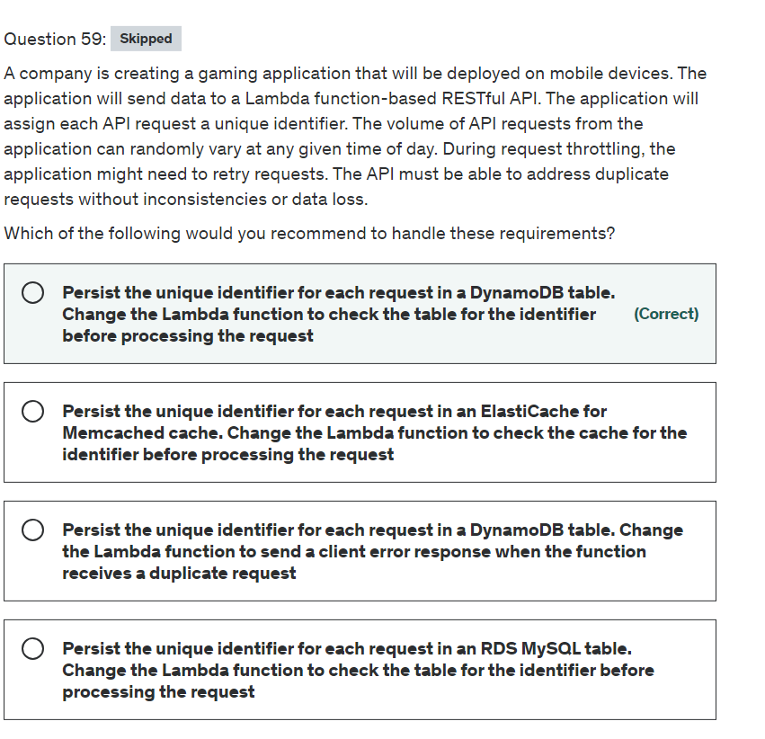

Explanation

Correct option:

**Persist the unique identifier for each request in a DynamoDB table. Change the Lambda function to check the table for the identifier before processing the request**

DynamoDB is a fully managed, serverless, key-value NoSQL database designed to run high-performance applications at any scale. DynamoDB offers built-in security, continuous backups, automated multi-Region replication, in-memory caching, and data import and export tools. On-demand backup and restore allows you to create full backups of your DynamoDB. Point-in-time recovery (PITR) helps protect your DynamoDB tables from accidental write or delete operations. PITR provides continuous backups of your DynamoDB table data, and you can restore that table to any point in time up to the second during the preceding 35 days.

These features ensure that there is no data loss for the application, thereby meeting a key requirement for the given use case. The solution should also be able to address any duplicate requests without inconsistencies, so the Lambda function should be changed to inspect the table for the given identifier and process the request only if the identifier is unique.

DynamoDB Overview: 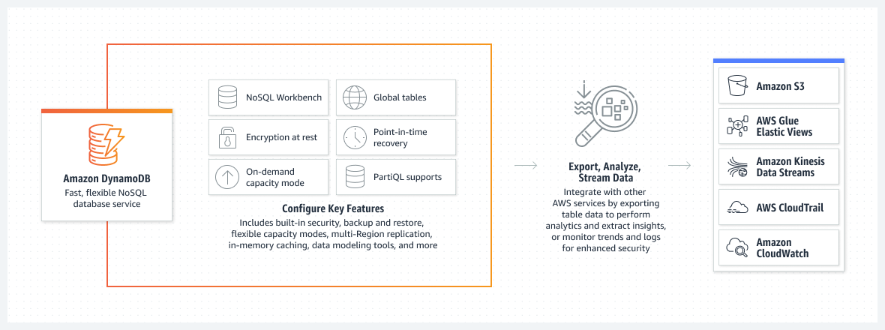 via - <https://aws.amazon.com/dynamodb/>

DynamoDB

Incorrect options:

**Persist the unique identifier for each request in an ElastiCache for Memcached cache. Change the Lambda function to check the cache for the identifier before processing the request** - Memcached is designed for simplicity and it does not offer any snapshot or replication features. This can lead to data loss for applications. Therefore, this option is not the right fit for the given use case.

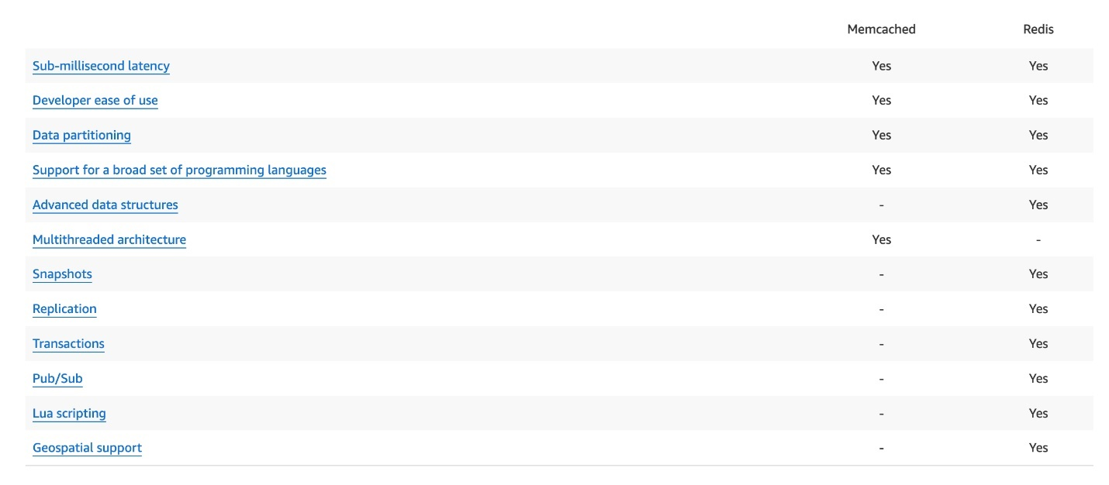 via - <https://aws.amazon.com/elasticache/redis-vs-memcached/>

**Persist the unique identifier for each request in an RDS MySQL table. Change the Lambda function to check the table for the identifier before processing the request** - DynamoDB is a better fit than RDS MySQL to handle massive traffic spikes for write requests. DynamoDB is a key-value and document database that supports tables of virtually any size with horizontal scaling. DynamoDB scales to more than 10 trillion requests per day and with tables that have more than ten million read and write requests per second and petabytes of data storage. DynamoDB can be used to build applications that need consistent single-digit millisecond performance. MySQL RDS can be scaled vertically, however, it cannot match the performance benefits offered by DynamoDB for the given use case.

**Persist the unique identifier for each request in a DynamoDB table. Change the Lambda function to send a client error response when the function receives a duplicate request** - The solution should be able to address any duplicates without any inconsistencies. If Lambda sends a client error response upon receiving a duplicate request, it represents an inconsistent response. So this option is incorrect.

References:

<https://aws.amazon.com/dynamodb/>

<https://aws.amazon.com/elasticache/redis-vs-memcached/>

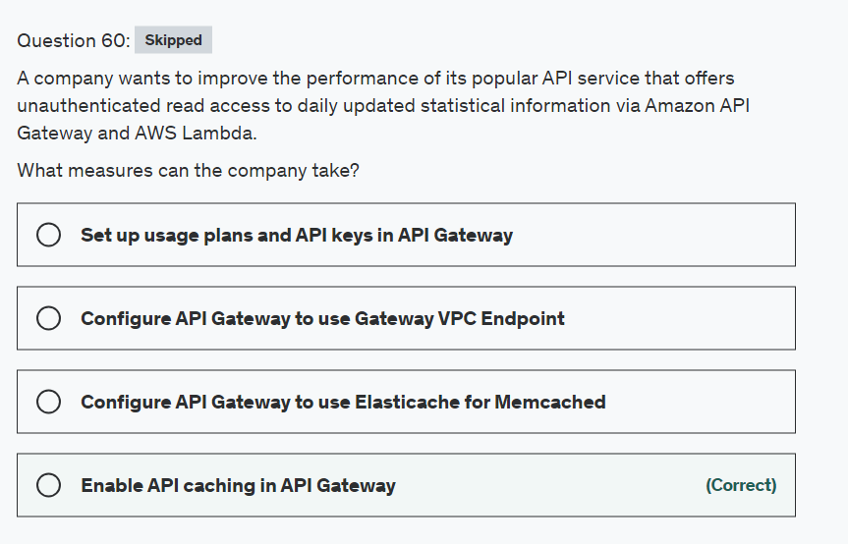

Explanation

Correct option:

**Enable API caching in API Gateway**

API Gateway provides a few strategies for optimizing your API to improve responsiveness, like response caching and payload compression. You can enable API caching in Amazon API Gateway to cache your endpoint's responses. With caching, you can reduce the number of calls made to your endpoint and also improve the latency of requests to your API.

Incorrect options:

**Set up usage plans and API keys in API Gateway** - After you create, test, and deploy your APIs, you can use API Gateway usage plans to make them available as product offerings for your customers. You can configure usage plans and API keys to allow customers to access selected APIs, and begin throttling requests to those APIs based on defined limits and quotas. These can be set at the API, or API method level. This option is incorrect as usage plans and API keys cannot be used to improve the responsiveness of the API.

**Configure API Gateway to use Elasticache for Memcached** - This option has been added as a distractor. Elasticache for Memcached cannot be used with API Gateway to improve the responsiveness of the API for the given use case. You should note that Elasticache for Memcached is a downstream service in the request flow.

**Configure API Gateway to use Gateway VPC Endpoint** - This option has been added as a distractor. Gateway endpoints provide reliable connectivity to Amazon S3 and DynamoDB without requiring an internet gateway or a NAT device for your VPC. Gateway endpoints do not enable AWS PrivateLink.

References:

<https://docs.aws.amazon.com/apigateway/latest/developerguide/api-gateway-caching.html>

<https://docs.aws.amazon.com/apigateway/latest/developerguide/api-gateway-api-usage-plans.html>

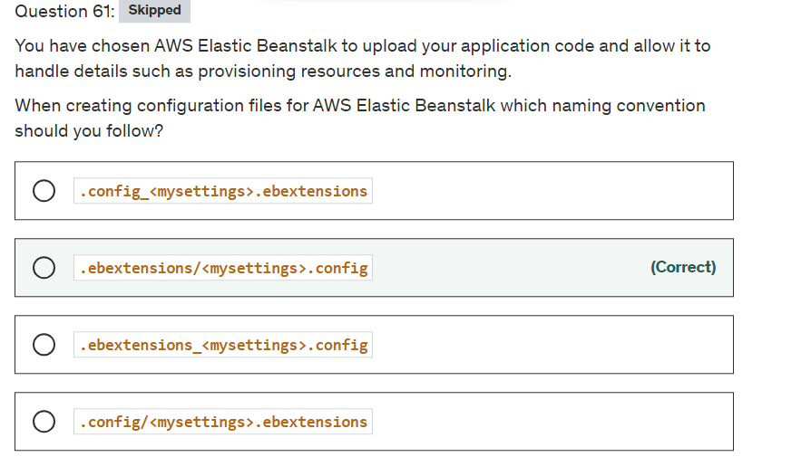

Explanation

Correct option:

**.ebextensions/<mysettings>.config** : You can add AWS Elastic Beanstalk configuration files (.ebextensions) to your web application's source code to configure your environment and customize the AWS resources that it contains. Configuration files are YAML or JSON formatted documents with a .config file extension that you place in a folder named .ebextensions and deploy in your application source bundle.

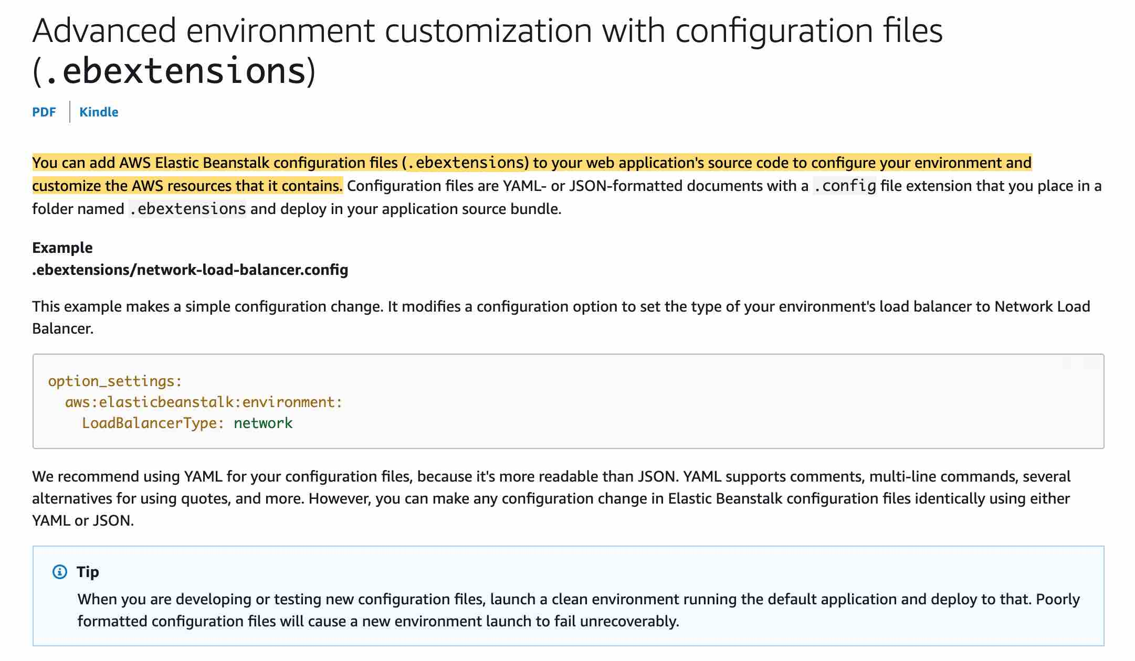 via - <https://docs.aws.amazon.com/elasticbeanstalk/latest/dg/ebextensions.html>

Incorrect options:

**.ebextensions_<mysettings>.config**

**.config/<mysettings>.ebextensions**

**.config_<mysettings>.ebextensions**

These three options contradict the explanation provided earlier. So these are incorrect.

Reference:

<https://docs.aws.amazon.com/elasticbeanstalk/latest/dg/ebextensions.html>

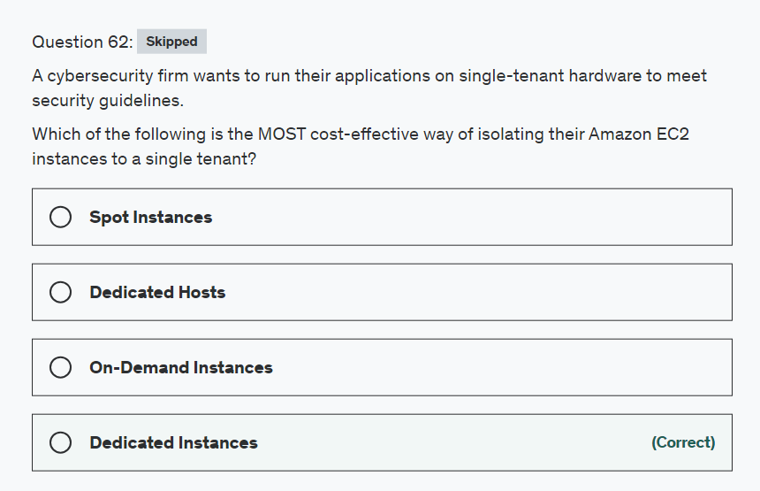

Explanation

Correct option:

**Dedicated Instances** - Dedicated Instances are Amazon EC2 instances that run in a virtual private cloud (VPC) on hardware that's dedicated to a single customer. Dedicated Instances that belong to different AWS accounts are physically isolated at a hardware level, even if those accounts are linked to a single-payer account. However, Dedicated Instances may share hardware with other instances from the same AWS account that are not Dedicated Instances.

A Dedicated Host is also a physical server that's dedicated for your use. With a Dedicated Host, you have visibility and control over how instances are placed on the server.

Differences between Dedicated Hosts and Dedicated Instances: 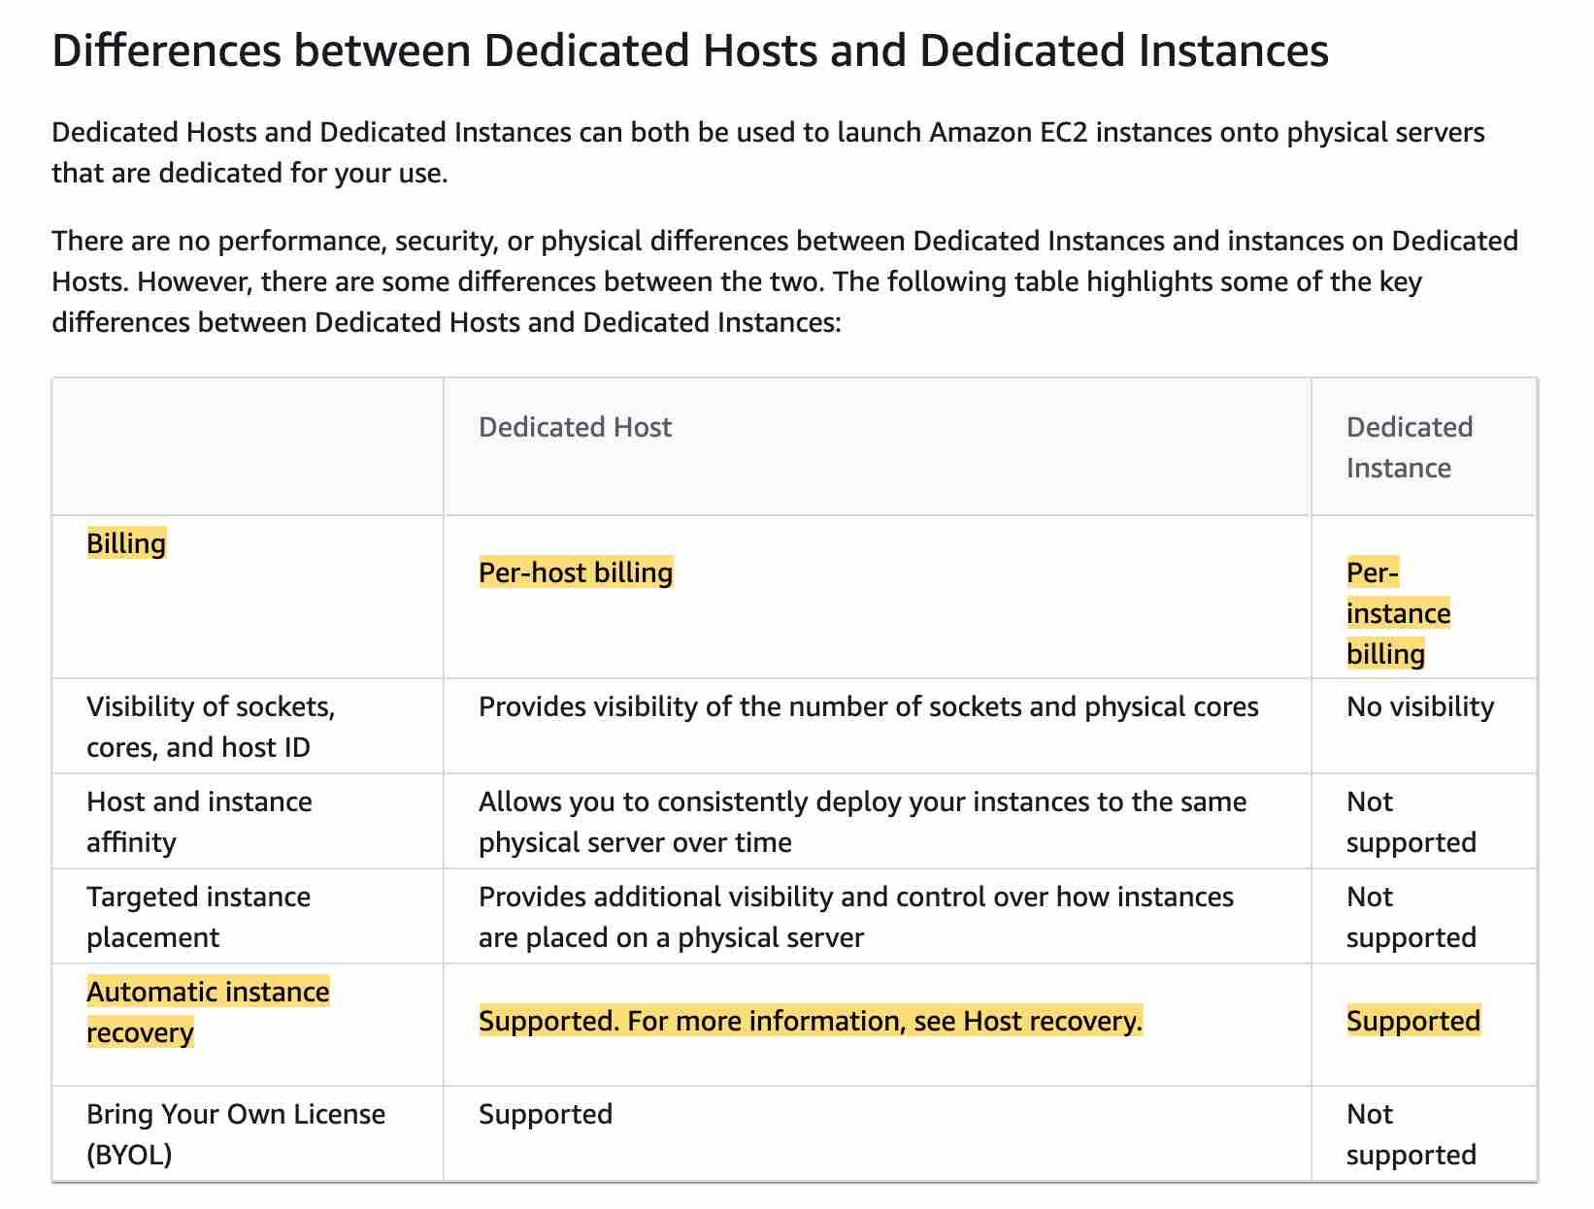 via - <https://docs.aws.amazon.com/AWSEC2/latest/UserGuide/dedicated-hosts-overview.html#dedicated-hosts-dedicated-instances>

Incorrect options:

**Spot Instances** - A Spot Instance is an unused EC2 instance that is available for less than the On-Demand price. Your Spot Instance runs whenever capacity is available and the maximum price per hour for your request exceeds the Spot price. Any instance present with unused capacity will be allocated. Even though this is cost-effective, it does not fulfill the single-tenant hardware requirement of the client and hence is not the correct option.

**Dedicated Hosts** - An Amazon EC2 Dedicated Host is a physical server with EC2 instance capacity fully dedicated to your use. Dedicated Hosts allow you to use your existing software licenses on EC2 instances. With a Dedicated Host, you have visibility and control over how instances are placed on the server. This option is costlier than the Dedicated Instance and hence is not the right choice for the current requirement.

**On-Demand Instances** - With On-Demand Instances, you pay for compute capacity by the second with no long-term commitments. You have full control over its lifecycle—you decide when to launch, stop, hibernate, start, reboot, or terminate it. Hardware isolation is not possible and on-demand has one of the costliest instance charges and hence is not the correct answer for current requirements.

High Level Overview of EC2 Instance Purchase Options: 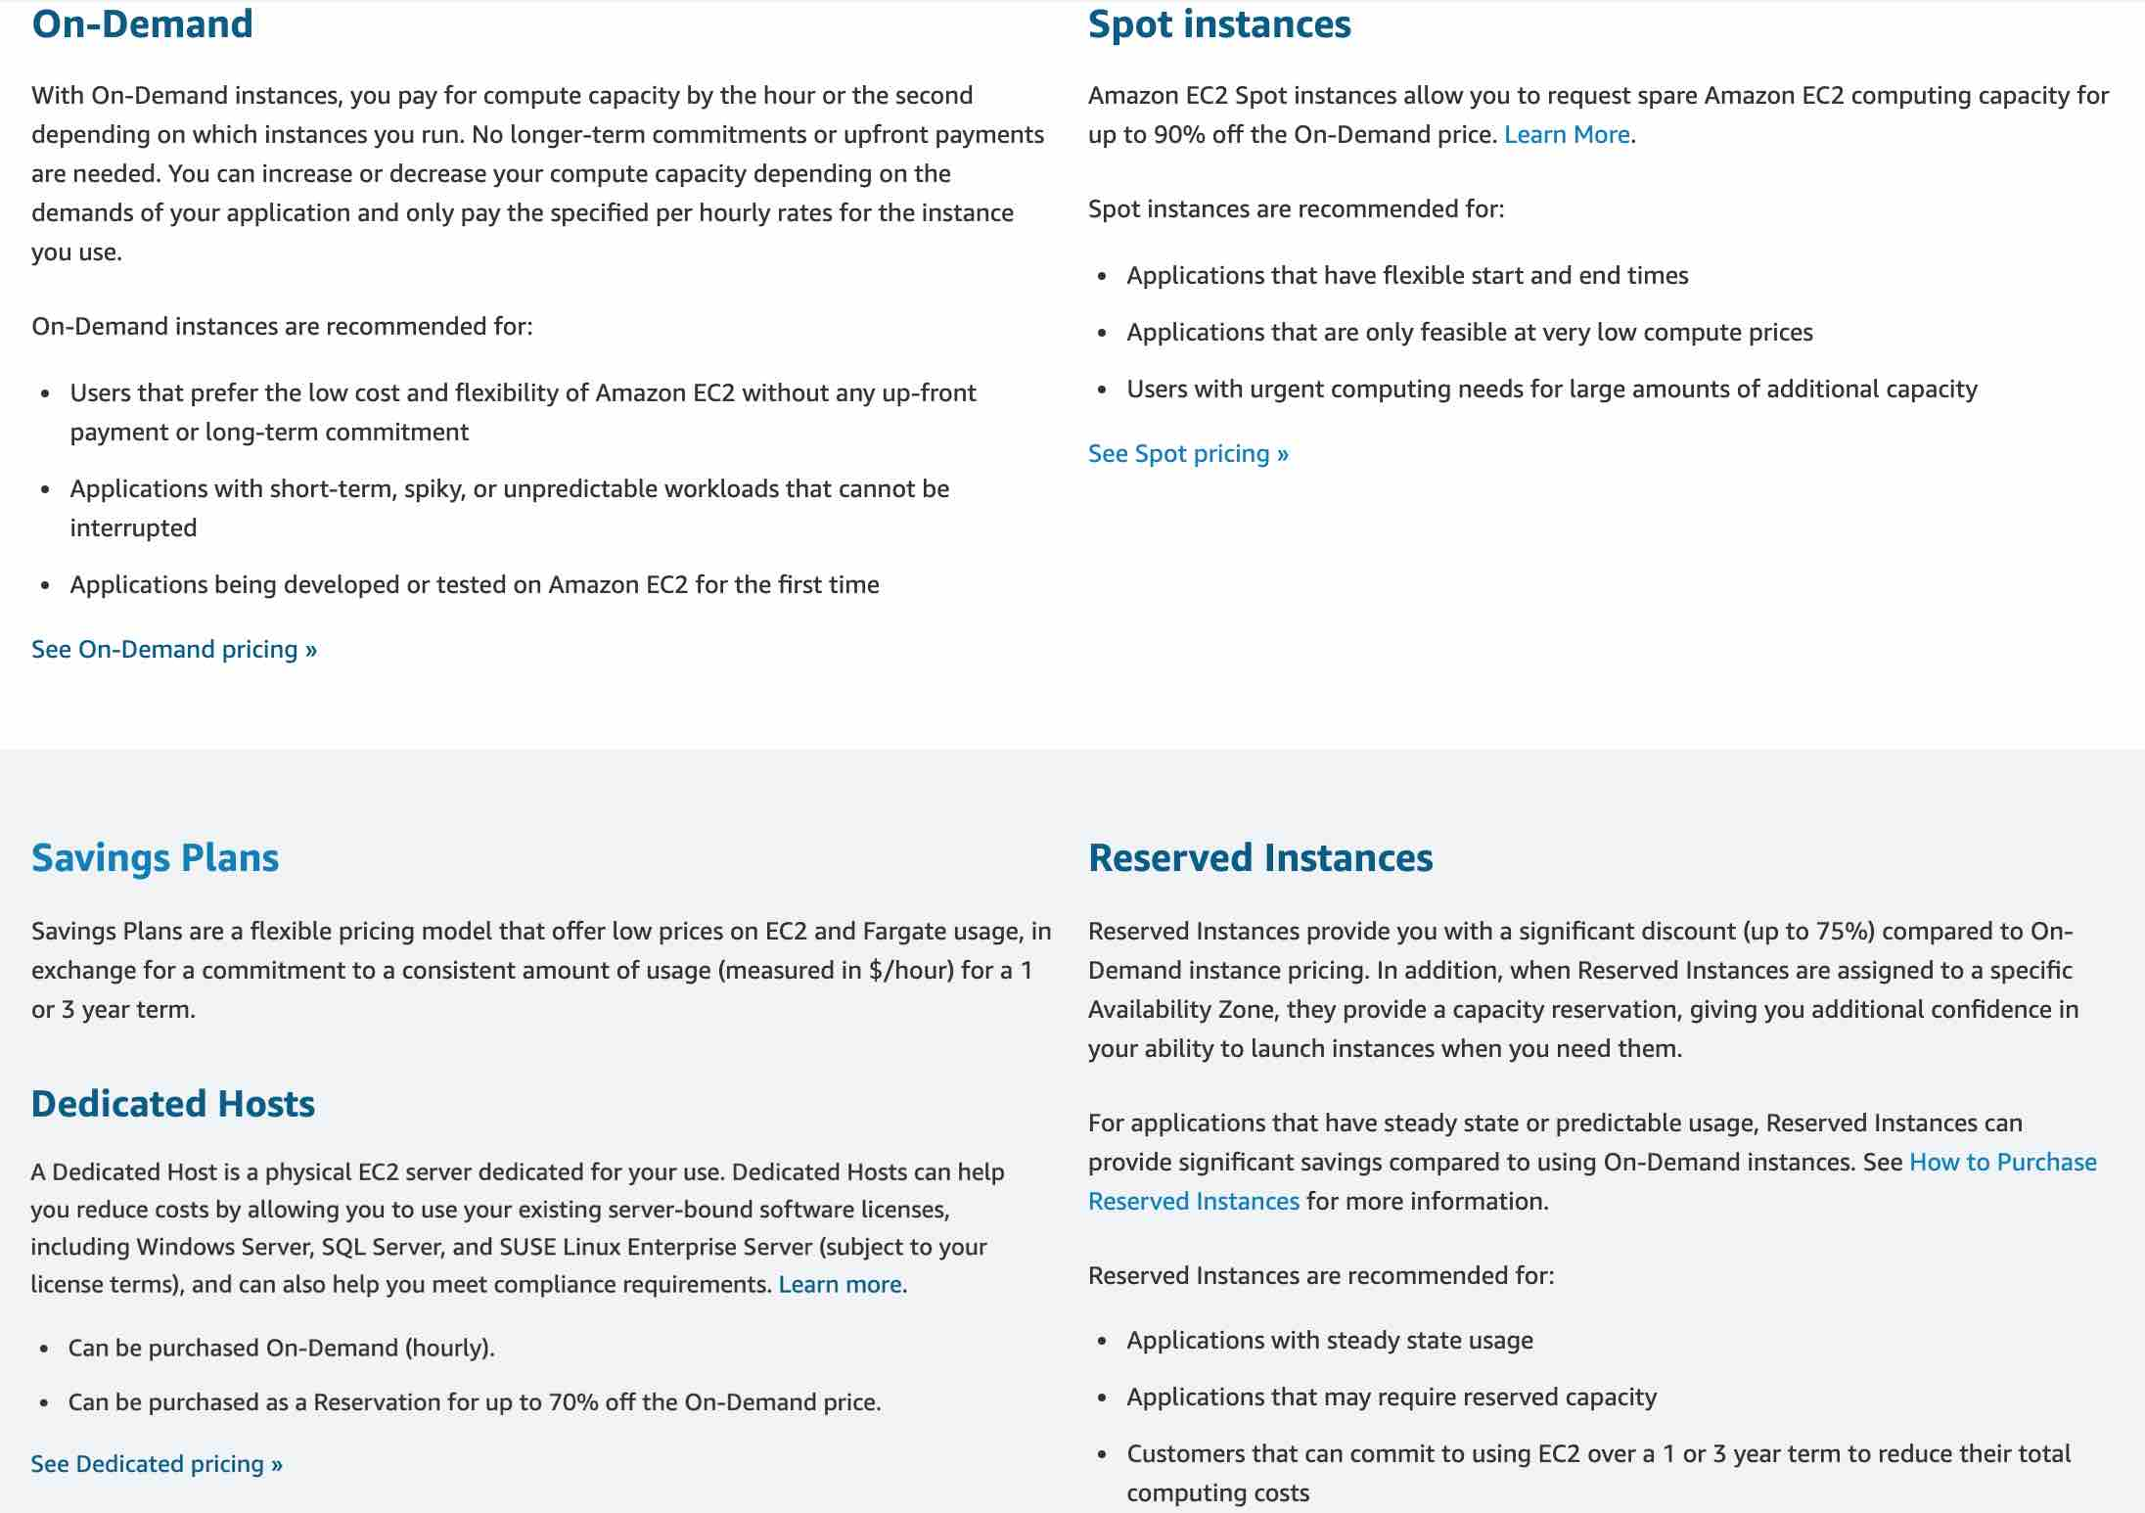 via - <https://aws.amazon.com/ec2/pricing/>

References:

<https://docs.aws.amazon.com/AWSEC2/latest/UserGuide/dedicated-instance.html>

<https://docs.aws.amazon.com/AWSEC2/latest/UserGuide/instance-purchasing-options.html>

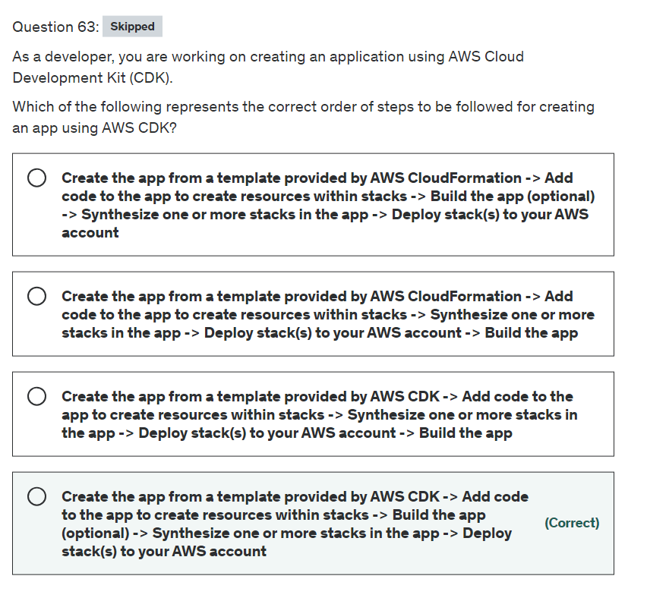

Explanation

Correct option:

**Create the app from a template provided by AWS CDK -> Add code to the app to create resources within stacks -> Build the app (optional) -> Synthesize one or more stacks in the app -> Deploy stack(s) to your AWS account**

The standard AWS CDK development workflow is similar to the workflow you're already familiar as a developer. There are a few extra steps:

Create the app from a template provided by AWS CDK - Each AWS CDK app should be in its own directory, with its own local module dependencies. Create a new directory for your app. Now initialize the app using the cdk init command, specifying the desired template ("app") and programming language. The cdk init command creates a number of files and folders inside the created home directory to help you organize the source code for your AWS CDK app.

Add code to the app to create resources within stacks - Add custom code as is needed for your application.

Build the app (optional) - In most programming environments, after making changes to your code, you'd build (compile) it. This isn't strictly necessary with the AWS CDK—the Toolkit does it for you so you can't forget. But you can still build manually whenever you want to catch syntax and type errors.

Synthesize one or more stacks in the app to create an AWS CloudFormation template - Synthesize one or more stacks in the app to create an AWS CloudFormation template. The synthesis step catches logical errors in defining your AWS resources. If your app contains more than one stack, you'd need to specify which stack(s) to synthesize.

Deploy one or more stacks to your AWS account - It is optional (though good practice) to synthesize before deploying. The AWS CDK synthesizes your stack before each deployment. If your code has security implications, you'll see a summary of these and need to confirm them before deployment proceeds. cdk deploy is used to deploy the stack using CloudFormation templates. This command displays progress information as your stack is deployed. When it's done, the command prompt reappears.

Incorrect options:

**Create the app from a template provided by AWS CloudFormation -> Add code to the app to create resources within stacks -> Build the app (optional) -> Synthesize one or more stacks in the app -> Deploy stack(s) to your AWS account**

**Create the app from a template provided by AWS CloudFormation -> Add code to the app to create resources within stacks -> Synthesize one or more stacks in the app -> Deploy stack(s) to your AWS account -> Build the app**

For both these options, you cannot use AWS CloudFormation to create the app. So these options are incorrect.

**Create the app from a template provided by AWS CDK -> Add code to the app to create resources within stacks -> Synthesize one or more stacks in the app -> Deploy stack(s) to your AWS account -> Build the app** - You cannot have the build step after deployment. So this option is incorrect.

Reference:

<https://docs.aws.amazon.com/cdk/latest/guide/hello_world.html>

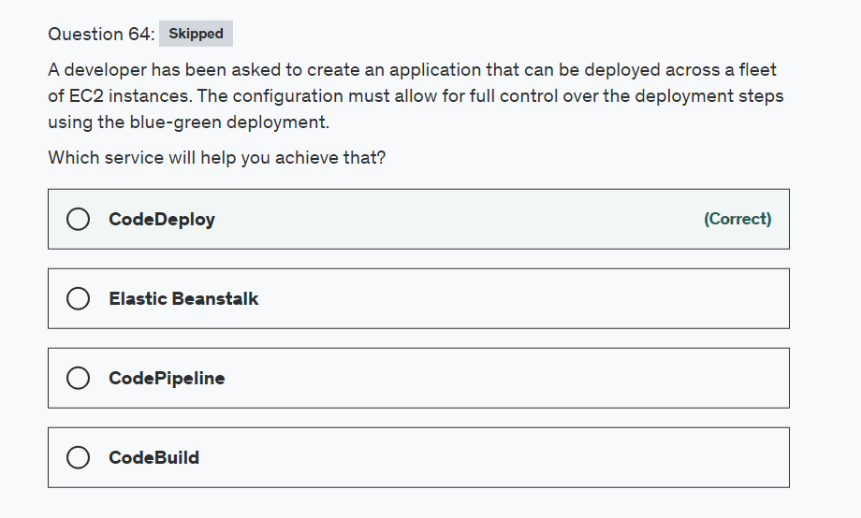

Explanation

Correct option:

**CodeDeploy**

AWS CodeDeploy is a deployment service that automates application deployments to Amazon EC2 instances, on-premises instances, or serverless Lambda functions. AWS CodeBuild is a fully managed continuous integration service that compiles source code, runs tests, and produces software packages that are ready to deploy.

The blue/green deployment type uses the blue/green deployment model controlled by CodeDeploy. This deployment type enables you to verify a new deployment of service before sending production traffic to it.

CodeDeploy offers lot of control over deployment steps. Please see this note for more details: 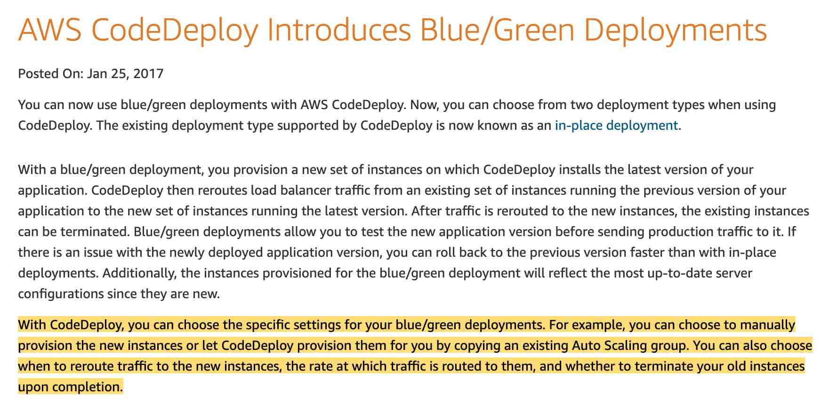 via - <https://aws.amazon.com/about-aws/whats-new/2017/01/aws-codedeploy-introduces-blue-green-deployments/>

Incorrect options:

**CodeBuild** - AWS CodeBuild is a fully managed continuous integration service that compiles source code, runs tests, and produces software packages that are ready to deploy. It cannot be used to deploy applications.

**Elastic Beanstalk** - AWS Elastic Beanstalk offers hooks but not as much control as CodeDeploy. Because AWS Elastic Beanstalk performs an in-place update when you update your application versions, your application can become unavailable to users for a short period of time. You can avoid this downtime by performing a blue/green deployment, where you deploy the new version to a separate environment, and then swap CNAMEs of the two environments to redirect traffic to the new version instantly.

**CodePipeline** - CodePipeline automates the build, test, and deploy phases of your release process every time there is a code change. CodePipeline by itself cannot deploy applications.

Reference:

<https://docs.amazonaws.cn/en_us/codedeploy/latest/userguide/deployment-configurations.html>

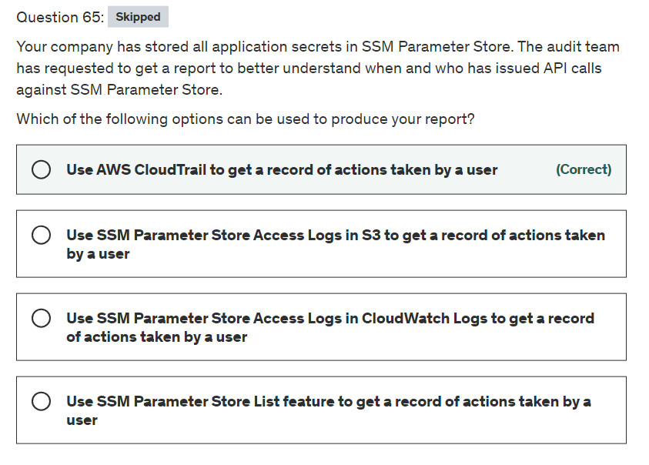

Explanation

Correct option:

**Use AWS CloudTrail to get a record of actions taken by a user**

AWS Systems Manager Parameter Store provides secure, hierarchical storage for configuration data management and secrets management. You can store data such as passwords, database strings, Amazon Machine Image (AMI) IDs, and license codes as parameter values. You can store values as plain text or encrypted data.

AWS CloudTrail provides a record of actions taken by a user, role, or an AWS service in Systems Manager. Using the information collected by AWS CloudTrail, you can determine the request that was made to Systems Manager, the IP address from which the request was made, who made the request, when it was made, and additional details.

Incorrect options:

**Use SSM Parameter Store List feature to get a record of actions taken by a user** - This option has been added as a distractor.

**Use SSM Parameter Store Access Logs in CloudWatch Logs to get a record of actions taken by a user** - CloudWatch Logs can be integrated but that will not help determine who issued API calls.

**Use SSM Parameter Store Access Logs in S3 to get a record of actions taken by a user** - S3 Access Logs can be integrated but that will not help determine who issued API calls.



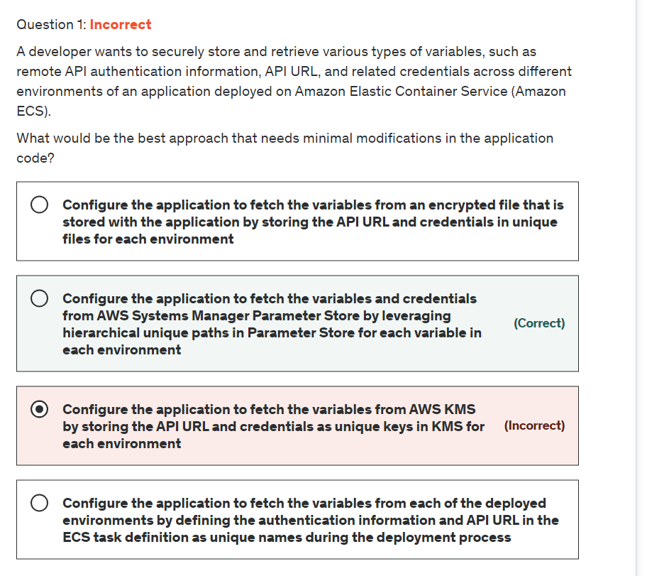

Explanation

Correct option:

**Configure the application to fetch the variables and credentials from AWS Systems Manager Parameter Store by leveraging hierarchical unique paths in Parameter Store for each variable in each environment**

Parameter Stores is a capability of AWS Systems Manager that provides secure, hierarchical storage for configuration data management and secrets management. You can store data such as passwords, database strings, Amazon Machine Image (AMI) IDs, and license codes as parameter values. You can store values as plain text or encrypted data. You can reference Systems Manager parameters in your scripts, commands, SSM documents, and configuration and automation workflows by using the unique name that you specified when you created the parameter.

Managing dozens or hundreds of parameters as a flat list is time-consuming and prone to errors. It can also be difficult to identify the correct parameter for a task. This means you might accidentally use the wrong parameter, or you might create multiple parameters that use the same configuration data.

You can use parameter hierarchies to help you organize and manage parameters. A hierarchy is a parameter name that includes a path that you define by using forward slashes (/).

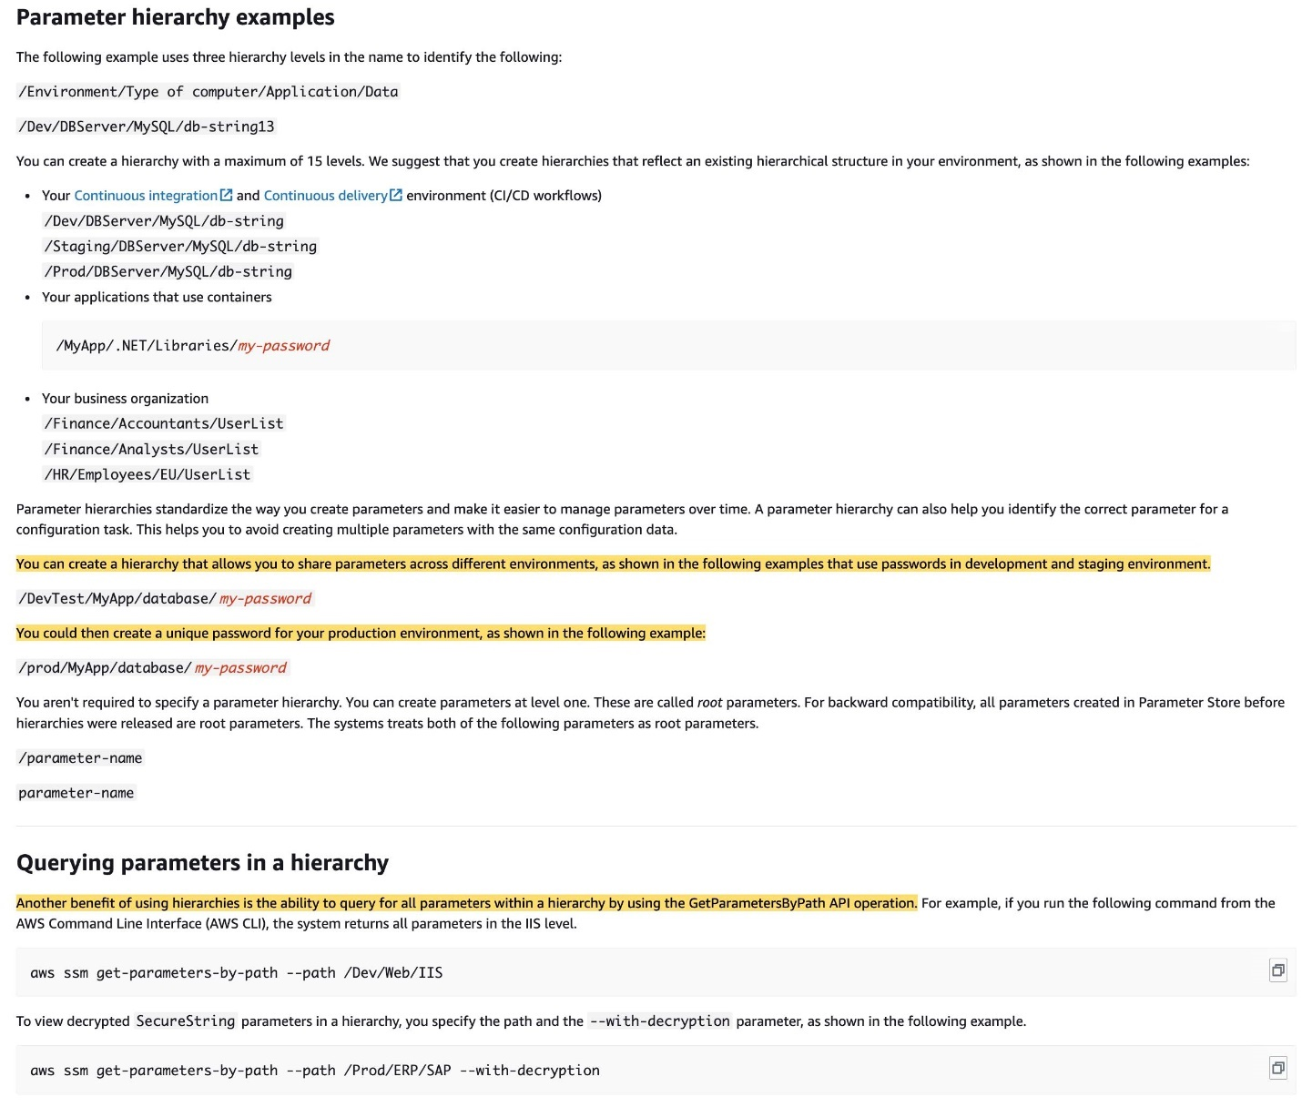 via - <https://docs.aws.amazon.com/systems-manager/latest/userguide/sysman-paramstore-hierarchies.html>

Incorrect options:

**Configure the application to fetch the variables from AWS KMS by storing the API URL and credentials as unique keys in KMS for each environment** - AWS KMS lets you create, manage, and control cryptographic keys across your applications and AWS services. KMS is not a key-value service that can be used for the given use case.

**Configure the application to fetch the variables from an encrypted file that is stored with the application by storing the API URL and credentials in unique files for each environment** - It is not considered a security best practice to store sensitive data and credentials in an encrypted file with the application. So this option is incorrect.

**Configure the application to fetch the variables from each of the deployed environments by defining the authentication information and API URL in the ECS task definition as unique names during the deployment process** - ECS task definition can be thought of as a blueprint for your application. Task definitions specify various parameters for your application. Examples of task definition parameters are which containers to use, which launch type to use, which ports should be opened for your application, and what data volumes should be used with the containers in the task. The specific parameters available for the task definition depend on which launch type you are using. The task definition is a text file, in JSON format, that describes one or more containers, up to a maximum of ten, that form your application. A task is the instantiation of a task definition within a cluster. After you create a task definition for your application within Amazon ECS, you can specify the number of tasks to run on your cluster.

AWS recommends storing your sensitive data in either AWS Secrets Manager secrets or AWS Systems Manager Parameter Store parameters. Environment variables specified in the task definition are readable by all users and roles that are allowed the DescribeTaskDefinition action for the task definition. So this option is incorrect.

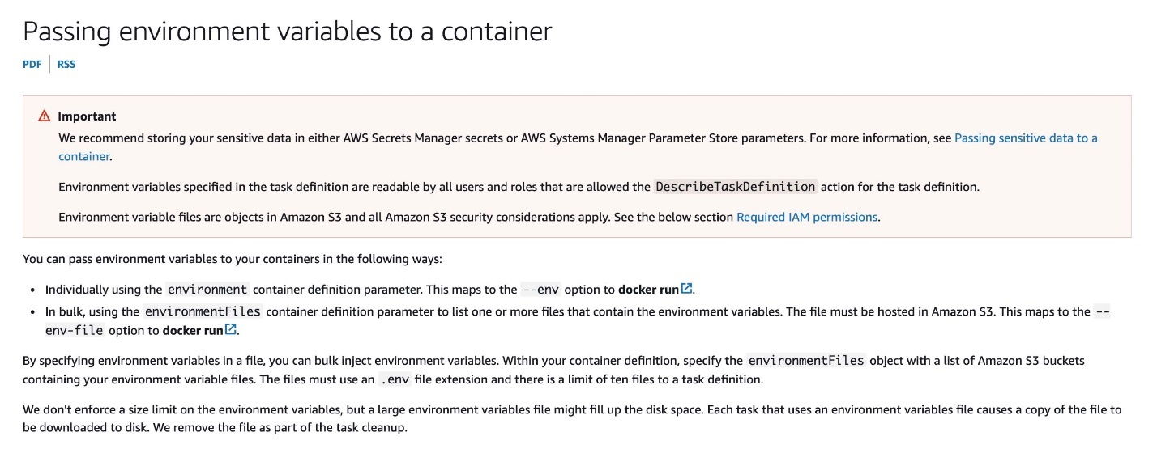 via - <https://docs.aws.amazon.com/AmazonECS/latest/developerguide/taskdef-envfiles.html>

References:

<https://docs.aws.amazon.com/systems-manager/latest/userguide/sysman-paramstore-hierarchies.html>

<https://aws.amazon.com/kms/>

<https://ecsworkshop.com/introduction/ecs_basics/task_definition/>

<https://docs.aws.amazon.com/AmazonECS/latest/developerguide/taskdef-envfiles.html>

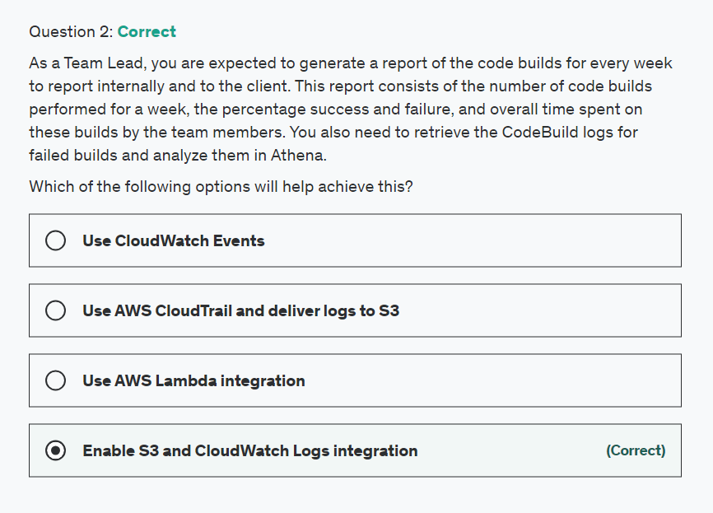

Explanation

Correct option:

**Enable S3 and CloudWatch Logs integration** - AWS CodeBuild monitors functions on your behalf and reports metrics through Amazon CloudWatch. These metrics include the number of total builds, failed builds, successful builds, and the duration of builds. You can monitor your builds at two levels: Project level, AWS account level. You can export log data from your log groups to an Amazon S3 bucket and use this data in custom processing and analysis, or to load onto other systems.

Incorrect options:

**Use CloudWatch Events** - You can integrate CloudWatch Events with CodeBuild. However, we are looking at storing and running queries on logs, so Cloudwatch logs with S3 integration makes sense for this context.o

**Use AWS Lambda integration** - Lambda is a good choice to use boto3 library to read logs programmatically. But, CloudWatch and S3 integration is already built-in and is an optimized way of managing the given use-case.

**Use AWS CloudTrail and deliver logs to S3** - AWS CodeBuild is integrated with AWS CloudTrail, a service that provides a record of actions taken by a user, role, or an AWS service in CodeBuild. CloudTrail captures all API calls for CodeBuild as events, including calls from the CodeBuild console and from code calls to the CodeBuild APIs. If you create a trail, you can enable continuous delivery of CloudTrail events to an S3 bucket, including events for CodeBuild. This is an important feature for monitoring a service but isn't a good fit for the current scenario.

References:

<https://docs.aws.amazon.com/codebuild/latest/userguide/monitoring-metrics.html>

<https://docs.aws.amazon.com/AmazonCloudWatch/latest/logs/S3Export.html>

<https://docs.aws.amazon.com/codebuild/latest/userguide/getting-started-input-bucket-console.html>

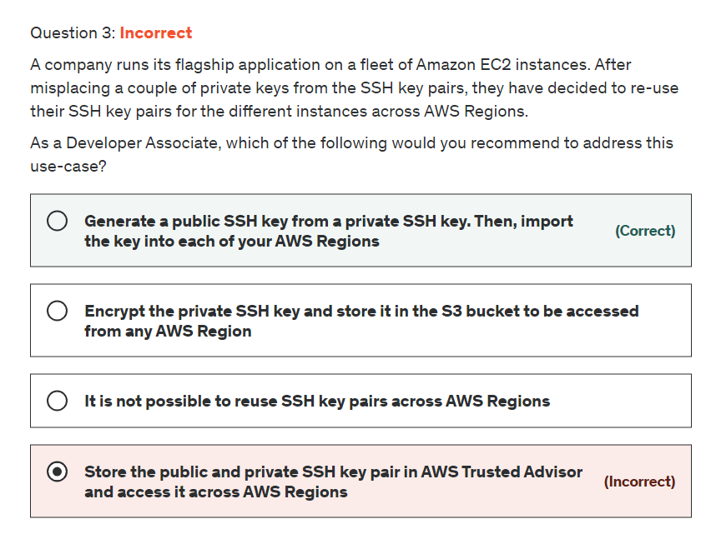

Explanation

Correct option:

**Generate a public SSH key from a private SSH key. Then, import the key into each of your AWS Regions**

Here is the correct way of reusing SSH keys in your AWS Regions:

Generate a public SSH key (.pub) file from the private SSH key (.pem) file.

Set the AWS Region you wish to import to.

Import the public SSH key into the new Region.

Incorrect options:

**It is not possible to reuse SSH key pairs across AWS Regions** - As explained above, it is possible to reuse with manual import.

**Store the public and private SSH key pair in AWS Trusted Advisor and access it across AWS Regions** - AWS Trusted Advisor is an application that draws upon best practices learned from AWS' aggregated operational history of serving hundreds of thousands of AWS customers. Trusted Advisor inspects your AWS environment and makes recommendations for saving money, improving system performance, or closing security gaps. It does not store key pair credentials.

**Encrypt the private SSH key and store it in the S3 bucket to be accessed from any AWS Region** - Storing private key to Amazon S3 is possible. But, this will not make the key accessible for all AWS Regions, as is the need in the current use case.

Reference:

<https://docs.aws.amazon.com/AWSEC2/latest/UserGuide/ec2-key-pairs.html>

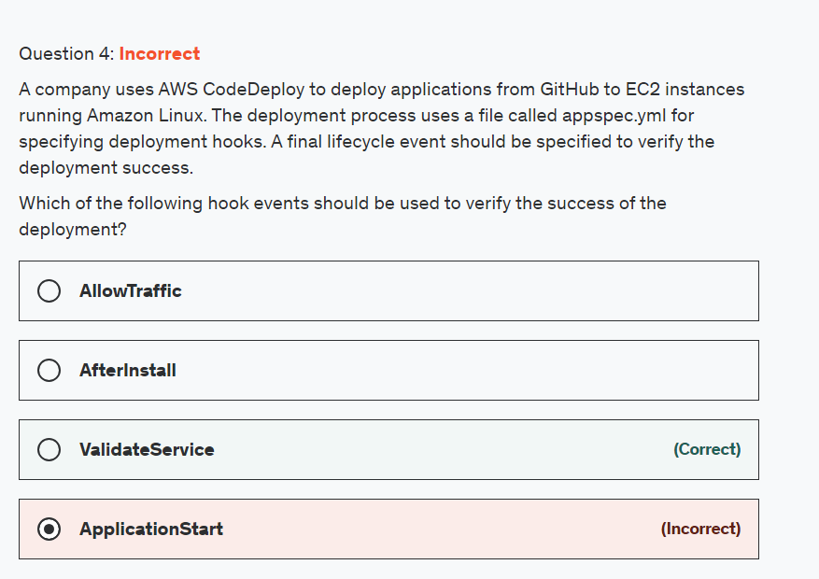

Explanation

Correct option:

AWS CodeDeploy is a fully managed deployment service that automates software deployments to a variety of compute services such as Amazon EC2, AWS Fargate, AWS Lambda, and your on-premises servers. AWS CodeDeploy makes it easier for you to rapidly release new features, helps you avoid downtime during application deployment, and handles the complexity of updating your applications.

An EC2/On-Premises deployment hook is executed once per deployment to an instance. You can specify one or more scripts to run in a hook.

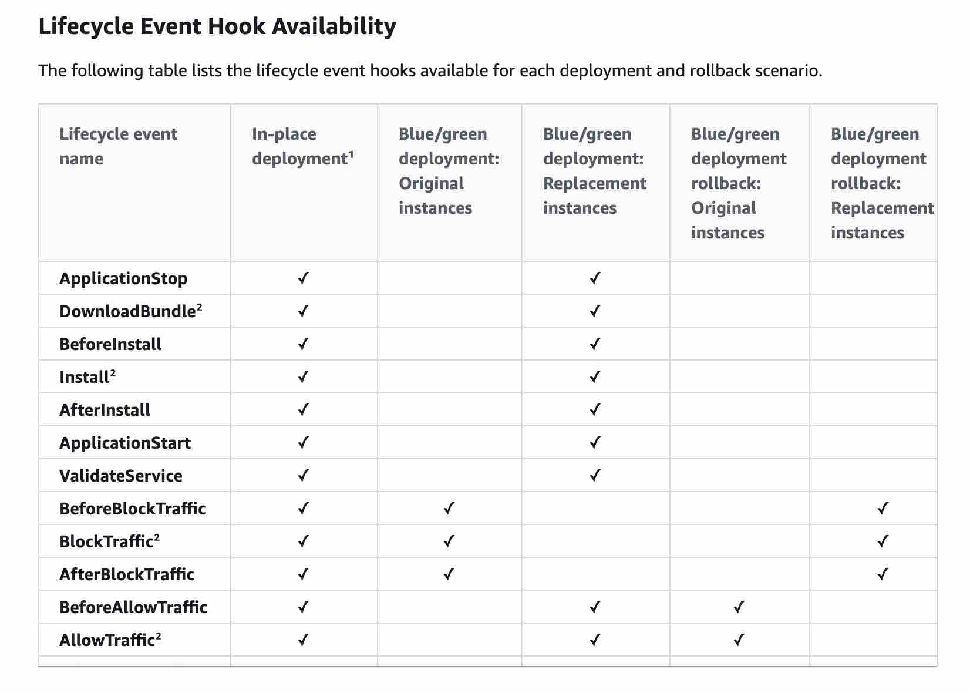 via - <https://docs.aws.amazon.com/codedeploy/latest/userguide/reference-appspec-file-structure-hooks.html#reference-appspec-file-structure-hooks-run-order>

**ValidateService**: ValidateService is the last deployment lifecycle event. It is used to verify the deployment was completed successfully.

Incorrect options:

**AfterInstall** - You can use this deployment lifecycle event for tasks such as configuring your application or changing file permissions

**ApplicationStart** - You typically use this deployment lifecycle event to restart services that were stopped during ApplicationStop

**AllowTraffic** - During this deployment lifecycle event, internet traffic is allowed to access instances after a deployment. This event is reserved for the AWS CodeDeploy agent and cannot be used to run scripts

Reference:

<https://docs.aws.amazon.com/codedeploy/latest/userguide/reference-appspec-file-structure-hooks.html#reference-appspec-file-structure-hooks-run-order>

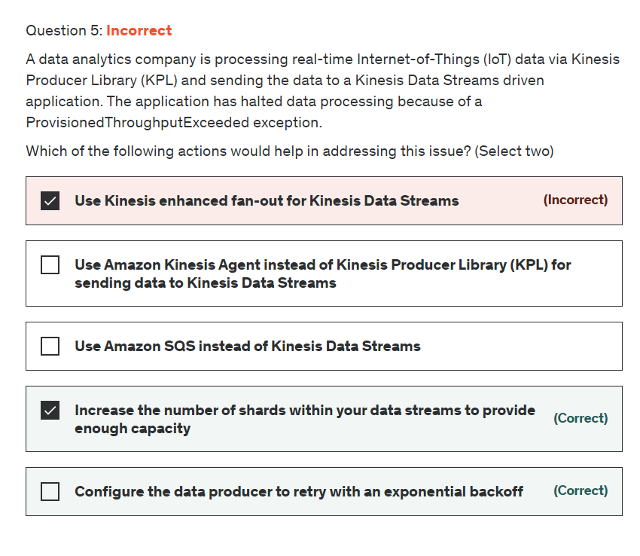

Explanation

Correct option:

**Configure the data producer to retry with an exponential backoff**

**Increase the number of shards within your data streams to provide enough capacity**

Amazon Kinesis Data Streams enables you to build custom applications that process or analyze streaming data for specialized needs. You can continuously add various types of data such as clickstreams, application logs, and social media to an Amazon Kinesis data stream from hundreds of thousands of sources.

How Kinesis Data Streams Work 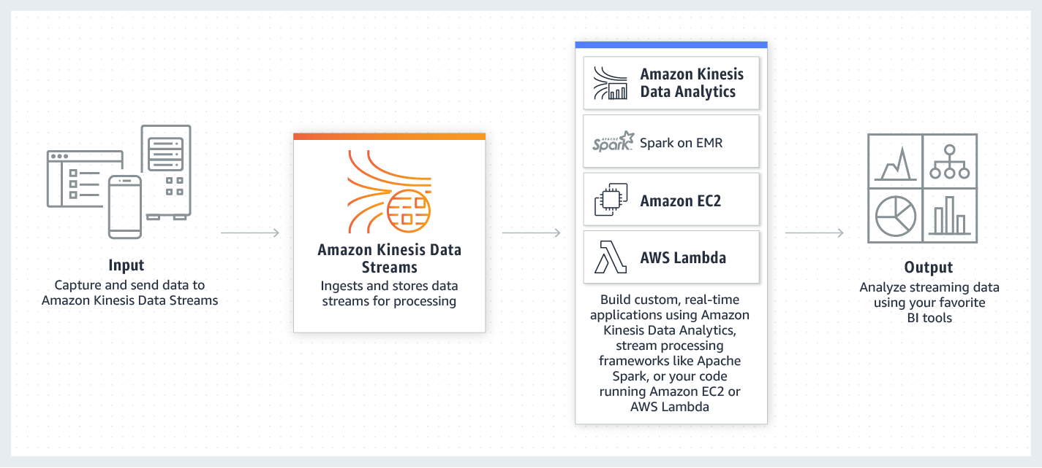 via - <https://aws.amazon.com/kinesis/data-streams/>

The capacity limits of an Amazon Kinesis data stream are defined by the number of shards within the data stream. The limits can be exceeded by either data throughput or the number of PUT records. While the capacity limits are exceeded, the put data call will be rejected with a ProvisionedThroughputExceeded exception.

If this is due to a temporary rise of the data stream’s input data rate, retry (with exponential backoff) by the data producer will eventually lead to the completion of the requests.

If this is due to a sustained rise of the data stream’s input data rate, you should increase the number of shards within your data stream to provide enough capacity for the put data calls to consistently succeed.

Incorrect options:

**Use Amazon Kinesis Agent instead of Kinesis Producer Library (KPL) for sending data to Kinesis Data Streams** - Kinesis Agent works with data producers. Using Kinesis Agent instead of KPL will not help as the constraint is the capacity limit of the Kinesis Data Stream.

**Use Amazon SQS instead of Kinesis Data Streams** - This is a distractor as using SQS will not help address the ProvisionedThroughputExceeded exception for the Kinesis Data Stream. This option does not address the issues in the use-case.

**Use Kinesis enhanced fan-out for Kinesis Data Streams** - You should use enhanced fan-out if you have, or expect to have, multiple consumers retrieving data from a stream in parallel. Therefore, using enhanced fan-out will not help address the ProvisionedThroughputExceeded exception as the constraint is the capacity limit of the Kinesis Data Stream.

Please review this note for more details on enhanced fan-out for Kinesis Data Streams: 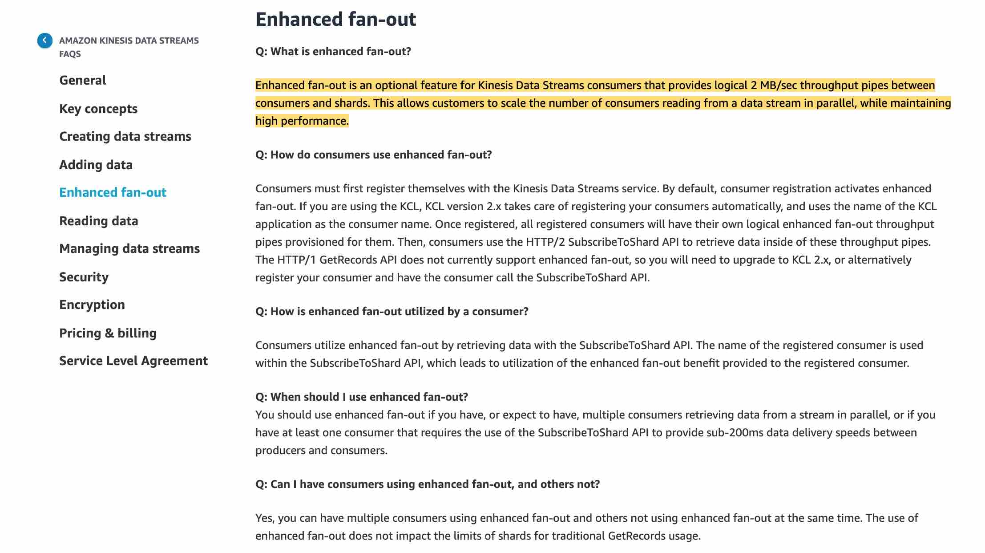 via - <https://aws.amazon.com/kinesis/data-streams/faqs/>

References:

<https://aws.amazon.com/kinesis/data-streams/>

<https://aws.amazon.com/kinesis/data-streams/faqs/>

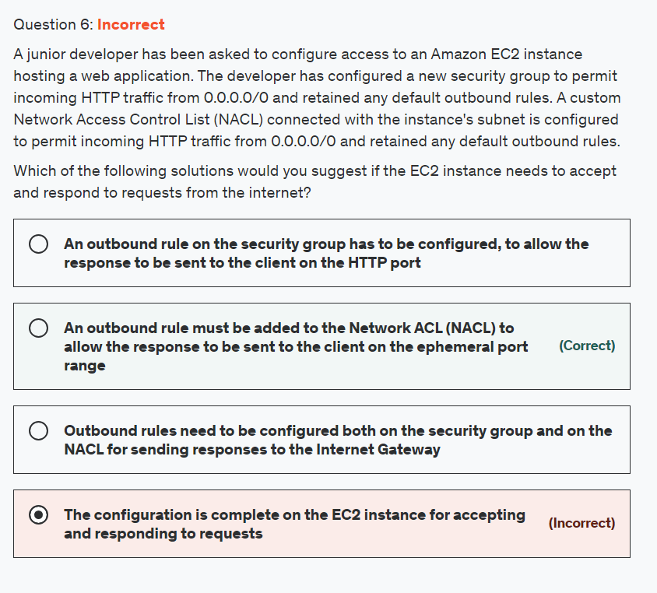

Explanation

Correct option:

**An outbound rule must be added to the Network ACL (NACL) to allow the response to be sent to the client on the ephemeral port range**

Security groups are stateful, so allowing inbound traffic to the necessary ports enables the connection. Network ACLs are stateless, so you must allow both inbound and outbound traffic. By default, each custom Network ACL denies all inbound and outbound traffic until you add rules.

To enable the connection to a service running on an instance, the associated network ACL must allow both: 1. Inbound traffic on the port that the service is listening on 2. Outbound traffic to ephemeral ports

When a client connects to a server, a random port from the ephemeral port range (1024-65535) becomes the client's source port.

The designated ephemeral port becomes the destination port for return traffic from the service. Outbound traffic to the ephemeral port must be allowed in the network ACL.

Incorrect options:

**The configuration is complete on the EC2 instance for accepting and responding to requests** - As explained above, this is an incorrect statement.

**An outbound rule on the security group has to be configured, to allow the response to be sent to the client on the HTTP port** - Security groups are stateful. Therefore you don't need a rule that allows responses to inbound traffic.

Outbound rules need to be configured both on the security group and on the NACL for sending responses to the Internet Gateway* - Security Groups are stateful. Hence, return traffic is automatically allowed, so there is no need to configure an outbound rule on the security group.

References:

<https://aws.amazon.com/premiumsupport/knowledge-center/resolve-connection-sg-acl-inbound/>

<https://docs.aws.amazon.com/vpc/latest/userguide/vpc-network-acls.html#nacl-ephemeral-ports>

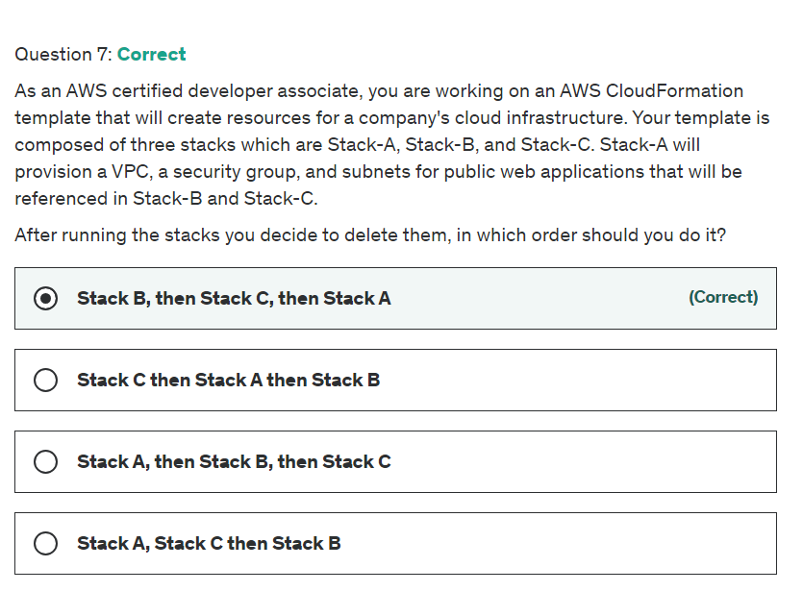

Explanation

Correct option:

AWS CloudFormation gives developers and businesses an easy way to create a collection of related AWS and third-party resources and provision them in an orderly and predictable fashion.

How CloudFormation Works:  via - <https://aws.amazon.com/cloudformation/>

**Stack B, then Stack C, then Stack A**

All of the imports must be removed before you can delete the exporting stack or modify the output value. In this case, you must delete Stack B as well as Stack C, before you delete Stack A.

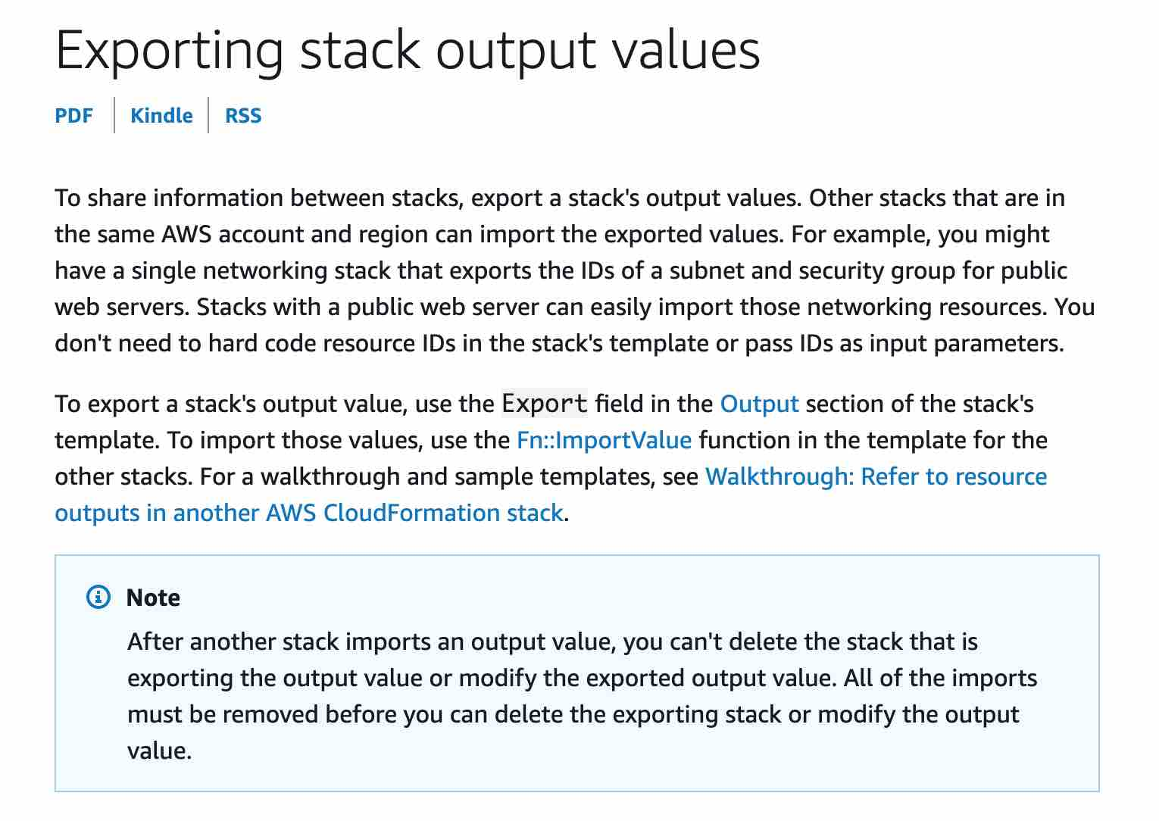 via - <https://docs.aws.amazon.com/AWSCloudFormation/latest/UserGuide/using-cfn-stack-exports.html>

Incorrect options:

**Stack A, then Stack B, then Stack C** - All of the imports must be removed before you can delete the exporting stack or modify the output value. In this case, you cannot delete Stack A first because that's being referenced in the other Stacks.

**Stack A, Stack C then Stack B** - All of the imports must be removed before you can delete the exporting stack or modify the output value. In this case, you cannot delete Stack A first because that's being referenced in the other Stacks.

**Stack C then Stack A then Stack B** - Stack C is fine but you should delete Stack B before Stack A because all of the imports must be removed before you can delete the exporting stack or modify the output value.

Reference: <https://docs.aws.amazon.com/AWSCloudFormation/latest/UserGuide/using-cfn-stack-exports.html>

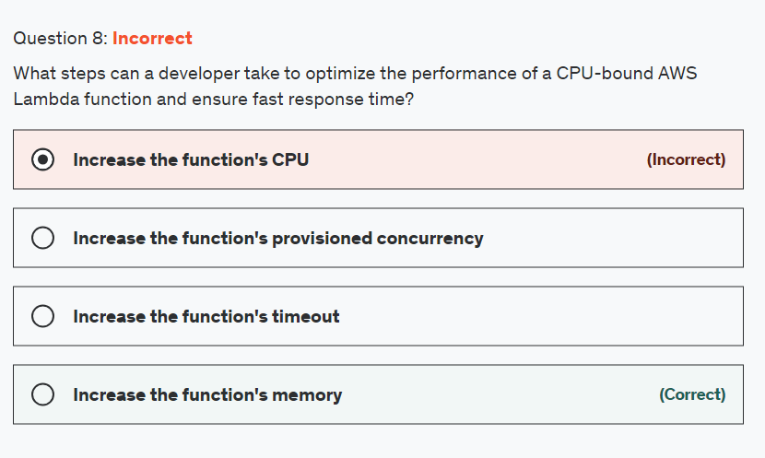

Explanation

Correct option:

**Increase the function's memory**

Memory is the principal lever available to Lambda developers for controlling the performance of a function. You can configure the amount of memory allocated to a Lambda function, between 128 MB and 10,240 MB. The Lambda console defaults new functions to the smallest setting and many developers also choose 128 MB for their functions.

The amount of memory also determines the amount of virtual CPU available to a function. Adding more memory proportionally increases the amount of CPU, increasing the overall computational power available. If a function is CPU-, network- or memory-bound, then changing the memory setting can dramatically improve its performance.

Incorrect options:

**Increase the function's provisioned concurrency**

**Increase the function's reserved concurrency**

In Lambda, concurrency is the number of requests your function can handle at the same time. There are two types of concurrency controls available:

Reserved concurrency – Reserved concurrency guarantees the maximum number of concurrent instances for the function. When a function has reserved concurrency, no other function can use that concurrency. There is no charge for configuring reserved concurrency for a function.

Provisioned concurrency – Provisioned concurrency initializes a requested number of execution environments so that they are prepared to respond immediately to your function's invocations. Note that configuring provisioned concurrency incurs charges to your AWS account.

Neither reserved concurrency nor provisioned concurrency has any impact on the CPU available to a function, so both these options are incorrect

**Increase the function's CPU** - This is a distractor as you cannot directly increase the CPU available to a function.

References:

<https://docs.aws.amazon.com/lambda/latest/operatorguide/computing-power.html>

<https://docs.aws.amazon.com/lambda/latest/dg/provisioned-concurrency.html>

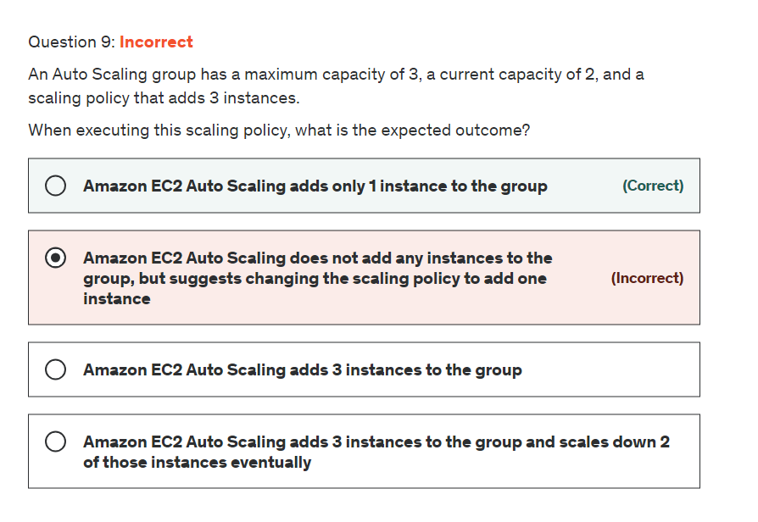

Explanation

Correct option:

A scaling policy instructs Amazon EC2 Auto Scaling to track a specific CloudWatch metric, and it defines what action to take when the associated CloudWatch alarm is in ALARM.

When a scaling policy is executed, if the capacity calculation produces a number outside of the minimum and maximum size range of the group, Amazon EC2 Auto Scaling ensures that the new capacity never goes outside of the minimum and maximum size limits.

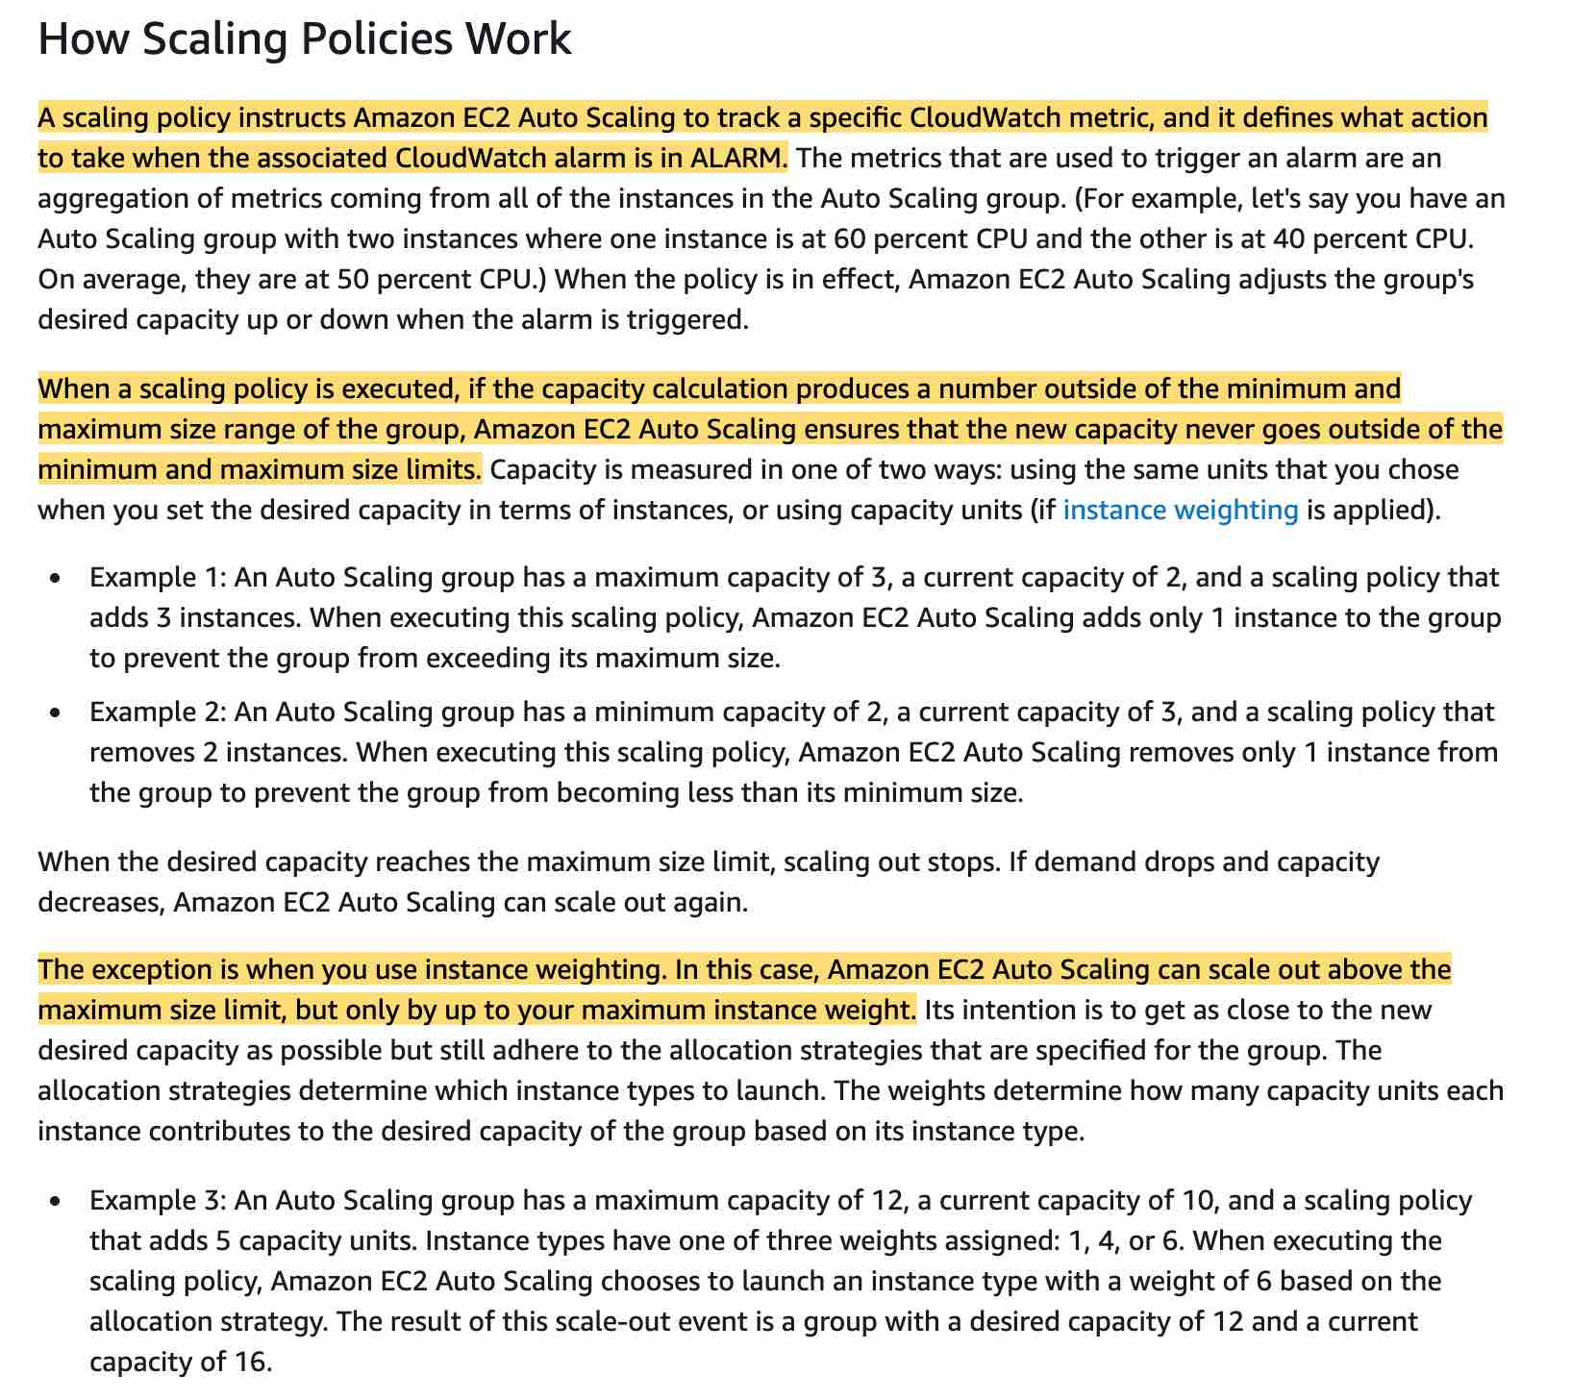 via - <https://docs.aws.amazon.com/autoscaling/ec2/userguide/as-scale-based-on-demand.html>

**Amazon EC2 Auto Scaling adds only 1 instance to the group**

For the given use-case, Amazon EC2 Auto Scaling adds only 1 instance to the group to prevent the group from exceeding its maximum size.

Incorrect options:

**Amazon EC2 Auto Scaling adds 3 instances to the group** - This is an incorrect statement. Auto Scaling ensures that the new capacity never goes outside of the minimum and maximum size limits.

**Amazon EC2 Auto Scaling adds 3 instances to the group and scales down 2 of those instances eventually** - This is an incorrect statement. Adding the instances initially and immediately downsizing them is impractical.

**Amazon EC2 Auto Scaling does not add any instances to the group, but suggests changing the scaling policy to add one instance** - This option has been added as a distractor.

Reference:

<https://docs.aws.amazon.com/autoscaling/ec2/userguide/as-scale-based-on-demand.html>

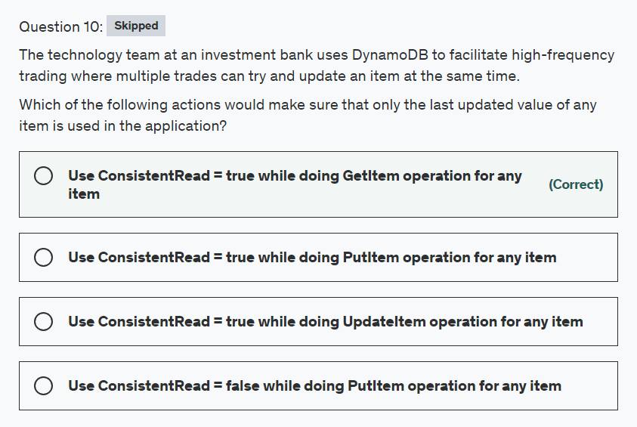

Explanation

Correct option:

**Use ConsistentRead = true while doing GetItem operation for any item**

DynamoDB supports eventually consistent and strongly consistent reads.

Eventually Consistent Reads

When you read data from a DynamoDB table, the response might not reflect the results of a recently completed write operation. The response might include some stale data. If you repeat your read request after a short time, the response should return the latest data.

Strongly Consistent Reads

When you request a strongly consistent read, DynamoDB returns a response with the most up-to-date data, reflecting the updates from all prior write operations that were successful.

DynamoDB uses eventually consistent reads by default. Read operations (such as GetItem, Query, and Scan) provide a ConsistentRead parameter. If you set this parameter to true, DynamoDB uses strongly consistent reads during the operation. As per the given use-case, to make sure that only the last updated value of any item is used in the application, you should use strongly consistent reads by setting ConsistentRead = true for GetItem operation.

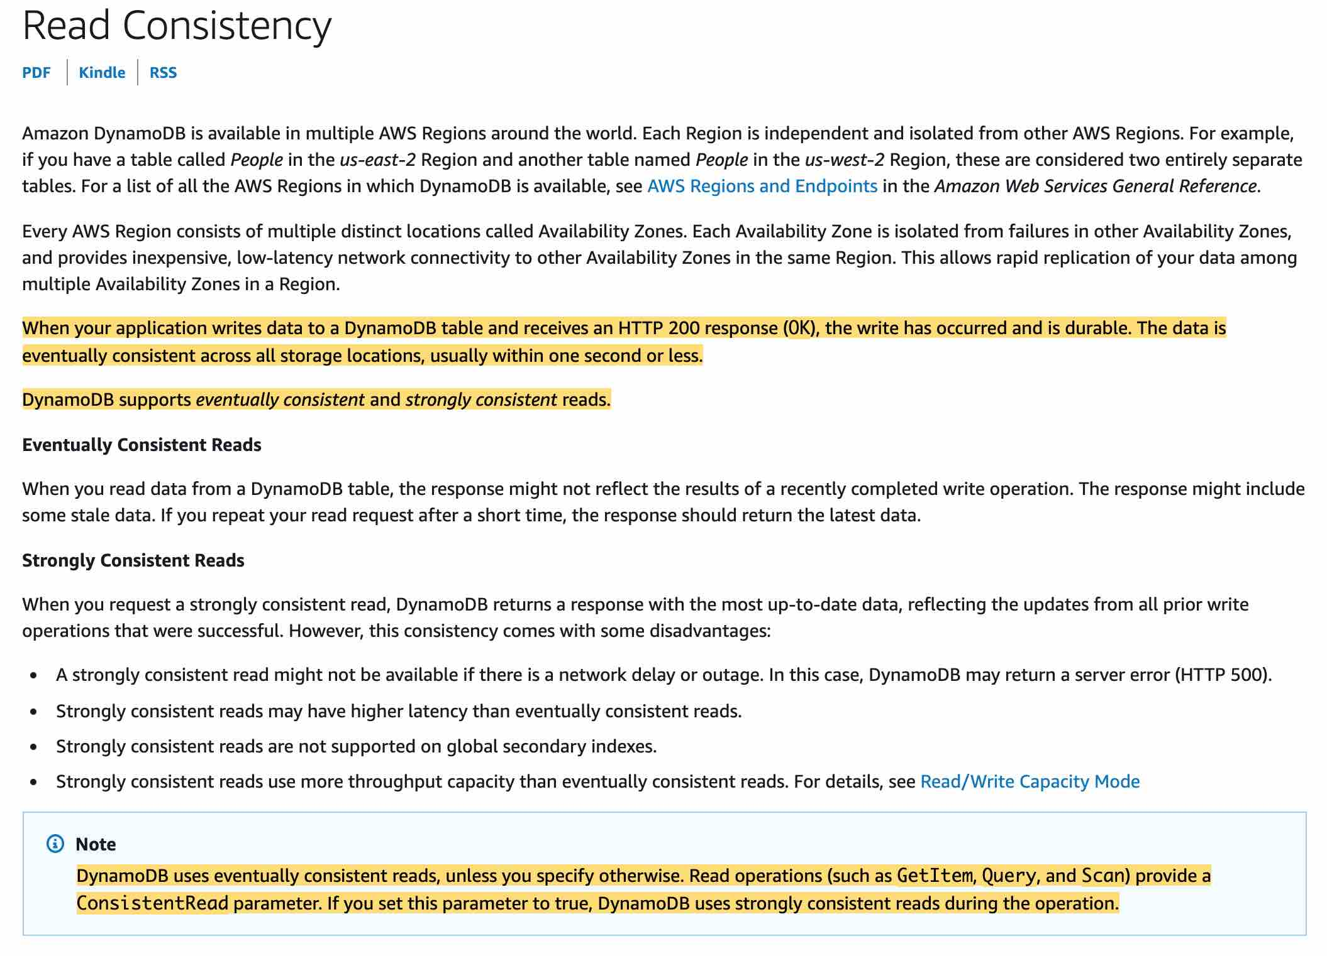 via - <https://docs.aws.amazon.com/amazondynamodb/latest/developerguide/HowItWorks.ReadConsistency.html>

Incorrect options:

**Use ConsistentRead = true while doing UpdateItem operation for any item**

**Use ConsistentRead = true while doing PutItem operation for any item**

**Use ConsistentRead = false while doing PutItem operation for any item**

As mentioned in the explanation above, strongly consistent reads apply only while using the read operations (such as GetItem, Query, and Scan). So these three options are incorrect.

Reference:

<https://docs.aws.amazon.com/amazondynamodb/latest/developerguide/HowItWorks.ReadConsistency.html>

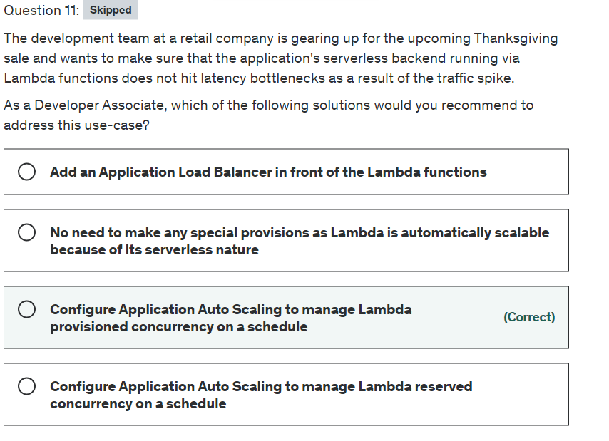

Explanation

Correct option:

**Configure Application Auto Scaling to manage Lambda provisioned concurrency on a schedule**

Concurrency is the number of requests that a Lambda function is serving at any given time. If a Lambda function is invoked again while a request is still being processed, another instance is allocated, which increases the function's concurrency.

Due to a spike in traffic, when Lambda functions scale, this causes the portion of requests that are served by new instances to have higher latency than the rest. To enable your function to scale without fluctuations in latency, use provisioned concurrency. By allocating provisioned concurrency before an increase in invocations, you can ensure that all requests are served by initialized instances with very low latency.

You can configure Application Auto Scaling to manage provisioned concurrency on a schedule or based on utilization. Use scheduled scaling to increase provisioned concurrency in anticipation of peak traffic. To increase provisioned concurrency automatically as needed, use the Application Auto Scaling API to register a target and create a scaling policy.

Please see this note for more details on provisioned concurrency: 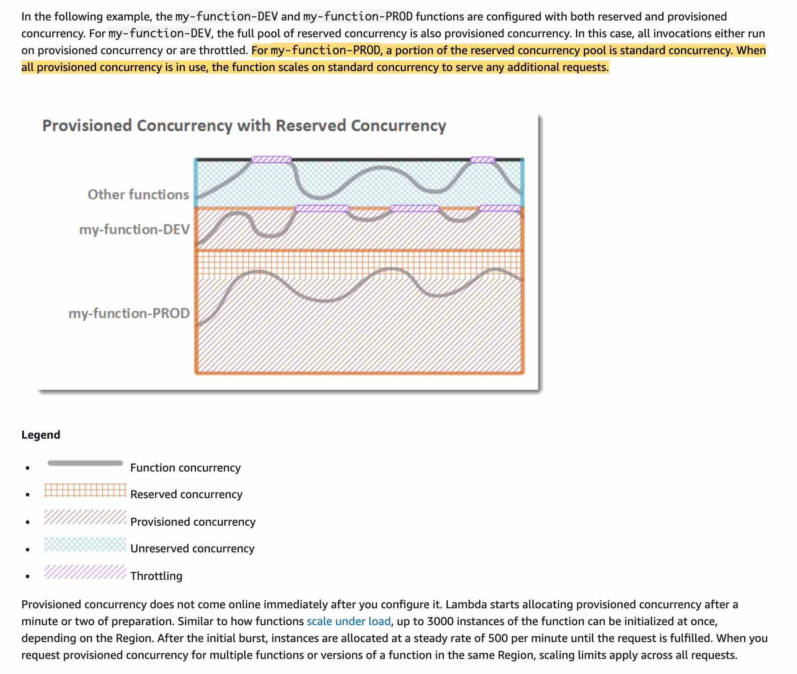 via - <https://docs.aws.amazon.com/lambda/latest/dg/configuration-concurrency.html>

Incorrect options:

**Configure Application Auto Scaling to manage Lambda reserved concurrency on a schedule** - To ensure that a function can always reach a certain level of concurrency, you can configure the function with reserved concurrency. When a function has reserved concurrency, no other function can use that concurrency. More importantly, reserved concurrency also limits the maximum concurrency for the function, and applies to the function as a whole, including versions and aliases.

You cannot configure Application Auto Scaling to manage Lambda reserved concurrency on a schedule.

**Add an Application Load Balancer in front of the Lambda functions** - This is a distractor as just adding the Application Load Balancer will not help in scaling the Lambda functions to address the surge in traffic.

**No need to make any special provisions as Lambda is automatically scalable because of its serverless nature** - It's true that Lambda is serverless, however, due to the surge in traffic the Lambda functions can still hit the concurrency limits. So this option is incorrect.

Reference:

<https://docs.aws.amazon.com/lambda/latest/dg/configuration-concurrency.html>

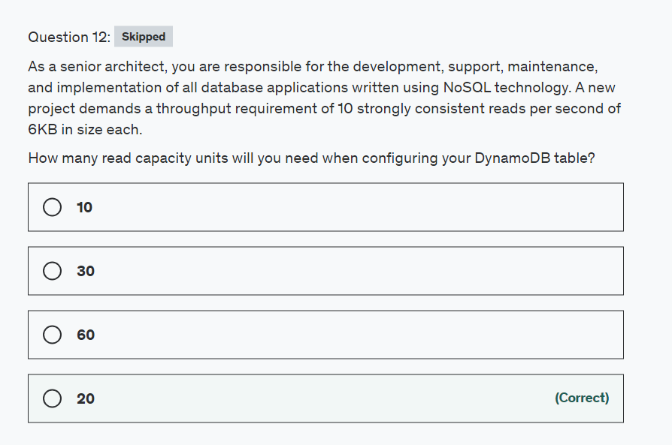

Explanation

Correct option:

Before proceeding with the calculations, please review the following:

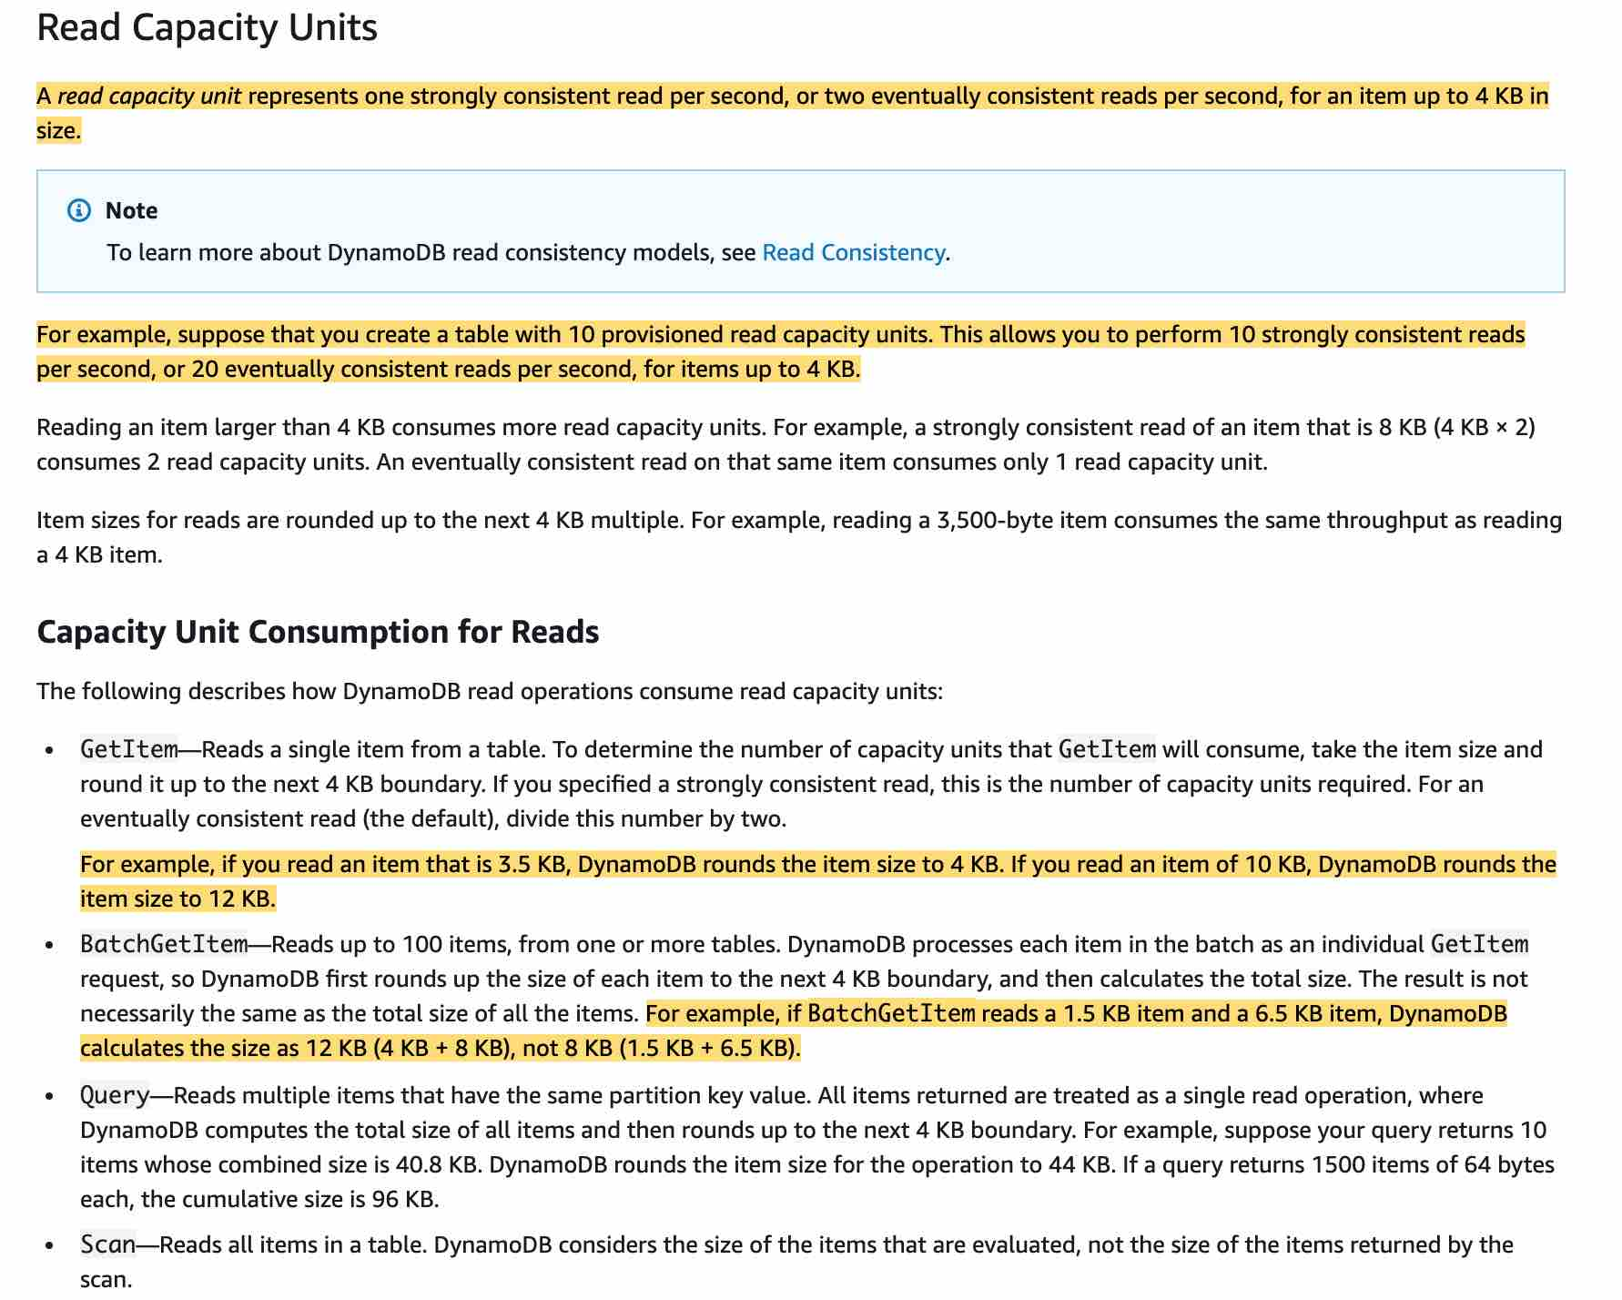

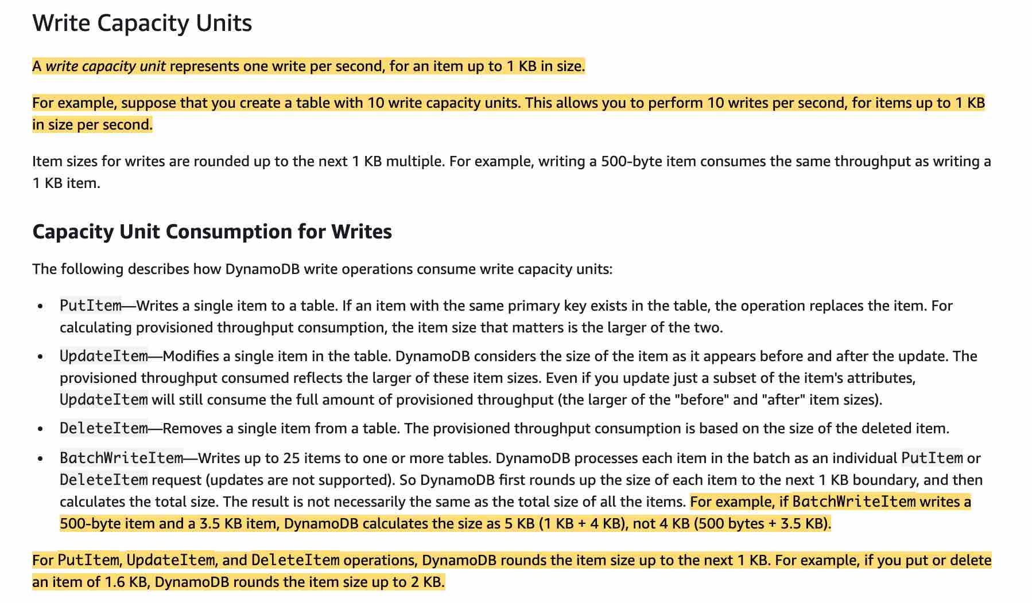

via - <https://docs.aws.amazon.com/amazondynamodb/latest/developerguide/ProvisionedThroughput.html>

**20**

One read capacity unit represents one strongly consistent read per second for an item up to 4 KB in size. If you need to read an item that is larger than 4 KB, DynamoDB will need to consume additional read capacity units.

1) Item Size / 4KB, rounding to the nearest whole number.

So, in the above case, 6KB / 4 KB = 1.5 or 2 read capacity units.

2) 1 read capacity unit per item (since strongly consistent read) × No of reads per second

So, in the above case, 2 x 10 = 20 read capacity units.

Incorrect options:

**60**

**30**

**10**

These three options contradict the details provided in the explanation above, so these are incorrect.

Reference:

<https://docs.aws.amazon.com/amazondynamodb/latest/developerguide/ProvisionedThroughput.html>

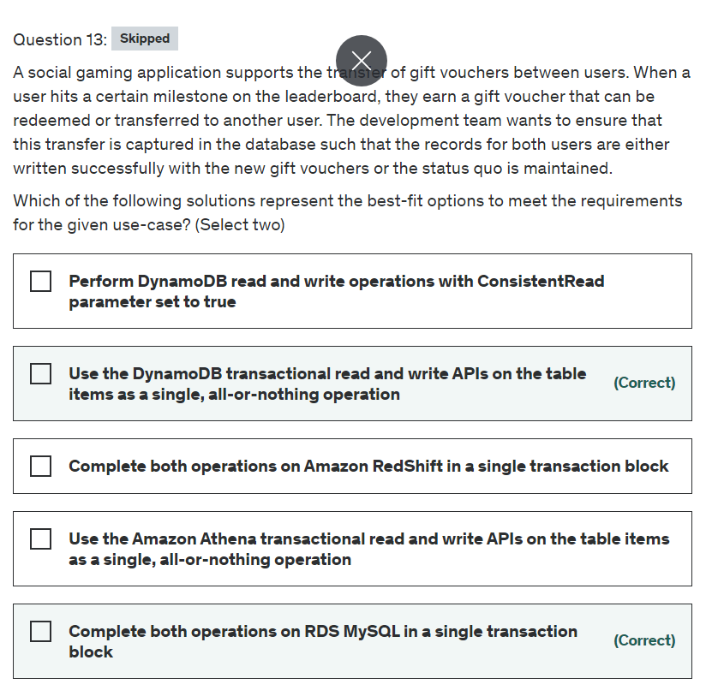

Explanation

Correct option:

**Use the DynamoDB transactional read and write APIs on the table items as a single, all-or-nothing operation**

You can use DynamoDB transactions to make coordinated all-or-nothing changes to multiple items both within and across tables. Transactions provide atomicity, consistency, isolation, and durability (ACID) in DynamoDB, helping you to maintain data correctness in your applications.

DynamoDB Transactions Overview: 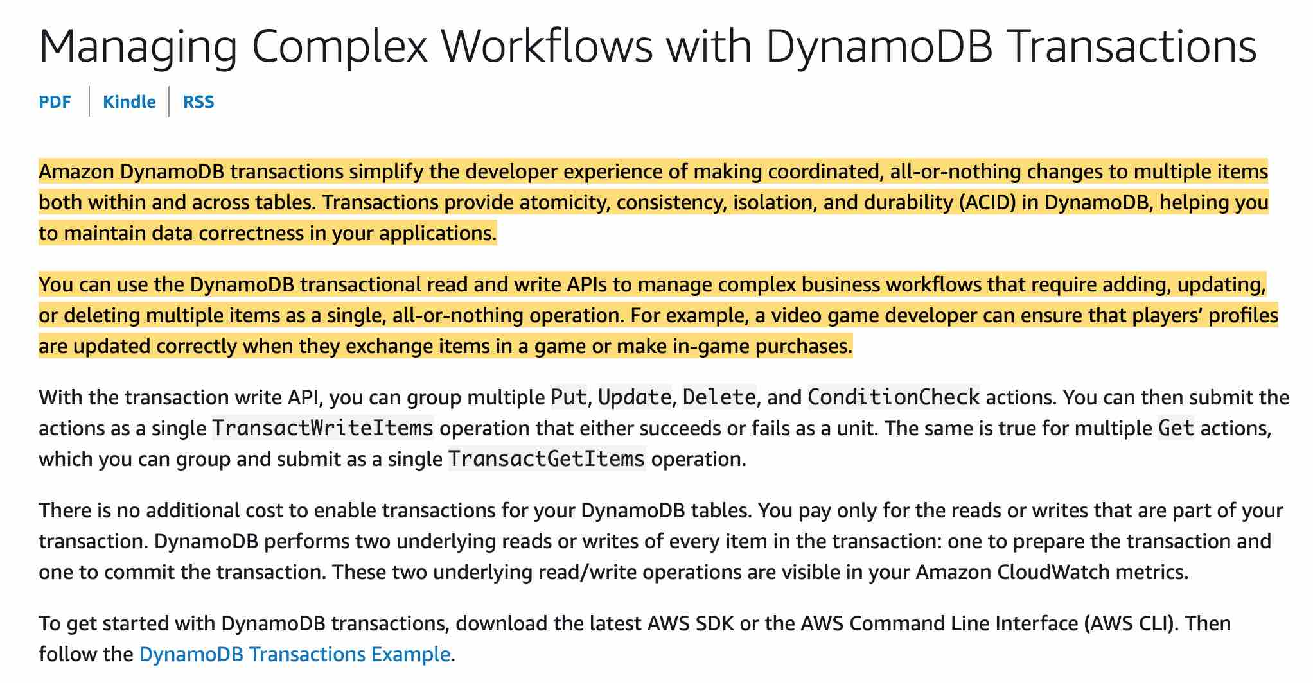 via - <https://docs.aws.amazon.com/amazondynamodb/latest/developerguide/transactions.html>

**Complete both operations on RDS MySQL in a single transaction block**

Amazon Relational Database Service (Amazon RDS) makes it easy to set up, operate, and scale a relational database with support for transactions in the cloud. A relational database is a collection of data items with pre-defined relationships between them. RDS supports the most demanding database applications. You can choose between two SSD-backed storage options: one optimized for high-performance Online Transaction Processing (OLTP) applications, and the other for cost-effective general-purpose use.

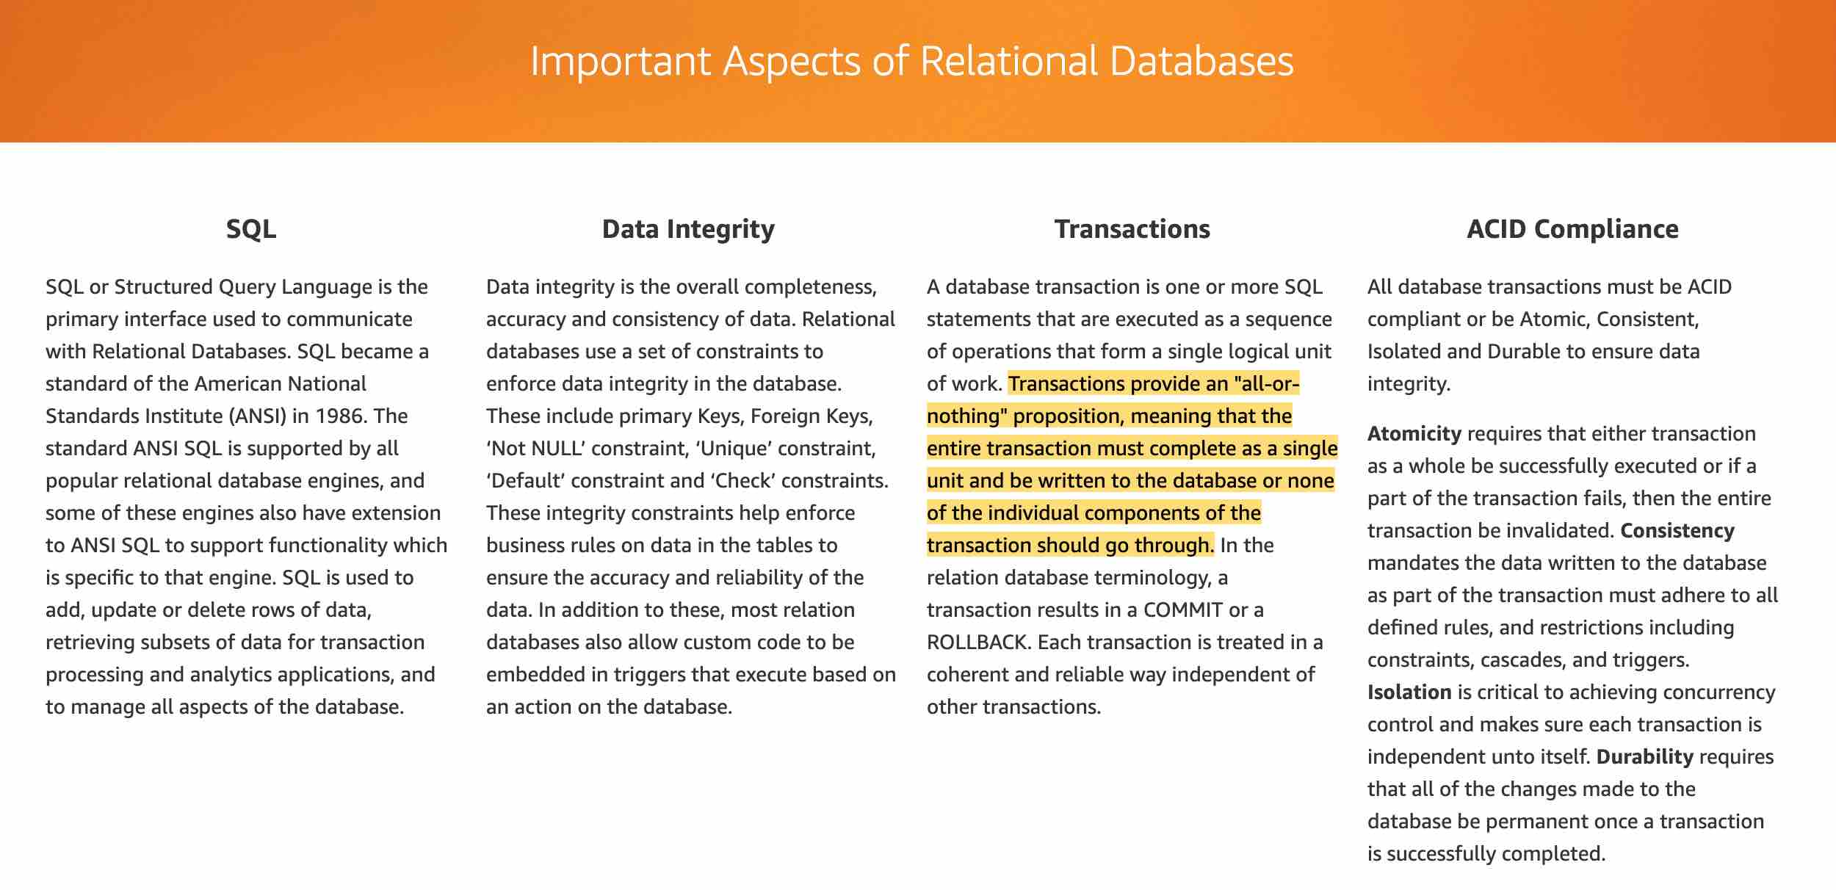 via - <https://aws.amazon.com/relational-database/>

Incorrect options:

**Perform DynamoDB read and write operations with ConsistentRead parameter set to true** - DynamoDB uses eventually consistent reads unless you specify otherwise. Read operations (such as GetItem, Query, and Scan) provide a ConsistentRead parameter. If you set this parameter to true, DynamoDB uses strongly consistent reads during the operation. Read consistency does not facilitate DynamoDB transactions and this option has been added as a distractor.

**Complete both operations on Amazon RedShift in a single transaction block** - Amazon Redshift is a fully-managed petabyte-scale cloud-based data warehouse product designed for large scale data set storage and analysis. It cannot be used to manage database transactions.

**Use the Amazon Athena transactional read and write APIs on the table items as a single, all-or-nothing operation** - Amazon Athena is an interactive query service that makes it easy to analyze data in Amazon S3 using standard SQL. Athena is serverless, so there is no infrastructure to manage, and you pay only for the queries that you run. It cannot be used to manage database transactions.

References:

<https://docs.aws.amazon.com/amazondynamodb/latest/developerguide/transactions.html>

<https://aws.amazon.com/relational-database/>

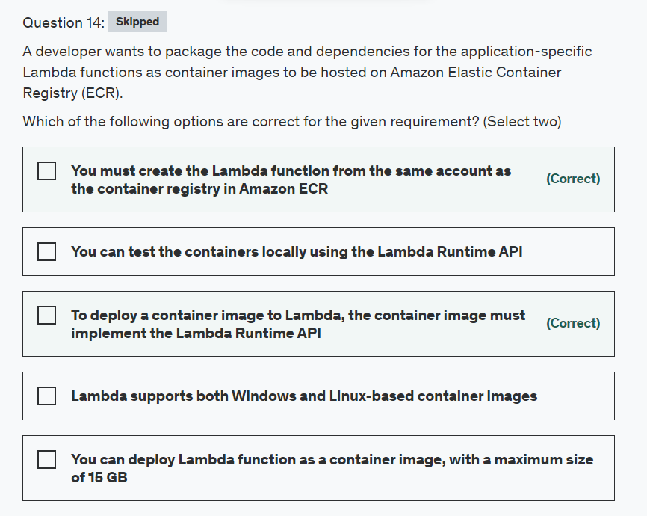

Explanation

Correct options:

**To deploy a container image to Lambda, the container image must implement the Lambda Runtime API** - To deploy a container image to Lambda, the container image must implement the Lambda Runtime API. The AWS open-source runtime interface clients implement the API. You can add a runtime interface client to your preferred base image to make it compatible with Lambda.

**You must create the Lambda function from the same account as the container registry in Amazon ECR** - You can package your Lambda function code and dependencies as a container image, using tools such as the Docker CLI. You can then upload the image to your container registry hosted on Amazon Elastic Container Registry (Amazon ECR). Note that you must create the Lambda function from the same account as the container registry in Amazon ECR.

Incorrect options:

**Lambda supports both Windows and Linux-based container images** - Lambda currently supports only Linux-based container images.

**You can test the containers locally using the Lambda Runtime API** - You can test the containers locally using the Lambda Runtime Interface Emulator.

**You can deploy Lambda function as a container image, with a maximum size of 15 GB** - You can deploy Lambda function as container image with the maximum size of 10GB.

Reference:

<https://docs.aws.amazon.com/lambda/latest/dg/images-create.html>

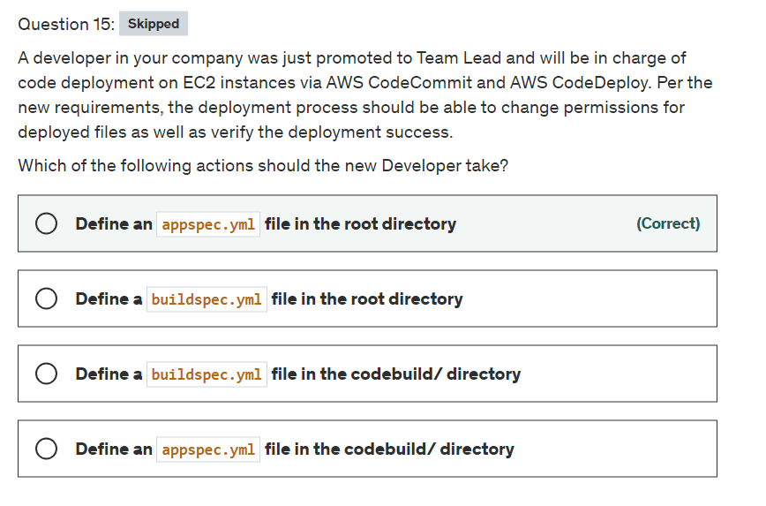

Explanation

Correct option:

**Define an appspec.yml file in the root directory**: An AppSpec file must be a YAML-formatted file named appspec.yml and it must be placed in the root of the directory structure of an application's source code.

The AppSpec file is used to:

Map the source files in your application revision to their destinations on the instance.

Specify custom permissions for deployed files.

Specify scripts to be run on each instance at various stages of the deployment process.

During deployment, the CodeDeploy agent looks up the name of the current event in the hooks section of the AppSpec file. If the event is not found, the CodeDeploy agent moves on to the next step. If the event is found, the CodeDeploy agent retrieves the list of scripts to execute. The scripts are run sequentially, in the order in which they appear in the file. The status of each script is logged in the CodeDeploy agent log file on the instance.

If a script runs successfully, it returns an exit code of 0 (zero). If the CodeDeploy agent installed on the operating system doesn't match what's listed in the AppSpec file, the deployment fails.

Incorrect options:

**Define a buildspec.yml file in the root directory** - This is a file used by AWS CodeBuild to run a build. This is not relevant to the given use case.

**Define a buildspec.yml file in the codebuild/ directory** - This is a file used by AWS CodeBuild to run a build. This is not relevant to the given use case.

**Define an appspec.yml file in the codebuild/ directory** - This file is for AWS CodeDeploy and must be placed in the root of the directory structure of an application's source code.

Reference:

<https://docs.aws.amazon.com/codedeploy/latest/userguide/application-specification-files.html>

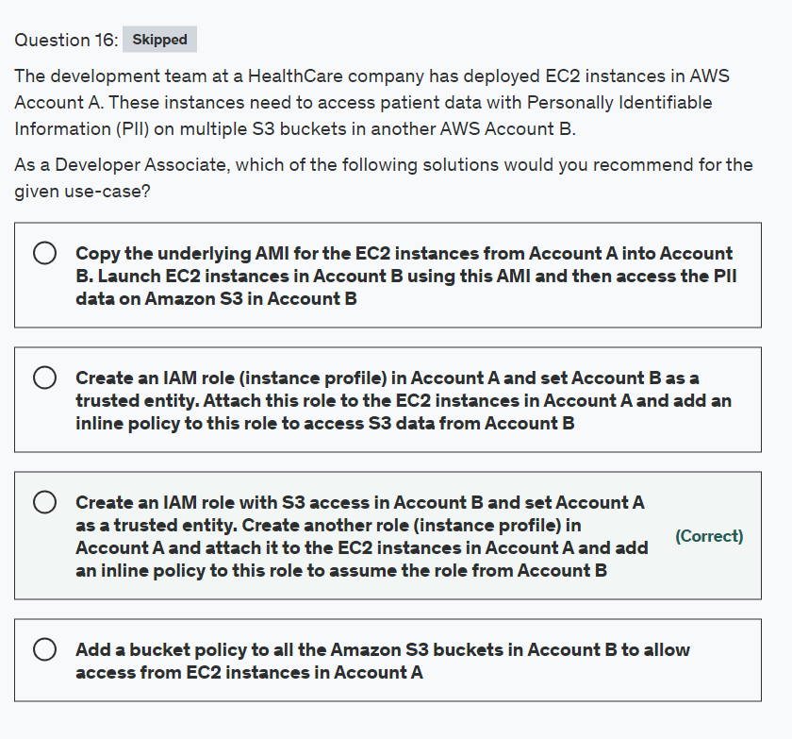

Explanation

Correct option:

**Create an IAM role with S3 access in Account B and set Account A as a trusted entity. Create another role (instance profile) in Account A and attach it to the EC2 instances in Account A and add an inline policy to this role to assume the role from Account B**

You can give EC2 instances in one account ("account A") permissions to assume a role from another account ("account B") to access resources such as S3 buckets. You need to create an IAM role in Account B and set Account A as a trusted entity. Then attach a policy to this IAM role such that it delegates access to Amazon S3 like so -

{

"Version": "2012-10-17",

"Statement": [

{

"Effect": "Allow",

"Action": "s3:*",

"Resource": [

"arn:aws:s3:::awsexamplebucket1",

"arn:aws:s3:::awsexamplebucket1/*",

"arn:aws:s3:::awsexamplebucket2",

"arn:aws:s3:::awsexamplebucket2/*"

]

}

]

}

Then you can create another role (instance profile) in Account A and attach it to the EC2 instances in Account A and add an inline policy to this role to assume the role from Account B like so -

{

"Version": "2012-10-17",

"Statement": [

{

"Effect": "Allow",

"Action": "sts:AssumeRole",

"Resource": "arn:aws:iam::AccountB_ID:role/ROLENAME"

}

]

}

Incorrect options:

**Create an IAM role (instance profile) in Account A and set Account B as a trusted entity. Attach this role to the EC2 instances in Account A and add an inline policy to this role to access S3 data from Account B** - This option contradicts the explanation provided earlier in the explanation, hence this option is incorrect.

**Copy the underlying AMI for the EC2 instances from Account A into Account B. Launch EC2 instances in Account B using this AMI and then access the PII data on Amazon S3 in Account B** - Copying the AMI is a distractor as this does not solve the use-case outlined in the problem statement.

**Add a bucket policy to all the Amazon S3 buckets in Account B to allow access from EC2 instances in Account A** - Just adding a bucket policy in Account B is not enough, as you also need to create an IAM policy in Account A to access S3 objects in Account B.

Please review this reference material for a deep-dive on cross-account access to objects that are in Amazon S3 buckets - <https://aws.amazon.com/premiumsupport/knowledge-center/cross-account-access-s3/>

References:

<https://aws.amazon.com/premiumsupport/knowledge-center/s3-instance-access-bucket/>

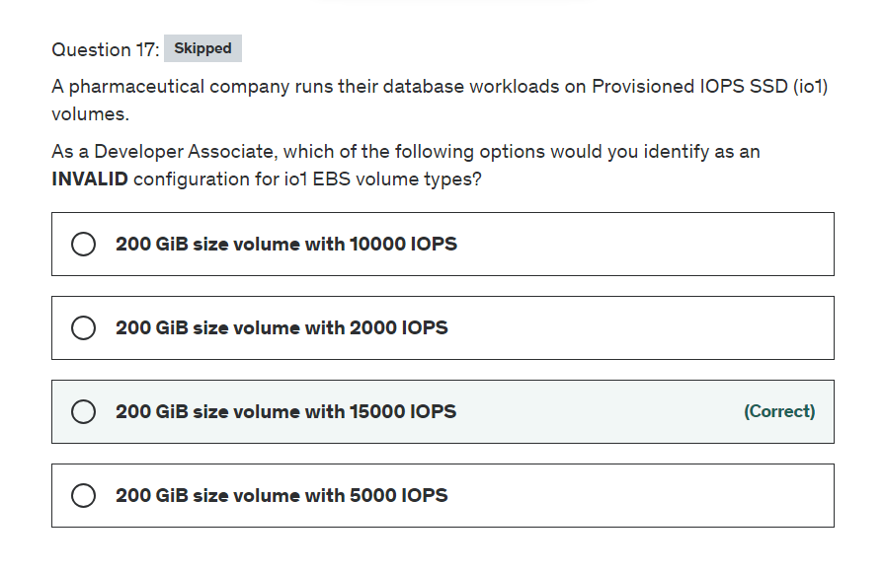

Explanation

Correct option:

**200 GiB size volume with 15000 IOPS** - This is an invalid configuration. The maximum ratio of provisioned IOPS to requested volume size (in GiB) is 50:1. So, for a 200 GiB volume size, max IOPS possible is 200*50 = 10000 IOPS.

Overview of Provisioned IOPS SSD (io1) volumes: 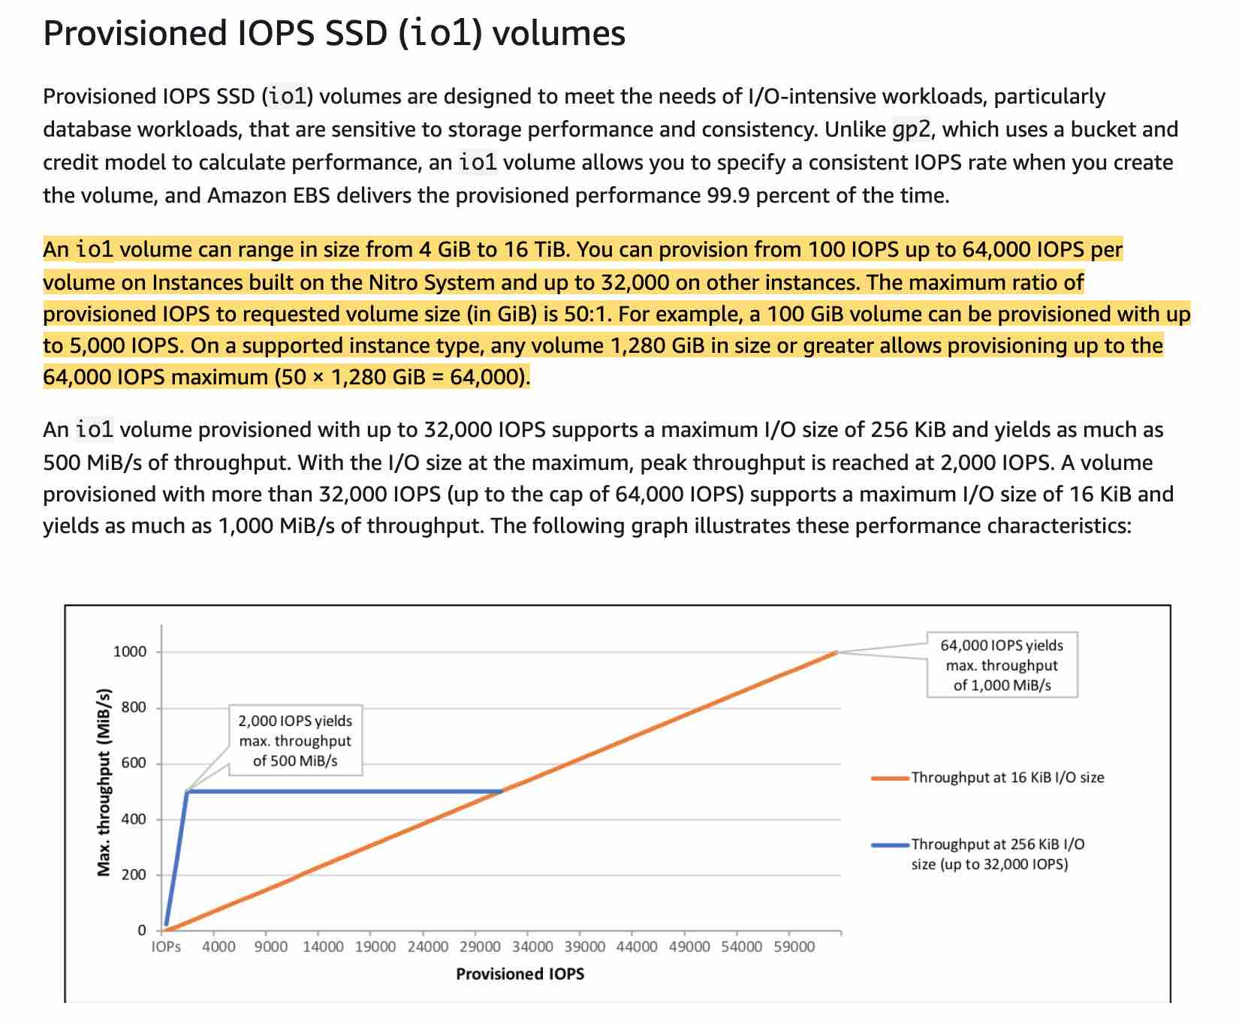 via - <https://docs.aws.amazon.com/AWSEC2/latest/UserGuide/ebs-volume-types.html>

Incorrect options:

Provisioned IOPS SSD (io1) volumes allow you to specify a consistent IOPS rate when you create the volume, and Amazon EBS delivers the provisioned performance 99.9 percent of the time. An io1 volume can range in size from 4 GiB to 16 TiB. The maximum ratio of provisioned IOPS to the requested volume size (in GiB) is 50:1. For example, a 100 GiB volume can be provisioned with up to 5,000 IOPS.

**200 GiB size volume with 2000 IOPS** - As explained above, up to 10000 IOPS is a valid configuration for the given use-case.

**200 GiB size volume with 10000 IOPS** - As explained above, up to 10000 IOPS is a valid configuration for the given use-case.

**200 GiB size volume with 5000 IOPS** - As explained above, up to 10000 IOPS is a valid configuration for the given use-case.

Reference:

<https://docs.aws.amazon.com/AWSEC2/latest/UserGuide/ebs-volume-types.html>

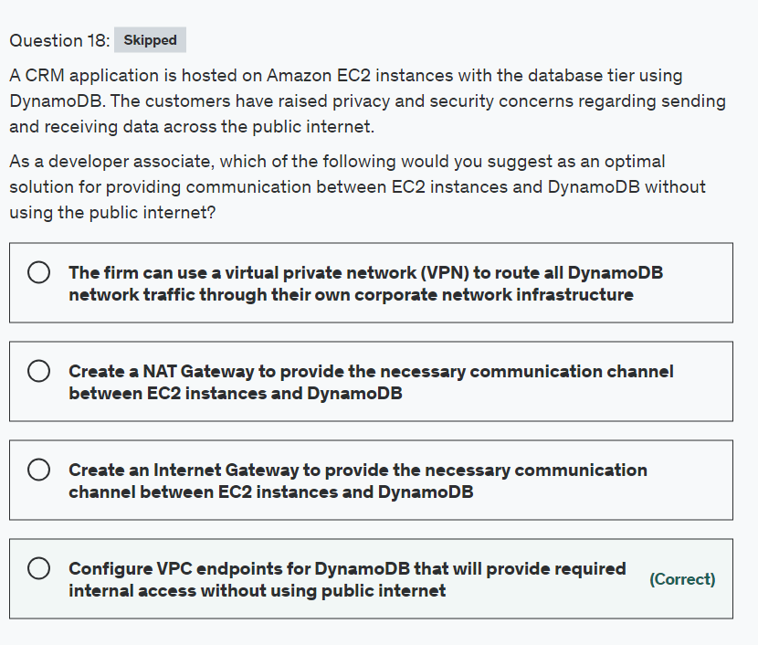

Explanation

Correct option:

**Configure VPC endpoints for DynamoDB that will provide required internal access without using public internet**

When you create a VPC endpoint for DynamoDB, any requests to a DynamoDB endpoint within the Region (for example, dynamodb.us-west-2.amazonaws.com) are routed to a private DynamoDB endpoint within the Amazon network. You don't need to modify your applications running on EC2 instances in your VPC. The endpoint name remains the same, but the route to DynamoDB stays entirely within the Amazon network, and does not access the public internet. You use endpoint policies to control access to DynamoDB. Traffic between your VPC and the AWS service does not leave the Amazon network.

Using Amazon VPC Endpoints to Access DynamoDB: 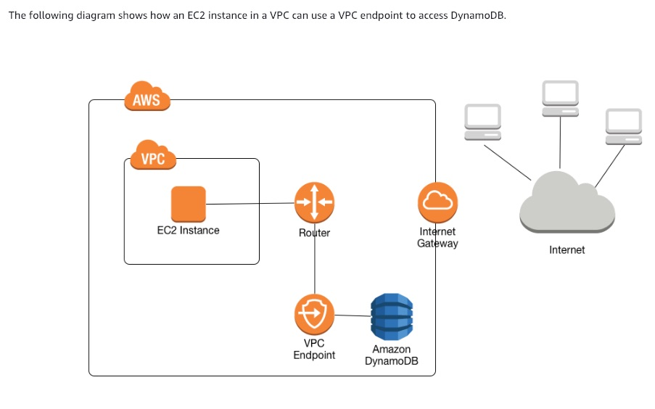 via - <https://docs.aws.amazon.com/amazondynamodb/latest/developerguide/vpc-endpoints-dynamodb.html>

Incorrect options:

**The firm can use a virtual private network (VPN) to route all DynamoDB network traffic through their own corporate network infrastructure** - You can address the requested security concerns by using a virtual private network (VPN) to route all DynamoDB network traffic through your own corporate network infrastructure. However, this approach can introduce bandwidth and availability challenges and hence is not an optimal solution here.

**Create a NAT Gateway to provide the necessary communication channel between EC2 instances and DynamoDB** - You can use a network address translation (NAT) gateway to enable instances in a private subnet to connect to the internet or other AWS services, but prevent the internet from initiating a connection with those instances. NAT Gateway is not useful here since the instance and DynamoDB are present in AWS network and do not need NAT Gateway for communicating with each other.

**Create an Internet Gateway to provide the necessary communication channel between EC2 instances and DynamoDB** - An internet gateway is a horizontally scaled, redundant, and highly available VPC component that allows communication between your VPC and the internet. An internet gateway serves two purposes: to provide a target in your VPC route tables for internet-routable traffic, and to perform network address translation (NAT) for instances that have been assigned public IPv4 addresses. Using an Internet Gateway would imply that the EC2 instances are connecting to DynamoDB using the public internet. Therefore, this option is incorrect.

References:

<https://docs.aws.amazon.com/amazondynamodb/latest/developerguide/vpc-endpoints-dynamodb.html>

<https://docs.aws.amazon.com/vpc/latest/userguide/vpc-nat-gateway.html>

<https://docs.aws.amazon.com/vpc/latest/userguide/Carrier_Gateway.html>

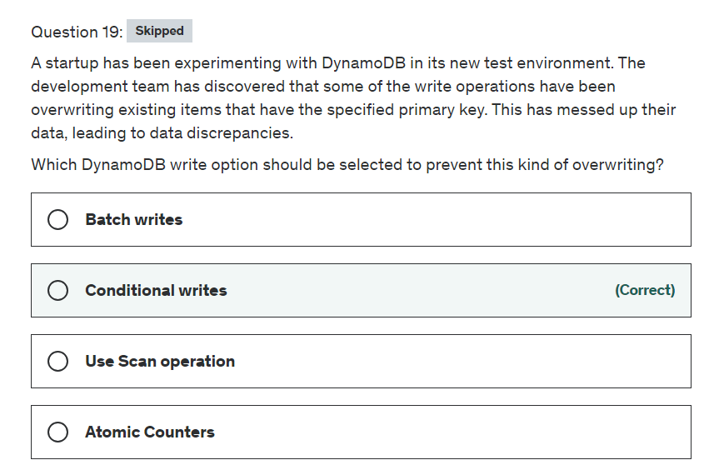

Explanation

Correct option:

**Conditional writes** - DynamoDB optionally supports conditional writes for write operations (PutItem, UpdateItem, DeleteItem). A conditional write succeeds only if the item attributes meet one or more expected conditions. Otherwise, it returns an error.

For example, you might want a PutItem operation to succeed only if there is not already an item with the same primary key. Or you could prevent an UpdateItem operation from modifying an item if one of its attributes has a certain value. Conditional writes are helpful in cases where multiple users attempt to modify the same item. This is the right choice for the current scenario.

Incorrect options:

**Batch writes** - Bath operations (read and write) help reduce the number of network round trips from your application to DynamoDB. In addition, DynamoDB performs the individual read or write operations in parallel. Applications benefit from this parallelism without having to manage concurrency or threading. But, this is of no use in the current scenario of overwriting changes.

**Atomic Counters** - Atomic Counters is a numeric attribute that is incremented, unconditionally, without interfering with other write requests. You might use an atomic counter to track the number of visitors to a website. This functionality is not useful for the current scenario.

**Use Scan operation** - A Scan operation in Amazon DynamoDB reads every item in a table or a secondary index. By default, a Scan operation returns all of the data attributes for every item in the table or index. This is given as a distractor and not related to DynamoDB item updates.

Reference:

<https://docs.aws.amazon.com/amazondynamodb/latest/developerguide/WorkingWithItems.html#WorkingWithItems.ConditionalUpdate>

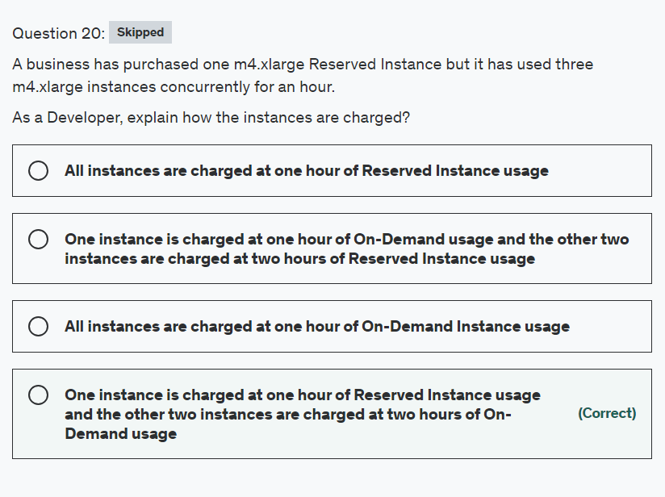

Explanation

Correct option:

All Reserved Instances provide you with a discount compared to On-Demand pricing.

**One instance is charged at one hour of Reserved Instance usage and the other two instances are charged at two hours of On-Demand usage**

A Reserved Instance billing benefit can apply to a maximum of 3600 seconds (one hour) of instance usage per clock-hour. You can run multiple instances concurrently, but can only receive the benefit of the Reserved Instance discount for a total of 3600 seconds per clock-hour; instance usage that exceeds 3600 seconds in a clock-hour is billed at the On-Demand rate.

Please review this note on the EC2 Reserved Instance types: 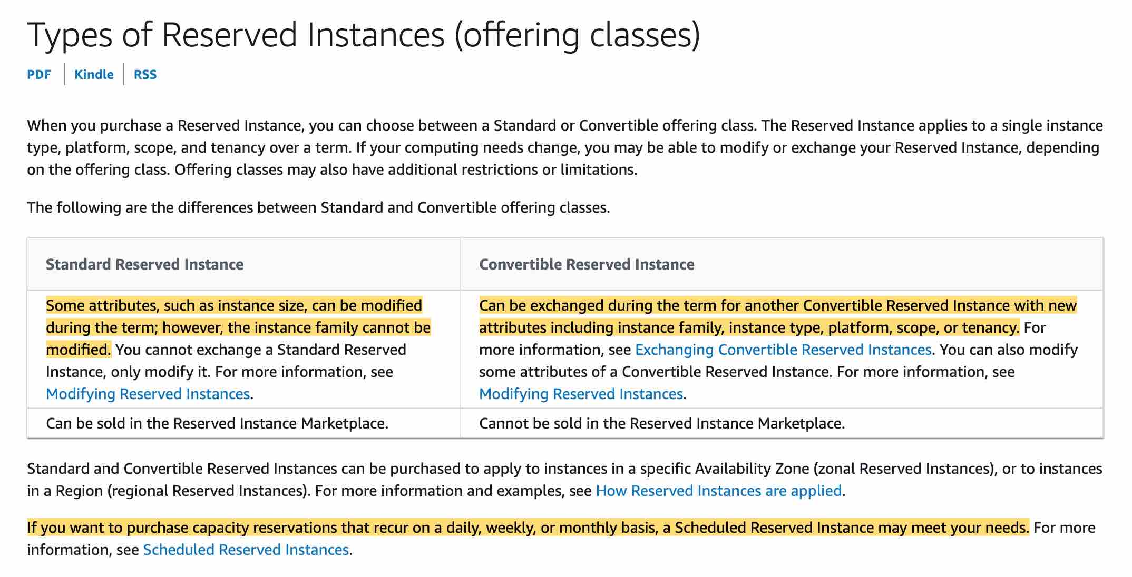 via - <https://docs.aws.amazon.com/AWSEC2/latest/UserGuide/reserved-instances-types.html>

High Level Overview of EC2 Instance Purchase Options:  via - <https://aws.amazon.com/ec2/pricing/>

Incorrect options:

**All instances are charged at one hour of Reserved Instance usage** - This is incorrect.

**All instances are charged at one hour of On-Demand Instance usage** - This is incorrect.

**One instance is charged at one hour of On-Demand usage and the other two instances are charged at two hours of Reserved Instance usage** - This is incorrect. If multiple eligible instances are running concurrently, the Reserved Instance billing benefit is applied to all the instances at the same time up to a maximum of 3600 seconds in a clock-hour; thereafter, On-Demand rates apply.

Reference:

<https://docs.aws.amazon.com/AWSEC2/latest/UserGuide/concepts-reserved-instances-application.html>

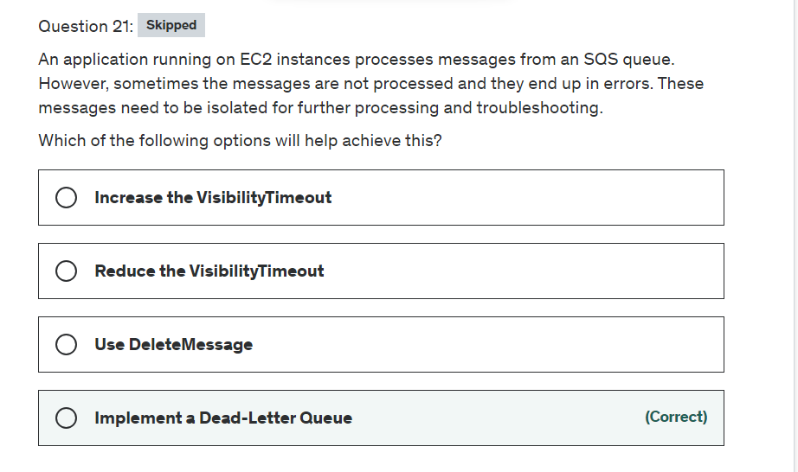

Explanation

Correct option:

**Implement a Dead-Letter Queue** - Amazon SQS supports dead-letter queues, which other queues (source queues) can target for messages that can't be processed (consumed) successfully. Dead-letter queues are useful for debugging your application or messaging system because they let you isolate problematic messages to determine why their processing doesn't succeed. Amazon SQS does not create the dead-letter queue automatically. You must first create the queue before using it as a dead-letter queue.

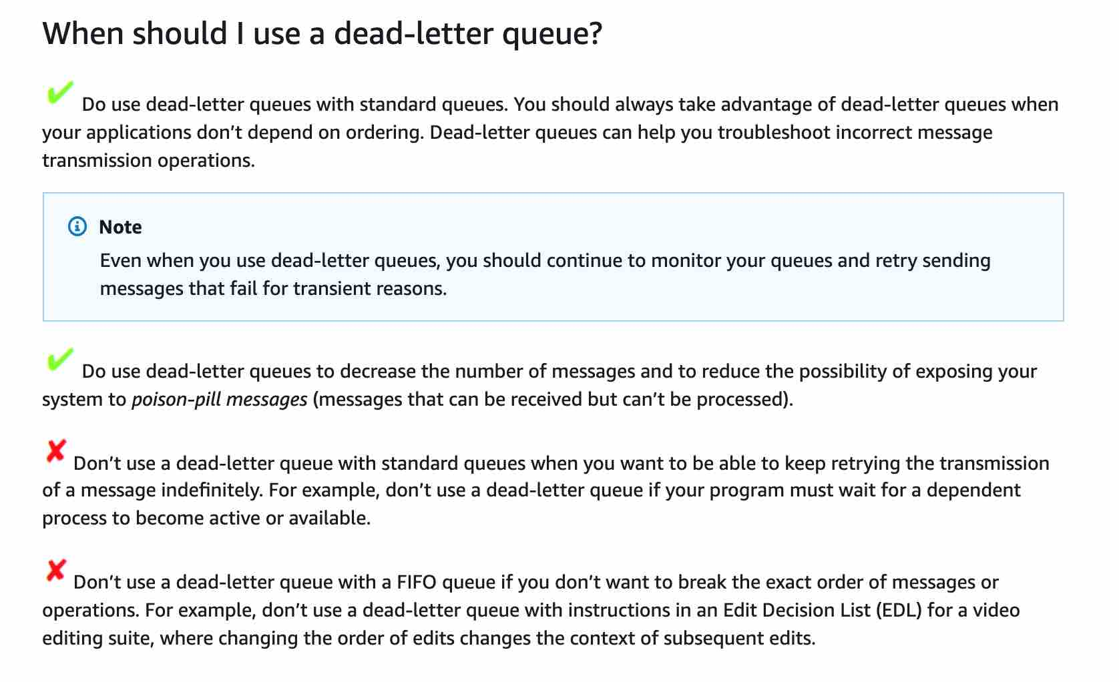 via - <https://docs.aws.amazon.com/AWSSimpleQueueService/latest/SQSDeveloperGuide/sqs-dead-letter-queues.html>

Incorrect options:

**Increase the VisibilityTimeout** - When a consumer receives and processes a message from a queue, the message remains in the queue. Amazon SQS doesn't automatically delete the message. Immediately after a message is received, it remains in the queue. To prevent other consumers from processing the message again, Amazon SQS sets a visibility timeout, a period of time during which Amazon SQS prevents other consumers from receiving and processing the message. Increasing visibility timeout will not help in troubleshooting the messages running into error or isolating them from the rest. Hence this is an incorrect option for the current use case.

**Use DeleteMessage** - Deletes the specified message from the specified queue. This will not help understand the reason for error or isolate messages ending with the error.

**Reduce the VisibilityTimeout** - As explained above, VisibilityTimeout makes sure that the message is not read by any other consumer while it is being processed by one consumer. By reducing the VisibilityTimeout, more consumers will receive the same failed message. Hence, this is an incorrect option for this use case.

References:

<https://docs.aws.amazon.com/AWSSimpleQueueService/latest/SQSDeveloperGuide/sqs-dead-letter-queues.html>

<https://docs.aws.amazon.com/AWSSimpleQueueService/latest/SQSDeveloperGuide/sqs-visibility-timeout.html>

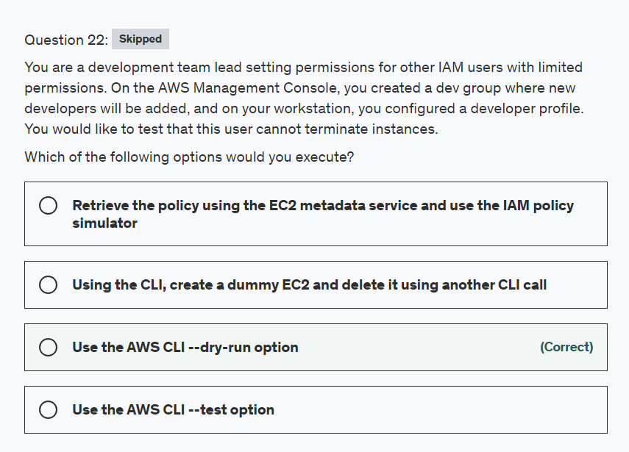

Explanation

Correct option:

**Use the AWS CLI --dry-run option**: The --dry-run option checks whether you have the required permissions for the action, without actually making the request, and provides an error response. If you have the required permissions, the error response is DryRunOperation, otherwise, it is UnauthorizedOperation.

Incorrect options:

**Use the AWS CLI --test option** - This is a made-up option and has been added as a distractor.

**Retrieve the policy using the EC2 metadata service and use the IAM policy simulator** - EC2 metadata service is used to retrieve dynamic information such as instance-id, local-hostname, public-hostname. This cannot be used to check whether you have the required permissions for the action.

**Using the CLI, create a dummy EC2 and delete it using another CLI call** - That would not work as the current EC2 may have permissions that the dummy instance does not have. If permissions were the same it can work but it's not as elegant as using the dry-run option.

References:

<https://docs.aws.amazon.com/AWSEC2/latest/APIReference/API_RunInstances.html>

<https://docs.aws.amazon.com/cli/latest/reference/ec2/terminate-instances.html>

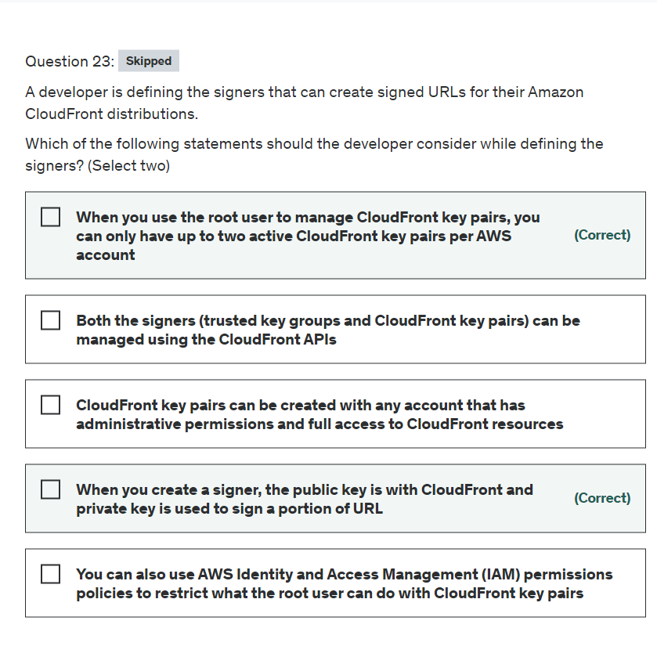

Explanation

Correct options:

**When you create a signer, the public key is with CloudFront and private key is used to sign a portion of URL** - Each signer that you use to create CloudFront signed URLs or signed cookies must have a public–private key pair. The signer uses its private key to sign the URL or cookies, and CloudFront uses the public key to verify the signature.

When you create signed URLs or signed cookies, you use the private key from the signer’s key pair to sign a portion of the URL or the cookie. When someone requests a restricted file, CloudFront compares the signature in the URL or cookie with the unsigned URL or cookie, to verify that it hasn’t been tampered with. CloudFront also verifies that the URL or cookie is valid, meaning, for example, that the expiration date and time haven’t passed.

**When you use the root user to manage CloudFront key pairs, you can only have up to two active CloudFront key pairs per AWS account** - When you use the root user to manage CloudFront key pairs, you can only have up to two active CloudFront key pairs per AWS account.

Whereas, with CloudFront key groups, you can associate a higher number of public keys with your CloudFront distribution, giving you more flexibility in how you use and manage the public keys. By default, you can associate up to four key groups with a single distribution, and you can have up to five public keys in a key group.

Incorrect options:

**You can also use AWS Identity and Access Management (IAM) permissions policies to restrict what the root user can do with CloudFront key pairs** - When you use the AWS account root user to manage CloudFront key pairs, you can’t restrict what the root user can do or the conditions in which it can do them. You can’t apply IAM permissions policies to the root user, which is one reason why AWS best practices recommend against using the root user.

**CloudFront key pairs can be created with any account that has administrative permissions and full access to CloudFront resources** - CloudFront key pairs can only be created using the root user account and hence is not a best practice to create CloudFront key pairs as signers.

**Both the signers (trusted key groups and CloudFront key pairs) can be managed using the CloudFront APIs** - With CloudFront key groups, you can manage public keys, key groups, and trusted signers using the CloudFront API. You can use the API to automate key creation and key rotation. When you use the AWS root user, you have to use the AWS Management Console to manage CloudFront key pairs, so you can’t automate the process.

Reference:

<https://docs.aws.amazon.com/AmazonCloudFront/latest/DeveloperGuide/private-content-trusted-signers.html>

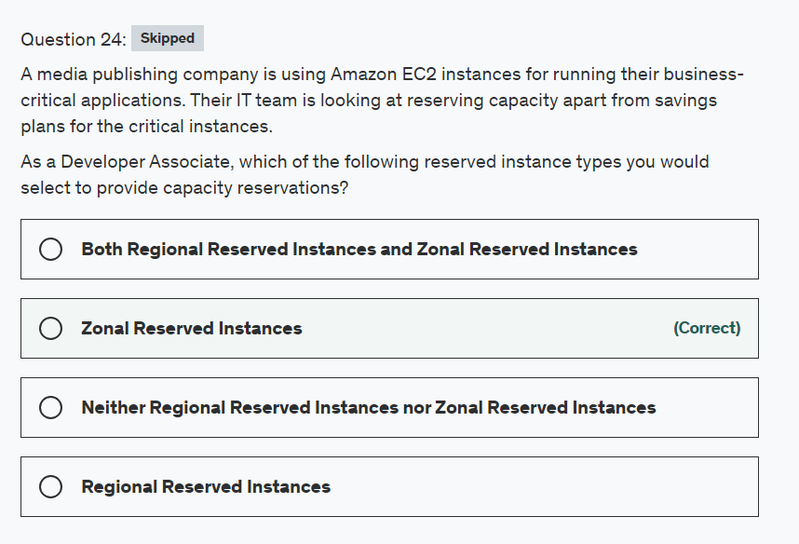

Explanation

Correct option:

When you purchase a Reserved Instance for a specific Availability Zone, it's referred to as a Zonal Reserved Instance. Zonal Reserved Instances provide capacity reservations as well as discounts.

**Zonal Reserved Instances** - A zonal Reserved Instance provides a capacity reservation in the specified Availability Zone. Capacity Reservations enable you to reserve capacity for your Amazon EC2 instances in a specific Availability Zone for any duration. This gives you the ability to create and manage Capacity Reservations independently from the billing discounts offered by Savings Plans or regional Reserved Instances.

Regional and Zonal Reserved Instances: 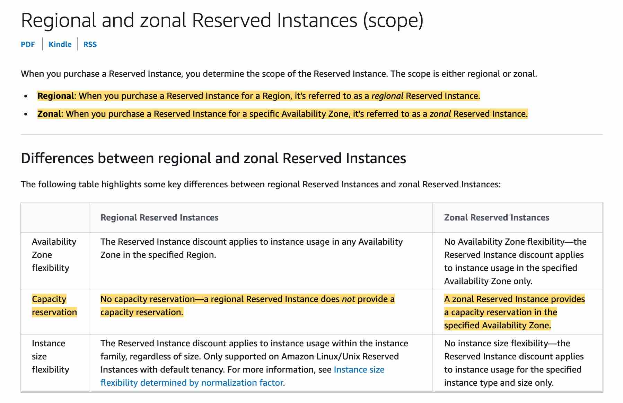 via - <https://docs.aws.amazon.com/AWSEC2/latest/UserGuide/reserved-instances-scope.html>

High Level Overview of EC2 Instance Purchase Options:  via - <https://aws.amazon.com/ec2/pricing/>

Incorrect options:

**Regional Reserved Instances** - When you purchase a Reserved Instance for a Region, it's referred to as a regional Reserved Instance. A regional Reserved Instance does not provide a capacity reservation.

**Both Regional Reserved Instances and Zonal Reserved Instances** - As discussed above, only Zonal Reserved Instances provide capacity reservation.

**Neither Regional Reserved Instances nor Zonal Reserved Instances** - As discussed above, Zonal Reserved Instances provide capacity reservation.

References:

<https://docs.aws.amazon.com/AWSEC2/latest/UserGuide/reserved-instances-scope.html>

<https://docs.aws.amazon.com/AWSEC2/latest/UserGuide/ec2-reserved-instances.html>

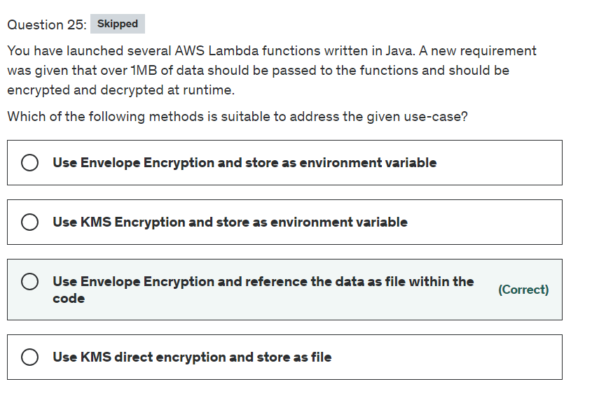

Explanation

Correct option:

**Use Envelope Encryption and reference the data as file within the code**

While AWS KMS does support sending data up to 4 KB to be encrypted directly, envelope encryption can offer significant performance benefits. When you encrypt data directly with AWS KMS it must be transferred over the network. Envelope encryption reduces the network load since only the request and delivery of the much smaller data key go over the network. The data key is used locally in your application or encrypting AWS service, avoiding the need to send the entire block of data to AWS KMS and suffer network latency.

AWS Lambda environment variables can have a maximum size of 4 KB. Additionally, the direct 'Encrypt' API of KMS also has an upper limit of 4 KB for the data payload. To encrypt 1 MB, you need to use the Encryption SDK and pack the encrypted file with the lambda function.

Incorrect options:

**Use KMS direct encryption and store as file** - You can only encrypt up to 4 kilobytes (4096 bytes) of arbitrary data such as an RSA key, a database password, or other sensitive information, so this option is not correct for the given use-case.

**Use Envelope Encryption and store as an environment variable** - Environment variables must not exceed 4 KB, so this option is not correct for the given use-case.

**Use KMS Encryption and store as an environment variable** - You can encrypt up to 4 kilobytes (4096 bytes) of arbitrary data such as an RSA key, a database password, or other sensitive information. Lambda Environment variables must not exceed 4 KB. So this option is not correct for the given use-case.

References:

<https://docs.aws.amazon.com/lambda/latest/dg/gettingstarted-limits.html>

<https://aws.amazon.com/kms/faqs/>

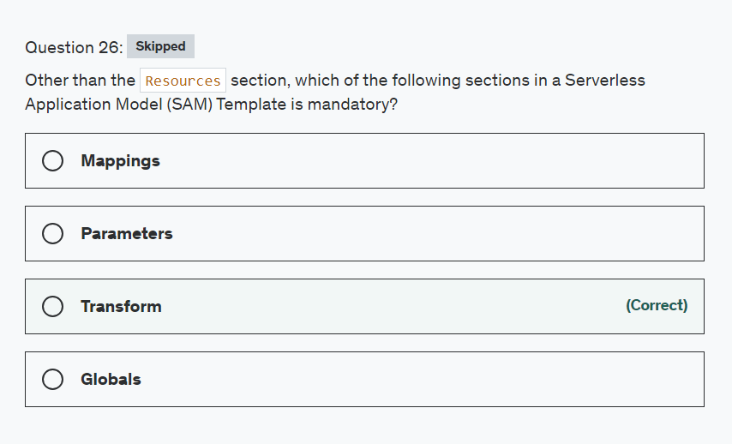

Explanation

Correct option:

**Transform**

The AWS Serverless Application Model (AWS SAM) is an open-source framework that you can use to build serverless applications on AWS.

A serverless application is a combination of Lambda functions, event sources, and other resources that work together to perform tasks. Note that a serverless application is more than just a Lambda function—it can include additional resources such as APIs, databases, and event source mappings.

Serverless Application Model (SAM) Templates include several major sections. Transform and Resources are the only required sections.

Please review this note for more details: 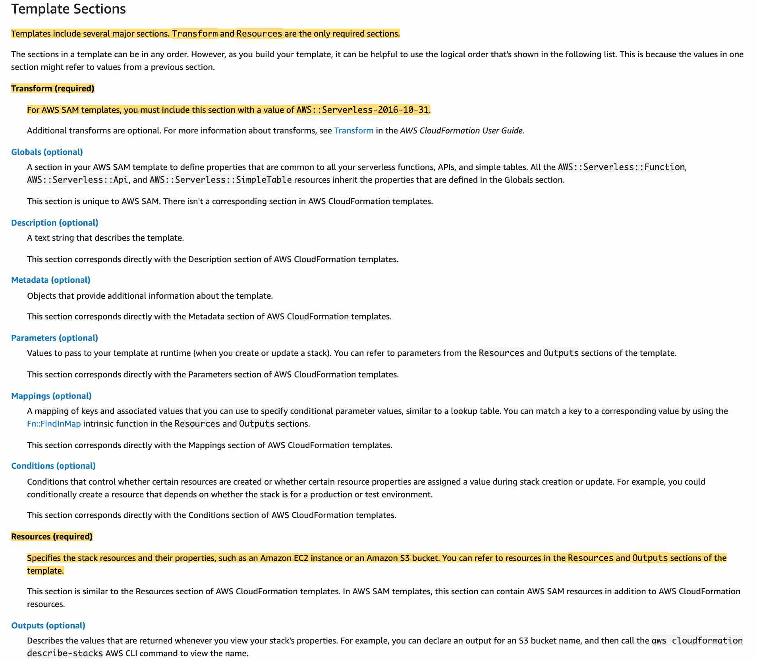 via - <https://docs.aws.amazon.com/serverless-application-model/latest/developerguide/sam-specification-template-anatomy.html>

Incorrect options:

**Parameters**

**Mappings**

**Globals**

These three options contradict the details provided in the explanation above, so these options are not correct.

Reference:

<https://docs.aws.amazon.com/serverless-application-model/latest/developerguide/sam-specification-template-anatomy.html>

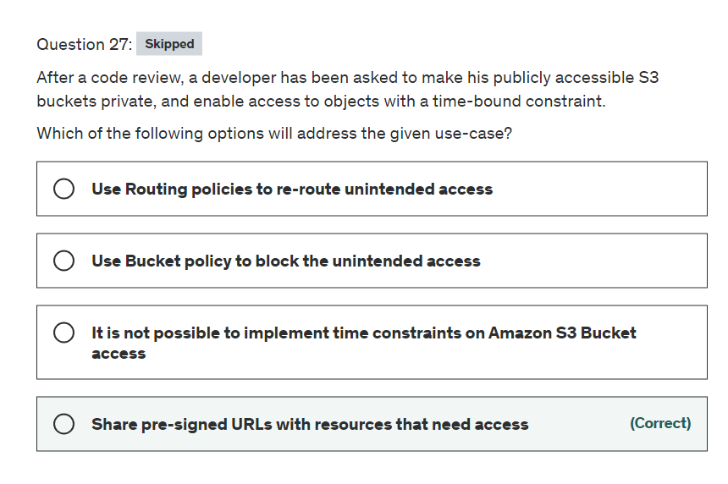

Explanation

Correct option:

**Share pre-signed URLs with resources that need access** - All objects by default are private, with the object owner having permission to access the objects. However, the object owner can optionally share objects with others by creating a pre-signed URL, using their own security credentials, to grant time-limited permission to download the objects. When you create a pre-signed URL for your object, you must provide your security credentials, specify a bucket name, an object key, specify the HTTP method (GET to download the object), and expiration date and time. The pre-signed URLs are valid only for the specified duration.

Incorrect options:

**Use Bucket policy to block the unintended access** - A bucket policy is a resource-based AWS Identity and Access Management (IAM) policy. You add a bucket policy to a bucket to grant other AWS accounts or IAM users access permissions for the bucket and the objects in it. Bucket policy can be used to block off unintended access, but it's not possible to provide time-based access, as is the case in the current use case.

**Use Routing policies to re-route unintended access** - There is no such facility directly available with Amazon S3.

**It is not possible to implement time constraints on Amazon S3 Bucket access** - This is an incorrect statement. As explained above, it is possible to give time-bound access permissions on S3 buckets and objects.

References:

<https://docs.aws.amazon.com/AmazonS3/latest/dev/ShareObjectPreSignedURL.html>

<https://docs.aws.amazon.com/AmazonS3/latest/user-guide/add-bucket-policy.html>

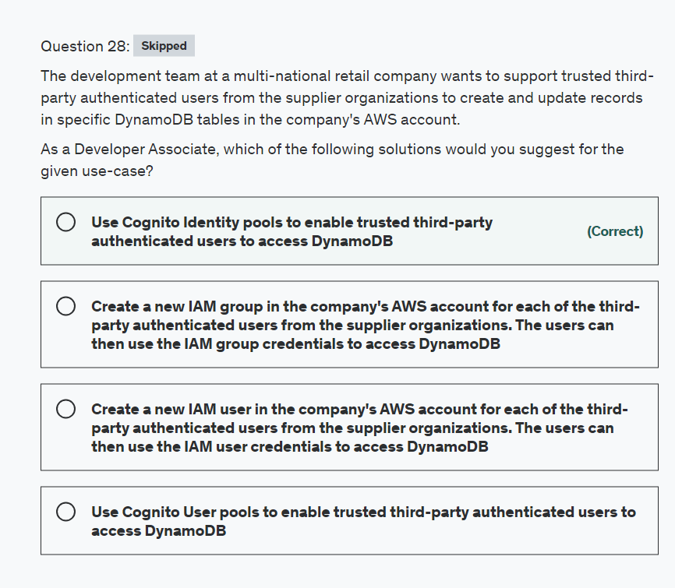

Explanation

Correct option:

**Use Cognito Identity pools to enable trusted third-party authenticated users to access DynamoDB**

Amazon Cognito identity pools (federated identities) enable you to create unique identities for your users and federate them with identity providers. With an identity pool, you can obtain temporary, limited-privilege AWS credentials to access other AWS services. Amazon Cognito identity pools support the following identity providers:

Public providers: Login with Amazon (Identity Pools), Facebook (Identity Pools), Google (Identity Pools), Sign in with Apple (Identity Pools).

Amazon Cognito User Pools

Open ID Connect Providers (Identity Pools)

SAML Identity Providers (Identity Pools)

Developer Authenticated Identities (Identity Pools)

Exam Alert:

Please review the following note to understand the differences between Cognito User Pools and Cognito Identity Pools:  via - <https://docs.aws.amazon.com/cognito/latest/developerguide/what-is-amazon-cognito.html>

Incorrect options:

**Use Cognito User pools to enable trusted third-party authenticated users to access DynamoDB** - A user pool is a user directory in Amazon Cognito. With a user pool, your users can sign in to your web or mobile app through Amazon Cognito, or federate through a third-party identity provider (IdP). Cognito User Pools cannot be used to obtain temporary AWS credentials to access AWS services, such as Amazon S3 and DynamoDB.

**Create a new IAM user in the company's AWS account for each of the third-party authenticated users from the supplier organizations. The users can then use the IAM user credentials to access DynamoDB**

**Create a new IAM group in the company's AWS account for each of the third-party authenticated users from the supplier organizations. The users can then use the IAM group credentials to access DynamoDB**

Both these options involve setting up IAM resources such as IAM users or IAM groups just to provide access to DynamoDB tables. As the users are already trusted third-party authenticated users, Cognito Identity Pool can address this use-case in an elegant way.

Reference:

<https://docs.aws.amazon.com/cognito/latest/developerguide/what-is-amazon-cognito.html>

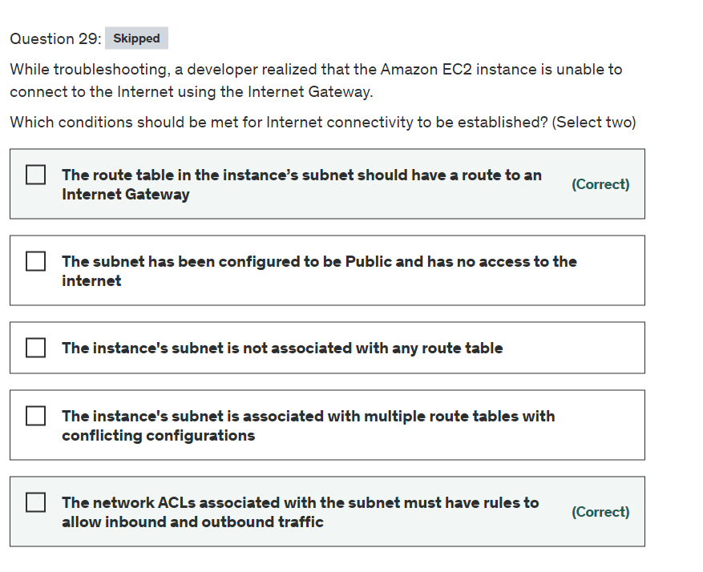

Explanation

Correct options:

**The network ACLs associated with the subnet must have rules to allow inbound and outbound traffic** - The network access control lists (ACLs) that are associated with the subnet must have rules to allow inbound and outbound traffic on port 80 (for HTTP traffic) and port 443 (for HTTPs traffic). This is a necessary condition for Internet Gateway connectivity

**The route table in the instance’s subnet should have a route to an Internet Gateway** - A route table contains a set of rules, called routes, that are used to determine where network traffic from your subnet or gateway is directed. The route table in the instance’s subnet should have a route defined to the Internet Gateway.

Incorrect options:

**The instance's subnet is not associated with any route table** - This is an incorrect statement. A subnet is implicitly associated with the main route table if it is not explicitly associated with a particular route table. So, a subnet is always associated with some route table.

**The instance's subnet is associated with multiple route tables with conflicting configurations** - This is an incorrect statement. A subnet can only be associated with one route table at a time.

**The subnet has been configured to be Public and has no access to internet** - This is an incorrect statement. Public subnets have access to the internet via Internet Gateway.

Reference:

<https://docs.aws.amazon.com/vpc/latest/userguide/VPC_Route_Tables.html>

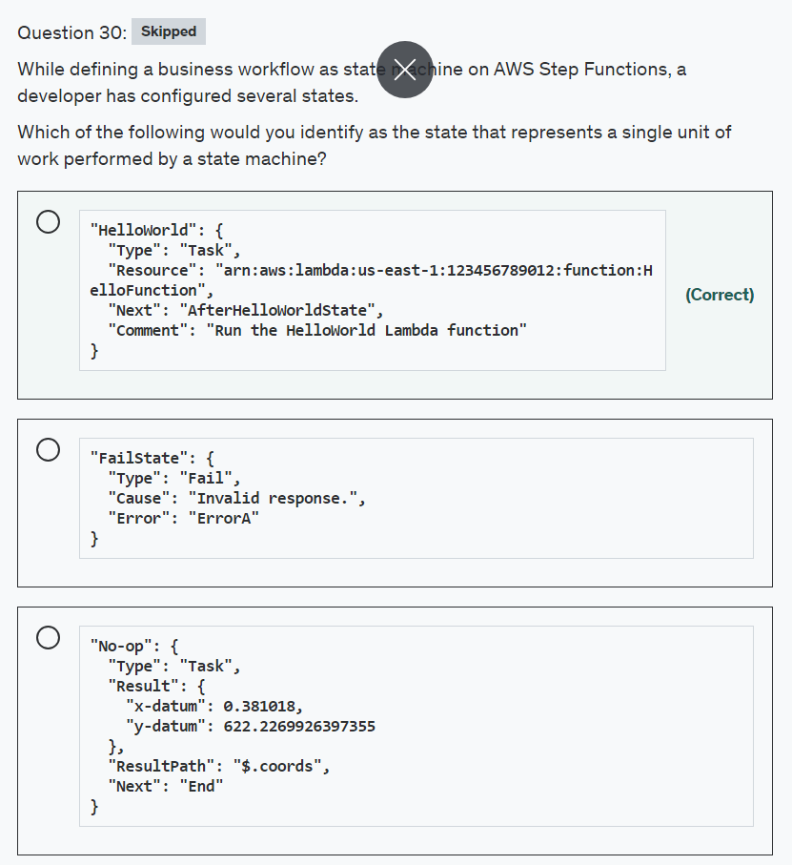

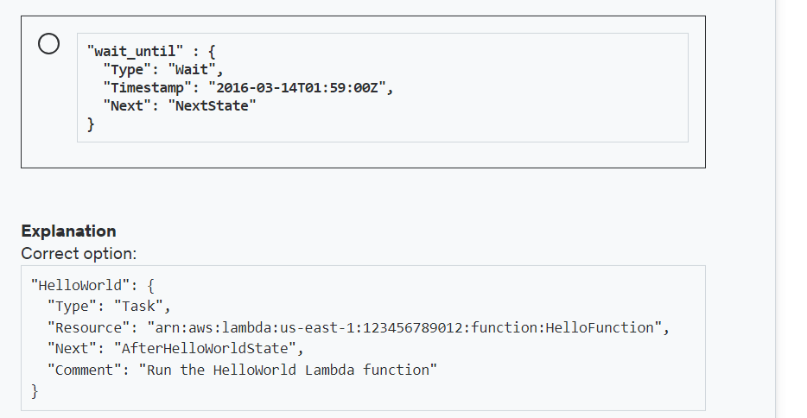

**Explanation**

Correct option:

"HelloWorld": {

"Type": "Task",

"Resource": "arn:aws:lambda:us-east-1:123456789012:function:HelloFunction",

"Next": "AfterHelloWorldState",

"Comment": "Run the HelloWorld Lambda function"

}

A Task state ("Type": "Task") represents a single unit of work performed by a state machine.

All work in your state machine is done by tasks. A task performs work by using an activity or an AWS Lambda function, or by passing parameters to the API actions of other services.

AWS Step Functions can invoke Lambda functions directly from a task state. A Lambda function is a cloud-native task that runs on AWS Lambda. You can write Lambda functions in a variety of programming languages, using the AWS Management Console or by uploading code to Lambda.

Incorrect options:

"wait_until" : {

"Type": "Wait",

"Timestamp": "2016-03-14T01:59:00Z",

"Next": "NextState"

}

A Wait state ("Type": "Wait") delays the state machine from continuing for a specified time.

"No-op": {

"Type": "Task",

"Result": {

"x-datum": 0.381018,

"y-datum": 622.2269926397355

},

"ResultPath": "$.coords",

"Next": "End"

}

Resource field is a required parameter for Task state. This definition is not of a Task but of type Pass.

"FailState": {

"Type": "Fail",

"Cause": "Invalid response.",

"Error": "ErrorA"

}

A Fail state ("Type": "Fail") stops the execution of the state machine and marks it as a failure unless it is caught by a Catch block. Because Fail states always exit the state machine, they have no Next field and don't require an End field.

Reference:

<https://docs.aws.amazon.com/step-functions/latest/dg/amazon-states-language-task-state.html>

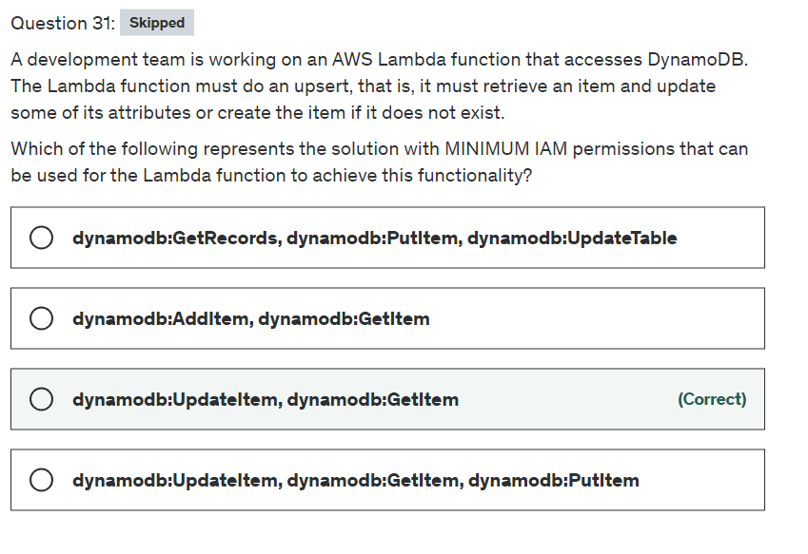

Explanation

Correct option:

**dynamodb:UpdateItem, dynamodb:GetItem** - With Amazon DynamoDB transactions, you can group multiple actions together and submit them as a single all-or-nothing TransactWriteItems or TransactGetItems operation.

You can use AWS Identity and Access Management (IAM) to restrict the actions that transactional operations can perform in Amazon DynamoDB. Permissions for Put, Update, Delete, and Get actions are governed by the permissions used for the underlying PutItem, UpdateItem, DeleteItem, and GetItem operations. For the ConditionCheck action, you can use the dynamodb:ConditionCheck permission in IAM policies.

UpdateItem action of DynamoDB APIs, edits an existing item's attributes or adds a new item to the table if it does not already exist. You can put, delete, or add attribute values. You can also perform a conditional update on an existing item (insert a new attribute name-value pair if it doesn't exist, or replace an existing name-value pair if it has certain expected attribute values).

There is no need to inlcude the dynamodb:PutItem action for the given use-case.

So, the IAM policy must include permissions to get and update the item in the DynamoDB table.

Actions defined by DynamoDB: 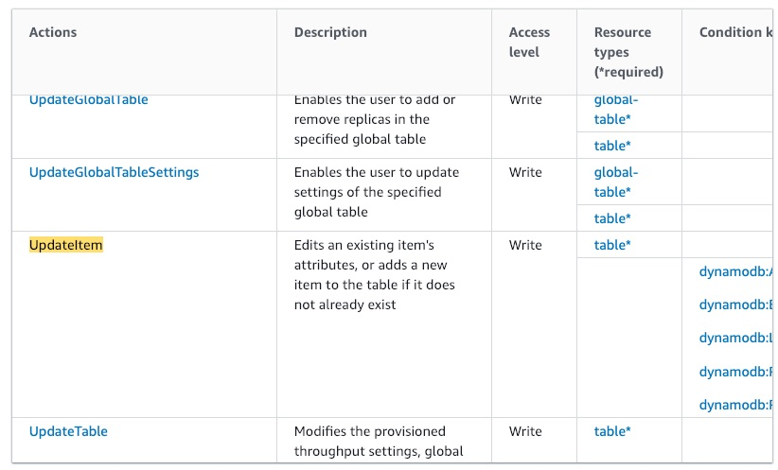 via - <https://docs.aws.amazon.com/service-authorization/latest/reference/list_amazondynamodb.html>

Incorrect options:

**dynamodb:AddItem, dynamodb:GetItem**

**dynamodb:GetRecords, dynamodb:PutItem, dynamodb:UpdateTable**

**dynamodb:UpdateItem, dynamodb:GetItem, dynamodb:PutItem**

These three options contradict the explanation provided above, so these options are incorrect.

References:

<https://docs.aws.amazon.com/service-authorization/latest/reference/list_amazondynamodb.html>

<https://docs.amazonaws.cn/en_us/amazondynamodb/latest/developerguide/transaction-apis-iam.html>

<https://docs.aws.amazon.com/service-authorization/latest/reference/list_amazondynamodb.html>

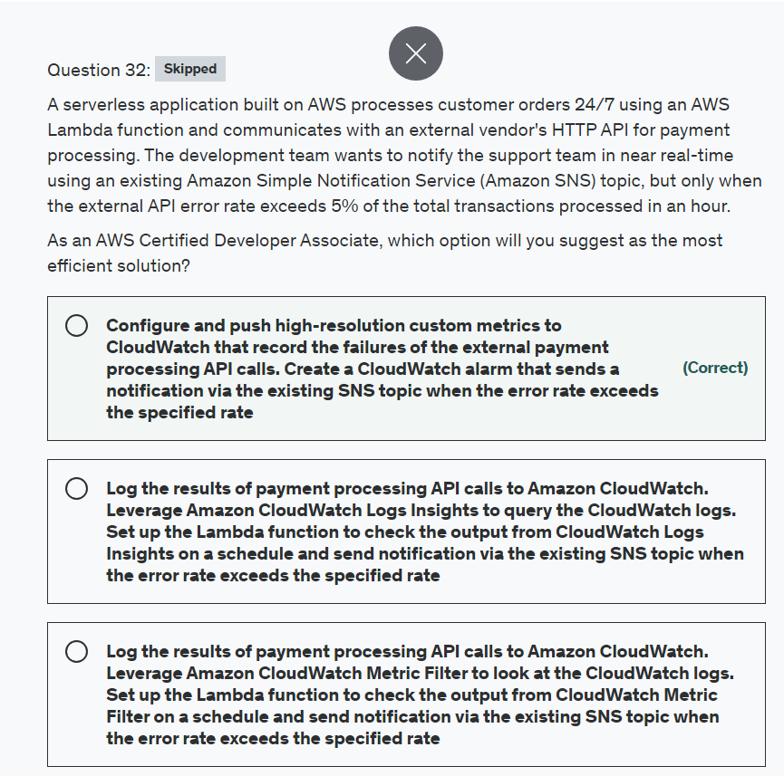

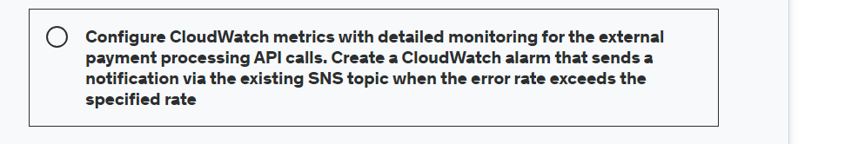

Explanation

Correct option:

**Configure and push high-resolution custom metrics to CloudWatch that record the failures of the external payment processing API calls. Create a CloudWatch alarm that sends a notification via the existing SNS topic when the error rate exceeds the specified rate**

You can publish your own metrics, known as custom metrics, to CloudWatch using the AWS CLI or an API.

Each metric is one of the following:

Standard resolution, with data having a one-minute granularity

High resolution, with data at a granularity of one second

Metrics produced by AWS services are standard resolution by default. When you publish a custom metric, you can define it as either standard resolution or high resolution. When you publish a high-resolution metric, CloudWatch stores it with a resolution of 1 second, and you can read and retrieve it with a period of 1 second, 5 seconds, 10 seconds, 30 seconds, or any multiple of 60 seconds.

High-resolution metrics can give you more immediate insight into your application's sub-minute activity. Keep in mind that every PutMetricData call for a custom metric is charged, so calling PutMetricData more often on a high-resolution metric can lead to higher charges.

You can create metric and composite alarms in Amazon CloudWatch. For the given use case, you can set up a CloudWatch metric alarm that watches the custom metric that captures the API errors and then triggers the alarm when the API error rate exceeds the 5% threshold. The alarm then sends a notification via the existing SNS topic.

Incorrect options:

**Configure CloudWatch metrics with detailed monitoring for the external payment processing API calls. Create a CloudWatch alarm that sends a notification via the existing SNS topic when the error rate exceeds the specified rate** - CloudWatch provides two categories of monitoring: basic monitoring and detailed monitoring. Detailed monitoring options differ based on the services that offer it. For example, Amazon EC2 detailed monitoring provides more frequent metrics, published at one-minute intervals, instead of the five-minute intervals used in Amazon EC2 basic monitoring. Detailed monitoring is offered by only some services. As explained above, you need to use custom metrics to capture data for the external payment processing API calls since detailed monitoring for the standard CloudWatch metrics cannot be used for this scenario.

**Log the results of payment processing API calls to Amazon CloudWatch. Leverage Amazon CloudWatch Logs Insights to query the CloudWatch logs. Set up the Lambda function to check the output from CloudWatch Logs Insights on a schedule and send notification via the existing SNS topic when the error rate exceeds the specified rate** - CloudWatch Logs Insights enables you to interactively search and analyze your log data in Amazon CloudWatch Logs. You can perform queries to help you more efficiently and effectively respond to operational issues. This option is not the right fit for the given use case since Lambda cannot monitor the output of the CloudWatch Logs Insights on a real-time basis since it is being invoked on a schedule. Also, it is not an efficient solution since Lambda will need significant custom code to parse and compute the external API error rate from the CloudWatch Logs Insights data.

**Log the results of payment processing API calls to Amazon CloudWatch. Leverage Amazon CloudWatch Metric Filter to look at the CloudWatch logs. Set up the Lambda function to check the output from CloudWatch Metric Filter on a schedule and send notification via the existing SNS topic when the error rate exceeds the specified rate** - You can search and filter the log data coming into CloudWatch Logs by creating one or more metric filters. Metric filters define the terms and patterns to look for in log data as it is sent to CloudWatch Logs. CloudWatch Logs uses these metric filters to turn log data into numerical CloudWatch metrics that you can graph or set an alarm on. This option is not the best fit for the given use case since Lambda cannot monitor the output of the CloudWatch Metric Filter on a real-time basis since it is being invoked on a schedule. Also, it is not an efficient solution since Lambda will need significant custom code to parse and compute the external API error rate from the CloudWatch Metric Filter data.

References:

<https://docs.aws.amazon.com/AmazonCloudWatch/latest/monitoring/publishingMetrics.html>

<https://aws.amazon.com/premiumsupport/knowledge-center/cloudwatch-push-custom-metrics/>

<https://docs.aws.amazon.com/AmazonCloudWatch/latest/monitoring/AlarmThatSendsEmail.html>

<https://docs.aws.amazon.com/AmazonCloudWatch/latest/logs/AnalyzingLogData.html>

<https://docs.aws.amazon.com/AmazonCloudWatch/latest/logs/MonitoringLogData.html>

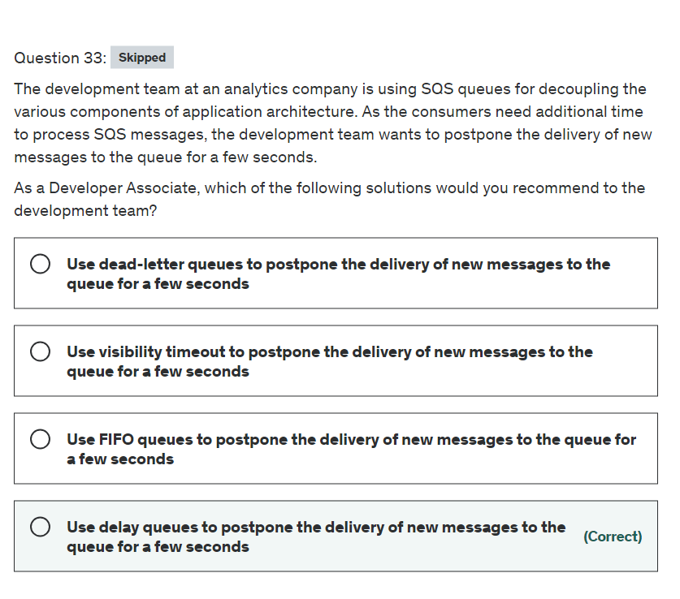

Explanation

Correct option:

**Use delay queues to postpone the delivery of new messages to the queue for a few seconds**

Amazon Simple Queue Service (SQS) is a fully managed message queuing service that enables you to decouple and scale microservices, distributed systems, and serverless applications. SQS offers two types of message queues. Standard queues offer maximum throughput, best-effort ordering, and at-least-once delivery. SQS FIFO queues are designed to guarantee that messages are processed exactly once, in the exact order that they are sent.

Delay queues let you postpone the delivery of new messages to a queue for several seconds, for example, when your consumer application needs additional time to process messages. If you create a delay queue, any messages that you send to the queue remain invisible to consumers for the duration of the delay period. The default (minimum) delay for a queue is 0 seconds. The maximum is 15 minutes.

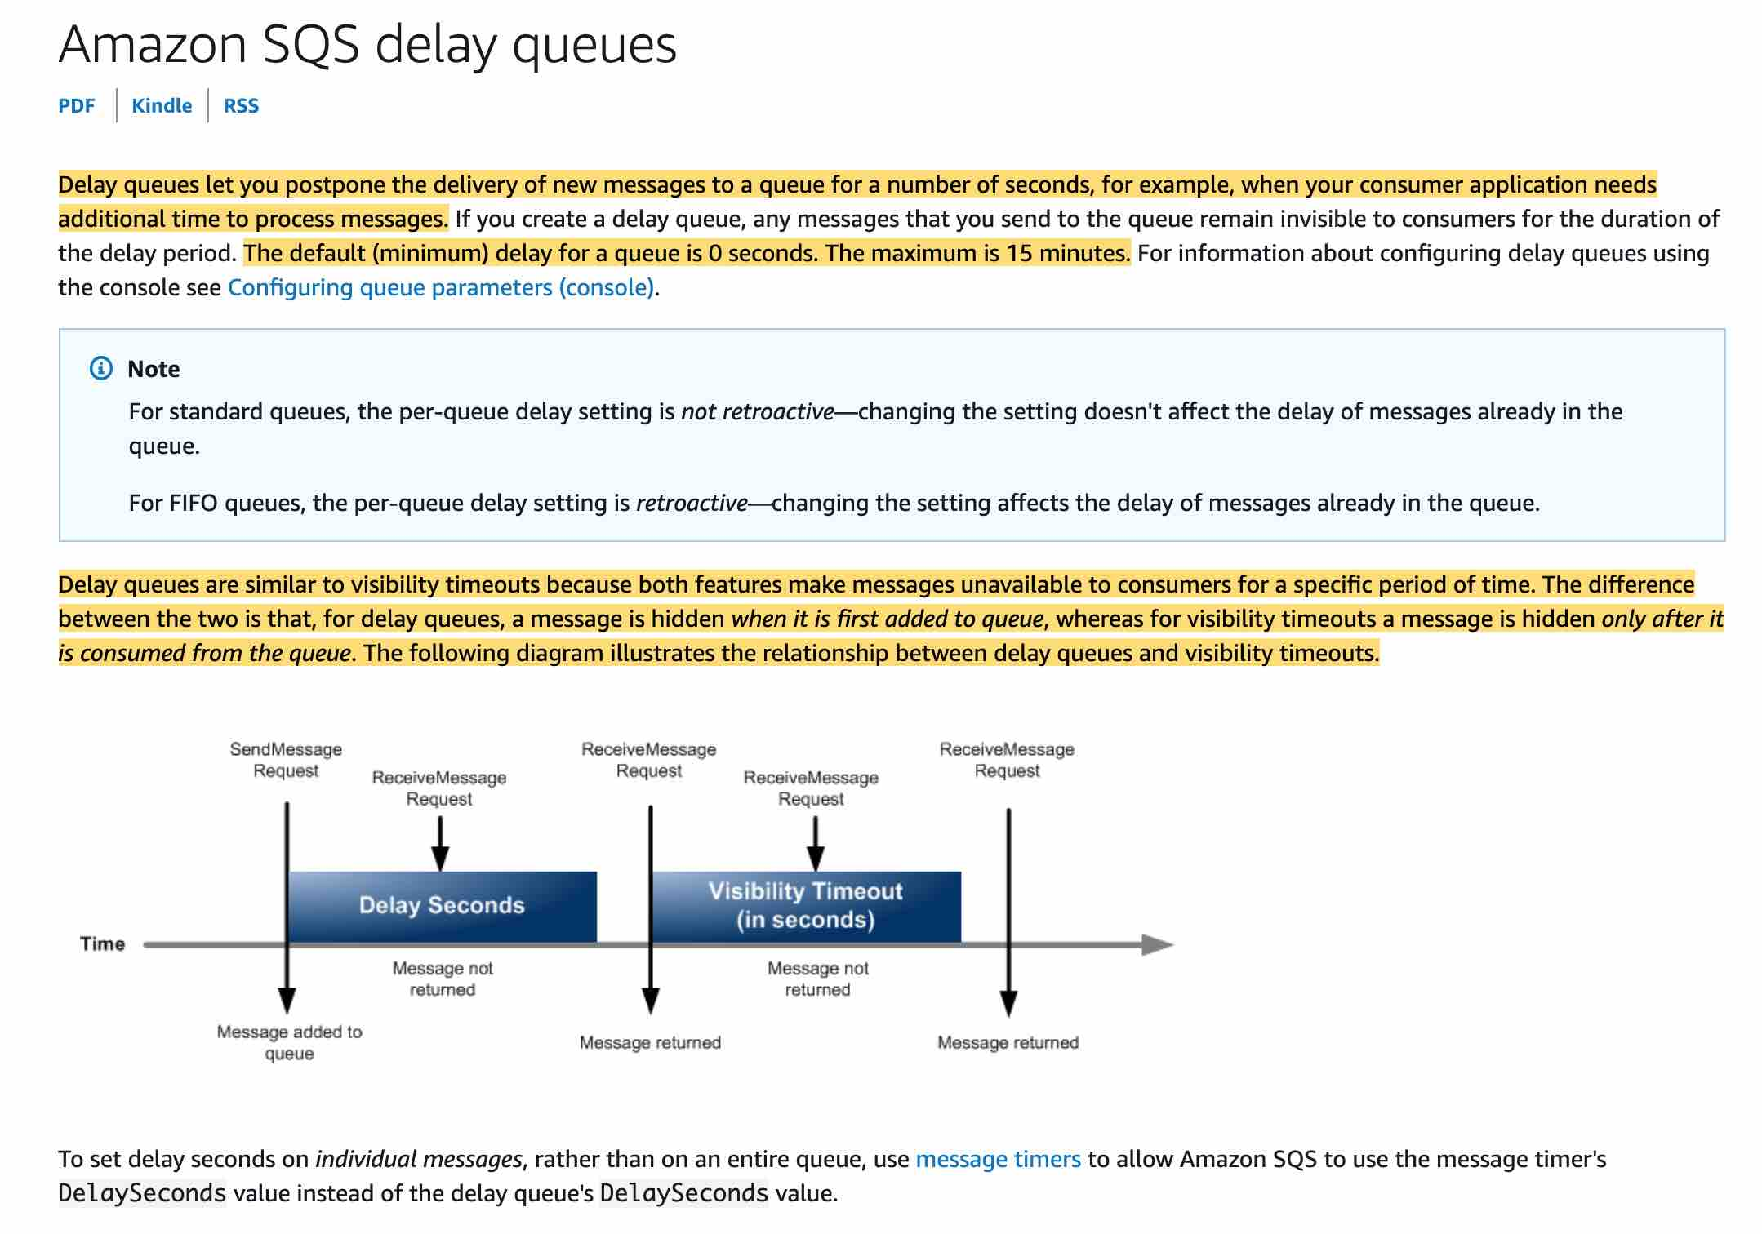 via - <https://docs.aws.amazon.com/AWSSimpleQueueService/latest/SQSDeveloperGuide/sqs-delay-queues.html>

Incorrect options:

**Use FIFO queues to postpone the delivery of new messages to the queue for a few seconds** - SQS FIFO queues are designed to guarantee that messages are processed exactly once, in the exact order that they are sent. You cannot use FIFO queues to postpone the delivery of new messages to the queue for a few seconds.

**Use dead-letter queues to postpone the delivery of new messages to the queue for a few seconds** - Dead-letter queues can be used by other queues (source queues) as a target for messages that can't be processed (consumed) successfully. Dead-letter queues are useful for debugging your application or messaging system because they let you isolate problematic messages to determine why their processing doesn't succeed. You cannot use dead-letter queues to postpone the delivery of new messages to the queue for a few seconds.

**Use visibility timeout to postpone the delivery of new messages to the queue for a few seconds** - Visibility timeout is a period during which Amazon SQS prevents other consumers from receiving and processing a given message. The default visibility timeout for a message is 30 seconds. The minimum is 0 seconds. The maximum is 12 hours. You cannot use visibility timeout to postpone the delivery of new messages to the queue for a few seconds.

Reference:

<https://docs.aws.amazon.com/AWSSimpleQueueService/latest/SQSDeveloperGuide/sqs-delay-queues.html>

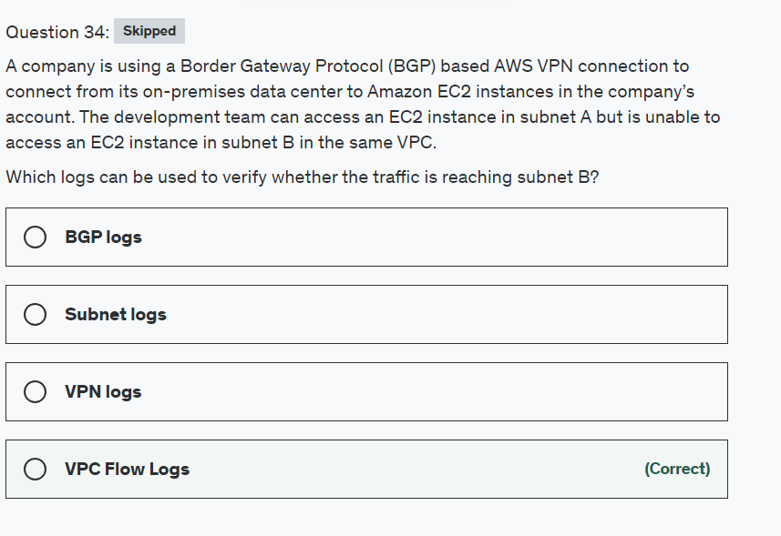

Explanation

Correct option:

**VPC Flow Logs** - VPC Flow Logs is a feature that enables you to capture information about the IP traffic going to and from network interfaces in your VPC. Flow log data can be published to Amazon CloudWatch Logs or Amazon S3. After you've created a flow log, you can retrieve and view its data in the chosen destination.

You can create a flow log for a VPC, a subnet, or a network interface. If you create a flow log for a subnet or VPC, each network interface in that subnet or VPC is monitored.

Flow log data for a monitored network interface is recorded as flow log records, which are log events consisting of fields that describe the traffic flow.

To create a flow log, you specify:

The resource for which to create the flow log

The type of traffic to capture (accepted traffic, rejected traffic, or all traffic)

The destinations to which you want to publish the flow log data

Incorrect options:

**VPN logs**

**Subnet logs**

**BGP logs**

These three options are incorrect and have been added as distractors.

Reference:

<https://docs.aws.amazon.com/vpc/latest/userguide/flow-logs.html>

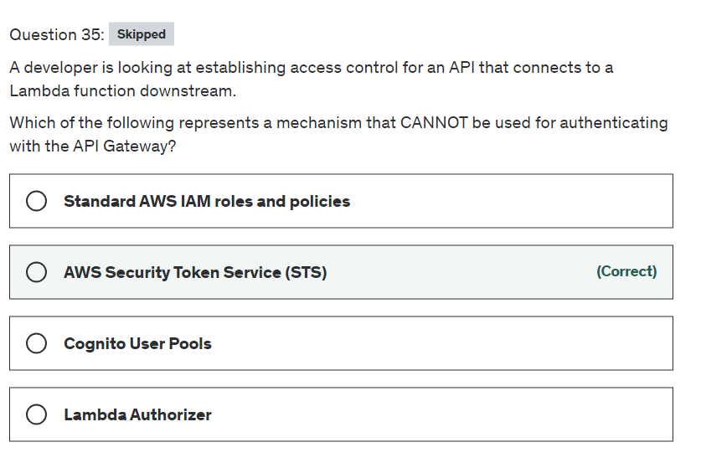

Explanation

Correct option:

Amazon API Gateway is an AWS service for creating, publishing, maintaining, monitoring, and securing REST, HTTP, and WebSocket APIs at any scale. API developers can create APIs that access AWS or other web services, as well as data stored in the AWS Cloud.

How API Gateway Works:  via - <https://aws.amazon.com/api-gateway/>

**AWS Security Token Service (STS)** - AWS Security Token Service (AWS STS) is a web service that enables you to request temporary, limited-privilege credentials for AWS Identity and Access Management (IAM) users or for users that you authenticate (federated users). However, it is not supported by API Gateway.

API Gateway supports the following mechanisms for authentication and authorization: 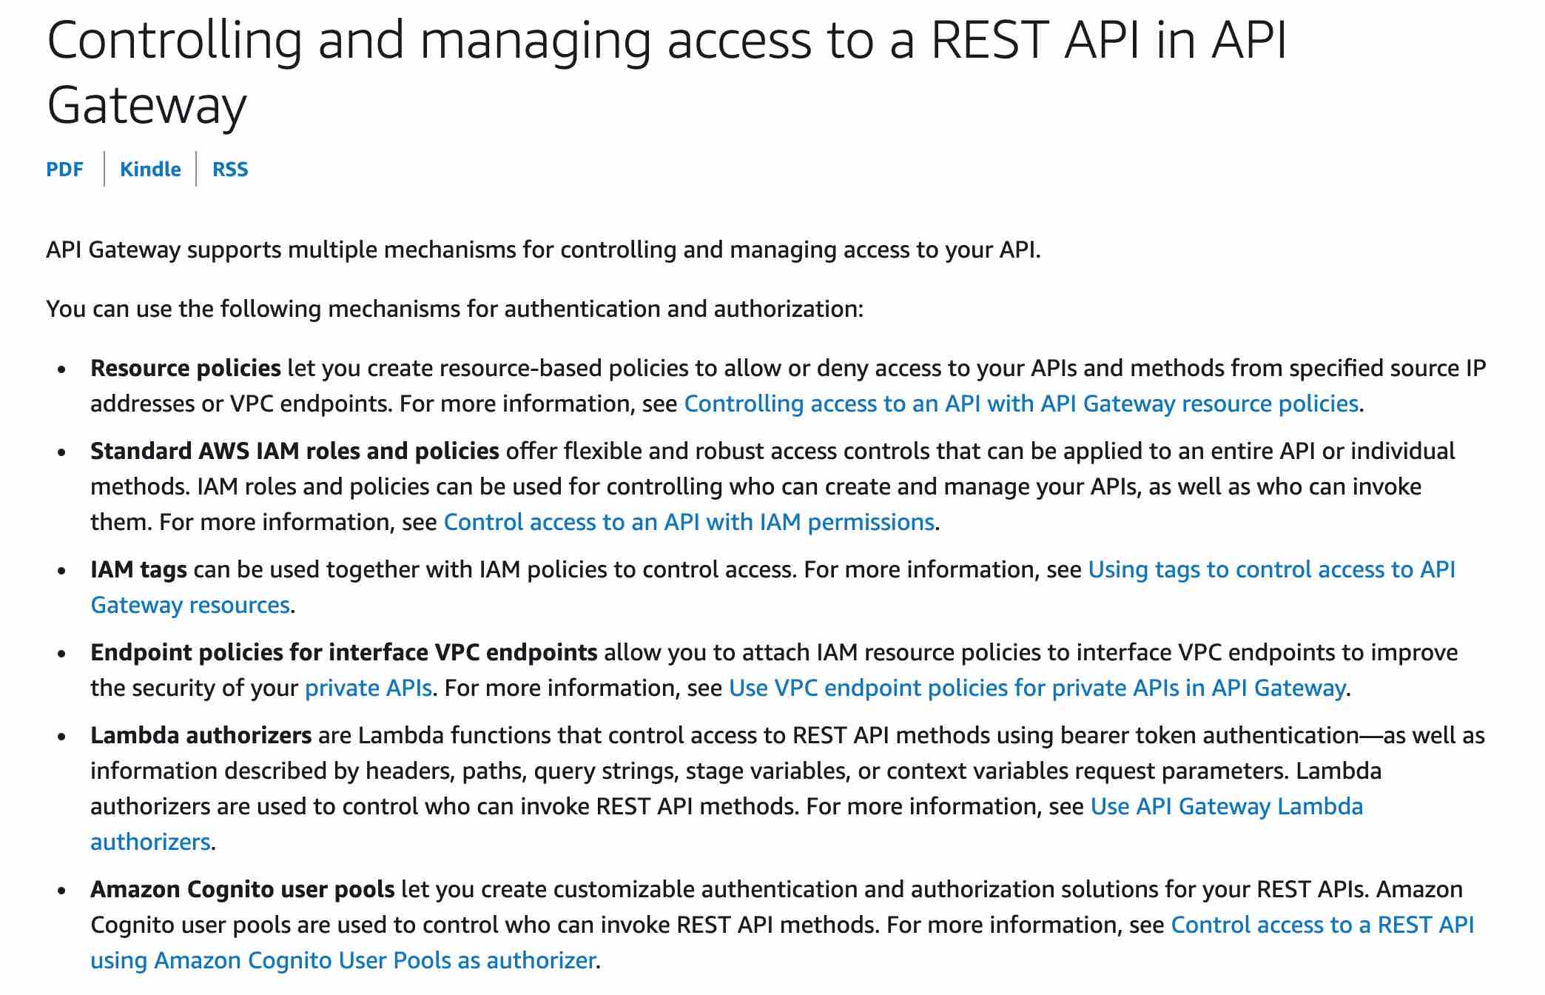 via - <https://docs.aws.amazon.com/apigateway/latest/developerguide/apigateway-control-access-to-api.html>

Incorrect options:

**Standard AWS IAM roles and policies** - Standard AWS IAM roles and policies offer flexible and robust access controls that can be applied to an entire API or individual methods. IAM roles and policies can be used for controlling who can create and manage your APIs, as well as who can invoke them.

**Lambda Authorizer** - Lambda authorizers are Lambda functions that control access to REST API methods using bearer token authentication—as well as information described by headers, paths, query strings, stage variables, or context variables request parameters. Lambda authorizers are used to control who can invoke REST API methods.

**Cognito User Pools** - Amazon Cognito user pools let you create customizable authentication and authorization solutions for your REST APIs. Amazon Cognito user pools are used to control who can invoke REST API methods.

References:

<https://docs.aws.amazon.com/apigateway/latest/developerguide/apigateway-control-access-to-api.html>

<https://docs.aws.amazon.com/STS/latest/APIReference/welcome.html>

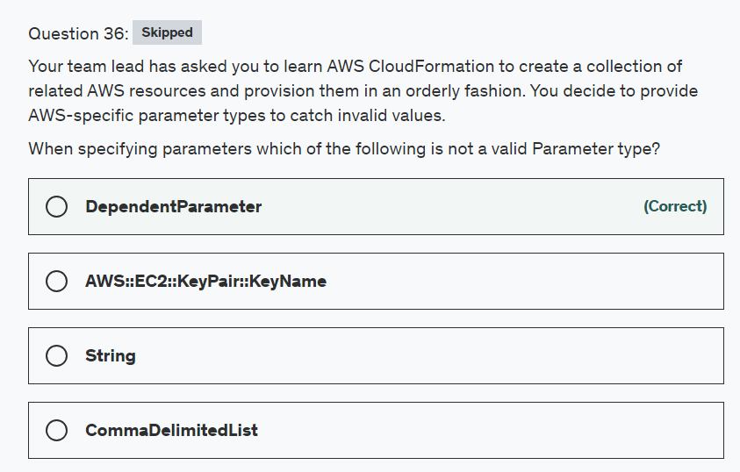

Explanation

Correct option:

AWS CloudFormation gives developers and businesses an easy way to create a collection of related AWS and third-party resources and provision them in an orderly and predictable fashion.

How CloudFormation Works:  via - <https://aws.amazon.com/cloudformation/>

Parameter types enable CloudFormation to validate inputs earlier in the stack creation process.

CloudFormation currently supports the following parameter types:

String – A literal string

Number – An integer or float

List<Number> – An array of integers or floats

CommaDelimitedList – An array of literal strings that are separated by commas

AWS::EC2::KeyPair::KeyName – An Amazon EC2 key pair name

AWS::EC2::SecurityGroup::Id – A security group ID

AWS::EC2::Subnet::Id – A subnet ID

AWS::EC2::VPC::Id – A VPC ID

List<AWS::EC2::VPC::Id> – An array of VPC IDs

List<AWS::EC2::SecurityGroup::Id> – An array of security group IDs

List<AWS::EC2::Subnet::Id> – An array of subnet IDs

**DependentParameter**

In CloudFormation, parameters are all independent and cannot depend on each other. Therefore, this is an invalid parameter type.

Incorrect options:

**String**

**CommaDelimitedList**

**AWS::EC2::KeyPair::KeyName**

As mentioned in the explanation above, these are valid parameter types.

Reference:

<https://aws.amazon.com/blogs/devops/using-the-new-cloudformation-parameter-types/>

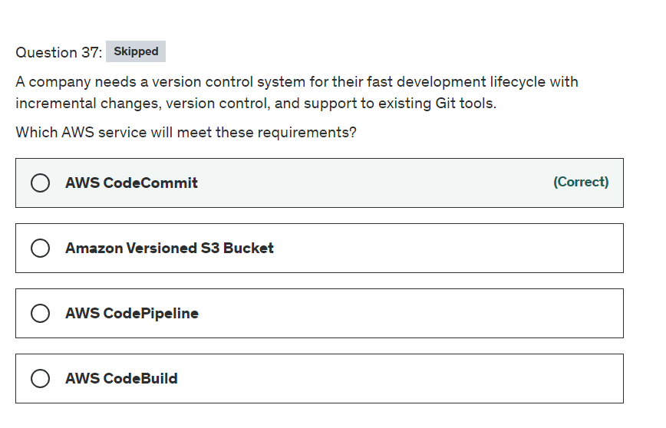

Top of Form

**Explanation**

Correct option:

**AWS CodeCommit** - AWS CodeCommit is a fully-managed Source Control service that hosts secure Git-based repositories. It makes it easy for teams to collaborate on code in a secure and highly scalable ecosystem. AWS CodeCommit helps you collaborate on code with teammates via pull requests, branching and merging. AWS CodeCommit keeps your repositories close to your build, staging, and production environments in the AWS cloud. You can transfer incremental changes instead of the entire application. AWS CodeCommit supports all Git commands and works with your existing Git tools. You can keep using your preferred development environment plugins, continuous integration/continuous delivery systems, and graphical clients with CodeCommit.

Incorrect options:

**Amazon Versioned S3 Bucket** - AWS CodeCommit is designed for collaborative software development. It manages batches of changes across multiple files, offers parallel branching, and includes version differencing ("diffing"). In comparison, Amazon S3 versioning supports recovering past versions of individual files but doesn’t support tracking batched changes that span multiple files or other features needed for collaborative software development.

**AWS CodePipeline** - AWS CodePipeline is a fully managed "continuous delivery" service that helps you automate your release pipelines for fast and reliable application and infrastructure updates. CodePipeline automates the build, test, and deploy phases of your release process every time there is a code change, based on the release model you define.

**AWS CodeBuild** - AWS CodeBuild is a fully managed continuous integration service that compiles source code, runs tests, and produces software packages that are ready to deploy. With CodeBuild, you don’t need to provision, manage, and scale your own build servers. CodeBuild scales continuously and processes multiple builds concurrently, so your builds are not left waiting in a queue.

References:

<https://aws.amazon.com/codecommit/>

<https://aws.amazon.com/codepipeline/>

<https://aws.amazon.com/codebuild/>

<https://docs.aws.amazon.com/AmazonS3/latest/dev/Versioning.html>

Bottom of Form

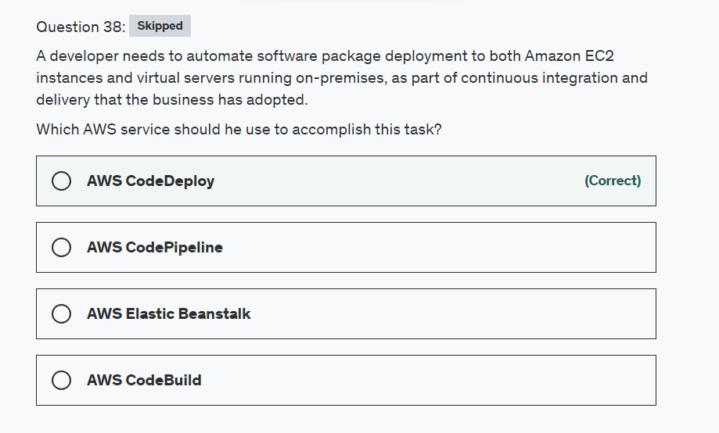

Explanation

Correct option:

Continuous integration is a DevOps software development practice where developers regularly merge their code changes into a central repository, after which automated builds and tests are run.

Continuous delivery is a software development practice where code changes are automatically prepared for a release to production. A pillar of modern application development, continuous delivery expands upon continuous integration by deploying all code changes to a testing environment and/or a production environment after the build stage.

**AWS CodeDeploy** - AWS CodeDeploy is a fully managed "deployment" service that automates software deployments to a variety of compute services such as Amazon EC2, AWS Fargate, AWS Lambda, and your on-premises servers. AWS CodeDeploy makes it easier for you to rapidly release new features, helps you avoid downtime during application deployment, and handles the complexity of updating your applications. This is the right choice for the current use case.

Incorrect options:

**AWS CodePipeline** - AWS CodePipeline is a fully managed "continuous delivery" service that helps you automate your release pipelines for fast and reliable application and infrastructure updates. CodePipeline automates the build, test, and deploy phases of your release process every time there is a code change, based on the release model you define. This enables you to rapidly and reliably deliver features and updates. Whereas CodeDeploy is a deployment service, CodePipeline is a continuous delivery service. For our current scenario, CodeDeploy is the correct choice.

**AWS CodeBuild** - AWS CodeBuild is a fully managed continuous integration service that compiles source code, runs tests, and produces software packages that are ready to deploy. With CodeBuild, you don’t need to provision, manage, and scale your own build servers. CodeBuild scales continuously and processes multiple builds concurrently, so your builds are not left waiting in a queue.

**AWS Elastic Beanstalk** - AWS Elastic Beanstalk is an easy-to-use service for deploying and scaling web applications and services developed with Java, .NET, PHP, Node.js, Python, Ruby, Go, and Docker on familiar servers such as Apache, Nginx, Passenger, and IIS. You can simply upload your code and Elastic Beanstalk automatically handles the deployment, from capacity provisioning, load balancing, auto-scaling to application health monitoring. At the same time, you retain full control over the AWS resources powering your application and can access the underlying resources at any time.

References:

<https://aws.amazon.com/codedeploy/>

<https://aws.amazon.com/codepipeline/>

<https://aws.amazon.com/codebuild/>

<https://aws.amazon.com/elasticbeanstalk/>

<https://aws.amazon.com/devops/continuous-delivery/>

<https://aws.amazon.com/devops/continuous-integration/>

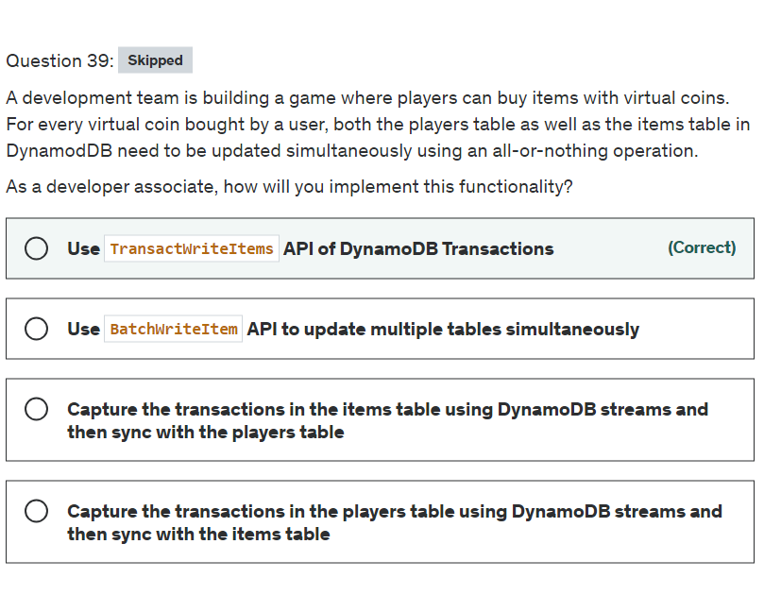

Explanation

Correct option: **Use TransactWriteItems API of DynamoDB Transactions**

With Amazon DynamoDB transactions, you can group multiple actions together and submit them as a single all-or-nothing TransactWriteItems or TransactGetItems operation.

TransactWriteItems is a synchronous and idempotent write operation that groups up to 25 write actions in a single all-or-nothing operation. These actions can target up to 25 distinct items in one or more DynamoDB tables within the same AWS account and in the same Region. The aggregate size of the items in the transaction cannot exceed 4 MB. The actions are completed atomically so that either all of them succeed or none of them succeeds.

You can optionally include a client token when you make a TransactWriteItems call to ensure that the request is idempotent. Making your transactions idempotent helps prevent application errors if the same operation is submitted multiple times due to a connection time-out or other connectivity issue.

Incorrect options:

**Use BatchWriteItem API to update multiple tables simultaneously** - A TransactWriteItems operation differs from a BatchWriteItem operation in that all the actions it contains must be completed successfully, or no changes are made at all. With a BatchWriteItem operation, it is possible that only some of the actions in the batch succeed while the others do not.

**Capture the transactions in the players table using DynamoDB streams and then sync with the items table**

**Capture the transactions in the items table using DynamoDB streams and then sync with the players table**

Many applications benefit from capturing changes to items stored in a DynamoDB table, at the point in time when such changes occur. DynamoDB supports streaming of item-level change data capture records in near-real-time. You can build applications that consume these streams and take action based on the contents. DynamoDB streams cannot be used to capture transactions in DynamoDB, therefore both these options are incorrect.

Reference:

<https://docs.aws.amazon.com/amazondynamodb/latest/developerguide/transaction-apis.html#transaction-apis-txwriteitems>

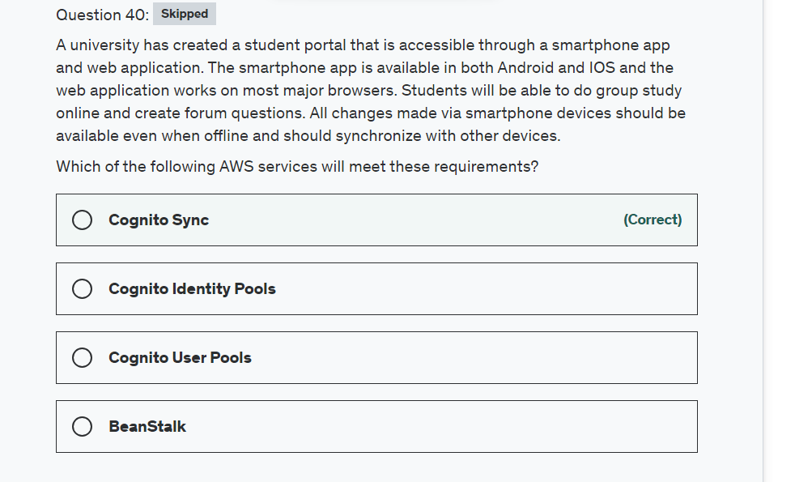

Explanation

Correct option:

**Cognito Sync**

Amazon Cognito Sync is an AWS service and client library that enables cross-device syncing of application-related user data. You can use it to synchronize user profile data across mobile devices and the web without requiring your own backend. The client libraries cache data locally so your app can read and write data regardless of device connectivity status. When the device is online, you can synchronize data, and if you set up push sync, notify other devices immediately that an update is available.

Incorrect options:

**Cognito Identity Pools** - You can use Identity pools to grant your users access to other AWS services. With an identity pool, your users can obtain temporary AWS credentials to access AWS services, such as Amazon S3 and DynamoDB. Identity pools support anonymous guest users, as well as the specific identity providers that you can use to authenticate users for identity pools.

**Cognito User Pools** - A Cognito user pool is a user directory in Amazon Cognito. With a user pool, your users can sign in to your web or mobile app through Amazon Cognito, or federate through a third-party identity provider (IdP). Whether your users sign-in directly or through a third party, all members of the user pool have a directory profile that you can access through an SDK.

Exam Alert:

Please review the following note to understand the differences between Cognito User Pools and Cognito Identity Pools:  via - <https://docs.aws.amazon.com/cognito/latest/developerguide/what-is-amazon-cognito.html>

**Beanstalk** - With Elastic Beanstalk, you can quickly deploy and manage applications in the AWS Cloud without having to learn about the infrastructure that runs those applications. Elastic Beanstalk reduces management complexity without restricting choice or control. You simply upload your application, and Elastic Beanstalk automatically handles the details of capacity provisioning, load balancing, scaling, and application health monitoring.

How Elastic BeanStalk Works:  via - <https://docs.aws.amazon.com/elasticbeanstalk/latest/dg/Welcome.html>

Reference:

<https://docs.aws.amazon.com/cognito/latest/developerguide/cognito-sync.html>

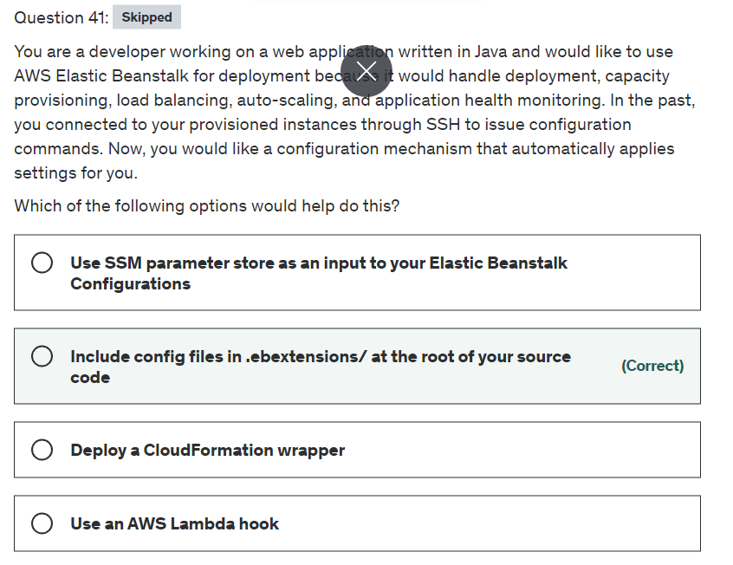

Explanation

Correct option:

**Include config files in .ebextensions/ at the root of your source code**

The option_settings section of a configuration file defines values for configuration options. Configuration options let you configure your Elastic Beanstalk environment, the AWS resources in it, and the software that runs your application. Configuration files are only one of several ways to set configuration options.

 via - <https://docs.aws.amazon.com/elasticbeanstalk/latest/dg/ebextensions.html>

Incorrect options:

**Deploy a CloudFormation wrapper** - This is a made-up option. This has been added as a distractor.

**Use SSM parameter store as an input to your Elastic Beanstalk Configurations** - SSM parameter is still not supported for Elastic Beanstalk. So this option is incorrect.

**Use an AWS Lambda hook** - Lambda functions are not the best-fit to trigger these configuration changes as it would involve significant development effort.

References:

<https://docs.aws.amazon.com/elasticbeanstalk/latest/dg/ebextensions.html>

<https://docs.aws.amazon.com/elasticbeanstalk/latest/dg/ebextensions-optionsettings.html>

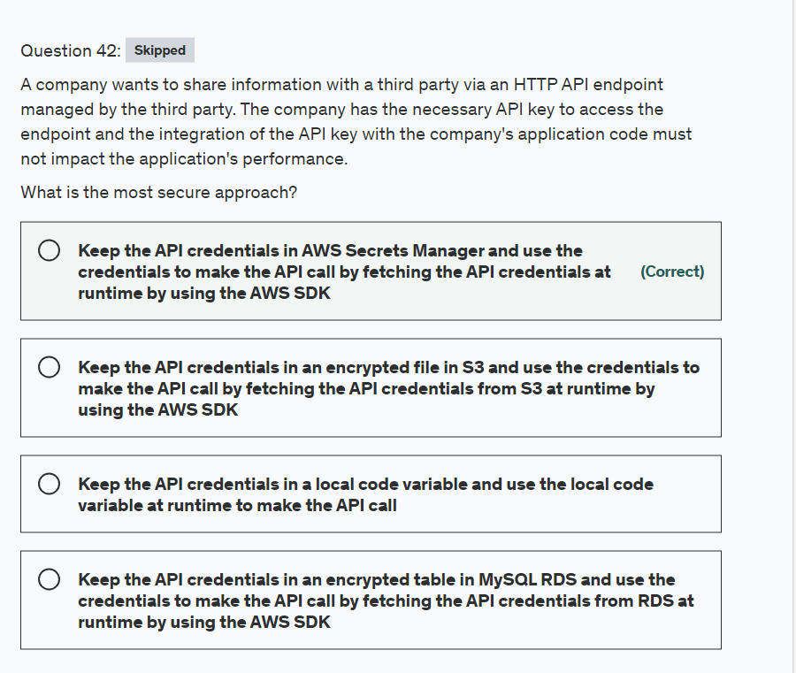

Explanation

Correct option:

**Keep the API credentials in AWS Secrets Manager and use the credentials to make the API call by fetching the API credentials at runtime by using the AWS SDK**

Secrets Manager enables you to replace hardcoded credentials in your code, including passwords, with an API call to Secrets Manager to retrieve the secret programmatically. This helps ensure the secret can't be compromised by someone examining your code, because the secret no longer exists in the code. Also, you can configure Secrets Manager to automatically rotate the secret for you according to a specified schedule. This enables you to replace long-term secrets with short-term ones, significantly reducing the risk of compromise.

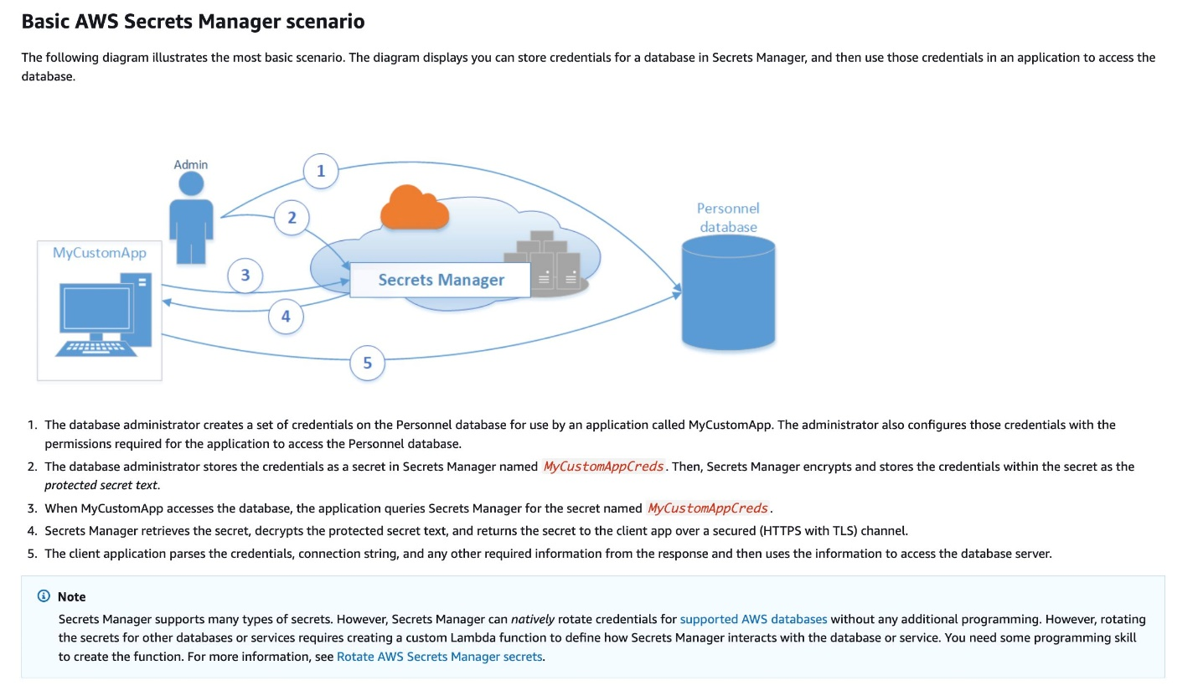 via - <https://docs.aws.amazon.com/secretsmanager/latest/userguide/intro.html>

In the past, when you created a custom application to retrieve information from a database, you typically embedded the credentials, the secret, for accessing the database directly in the application. When the time came to rotate the credentials, you had to do more than just create new credentials. You had to invest time to update the application to use the new credentials. Then you distributed the updated application. If you had multiple applications with shared credentials and you missed updating one of them, the application failed. Because of this risk, many customers choose not to regularly rotate credentials, which effectively substitutes one risk for another. You can also use caching with Secrets Manager to significantly improve the availability and latency of applications.

Incorrect options:

**Keep the API credentials in an encrypted table in MySQL RDS and use the credentials to make the API call by fetching the API credentials from RDS at runtime by using the AWS SDK**

**Keep the API credentials in an encrypted file in S3 and use the credentials to make the API call by fetching the API credentials from S3 at runtime by using the AWS SDK**

**Keep the API credentials in a local code variable and use the local code variable at runtime to make the API call**

It is considered a security bad practice to keep sensitive access credentials in code, database, or a flat file on a file system or object storage. Therefore, all three options are incorrect.

References:

<https://docs.aws.amazon.com/secretsmanager/latest/userguide/intro.html>

<https://aws.amazon.com/blogs/security/improve-availability-and-latency-of-applications-by-using-aws-secret-managers-python-client-side-caching-library/>

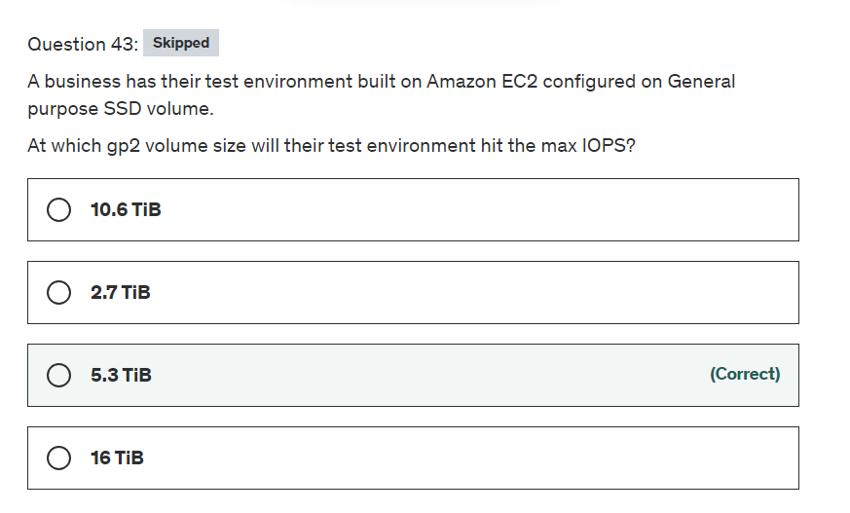

Explanation

Correct option:

The performance of gp2 volumes is tied to volume size, which determines the baseline performance level of the volume and how quickly it accumulates I/O credits; larger volumes have higher baseline performance levels and accumulate I/O credits faster.

**5.3 TiB** - General Purpose SSD (gp2) volumes offer cost-effective storage that is ideal for a broad range of workloads. These volumes deliver single-digit millisecond latencies and the ability to burst to 3,000 IOPS for extended periods of time. Between a minimum of 100 IOPS (at 33.33 GiB and below) and a maximum of 16,000 IOPS (at 5,334 GiB and above), baseline performance scales linearly at 3 IOPS per GiB of volume size.

Maximum IOPS vs Volume Size for General Purpose SSD (gp2) volumes:  via - <https://docs.aws.amazon.com/AWSEC2/latest/UserGuide/ebs-volume-types.html>

Incorrect options:

**10.6 TiB** - As explained above, this is an incorrect option.

**16 TiB** - As explained above, this is an incorrect option.

**2.7 TiB** - As explained above, this is an incorrect option.

Reference:

<https://docs.aws.amazon.com/AWSEC2/latest/UserGuide/ebs-volume-types.html>

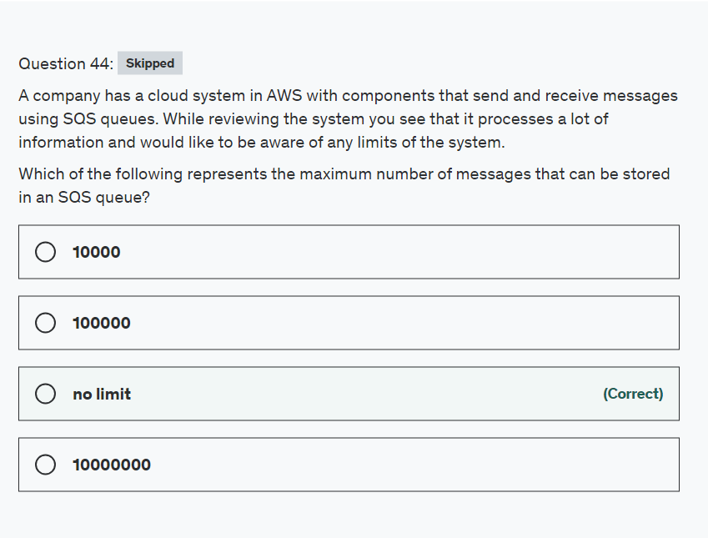

Explanation

Correct option:

"no limit": There are no message limits for storing in SQS, but 'in-flight messages' do have limits. Make sure to delete messages after you have processed them. There can be a maximum of approximately 120,000 inflight messages (received from a queue by a consumer, but not yet deleted from the queue).

Incorrect options:

"10000"

"100000"

"10000000"

These three options contradict the details provided in the explanation above, so these are incorrect.

Reference:

<https://docs.aws.amazon.com/AWSSimpleQueueService/latest/SQSDeveloperGuide/sqs-limits.html>

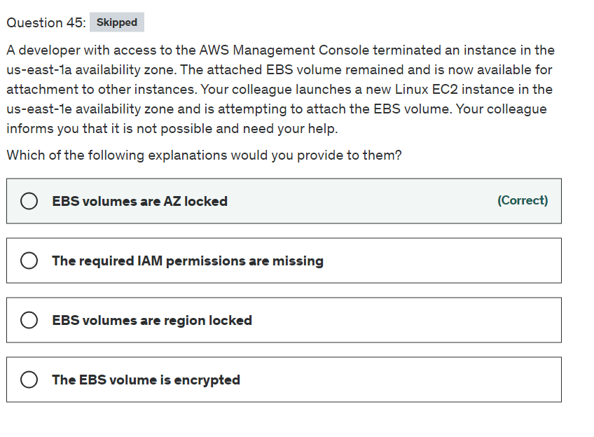

Explanation

Correct option:

**EBS volumes are AZ locked**

An Amazon EBS volume is a durable, block-level storage device that you can attach to your instances. After you attach a volume to an instance, you can use it as you would use a physical hard drive. EBS volumes are flexible. For current-generation volumes attached to current-generation instance types, you can dynamically increase size, modify the provisioned IOPS capacity, and change volume type on live production volumes.

When you create an EBS volume, it is automatically replicated within its Availability Zone to prevent data loss due to the failure of any single hardware component. You can attach an EBS volume to an EC2 instance in the same Availability Zone.

![EBS Volume Overview]https://assets-pt.media.datacumulus.com/aws-dva-pt/assets/pt2-q62-i1.jpg) via - <https://docs.aws.amazon.com/AWSEC2/latest/UserGuide/ebs-volumes.html>

Incorrect options:

**EBS volumes are region locked** - It's confined to an Availability Zone and not by region.

**The required IAM permissions are missing** - This is a possibility as well but if permissions are not an issue then you are still confined to an availability zone.

**The EBS volume is encrypted** - This doesn't affect the ability to attach an EBS volume.

Reference:

<https://docs.aws.amazon.com/AWSEC2/latest/UserGuide/EBSVolumes.html>

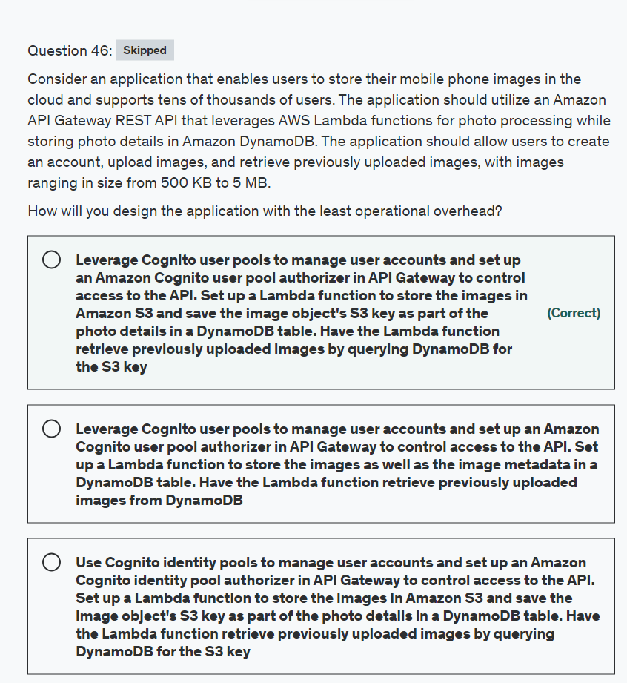

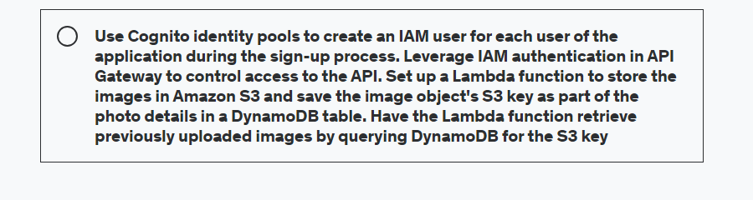

Explanation

Correct option:

**Leverage Cognito user pools to manage user accounts and set up an Amazon Cognito user pool authorizer in API Gateway to control access to the API. Set up a Lambda function to store the images in Amazon S3 and save the image object's S3 key as part of the photo details in a DynamoDB table. Have the Lambda function retrieve previously uploaded images by querying DynamoDB for the S3 key**

A user pool is a user directory in Amazon Cognito. With a user pool, your users can sign in to your web or mobile app through Amazon Cognito. Your users can also sign in through social identity providers like Google, Facebook, Amazon, or Apple, and SAML identity providers. Whether your users sign in directly or through a third party, all members of the user pool have a directory profile that you can access through a Software Development Kit (SDK).

User pools provide:

Sign-up and sign-in services.

A built-in, customizable web UI to sign in users.

Social sign-in with Facebook, Google, Login with Amazon, and Sign in with Apple, as well as sign-in with SAML identity providers from your user pool.

User directory management and user profiles.

Security features such as multi-factor authentication (MFA), checks for compromised credentials, account takeover protection, and phone and email verification.

Customized workflows and user migration through AWS Lambda triggers.

To use an Amazon Cognito user pool with your Amazon API Gateway API, you must first create an authorizer of the COGNITO_USER_POOLS type and then configure an API method to use that authorizer. After the API is deployed, the client must first sign the user into the user pool, obtain an identity or access token for the user, and then call the API method with one of the tokens, which are typically set to the request's Authorization header.

For the given use case, you can use a Cognito user pool to manage user accounts and configure an Amazon Cognito user pool authorizer in API Gateway to control access to the API. You should use a Lambda function to store the actual images on S3 and the image metadata on DynamoDB. Finally, you can get the images using the Lambda function that leverages the metadata stored in DynamoDB.

Incorrect options:

**Use Cognito identity pools to manage user accounts and set up an Amazon Cognito identity pool authorizer in API Gateway to control access to the API. Set up a Lambda function to store the images in Amazon S3 and save the image object's S3 key as part of the photo details in a DynamoDB table. Have the Lambda function retrieve previously uploaded images by querying DynamoDB for the S3 key**

**Use Cognito identity pools to create an IAM user for each user of the application during the sign-up process. Leverage IAM authentication in API Gateway to control access to the API. Set up a Lambda function to store the images in Amazon S3 and save the image object's S3 key as part of the photo details in a DynamoDB table. Have the Lambda function retrieve previously uploaded images by querying DynamoDB for the S3 key**

Amazon Cognito identity pools (federated identities) enable you to create unique identities for your users and federate them with identity providers. With an identity pool, you can obtain temporary, limited-privilege AWS credentials to access other AWS services. You cannot use identity pools to manage users or to create IAM users. So both of these options are incorrect.

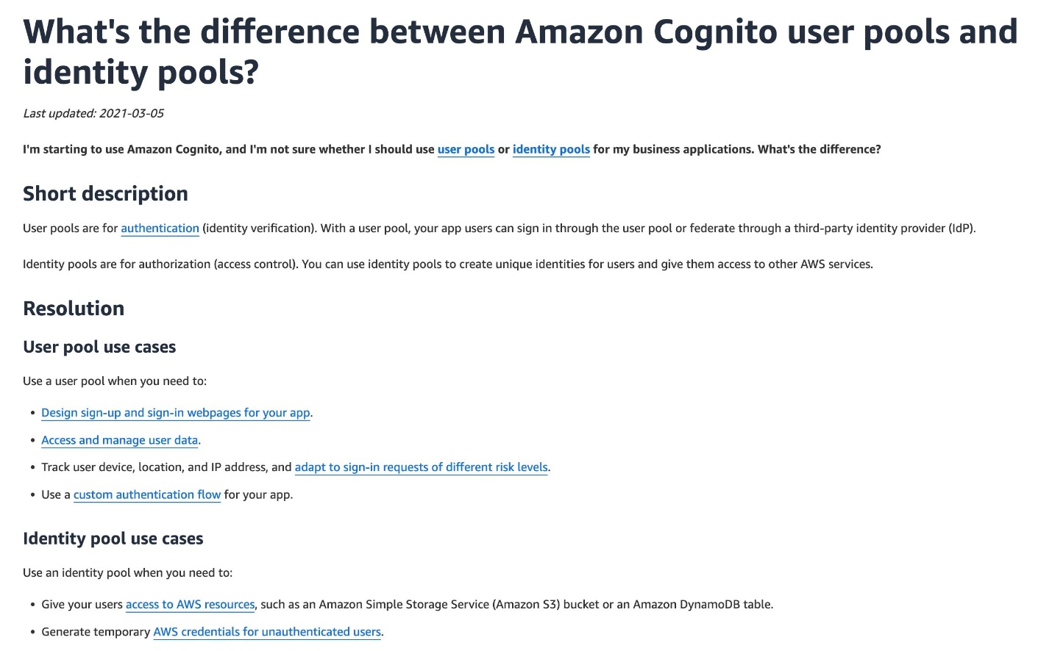 via - <https://aws.amazon.com/premiumsupport/knowledge-center/cognito-user-pools-identity-pools/>

**Leverage Cognito user pools to manage user accounts and set up an Amazon Cognito user pool authorizer in API Gateway to control access to the API. Set up a Lambda function to store the images as well as the image metadata in a DynamoDB table. Have the Lambda function retrieve previously uploaded images from DynamoDB** - You cannot use DynamoDB to store images as the maximum allowed item size is 400KB and the images range in size from 500KB to 5MB. You should also note that storing images on DynamoDB is an anti-pattern. So this option is incorrect.

References:

<https://docs.aws.amazon.com/cognito/latest/developerguide/cognito-user-identity-pools.html>

<https://docs.aws.amazon.com/cognito/latest/developerguide/cognito-identity.html>

<https://docs.aws.amazon.com/apigateway/latest/developerguide/apigateway-integrate-with-cognito.html>

<https://aws.amazon.com/premiumsupport/knowledge-center/cognito-user-pools-identity-pools/>

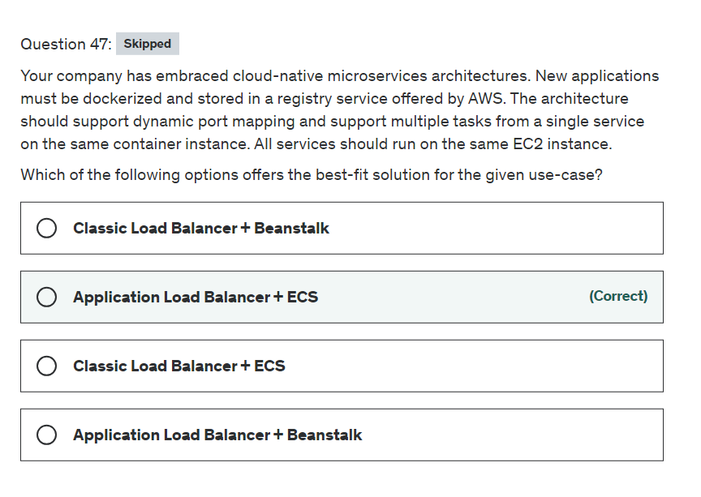

Explanation

Correct option:

**Application Load Balancer + ECS**

Amazon Elastic Container Service (Amazon ECS) is a highly scalable, fast, container management service that makes it easy to run, stop, and manage Docker containers on a cluster. You can host your cluster on a serverless infrastructure that is managed by Amazon ECS by launching your services or tasks using the Fargate launch type. For more control over your infrastructure, you can host your tasks on a cluster of Amazon Elastic Compute Cloud (Amazon EC2) instances that you manage by using the EC2 launch type.

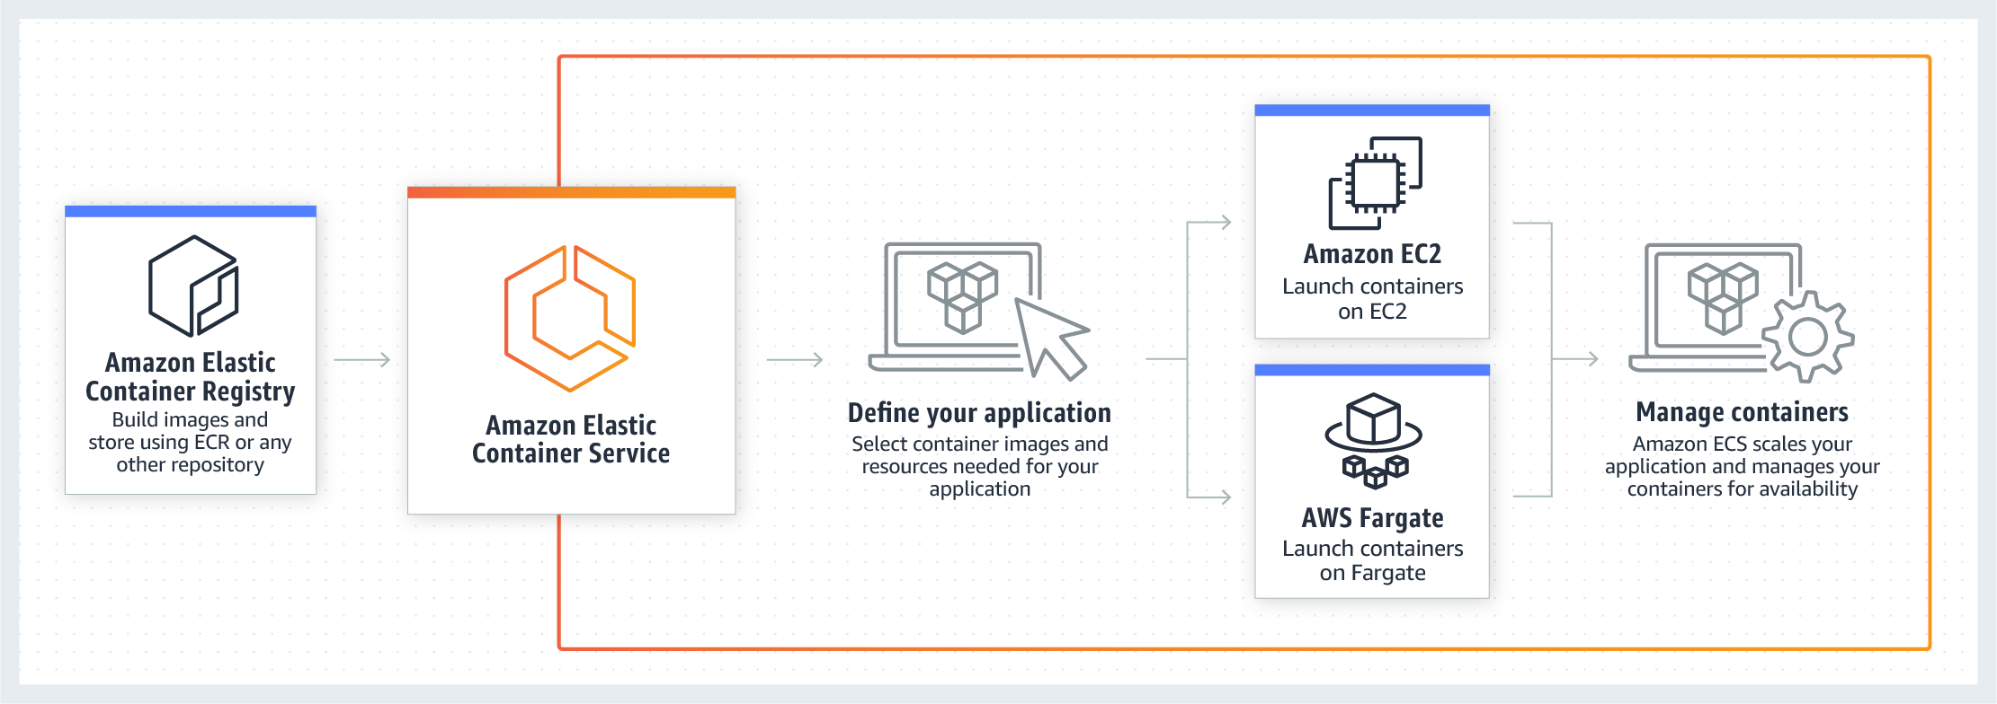 via - <https://aws.amazon.com/ecs/>

An Application load balancer distributes incoming application traffic across multiple targets, such as EC2 instances, in multiple Availability Zones. A listener checks for connection requests from clients, using the protocol and port that you configure. The rules that you define for a listener determine how the load balancer routes requests to its registered targets. Each rule consists of a priority, one or more actions, and one or more conditions.

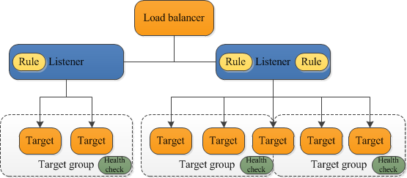 via - <https://docs.aws.amazon.com/elasticloadbalancing/latest/application/introduction.html>

When you deploy your services using Amazon Elastic Container Service (Amazon ECS), you can use dynamic port mapping to support multiple tasks from a single service on the same container instance. Amazon ECS manages updates to your services by automatically registering and deregistering containers with your target group using the instance ID and port for each container.

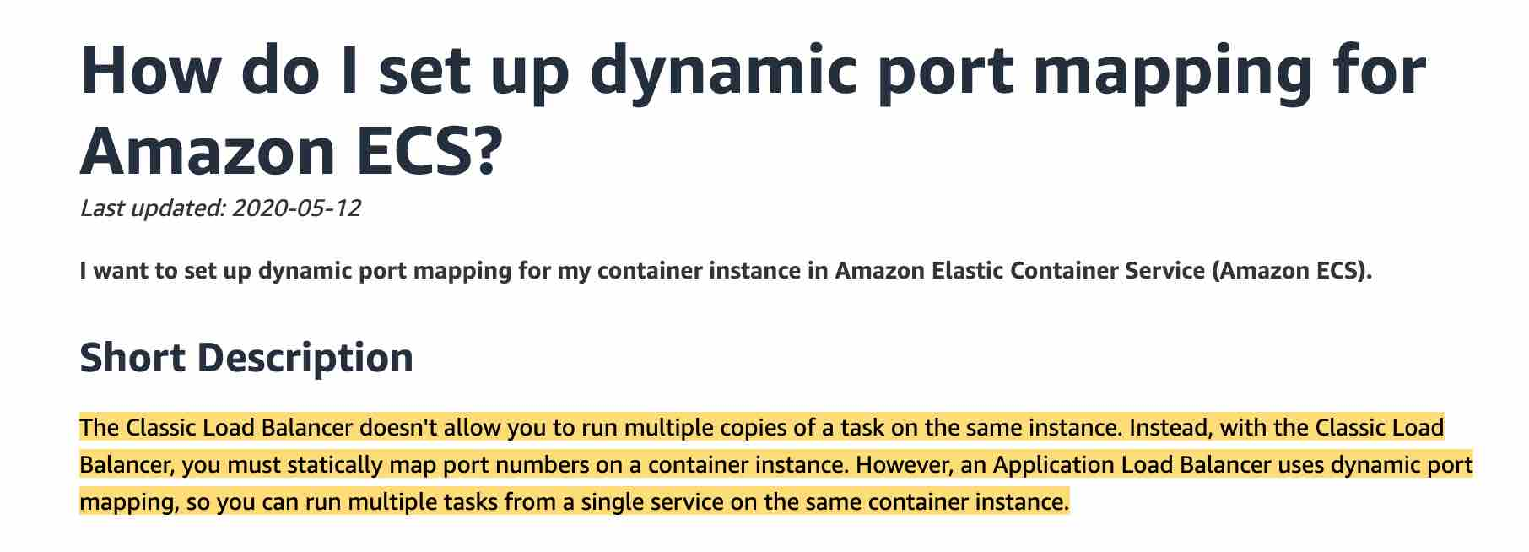 via - <https://aws.amazon.com/premiumsupport/knowledge-center/dynamic-port-mapping-ecs>

Incorrect options:

**Classic Load Balancer + Beanstalk** - The Classic Load Balancer doesn't allow you to run multiple copies of a task on the same instance. Instead, with the Classic Load Balancer, you must statically map port numbers on a container instance. So this option is ruled out.

**Application Load Balancer + Beanstalk** - You can create docker environments that support multiple containers per Amazon EC2 instance with a multi-container Docker platform for Elastic Beanstalk. However, ECS gives you finer control.

**Classic Load Balancer + ECS** - The Classic Load Balancer doesn't allow you to run multiple copies of a task in the same instance. Instead, with the Classic Load Balancer, you must statically map port numbers on a container instance. So this option is ruled out.

References:

<https://aws.amazon.com/premiumsupport/knowledge-center/dynamic-port-mapping-ecs>

<https://docs.aws.amazon.com/elasticloadbalancing/latest/application/tutorial-target-ecs-containers.html>

<https://docs.aws.amazon.com/elasticbeanstalk/latest/dg/create_deploy_docker_ecs.html>

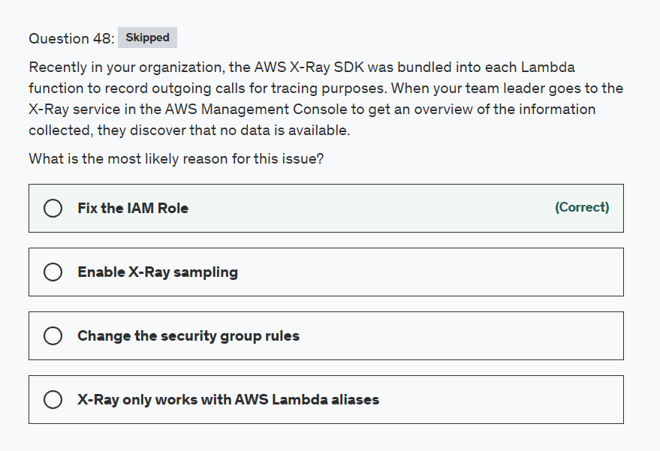

Explanation

Correct option:

AWS X-Ray helps developers analyze and debug production, distributed applications, such as those built using a microservices architecture. With X-Ray, you can understand how your application and its underlying services are performing to identify and troubleshoot the root cause of performance issues and errors. X-Ray provides an end-to-end view of requests as they travel through your application, and shows a map of your application’s underlying components.

How X-Ray Works:  via - <https://aws.amazon.com/xray/>

**Fix the IAM Role**

Create an IAM role with write permissions and assign it to the resources running your application. You can use AWS Identity and Access Management (IAM) to grant X-Ray permissions to users and compute resources in your account. This should be one of the first places you start by checking that your permissions are properly configured before exploring other troubleshooting options.

Here is an example of X-Ray Read-Only permissions via an IAM policy:

{

"Version": "2012-10-17",

"Statement": [

{

"Effect": "Allow",

"Action": [

"xray:GetSamplingRules",

"xray:GetSamplingTargets",

"xray:GetSamplingStatisticSummaries",

"xray:BatchGetTraces",

"xray:GetServiceGraph",

"xray:GetTraceGraph",

"xray:GetTraceSummaries",

"xray:GetGroups",

"xray:GetGroup"

],

"Resource": [

"*"

]

}

]

}

Another example of write permissions for using X-Ray via an IAM policy:

{

"Version": "2012-10-17",

"Statement": [

{

"Effect": "Allow",

"Action": [

"xray:PutTraceSegments",

"xray:PutTelemetryRecords",

"xray:GetSamplingRules",

"xray:GetSamplingTargets",

"xray:GetSamplingStatisticSummaries"

],

"Resource": [

"*"

]

}

]

}

Incorrect options:

**Enable X-Ray sampling** - If permissions are not configured correctly sampling will not work, so this option is not correct.

**X-Ray only works with AWS Lambda aliases** - This is not true, aliases are pointers to specific Lambda function versions. To use the X-Ray SDK on Lambda, bundle it with your function code each time you create a new version.

**Change the security group rules** - You grant permissions to your Lambda function to access other resources using an IAM role and not via security groups.

Reference:

<https://docs.aws.amazon.com/xray/latest/devguide/security_iam_troubleshoot.html>

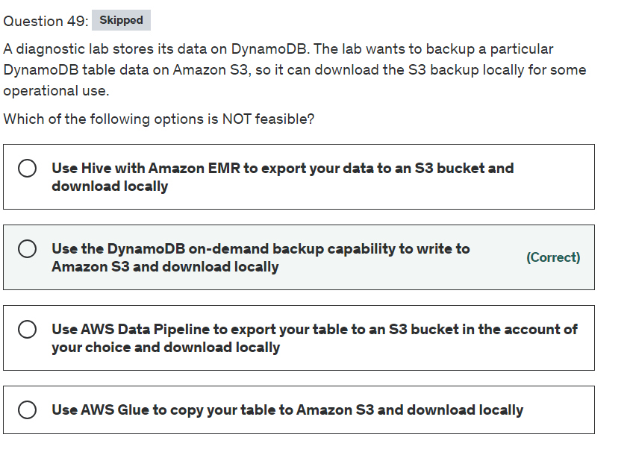

Explanation

Correct option:

**Use the DynamoDB on-demand backup capability to write to Amazon S3 and download locally** - This option is not feasible for the given use-case. DynamoDB has two built-in backup methods (On-demand, Point-in-time recovery) that write to Amazon S3, but you will not have access to the S3 buckets that are used for these backups.

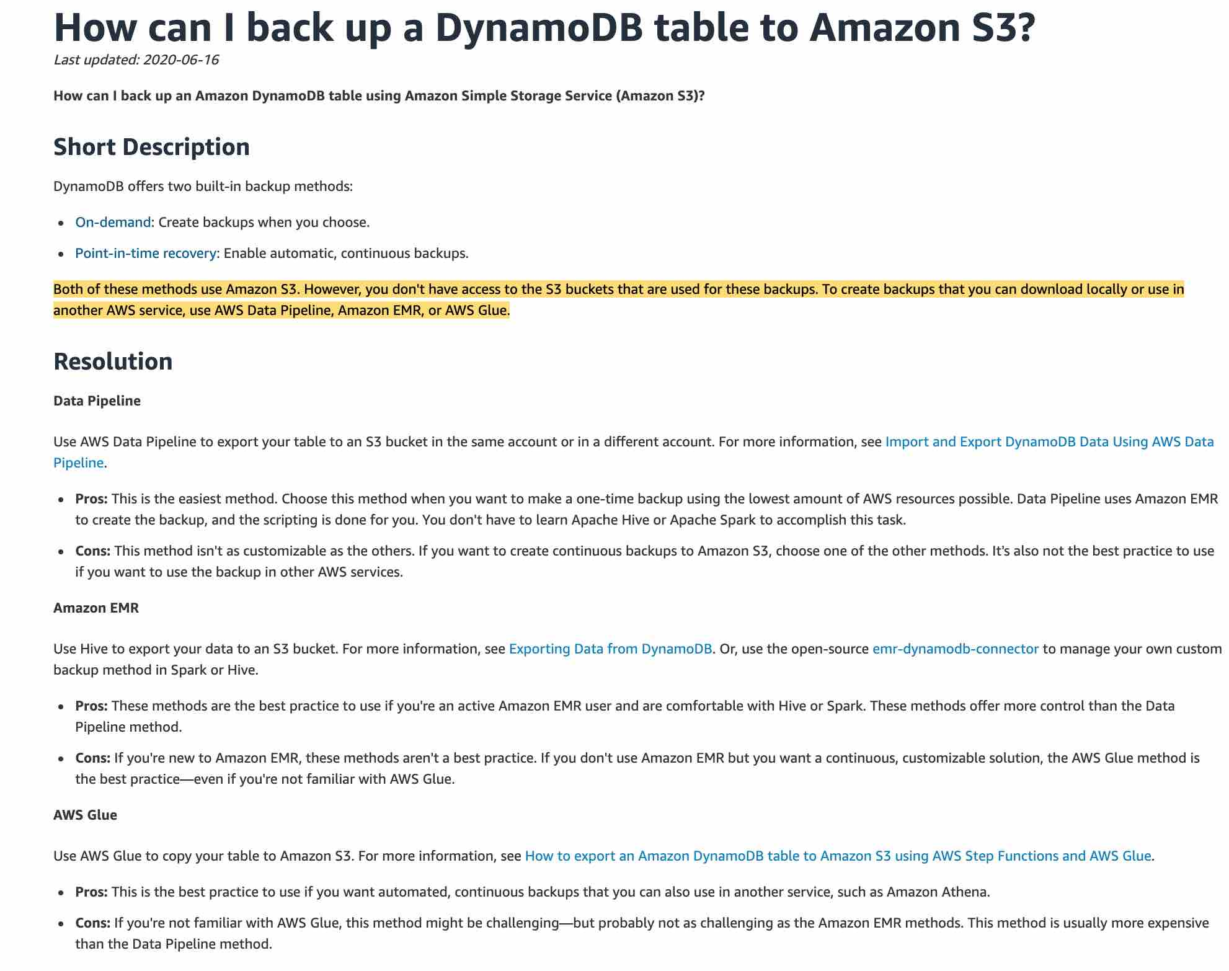 via - <https://aws.amazon.com/premiumsupport/knowledge-center/back-up-dynamodb-s3/>

Incorrect options:

**Use AWS Data Pipeline to export your table to an S3 bucket in the account of your choice and download locally** - This is the easiest method. This method is used when you want to make a one-time backup using the lowest amount of AWS resources possible. Data Pipeline uses Amazon EMR to create the backup, and the scripting is done for you. You don't have to learn Apache Hive or Apache Spark to accomplish this task.

**Use Hive with Amazon EMR to export your data to an S3 bucket and download locally** - Use Hive to export data to an S3 bucket. Or, use the open-source emr-dynamodb-connector to manage your own custom backup method in Spark or Hive. These methods are the best practice to use if you're an active Amazon EMR user and are comfortable with Hive or Spark. These methods offer more control than the Data Pipeline method.

**Use AWS Glue to copy your table to Amazon S3 and download locally** - Use AWS Glue to copy your table to Amazon S3. This is the best practice to use if you want automated, continuous backups that you can also use in another service, such as Amazon Athena.

References:

<https://docs.aws.amazon.com/amazondynamodb/latest/developerguide/BackupRestore.html>

<https://docs.aws.amazon.com/datapipeline/latest/DeveloperGuide/dp-importexport-ddb-part1.html>

<https://docs.aws.amazon.com/emr/latest/ReleaseGuide/EMR_Hive_Commands.html#EMR_Hive_Commands_exporting>

<https://aws.amazon.com/blogs/big-data/how-to-export-an-amazon-dynamodb-table-to-amazon-s3-using-aws-step-functions-and-aws-glue/>

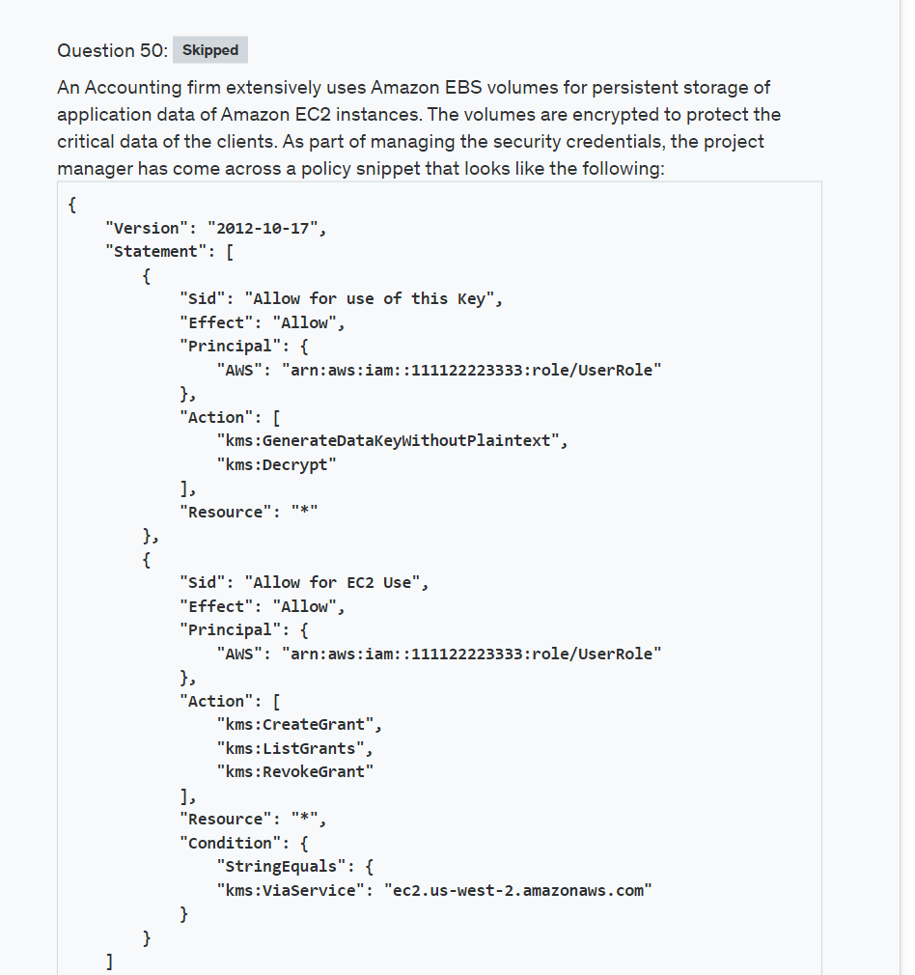

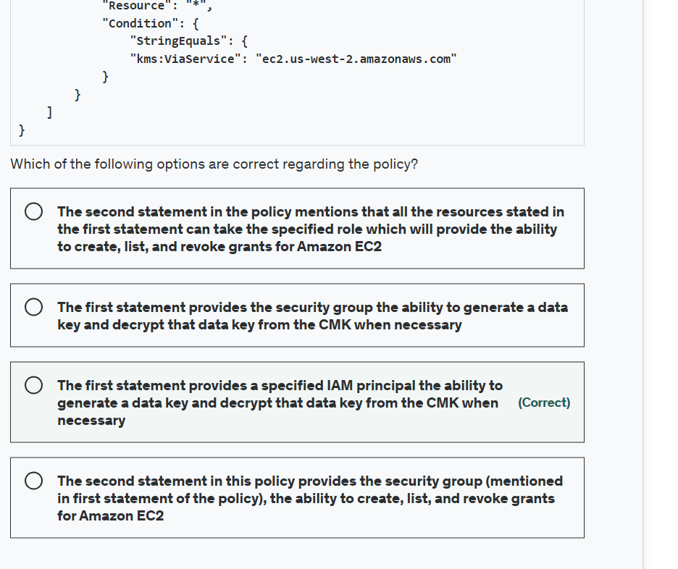

Explanation

Correct option:

**The first statement provides a specified IAM principal the ability to generate a data key and decrypt that data key from the CMK when necessary** - To create and use an encrypted Amazon Elastic Block Store (EBS) volume, you need permissions to use Amazon EBS. The key policy associated with the CMK would need to include these. The above policy is an example of one such policy.

In this CMK policy, the first statement provides a specified IAM principal the ability to generate a data key and decrypt that data key from the CMK when necessary. These two APIs are necessary to encrypt the EBS volume while it’s attached to an Amazon Elastic Compute Cloud (EC2) instance.

The second statement in this policy provides the specified IAM principal the ability to create, list, and revoke grants for Amazon EC2. Grants are used to delegate a subset of permissions to AWS services, or other principals, so that they can use your keys on your behalf. In this case, the condition policy explicitly ensures that only Amazon EC2 can use the grants. Amazon EC2 will use them to re-attach an encrypted EBS volume back to an instance if the volume gets detached due to a planned or unplanned outage. These events will be recorded within AWS CloudTrail when, and if, they do occur for your auditing.

Incorrect options:

**The first statement provides the security group the ability to generate a data key and decrypt that data key from the CMK when necessary**

**The second statement in this policy provides the security group (mentioned in the first statement of the policy), the ability to create, list, and revoke grants for Amazon EC2**

**The second statement in the policy mentions that all the resources stated in the first statement can take the specified role which will provide the ability to create, list, and revoke grants for Amazon EC2**

These three options contradict the explanation provided above, so these options are incorrect.

Reference:

<https://d0.awsstatic.com/whitepapers/aws-kms-best-practices.pdf>

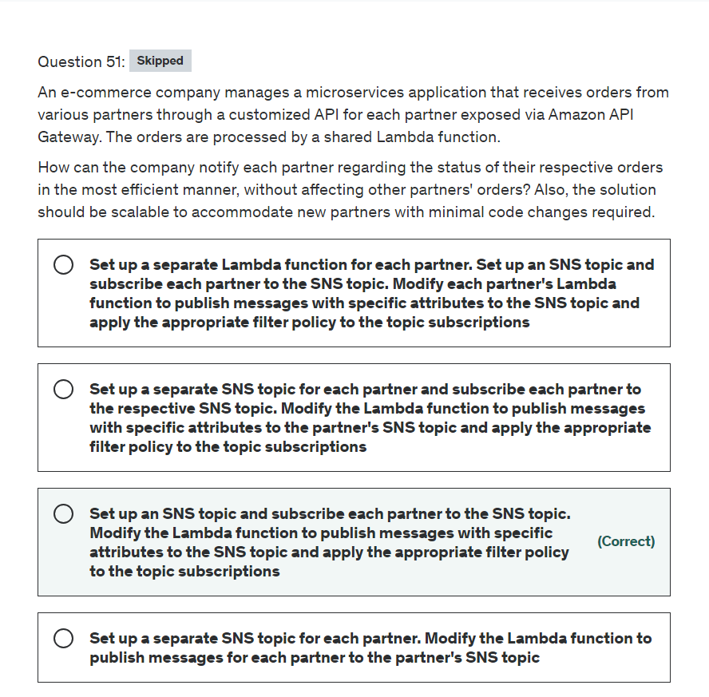

Explanation

Correct option:

**Set up an SNS topic and subscribe each partner to the SNS topic. Modify the Lambda function to publish messages with specific attributes to the SNS topic and apply the appropriate filter policy to the topic subscriptions**

An Amazon SNS topic is a logical access point that acts as a communication channel. A topic lets you group multiple endpoints (such as AWS Lambda, Amazon SQS, HTTP/S, or an email address). For example, to broadcast the messages of a message-producer system (such as, an e-commerce website) working with multiple other services that require its messages (for example, checkout and fulfillment systems), you can create a topic for your producer system.

By default, an Amazon SNS topic subscriber receives every message that's published to the topic. To receive only a subset of the messages, a subscriber must assign a filter policy to the topic subscription. A filter policy is a JSON object containing properties that define which messages the subscriber receives. Amazon SNS supports policies that act on the message attributes or the message body, according to the filter policy scope that you set for the subscription. Filter policies for the message body assume that the message payload is a well-formed JSON object.

For the given use case, you can change the Lambda function to publish messages with specific attributes to the single SNS topic and apply the appropriate filter policy to the topic subscriptions for each of the partners. This is also easily scalable for new partners since only the filter policy needs to be set up for the new partner.

Incorrect options:

**Set up a separate SNS topic for each partner. Modify the Lambda function to publish messages for each partner to the partner's SNS topic**

**Set up a separate SNS topic for each partner and subscribe each partner to the respective SNS topic. Modify the Lambda function to publish messages with specific attributes to the partner's SNS topic and apply the appropriate filter policy to the topic subscriptions**

Both of these options represent an inefficient solution as there is no need to segregate each partner's updates into a separate SNS topic. A single SNS topic with distinct filter policies is sufficient.

**Set up a separate Lambda function for each partner. Set up an SNS topic and subscribe each partner to the SNS topic. Modify each partner's Lambda function to publish messages with specific attributes to the SNS topic and apply the appropriate filter policy to the topic subscriptions** - This is again an inefficient solution as there is no need to create a separate Lambda function for each partner as just a shared Lambda function is sufficient to process the orders and send an update to the single SNS topic with distinct filter policies.

References:

<https://docs.aws.amazon.com/sns/latest/dg/sns-create-topic.html>

<https://docs.aws.amazon.com/sns/latest/dg/sns-message-filtering.html>

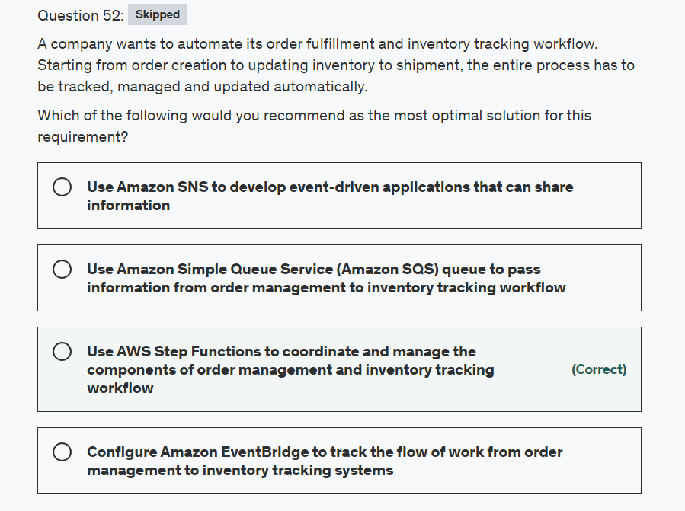

Explanation

Correct option:

**Use AWS Step Functions to coordinate and manage the components of order management and inventory tracking workflow**

AWS Step Functions is a serverless function orchestrator that makes it easy to sequence AWS Lambda functions and multiple AWS services into business-critical applications. Through its visual interface, you can create and run a series of checkpointed and event-driven workflows that maintain the application state. The output of one step acts as an input to the next. Each step in your application executes in order, as defined by your business logic.

AWS Step Functions enables you to implement a business process as a series of steps that make up a workflow. The individual steps in the workflow can invoke a Lambda function or a container that has some business logic, update a database such as DynamoDB or publish a message to a queue once that step or the entire workflow completes execution.

Benefits of Step Functions:

Build and update apps quickly: AWS Step Functions lets you build visual workflows that enable the fast translation of business requirements into technical requirements. You can build applications in a matter of minutes, and when needs change, you can swap or reorganize components without customizing any code.

Improve resiliency: AWS Step Functions manages state, checkpoints and restarts for you to make sure that your application executes in order and as expected. Built-in try/catch, retry and rollback capabilities deal with errors and exceptions automatically.

Write less code: AWS Step Functions manages the logic of your application for you and implements basic primitives such as branching, parallel execution, and timeouts. This removes extra code that may be repeated in your microservices and functions.

How Step Functions work: 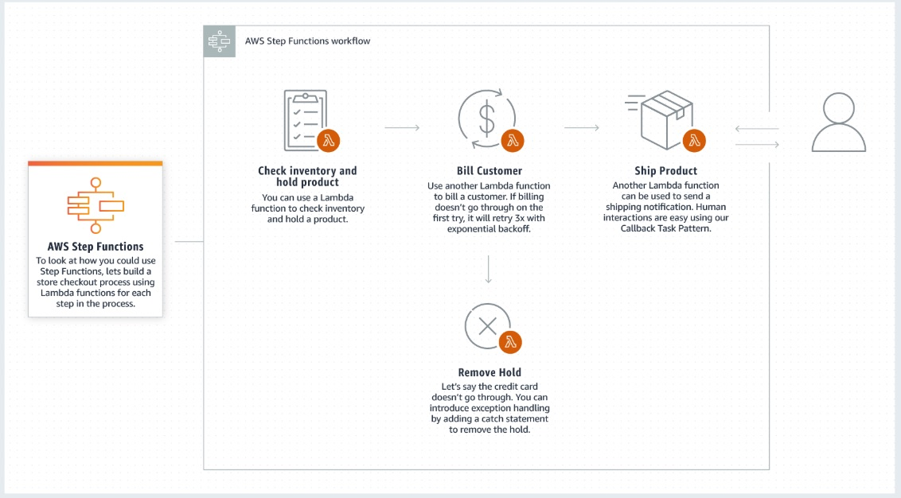 via - <https://aws.amazon.com/step-functions/>

Incorrect options:

**Use Amazon Simple Queue Service (Amazon SQS) queue to pass information from order management to inventory tracking workflow** - You should consider AWS Step Functions when you need to coordinate service components in the development of highly scalable and auditable applications. You should consider using Amazon Simple Queue Service (Amazon SQS), when you need a reliable, highly scalable, hosted queue for sending, storing, and receiving messages between services. Step Functions keeps track of all tasks and events in an application. Amazon SQS requires you to implement your own application-level tracking, especially if your application uses multiple queues.

**Configure Amazon EventBridge to track the flow of work from order management to inventory tracking systems** - Both Amazon EventBridge and Amazon SNS can be used to develop event-driven applications, and your choice will depend on your specific needs. Amazon EventBridge is recommended when you want to build an application that reacts to events from SaaS applications and/or AWS services. Amazon EventBridge is the only event-based service that integrates directly with third-party SaaS partners.

**Use Amazon SNS to develop event-driven applications that can share information** - Amazon SNS is recommended when you want to build an application that reacts to high throughput or low latency messages published by other applications or microservices (as Amazon SNS provides nearly unlimited throughput), or for applications that need very high fan-out (thousands or millions of endpoints).

References:

<https://aws.amazon.com/step-functions/faqs/>

<https://aws.amazon.com/eventbridge/faqs/>

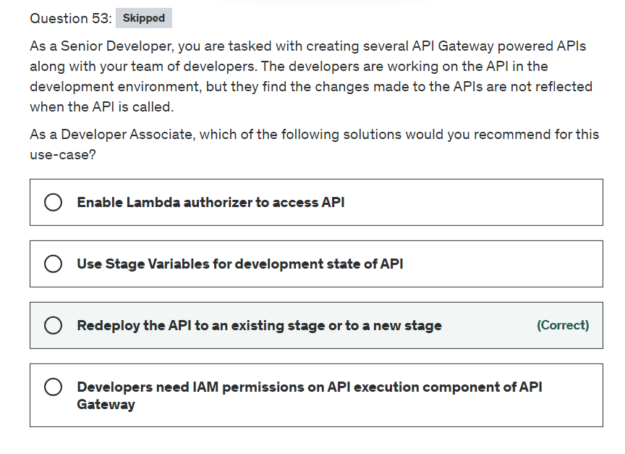

Explanation

Correct option:

**Redeploy the API to an existing stage or to a new stage**

After creating your API, you must deploy it to make it callable by your users. To deploy an API, you create an API deployment and associate it with a stage. A stage is a logical reference to a lifecycle state of your API (for example, dev, prod, beta, v2). API stages are identified by the API ID and stage name. Every time you update an API, you must redeploy the API to an existing stage or to a new stage. Updating an API includes modifying routes, methods, integrations, authorizers, and anything else other than stage settings.

Incorrect options:

**Developers need IAM permissions on API execution component of API Gateway** - Access control access to Amazon API Gateway APIs is done with IAM permissions. To call a deployed API or to refresh the API caching, you must grant the API caller permissions to perform required IAM actions supported by the API execution component of API Gateway. In the current scenario, developers do not need permissions on "execution components" but on "management components" of API Gateway that help them to create, deploy, and manage an API. Hence, this statement is an incorrect option.

**Enable Lambda authorizer to access API** - A Lambda authorizer (formerly known as a custom authorizer) is an API Gateway feature that uses a Lambda function to control access to your API. So, this feature too helps in access control, but in the current scenario its the developers and not the users who are facing the issue. So, this statement is an incorrect option.

**Use Stage Variables for development state of API** - Stage variables are name-value pairs that you can define as configuration attributes associated with a deployment stage of a REST API. They act like environment variables and can be used in your API setup and mapping templates. Stage variables are not connected to the scenario described in the current use case.

References:

<https://docs.aws.amazon.com/apigateway/latest/developerguide/how-to-deploy-api.html>

<https://docs.aws.amazon.com/apigateway/latest/developerguide/permissions.html>

<https://docs.aws.amazon.com/apigateway/latest/developerguide/apigateway-use-lambda-authorizer.html>

<https://docs.aws.amazon.com/apigateway/latest/developerguide/stage-variables.html>

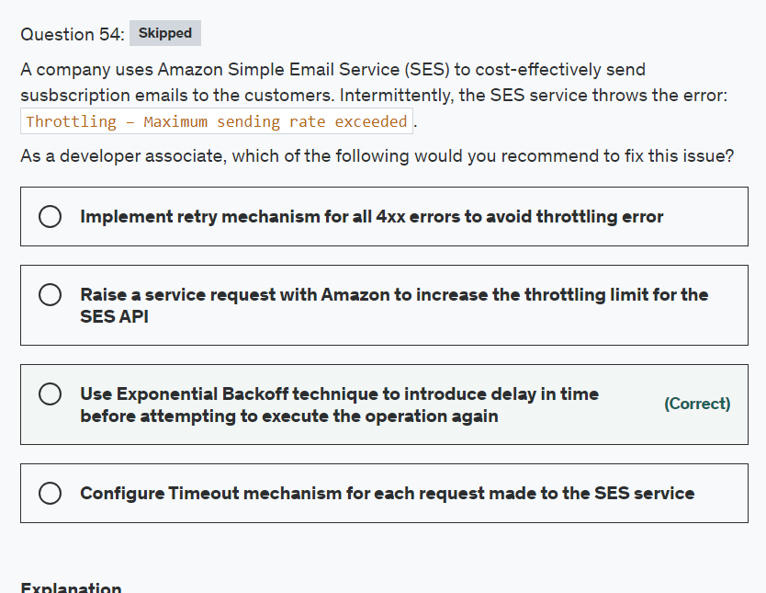

Explanation

Correct option:

**Use Exponential Backoff technique to introduce delay in time before attempting to execute the operation again** - A “Throttling – Maximum sending rate exceeded” error is retriable. This error is different than other errors returned by Amazon SES. A request rejected with a “Throttling” error can be retried at a later time and is likely to succeed.

Retries are “selfish.” In other words, when a client retries, it spends more of the server's time to get a higher chance of success. Where failures are rare or transient, that's not a problem. This is because the overall number of retried requests is small, and the tradeoff of increasing apparent availability works well. When failures are caused by overload, retries that increase load can make matters significantly worse. They can even delay recovery by keeping the load high long after the original issue is resolved.

The preferred solution is to use a backoff. Instead of retrying immediately and aggressively, the client waits some amount of time between tries. The most common pattern is an exponential backoff, where the wait time is increased exponentially after every attempt.

A variety of factors can affect your send rate, e.g. message size, network performance or Amazon SES availability. The advantage of the exponential backoff approach is that your application will self-tune and it will call Amazon SES at close to the maximum allowed rate.

Incorrect options:

**Configure Timeout mechanism for each request made to the SES service** - Requests are configured to timeout if they do not complete successfully in a given time. This helps free up the database, application and any other resource that could potentially keep on waiting to eventually succeed. But, if errors are caused by load, retries can be ineffective if all clients retry at the same time. Throttling error signifies that load is high on SES and it does not make sense to keep retrying.

**Raise a service request with Amazon to increase the throttling limit for the SES API** - If throttling error is persistent, then it indicates a high load on the system consistently and increasing the throttling limit will be the right solution for the problem. But, the error is only intermittent here, signifying that decreasing the rate of requests will handle the error.

**Implement retry mechanism for all 4xx errors to avoid throttling error** - 4xx status codes indicate that there was a problem with the client request. Common client request errors include providing invalid credentials and omitting required parameters. When you get a 4xx error, you need to correct the problem and resubmit a properly formed client request. Throttling is a server error and not a client error, hence retry on 4xx errors does not make sense here.

References:

<https://aws.amazon.com/builders-library/timeouts-retries-and-backoff-with-jitter/>

<https://aws.amazon.com/blogs/messaging-and-targeting/how-to-handle-a-throttling-maximum-sending-rate-exceeded-error/>

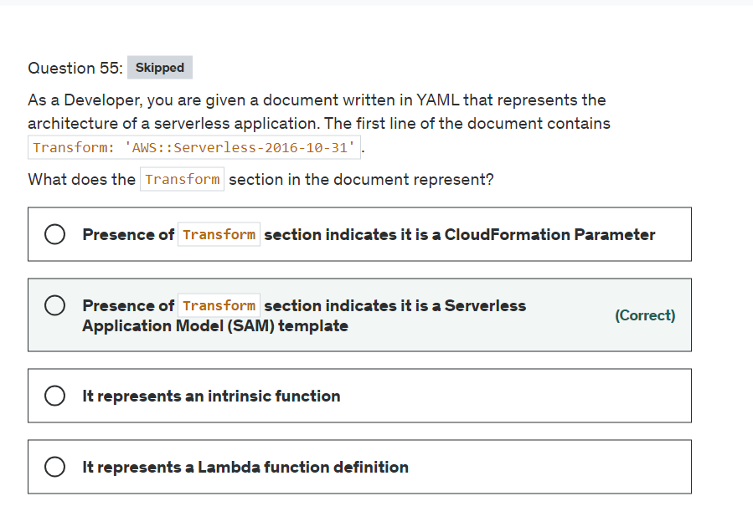

Explanation

Correct option:

AWS CloudFormation template is a JSON- or YAML-formatted text file that describes your AWS infrastructure. Templates include several major sections. The "Resources" section is the only required section. The optional "Transform" section specifies one or more macros that AWS CloudFormation uses to process your template.

**Presence of Transform section indicates it is a Serverless Application Model (SAM) template** - The AWS::Serverless transform, which is a macro hosted by AWS CloudFormation, takes an entire template written in the AWS Serverless Application Model (AWS SAM) syntax and transforms and expands it into a compliant AWS CloudFormation template. So, the presence of the Transform section indicates, the document is a SAM template.

Incorrect options:

**It represents a Lambda function definition** - Lambda function is created using "AWS::Lambda::Function" resource and has no connection to Transform section.

**It represents an intrinsic function** - Intrinsic Functions in templates are used to assign values to properties that are not available until runtime. They usually start with Fn:: or !. Example: !Sub or Fn::Sub.

**Presence of 'Transform' section indicates it is a CloudFormation Parameter** - CloudFormation parameters are part of Parameters block of the template, similar to below code:

References:

<https://docs.aws.amazon.com/AWSCloudFormation/latest/UserGuide/transform-aws-serverless.html>

<https://docs.aws.amazon.com/AWSCloudFormation/latest/UserGuide/template-anatomy.html>

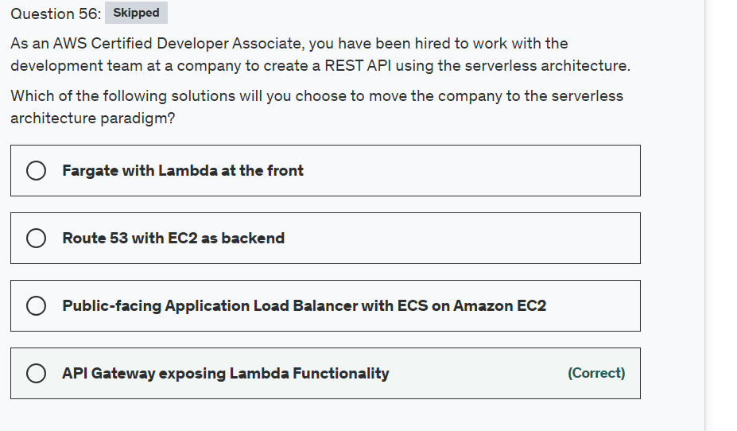

Explanation

Correct option:

**API Gateway exposing Lambda Functionality**

Amazon API Gateway is a fully managed service that makes it easy for developers to create, publish, maintain, monitor, and secure APIs at any scale. APIs act as the "front door" for applications to access data, business logic, or functionality from your backend services.

How API Gateway Works:  via - <https://aws.amazon.com/api-gateway/>

AWS Lambda lets you run code without provisioning or managing servers. You pay only for the compute time you consume.

How Lambda function works: 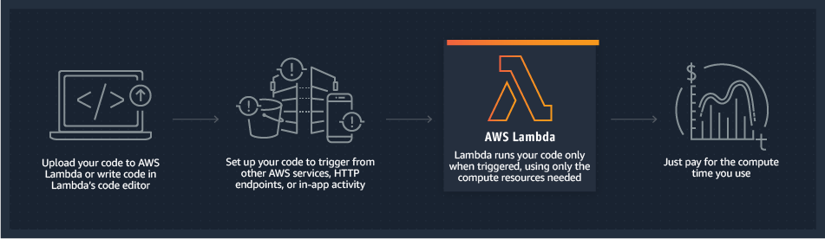 via - <https://aws.amazon.com/lambda/>

API Gateway can expose Lambda functionality through RESTful APIs. Both are serverless options offered by AWS and hence the right choice for this scenario, considering all the functionality they offer.

Incorrect options:

**Fargate with Lambda at the front** - Lambda cannot directly handle RESTful API requests. You can invoke a Lambda function over HTTPS by defining a custom RESTful API using Amazon API Gateway. So, Fargate with Lambda as the front-facing service is a wrong combination, though both Fargate and Lambda are serverless.

**Public-facing Application Load Balancer with ECS on Amazon EC2** - ECS on Amazon EC2 does not come under serverless and hence cannot be considered for this use case.

**Route 53 with EC2 as backend** - Amazon EC2 is not a serverless service and hence cannot be considered for this use case.

References:

<https://aws.amazon.com/serverless/>

<https://aws.amazon.com/api-gateway/>

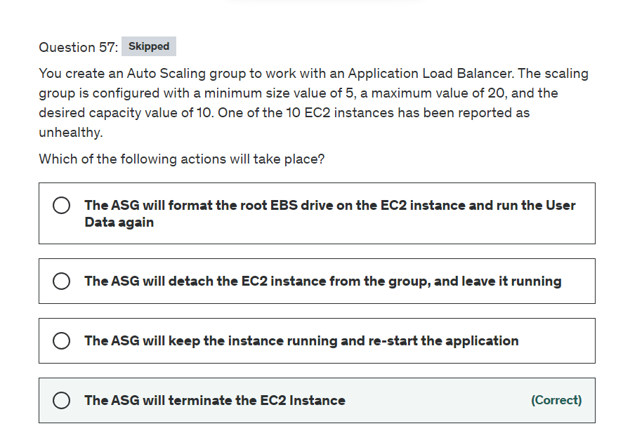

Explanation

Correct option:

**The ASG will terminate the EC2 Instance**

To maintain the same number of instances, Amazon EC2 Auto Scaling performs a periodic health check on running instances within an Auto Scaling group. When it finds that an instance is unhealthy, it terminates that instance and launches a new one. Amazon EC2 Auto Scaling creates a new scaling activity for terminating the unhealthy instance and then terminates it. Later, another scaling activity launches a new instance to replace the terminated instance.

Incorrect options:

**The ASG will detach the EC2 instance from the group, and leave it running** - The goal of the auto-scaling group is to get rid of the bad instance and replace it

**The ASG will keep the instance running and re-start the application** - The ASG does not have control of your application

**The ASG will format the root EBS drive on the EC2 instance and run the User Data again** - This will not happen, the ASG cannot assume the format of your EBS drive, and User Data only runs once at instance first boot.

References:

<https://aws.amazon.com/premiumsupport/knowledge-center/auto-scaling-terminate-instance>

<https://docs.aws.amazon.com/autoscaling/ec2/userguide/as-maintain-instance-levels.html#replace-unhealthy-instance>

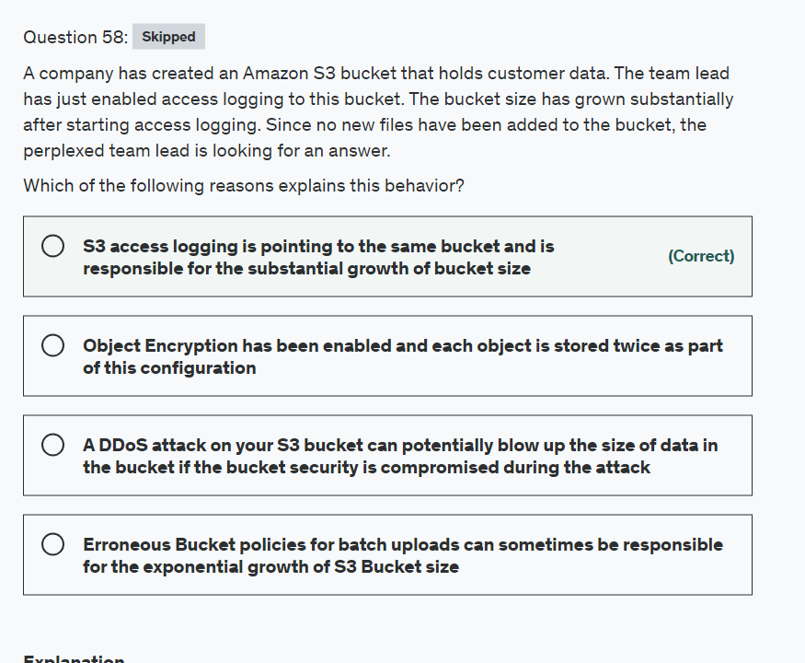

Explanation

Correct option:

**S3 access logging is pointing to the same bucket and is responsible for the substantial growth of bucket size** - When your source bucket and target bucket are the same bucket, additional logs are created for the logs that are written to the bucket. The extra logs about logs might make it harder to find the log that you are looking for. This configuration would drastically increase the size of the S3 bucket.

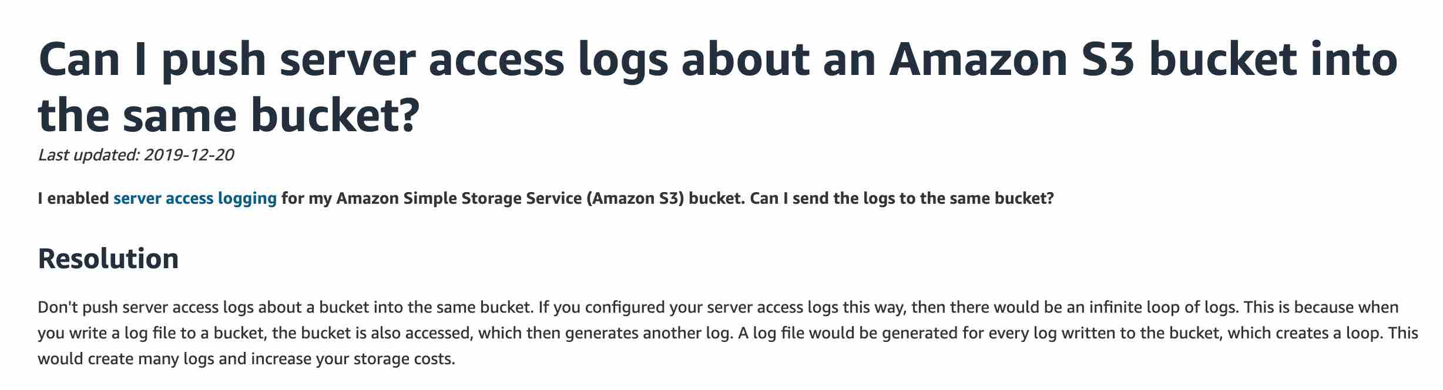 via - <https://aws.amazon.com/premiumsupport/knowledge-center/s3-server-access-logs-same-bucket/>

Incorrect options:

**Erroneous Bucket policies for batch uploads can sometimes be responsible for the exponential growth of S3 Bucket size** - This is an incorrect statement. A bucket policy is a resource-based AWS Identity and Access Management (IAM) policy. You add a bucket policy to a bucket to grant other AWS accounts or IAM users access permissions for the bucket and the objects in it. A bucket policy, for batch processes or normal processes, will not increase the size of the bucket or the objects in it.

**A DDOS attack on your S3 bucket can potentially blow up the size of data in the bucket if the bucket security is compromised during the attack** - This is an incorrect statement. AWS handles DDoS attacks on all of its managed services. However, a DDoS attack will not increase the size of the bucket.

**Object Encryption has been enabled and each object is stored twice as part of this configuration** - Encryption does not increase a bucket's size, that too, on daily basis, as if the case in the current scenario

References:

<https://docs.aws.amazon.com/AmazonS3/latest/dev/ServerLogs.html>

<https://docs.aws.amazon.com/AmazonS3/latest/user-guide/set-permissions.html>

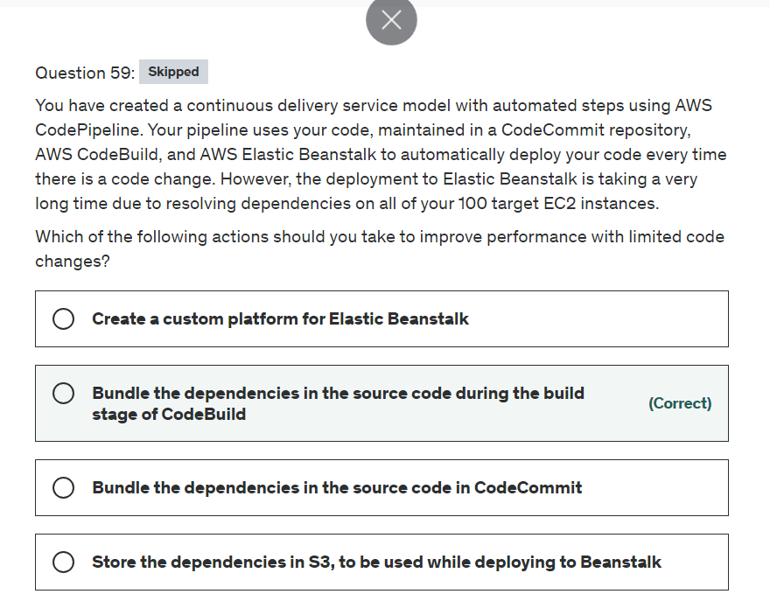

Explanation

Correct option:

**Bundle the dependencies in the source code during the build stage of CodeBuild**

AWS CodeBuild is a fully managed build service. There are no servers to provision and scale, or software to install, configure, and operate.

A typical application build process includes phases like preparing the environment, updating the configuration, downloading dependencies, running unit tests, and finally, packaging the built artifact.

Downloading dependencies is a critical phase in the build process. These dependent files can range in size from a few KBs to multiple MBs. Because most of the dependent files do not change frequently between builds, you can noticeably reduce your build time by caching dependencies.

This will allow the code bundle to be deployed to Elastic Beanstalk to have both the dependencies and the code, hence speeding up the deployment time to Elastic Beanstalk

Incorrect options:

**Bundle the dependencies in the source code in CodeCommit** - This is not the best practice and could make the CodeCommit repository huge.

**Store the dependencies in S3, to be used while deploying to Beanstalk** - This option acts as a distractor. S3 can be used as a storage location for your source code, logs, and other artifacts that are created when you use Elastic Beanstalk. Dependencies are used during the process of building code, not while deploying to Beanstalk.

**Create a custom platform for Elastic Beanstalk** - This is a more advanced feature that requires code changes, so does not fit the use-case.

Reference:

<https://aws.amazon.com/blogs/devops/how-to-enable-caching-for-aws-codebuild/>

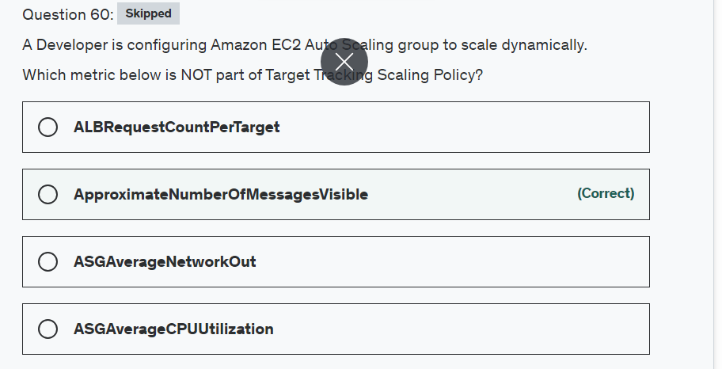

Explanation

Correct option:

**ApproximateNumberOfMessagesVisible** - This is a CloudWatch Amazon SQS queue metric. The number of messages in a queue might not change proportionally to the size of the Auto Scaling group that processes messages from the queue. Hence, this metric does not work for target tracking.

Incorrect options:

With target tracking scaling policies, you select a scaling metric and set a target value. Amazon EC2 Auto Scaling creates and manages the CloudWatch alarms that trigger the scaling policy and calculates the scaling adjustment based on the metric and the target value.

It is important to note that a target tracking scaling policy assumes that it should scale out your Auto Scaling group when the specified metric is above the target value. You cannot use a target tracking scaling policy to scale out your Auto Scaling group when the specified metric is below the target value.

**ASGAverageCPUUtilization** - This is a predefined metric for target tracking scaling policy. This represents the Average CPU utilization of the Auto Scaling group.

**ASGAverageNetworkOut** - This is a predefined metric for target tracking scaling policy. This represents the Average number of bytes sent out on all network interfaces by the Auto Scaling group.

**ALBRequestCountPerTarget** - This is a predefined metric for target tracking scaling policy. This represents the Number of requests completed per target in an Application Load Balancer target group.

Reference:

<https://docs.aws.amazon.com/autoscaling/ec2/userguide/as-scaling-target-tracking.html>

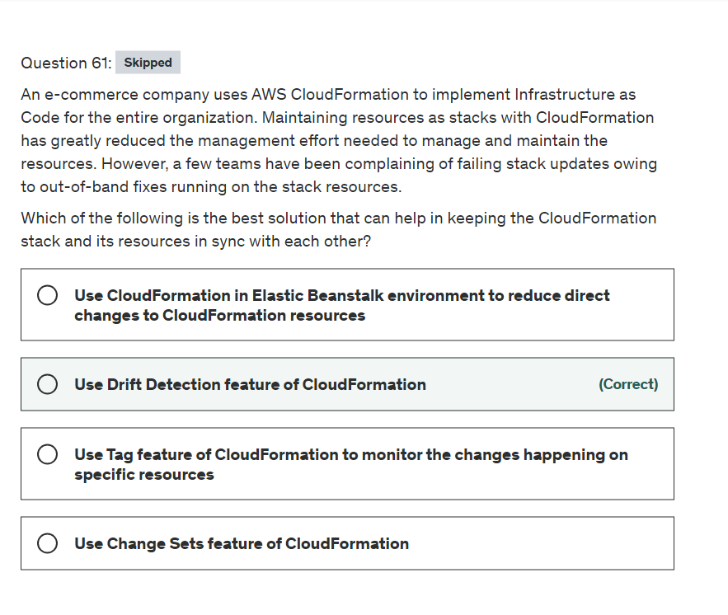

Explanation

Correct option:

**Use Drift Detection feature of CloudFormation**

Drift detection enables you to detect whether a stack's actual configuration differs, or has drifted, from its expected configuration. Use CloudFormation to detect drift on an entire stack, or individual resources within the stack. A resource is considered to have drifted if any of its actual property values differ from the expected property values. This includes if the property or resource has been deleted. A stack is considered to have drifted if one or more of its resources have drifted.

To determine whether a resource has drifted, CloudFormation determines the expected resource property values, as defined in the stack template and any values specified as template parameters. CloudFormation then compares those expected values with the actual values of those resource properties as they currently exist in the stack. A resource is considered to have drifted if one or more of its properties have been deleted, or had their value changed.

You can then take corrective action so that your stack resources are again in sync with their definitions in the stack template, such as updating the drifted resources directly so that they agree with their template definition. Resolving drift helps to ensure configuration consistency and successful stack operations.

Incorrect options:

**Use CloudFormation in Elastic Beanstalk environment to reduce direct changes to CloudFormation resources** - Elastic Beanstalk environment provides full access to the resources created. So, it is possible to edit the resources and hence does not solve the issue mentioned for the given use case.

**Use Tag feature of CloudFormation to monitor the changes happening on specific resources** - Tags help you identify and categorize the resources created as part of CloudFormation template. This feature is not helpful for the given use case.

**Use Change Sets feature of CloudFormation** - When you need to update a stack, understanding how your changes will affect running resources before you implement them can help you update stacks with confidence. Change sets allow you to preview how proposed changes to a stack might impact your running resources, for example, whether your changes will delete or replace any critical resources, AWS CloudFormation makes the changes to your stack only when you decide to execute the change set, allowing you to decide whether to proceed with your proposed changes or explore other changes by creating another change set. Change sets are not useful for the given use-case.

References:

<https://docs.aws.amazon.com/AWSCloudFormation/latest/UserGuide/detect-drift-stack.html>

<https://docs.aws.amazon.com/AWSCloudFormation/latest/UserGuide/using-cfn-updating-stacks-changesets.html>

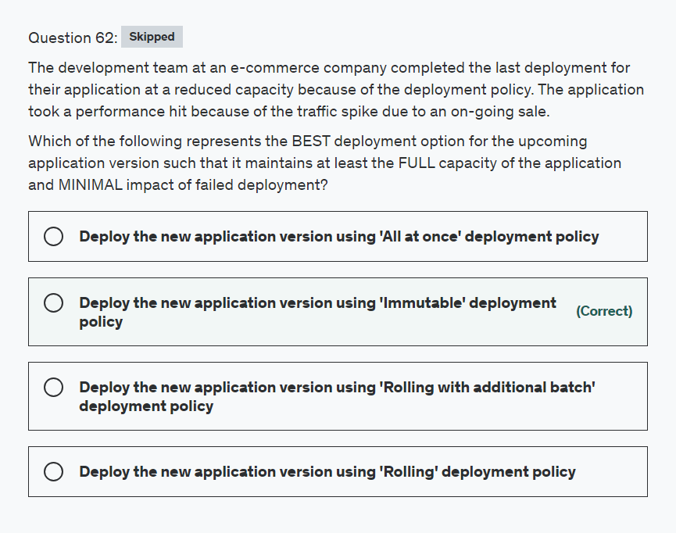

Explanation

Correct option:

**Deploy the new application version using 'Immutable' deployment policy**

With Elastic Beanstalk, you can quickly deploy and manage applications in the AWS Cloud without having to learn about the infrastructure that runs those applications. Elastic Beanstalk reduces management complexity without restricting choice or control. You simply upload your application, and Elastic Beanstalk automatically handles the details of capacity provisioning, load balancing, scaling, and application health monitoring.

How Elastic BeanStalk Works:  via - <https://docs.aws.amazon.com/elasticbeanstalk/latest/dg/Welcome.html>

The 'Immutable' deployment policy ensures that your new application version is always deployed to new instances, instead of updating existing instances. It also has the additional advantage of a quick and safe rollback in case the deployment fails. In an immutable update, a second Auto Scaling group is launched in your environment and the new version serves traffic alongside the old version until the new instances pass health checks. In case of deployment failure, the new instances are terminated, so the impact is minimal.

Overview of Elastic Beanstalk Deployment Policies:  via - <https://docs.aws.amazon.com/elasticbeanstalk/latest/dg/using-features.deploy-existing-version.html>

Incorrect options:

**Deploy the new application version using 'All at once' deployment policy** - Although 'All at once' is the quickest deployment method, but the application may become unavailable to users (or have low availability) for a short time. Also in case of deployment failure, the application sees a downtime, so this option is not correct.

**Deploy the new application version using 'Rolling' deployment policy** - This policy avoids downtime and minimizes reduced availability, at a cost of a longer deployment time. However in case of deployment failure, the rollback process is via manual redeploy, so it's not as quick as the Immutable deployment.

**Deploy the new application version using 'Rolling with additional batch' deployment policy** - This policy avoids any reduced availability, at a cost of an even longer deployment time compared to the Rolling method. Suitable if you must maintain the same bandwidth throughout the deployment. However in case of deployment failure, the rollback process is via manual redeploy, so it's not as quick as the Immutable deployment.

References:

<https://docs.aws.amazon.com/elasticbeanstalk/latest/dg/Welcome.html>

<https://docs.aws.amazon.com/elasticbeanstalk/latest/dg/using-features.deploy-existing-version.html>

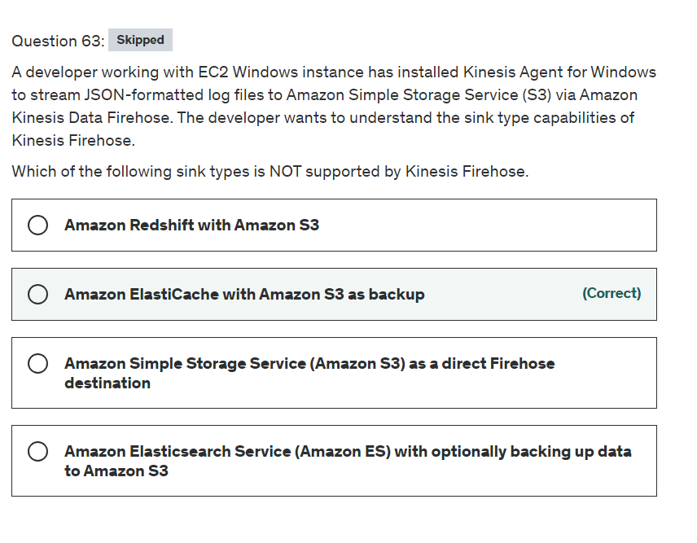

Explanation

Correct option:

Amazon Kinesis Data Firehose is a fully managed service for delivering real-time streaming data to destinations such as Amazon Simple Storage Service (Amazon S3), Amazon Redshift, Amazon Elasticsearch Service (Amazon ES), and Splunk. With Kinesis Data Firehose, you don't need to write applications or manage resources. You configure your data producers to send data to Kinesis Data Firehose, and it automatically delivers the data to the destination that you specified.

**Amazon ElastiCache with Amazon S3 as backup** - Amazon ElastiCache is a fully managed in-memory data store, compatible with Redis or Memcached. ElastiCache is NOT a supported destination for Amazon Kinesis Data Firehose.

Incorrect options:

**Amazon Elasticsearch Service (Amazon ES) with optionally backing up data to Amazon S3** - Amazon ES is a supported destination type for Kinesis Firehose. Streaming data is delivered to your Amazon ES cluster, and can optionally be backed up to your S3 bucket concurrently.

Data Flow for ES: 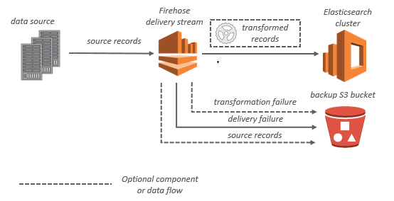 via - <https://docs.aws.amazon.com/firehose/latest/dev/what-is-this-service.html>

**Amazon Simple Storage Service (Amazon S3) as a direct Firehose destination** - For Amazon S3 destinations, streaming data is delivered to your S3 bucket. If data transformation is enabled, you can optionally back up source data to another Amazon S3 bucket.

Data Flow for S3: 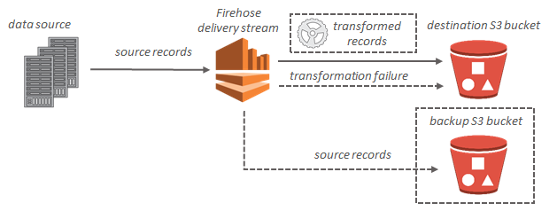 via - <https://docs.aws.amazon.com/firehose/latest/dev/what-is-this-service.html>

**Amazon Redshift with Amazon S3** - For Amazon Redshift destinations, streaming data is delivered to your S3 bucket first. Kinesis Data Firehose then issues an Amazon Redshift COPY command to load data from your S3 bucket to your Amazon Redshift cluster. If data transformation is enabled, you can optionally back up source data to another Amazon S3 bucket.

Data Flow for Redshift: 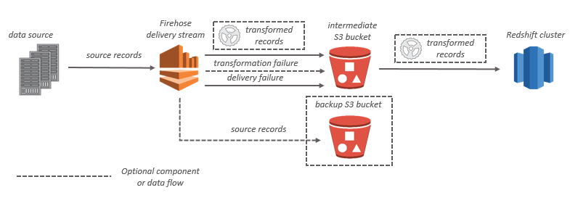 via - <https://docs.aws.amazon.com/firehose/latest/dev/what-is-this-service.html>

Reference:

<https://docs.aws.amazon.com/firehose/latest/dev/what-is-this-service.html>

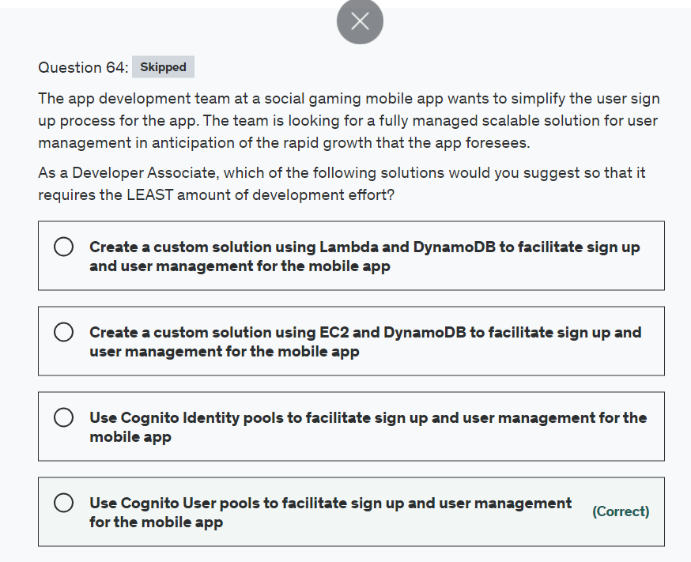

Explanation

Correct option:

**Use Cognito User pools to facilitate sign up and user management for the mobile app**

Amazon Cognito provides authentication, authorization, and user management for your web and mobile apps. Your users can sign in directly with a user name and password, or through a third party such as Facebook, Amazon, Google or Apple.

A user pool is a user directory in Amazon Cognito. With a user pool, your users can sign in to your web or mobile app through Amazon Cognito, or federate through a third-party identity provider (IdP). Whether your users sign-in directly or through a third party, all members of the user pool have a directory profile that you can access through an SDK.

Cognito is fully managed by AWS and works out of the box so it meets the requirements for the given use-case.

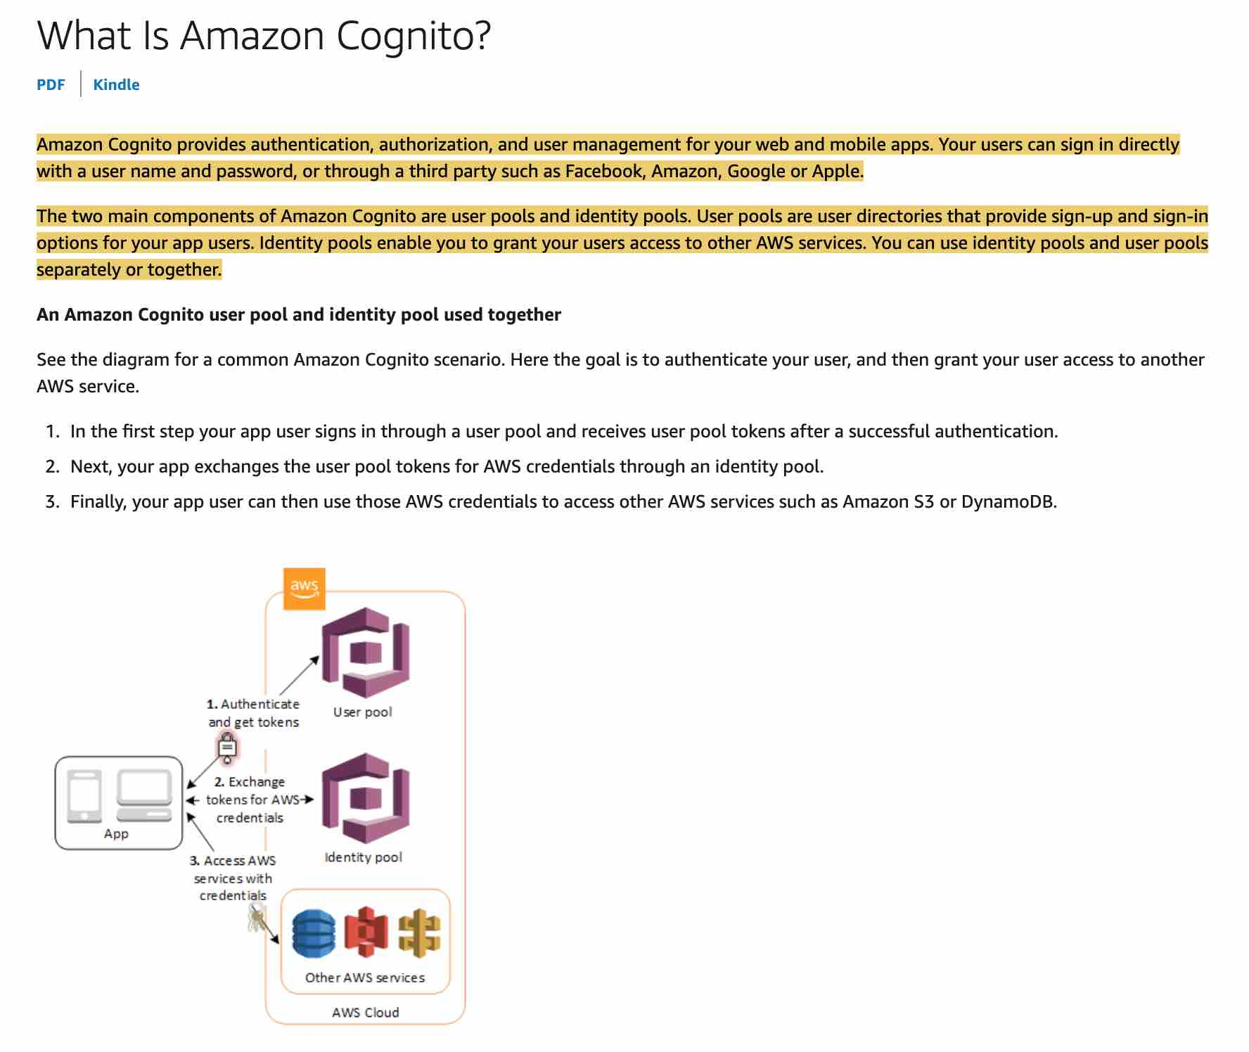 via - <https://docs.aws.amazon.com/cognito/latest/developerguide/what-is-amazon-cognito.html>

Incorrect options:

**Use Cognito Identity pools to facilitate sign up and user management for the mobile app** - You can use Identity pools to grant your users access to other AWS services. With an identity pool, your users can obtain temporary AWS credentials to access AWS services, such as Amazon S3 and DynamoDB. Identity pools support anonymous guest users, as well as the specific identity providers that you can use to authenticate users for identity pools.

Exam Alert:

Please review the following note to understand the differences between Cognito User Pools and Cognito Identity Pools:  via - <https://docs.aws.amazon.com/cognito/latest/developerguide/what-is-amazon-cognito.html>

**Create a custom solution with EC2 and DynamoDB to facilitate sign up and user management for the mobile app**

**Create a custom solution with Lambda and DynamoDB to facilitate sign up and user management for the mobile app**

As the problem statement mentions that the solution needs to be fully managed and should require the least amount of development effort, so you cannot use EC2 or Lambda functions with DynamoDB to create a custom solution.

Reference:

<https://docs.aws.amazon.com/cognito/latest/developerguide/what-is-amazon-cognito.html>

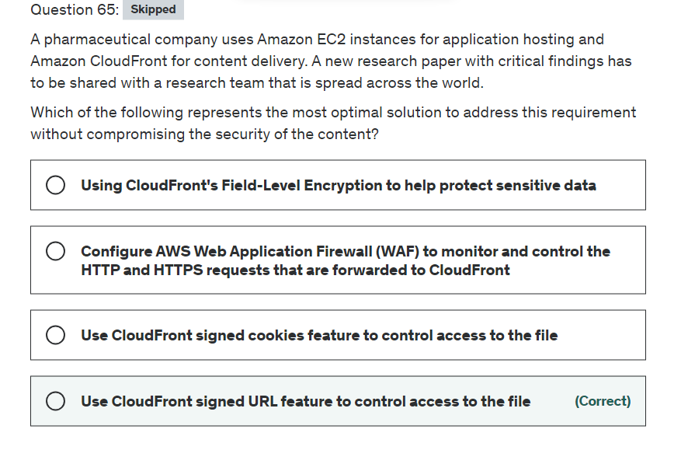

**Explanation**

Correct option:

**Use CloudFront signed URL feature to control access to the file**

A signed URL includes additional information, for example, expiration date and time, that gives you more control over access to your content.

Here's an overview of how you configure CloudFront for signed URLs and how CloudFront responds when a user uses a signed URL to request a file:

In your CloudFront distribution, specify one or more trusted key groups, which contain the public keys that CloudFront can use to verify the URL signature. You use the corresponding private keys to sign the URLs.

Develop your application to determine whether a user should have access to your content and to create signed URLs for the files or parts of your application that you want to restrict access to.

A user requests a file for which you want to require signed URLs. Your application verifies that the user is entitled to access the file: they've signed in, they've paid for access to the content, or they've met some other requirement for access.

Your application creates and returns a signed URL to the user. The signed URL allows the user to download or stream the content.

This step is automatic; the user usually doesn't have to do anything additional to access the content. For example, if a user is accessing your content in a web browser, your application returns the signed URL to the browser. The browser immediately uses the signed URL to access the file in the CloudFront edge cache without any intervention from the user.

CloudFront uses the public key to validate the signature and confirm that the URL hasn't been tampered with. If the signature is invalid, the request is rejected. If the request meets the requirements in the policy statement, CloudFront does the standard operations: determines whether the file is already in the edge cache, forwards the request to the origin if necessary, and returns the file to the user.

Incorrect options:

**Use CloudFront signed cookies feature to control access to the file** - CloudFront signed cookies allow you to control who can access your content when you don't want to change your current URLs or when you want to provide access to multiple restricted files, for example, all of the files in the subscribers' area of a website. Our requirement has only one file that needs to be shared and hence signed URL is the optimal solution.

Signed URLs take precedence over signed cookies. If you use both signed URLs and signed cookies to control access to the same files and a viewer uses a signed URL to request a file, CloudFront determines whether to return the file to the viewer based only on the signed URL.

**Configure AWS Web Application Firewall (WAF) to monitor and control the HTTP and HTTPS requests that are forwarded to CloudFront** - AWS WAF is a web application firewall that lets you monitor the HTTP and HTTPS requests that are forwarded to CloudFront, and lets you control access to your content. Based on conditions that you specify, such as the values of query strings or the IP addresses that requests originate from, CloudFront responds to requests either with the requested content or with an HTTP status code 403 (Forbidden). A firewall is optimal for broader use cases than restricted access to a single file.

**Using CloudFront's Field-Level Encryption to help protect sensitive data** - CloudFront's field-level encryption further encrypts sensitive data in an HTTPS form using field-specific encryption keys (which you supply) before a POST request is forwarded to your origin. This ensures that sensitive data can only be decrypted and viewed by certain components or services in your application stack. This feature is not useful for the given use case.

References:

<https://docs.aws.amazon.com/AmazonCloudFront/latest/DeveloperGuide/private-content-signed-urls.html>

<https://docs.aws.amazon.com/AmazonCloudFront/latest/DeveloperGuide/distribution-web-awswaf.html>

<https://aws.amazon.com/about-aws/whats-new/2017/12/introducing-field-level-encryption-on-amazon-cloudfront/>